based off this give me a short description of challenges experienced and challenges resolved.

Activity 3.1: Debugging and Error Handling
based off this give me a short description of challenges experienced and challenges resolved.

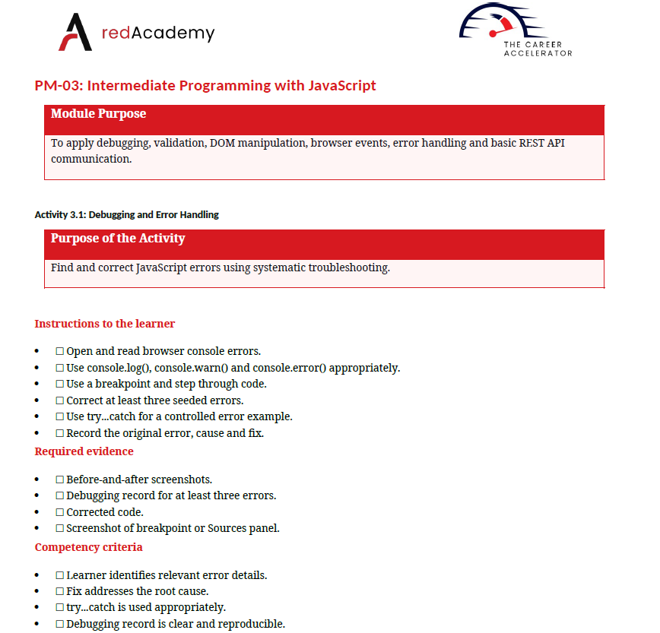

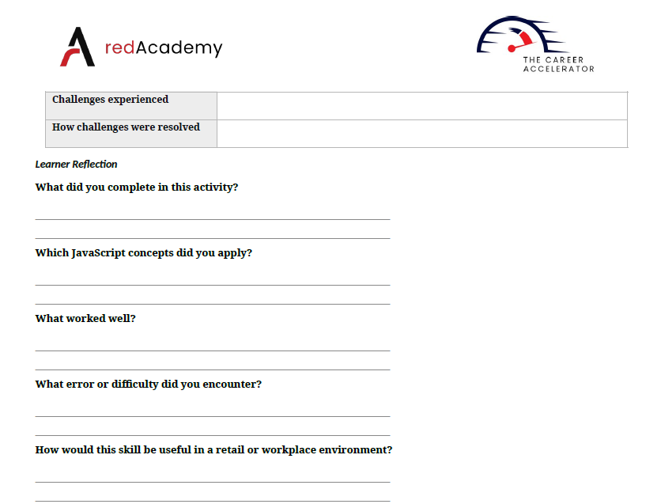

Challenges experienced
I had difficulty finding some JavaScript errors and understanding why the code was not working as expected.

How challenges were resolved
I used the browser console, console.log(), breakpoints and step-by-step debugging to find the cause and correct the errors.

Learner Reflection

What did you complete in this activity?
I found and fixed three seeded JavaScript errors and tested the corrected code. I also used try...catch to handle an error.

Which JavaScript concepts did you apply?
I applied event handling, DOM manipulation, console debugging, breakpoints, try...catch, and error handling.

What worked well?
Using the browser console and console.log() helped me see what the code was doing and identify where the problem occurred.

What error or difficulty did you encounter?
I encountered errors caused by incorrect or missing code, such as a missing event.preventDefault() and other seeded errors. I used debugging tools to identify and fix them.

How would this skill be useful in a retail or workplace environment?
Debugging helps identify and fix software problems quickly, reducing system downtime and helping business applications work correctly for users and customers.

Activity 3.2: Department Contact Form with Validation
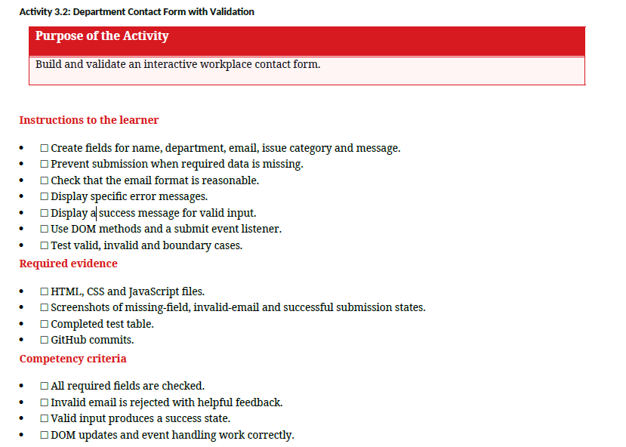

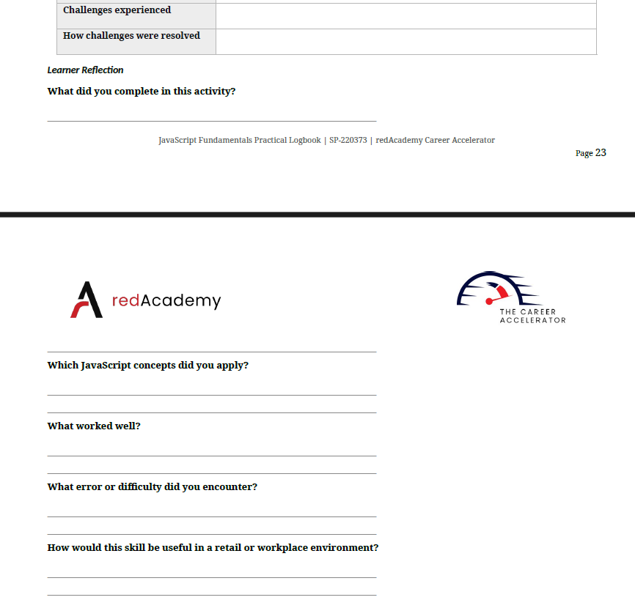

Challenges experienced
- Form Auto-Reload: Submitting the form automatically refreshed the browser, clearing the form fields before JavaScript could validate the inputs.
- Flaky Email Validation: Writing a JavaScript logic condition that properly caught invalid email formats (like missing @ symbols) without blocking valid ones.

How challenges were resolved
- Preventing Default Behavior: Used event.preventDefault() inside the submit event listener to stop the form from reloading the page automatically.
- Applying Regex & Testing: Used a standard Regular Expression (RegEx) to test the email string format, and systematically tested valid, invalid, and edge-case email inputs to ensure accuracy

What did you complete in this activity?
I built an interactive workplace contact form using HTML, CSS, and JavaScript. The form collects user details (Name, Department, Email, Issue Category, Message) and validates the inputs dynamically before allowing submission.

Which JavaScript concepts did you apply?
- DOM Manipulation: Selecting elements using methods like document.getElementById() and dynamically altering text/styles to display error or success messages.
- Event Handling: Adding an addEventListener to listen for the form's submit event and using event.preventDefault() to stop automatic page reloads.
- Conditional Logic & Regular Expressions (RegEx): Using if/else statements to check for missing inputs and applying RegEx to check if the email format is valid.

What worked well?
The event listener effectively intercepted form submissions, allowing real-time feedback. Dynamically updating the DOM meant users received clear, immediate error messages next to invalid fields without needing to refresh the page.

What error or difficulty did you encounter?
- Page Refreshing: Initially, submitting the form caused the page to reload instantly, clearing all user inputs before validation could run.
- Regex Validation: Creating a pattern for email validation that correctly flagged invalid emails without breaking on valid ones.

How would this skill be useful in a retail or workplace environment?
Form validation ensures that customer inquiries, internal support tickets, or feedback submissions are captured accurately without missing key info (like an email address). This saves time, prevents database clutter with broken entries, and improves overall communication efficiency in a business setting.
Activity 3.3: DOM Events and Dynamic Content
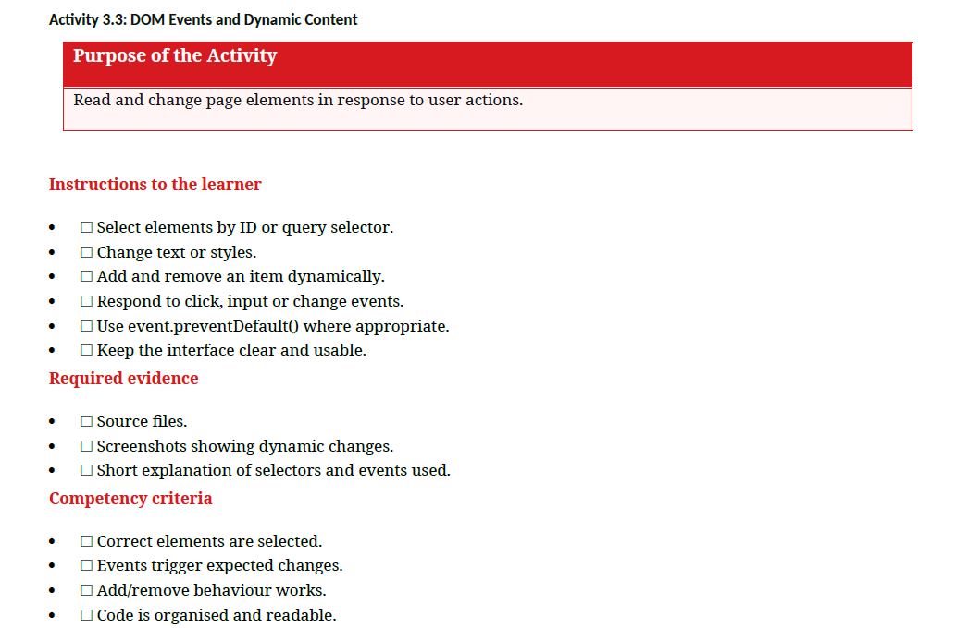

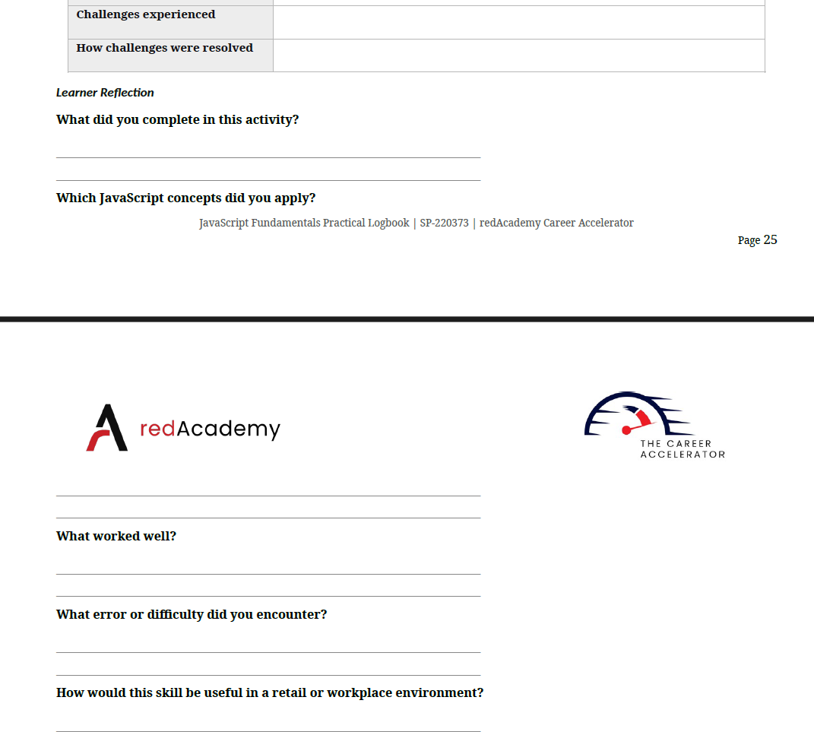

Challenges experienced
- Targeting Newly Created Elements: Dynamically added list items could not be targeted by event listeners attached when the page initially loaded.
- Unexpected Page Reloads: Default form or button actions triggered page refreshes, causing dynamically added content to disappear immediately.

How challenges were resolved
- Event Delegation: Attached event listeners to the parent element container so click events could be caught for dynamically added items.
- Preventing Default Actions: Applied event.preventDefault() inside event handler functions to prevent automatic page reloads.

What did you complete in this activity?
I built an interactive web page that reads and updates content in real time based on user actions like clicks and text input. I added functionality to dynamically add and remove list items, update styles, and modify text content without reloading the page.

Which JavaScript concepts did you apply?
- DOM Selection: Used methods like document.getElementById() and document.querySelector() to find and manipulate elements.
- Event Listeners: Used addEventListener() to detect user interactions such as click, input, and change events.
- Dynamic DOM Manipulation: Used createElement(), appendChild(), and .remove() to add or delete elements on the fly.

What worked well?
Using addEventListener() allowed the page to feel fast and responsive. Updating text content and toggling styles directly through JavaScript provided immediate feedback whenever a user interacted with the page.

What error or difficulty did you encounter?
- Element Selection Errors: Getting null errors when attempting to select HTML elements using slightly incorrect ID or selector names.
- Event Behavior Issues: Buttons submitting data prematurely before event.preventDefault() was properly implemented.

How would this skill be useful in a retail or workplace environment?
Dynamic DOM manipulation is essential for creating interactive workplace tools like digital shopping carts, task tracking lists, or inventory management dashboards. It allows staff or customers to add, update, or remove items in real time, keeping the interface clean and user-friendly without unnecessary page reloads.

Activity 3.4: Display Data from an API

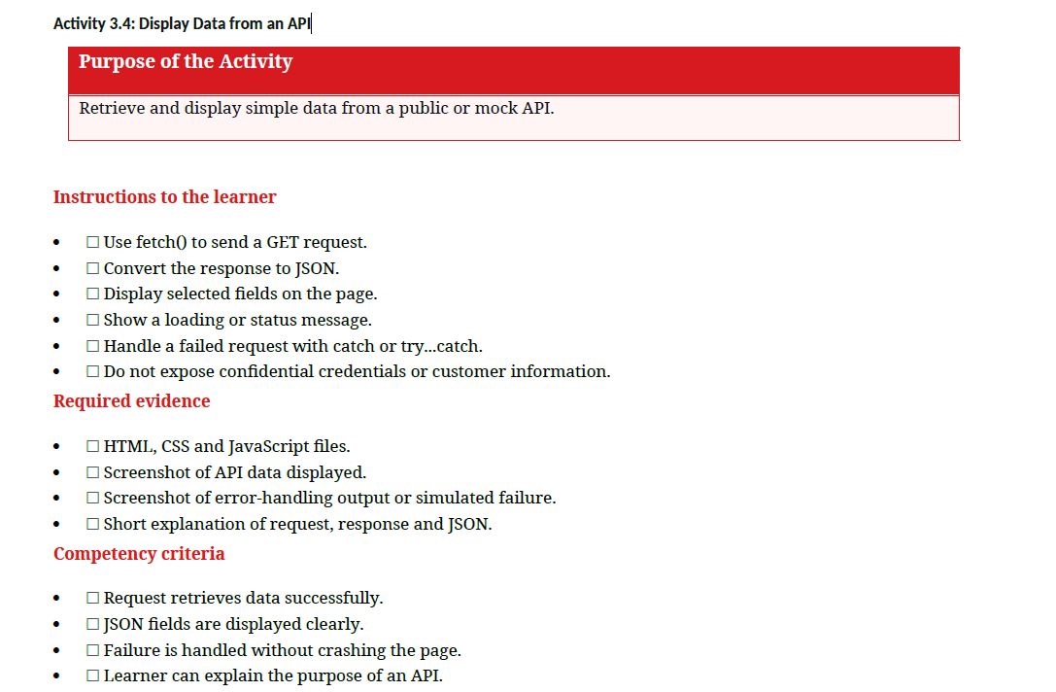

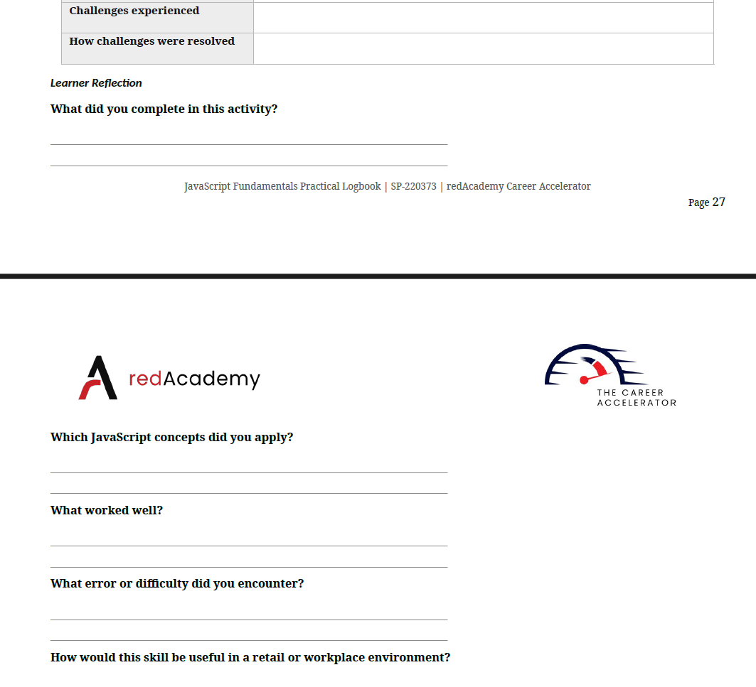

Challenges experienced
- Handling Asynchronous Delays: Managing the delay between requesting external API data and rendering it without breaking the UI layout.
- Dealing with Network Failures: Gracefully handling API request failures (like a bad URL or offline connection) without causing JavaScript errors in the browser console.

How challenges were resolved
- Loading Indicators: Implemented a simple "Loading..." message to give immediate visual feedback to the user while data was fetching.
- Error Handling Blocks: Wrapped the fetch operation inside a try...catch block to intercept network errors and display a clear error message on the page

What did you complete in this activity?
I retrieved data from a public/mock API using JavaScript and dynamically displayed selected JSON fields on a web page. I also added status/loading indicators and error-handling routines so the application handles successful and failed network requests gracefully.

Which JavaScript concepts did you apply?
- Fetch API (fetch()): Sent asynchronous GET requests to an external API endpoint to fetch raw data.
- Promises & JSON Parsing: Converted the raw API response stream into readable JSON objects using .json().
- Asynchronous Control (try...catch): Managed network outcomes and errors using try...catch or .catch() blocks to prevent app crashes.
- DOM Data Rendering: Injected specific JSON fields dynamically into targeted HTML elements.

What worked well?
Displaying a loading message immediately provided a responsive user experience while the request was in progress. Converting the API response straight into JSON made extracting and rendering specific fields straightforward.

What error or difficulty did you encounter?
- Unresolved Promises / Syntax Errors: Forgetting to await the .json() conversion step, which returned an empty Promise object instead of actual data.
- Unchecked HTTP Errors: Learning that fetch() doesn't automatically reject HTTP error statuses (like 404 or 500), requiring manual checks on response.ok.

How would this skill be useful in a retail or workplace environment?
Fetching data from APIs allows web applications to display real-time information—such as live product inventory, customer profile data, pricing updates, or order tracking information—directly from a central workplace database without needing manual page updates.

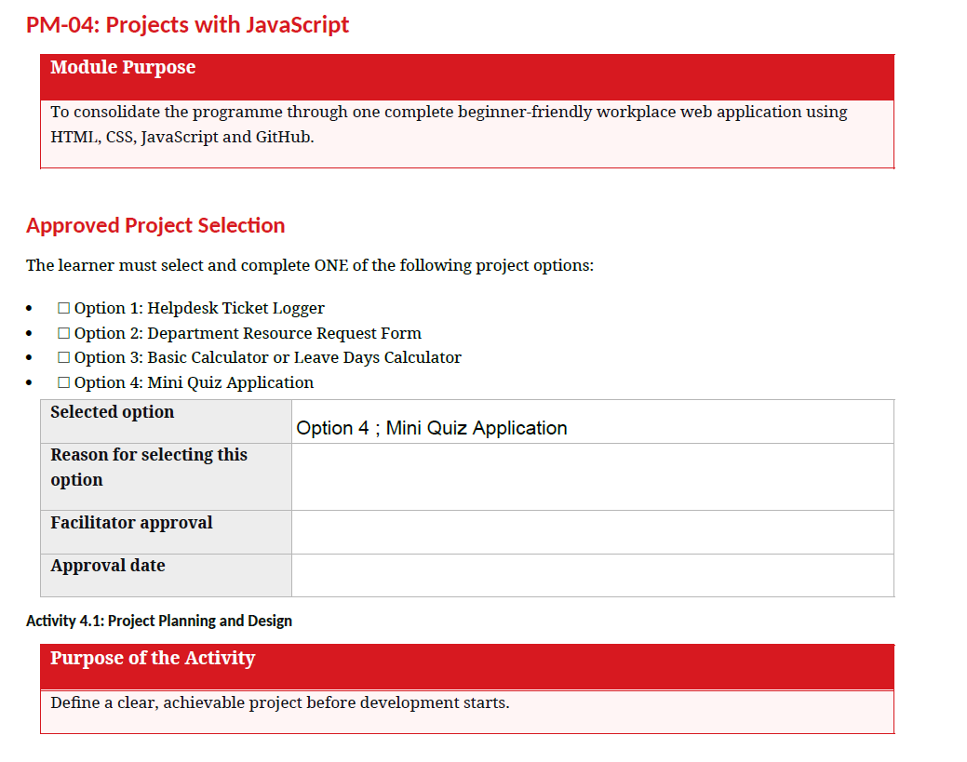

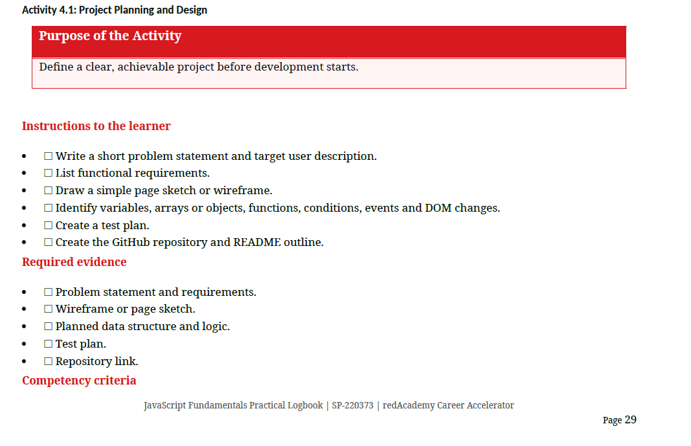

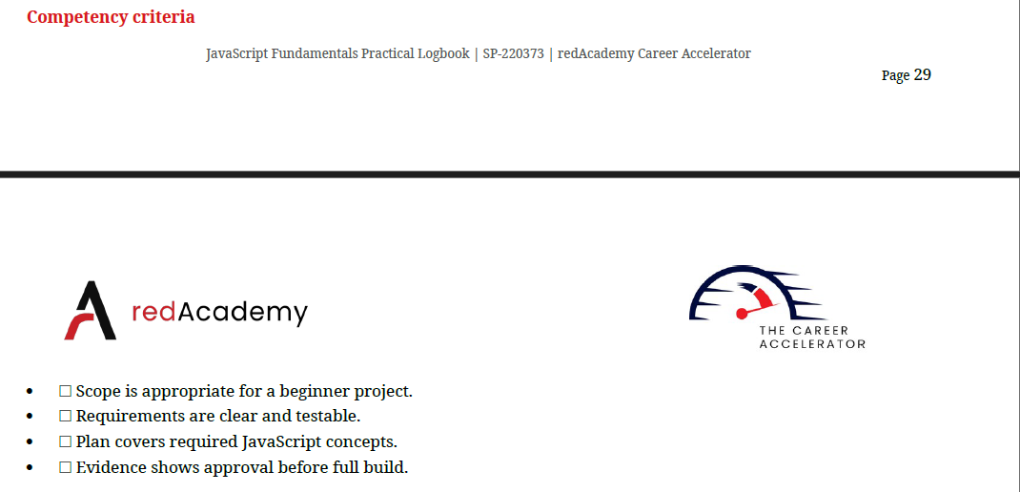

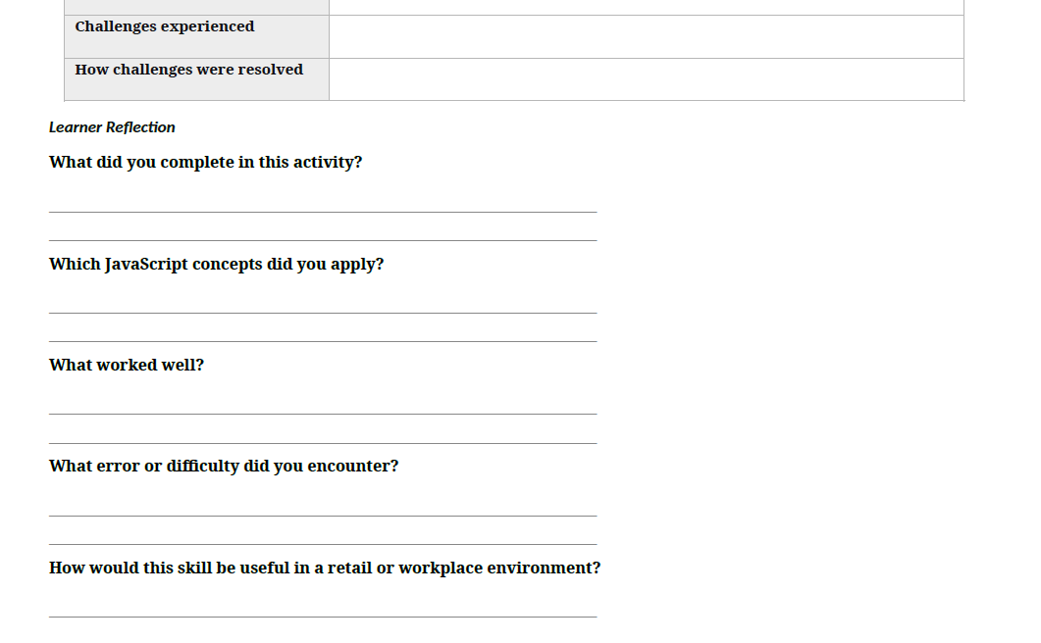

Activity 4.1: Project Planning and Design:
- Problem Statement & Target User: A brief overview explaining the specific issue the application solves and a clear profile of who will be using it.
- Functional Requirements: A definitive list of specific features, capabilities, and system behaviors that the web application must perform.
- Wireframe / Page Sketch: A simple visual layout or blueprint showing where text, buttons, and elements will be positioned on the interface.
- Planned Data Structure & Logic: An outline identifying the specific variables, object arrays, functions, conditional branches, and DOM updates needed to run the app.
- Test Plan: A structured table mapping out normal, boundary, and edge-case inputs alongside their expected outcomes to verify code reliability.
- GitHub Repository & README: A version-controlled project hosting space initialized with a structured markdown guide detailing installation and project scope.
Mini Quiz Application:
1. Problem Statement & Target User Description
- Problem Statement: Users need an engaging way to test their knowledge. Static learning materials are often dry. This application provides an interactive, immediate feedback loop to make self-assessment fast and fun.
- Target User: Students and general learners who want a quick, web-based tool to test their memory on specific topics without dealing with complex logins or heavy setups.
2. Functional Requirements
- Question Display: The app must dynamically display one question at a time along with four multiple-choice options.
- Answer Validation: The system must check if the user's selected choice matches the correct answer key.
- Score Tracking: The program must increment a counter whenever a user selects a correct answer.
- Navigation Flow: The app must automatically advance to the next question after an option is selected.
- End-Game Summary: The interface must show a final results screen displaying the total score once all questions are finished.
- Reset Capability: The user must be able to click a "Restart Quiz" button to reset their score and start over.

Now that the blueprint is ready, would you like me to write the JavaScript object array structure for your quiz questions, or should we design the test plan table matrix next?
// Array holding the quiz data structure
const quizQuestions = [
{
question: "What does DOM stand for in JavaScript?",
options: [
"Document Object Model",
"Data Object Management",
"Dynamic Order Module",
"Digital Output Mapping"
],
correctAnswer: 0 // Index pointing to the correct option
},
{
question: "Which keyword declares a block-scoped variable that can be reassigned?",
options: ["var", "const", "let", "define"],
correctAnswer: 2
},
{
question: "How do you call a function named 'myFunction'?",
options: ["call myFunction()", "myFunction()", "execute myFunction", "run.myFunction"],
correctAnswer: 1
}
];

Here are the JavaScript object array structure and the Test Plan matrix for your Mini Quiz Application:
1. JavaScript Object Array Structure
javascript
// Array holding the quiz data structure
const quizQuestions = [
{
question: "What does DOM stand for in JavaScript?",
options: [
"Document Object Model",
"Data Object Management",
"Dynamic Order Module",
"Digital Output Mapping"
],
correctAnswer: 0 // Index pointing to the correct option
},
{
question: "Which keyword declares a block-scoped variable that can be reassigned?",
options: ["var", "const", "let", "define"],
correctAnswer: 2
},
{
question: "How do you call a function named 'myFunction'?",
options: ["call myFunction()", "myFunction()", "execute myFunction", "run.myFunction"],
correctAnswer: 1
}
];
Use code with caution.
2. Test Plan Matrix
Test Case ID | Scenario / Input Type | Test Input / Action | Expected Outcome
TC-01 | Normal Case | Click correct answer option | Score increments by 1; advances to next question.
TC-02 | Normal Case | Click incorrect answer option | Score remains unchanged; advances to next question.
TC-03 | Boundary Case | Answer the final question | App hides quiz interface; displays final summary screen.
TC-04 | Edge Case | Click "Restart Quiz" button | Score resets to 0; app displays the first question again.
the data structure and test plans are set,
+-----------------------------------------------------------------------+

| [ MINI QUIZ APP ] |
+-----------------------------------------------------------------------+

| |
| +---------------------------------------------------------------+ |
| | Question 1 of 3 | |
| | Score: 0 | |
| +---------------------------------------------------------------+ |
| |
| +---------------------------------------------------------------+ |
| | | |
| | What does DOM stand for in JavaScript? | |
| | | |
| +---------------------------------------------------------------+ |
| |
| +---------------------------------------------------------------+ |
| | [ A. Document Object Model ] | |
| +---------------------------------------------------------------+ |
| | [ B. Data Object Management ] | |
| +---------------------------------------------------------------+ |
| | [ C. Dynamic Order Module ] | |
| +---------------------------------------------------------------+ |
| | [ D. Digital Output Mapping ] | |
| +---------------------------------------------------------------+ |
| |
| +---------------------------------------------------------------+ |
| | [ Restart Quiz ] | |
| +---------------------------------------------------------------+ |
| |
+-----------------------------------------------------------------------+
Layout Elements & Component Guide
- Header Bar: A clean top banner holding the application title block.
- Status Container: Displays real-time metadata (e.g., active question count index and accumulated score metrics).
- Question Window: A bold card containing the active question text pulled dynamically from the array.
- Interactive Option List: Four clickable button structures assigned with hover events for answer choices.
- Control Footer: Houses the "Restart Quiz" element to clear states back to baseline values easily.

Here is the breakdown identifying the core JavaScript architectural components for your Mini Quiz Application:
Variables, Arrays, and Objects
- quizQuestions: Array storing question data.
- currentQuestionIndex: Variable tracking active question numbers.
- score: Variable tracking correct choices.
- quizQuestions[i]: Objects containing single questions, choices, and answers.
Functions
- startQuiz(): Initializes scores and counters to baseline.
- loadQuestion(): Renders the active question data object.
- checkAnswer(): Validates user selections against correct indices.
- showResults(): Displays final score summaries upon completion.
Conditions
- if (selectedIndex === correctAnswer): Checks if chosen selection is accurate.
- if (currentQuestionIndex < quizQuestions.length): Determines if further questions remain.
- else: Triggers end-game layout state changes.
Events
- click (Answer Buttons): Triggers selection checking algorithms.
- click (Restart Button): Triggers application re-initialization.
DOM Changes
- textContent: Updates dynamic question textual elements.
- innerHTML: Rebuilds clickable answer button option fields.
- classList.add('hidden'): Conceals components when switching states.
- classList.remove('hidden'): Reveals elements dynamically during navigation.

Test Plan Matrix tailored specifically for the Mini Quiz Application.

Mini Quiz Application Test Plan
Test ID | Test Category | Scenario / Action | Test Data / Inputs | Expected Outcome | Actual Outcome | Status
TP-01 | Normal Case | Selecting a correct answer choice. | Click Option A on Question 1 (Correct Index: 0). | score increments by 1. Next question renders dynamically. | TBD on Test | Pending
TP-02 | Normal Case | Selecting an incorrect answer choice. | Click Option B on Question 1 (Correct Index: 0). | score remains unchanged. Next question renders dynamically. | TBD on Test | Pending
TP-03 | Boundary Case | Answering the final question of the quiz array. | Click any option on the last question block. | Quiz layout is hidden. Final Results Summary Screen is revealed showing the total score. | TBD on Test | Pending
TP-04 | Edge Case | Resetting the application state mid-game or at the end. | Click the "Restart Quiz" control button. | currentQuestionIndex resets to 0. score resets to 0. Interface renders Question 1. | TBD on Test | Pending
Testing Criteria Verification Checklist
- Normal Cases: Validates standard user flow pathways and positive logic calculations.
- Boundary Cases: Confirms the terminal condition evaluates cleanly without index-out-of-bounds runtime crashes.
- Edge Cases: Verifies state sanitization and element re-initialization behaviors.

# Initialize local Git repository
git init

# Create the README file
touch README.md

# Stage the file and make the initial commit
git add README.md
git commit -m "Initial commit: Add project README structure"

# Link your local repository to your remote GitHub project
git branch -M main
git remote add origin https://github.com

# Push your setup to GitHub
git push -u origin main

# Mini Quiz Application

An interactive, beginner-friendly web application built with HTML, CSS, and vanilla JavaScript. This project satisfies the requirements for Activity 4.1 by building a clean self-assessment tool.

## 📋 Problem Statement & Purpose
Traditional learning materials can be passive and disengaging. This application provides users with a fast, interactive way to self-assess their knowledge through instant feedback, multiple-choice questioning, and live score tracking.

## 👤 Target User
Students, self-taught learners, and developers looking for a lightweight, zero-setup interface to quickly test their conceptual memory without requiring account creation.

## ⚙️ Functional Requirements
* **Dynamic Questions:** Renders questions and multi-choice options dynamically from a structured data array.
* **Score Tracking:** Increments a score counter for correct answers.
* **Automatic Progression:** Advances immediately to the next question upon answer selection.
* **Results screen:** Provides a summary breakdown of performance once the final question is answered.
* **Game Reset:** Features a "Restart" capability to reset application tracking states back to baseline.

## 🛠️ Architecture & Logic Map
* **Variables & Arrays:** `quizQuestions` (Object Array), `currentQuestionIndex` (Number), `score` (Number).
* **Functions:** `startQuiz()`, `loadQuestion()`, `checkAnswer()`, `showResults()`.
* **Events:** Mouse click listeners attached to options and control elements.
* **DOM Manipulations:** Updating text surfaces (`textContent`) and structural display toggles (`classList`).

## 🚀 How to Run Locally
1. Clone this repository:
```bash
git clone https://github.com
```
2. Navigate into the project folder.
3. Open `index.html` directly in any modern web browser.

