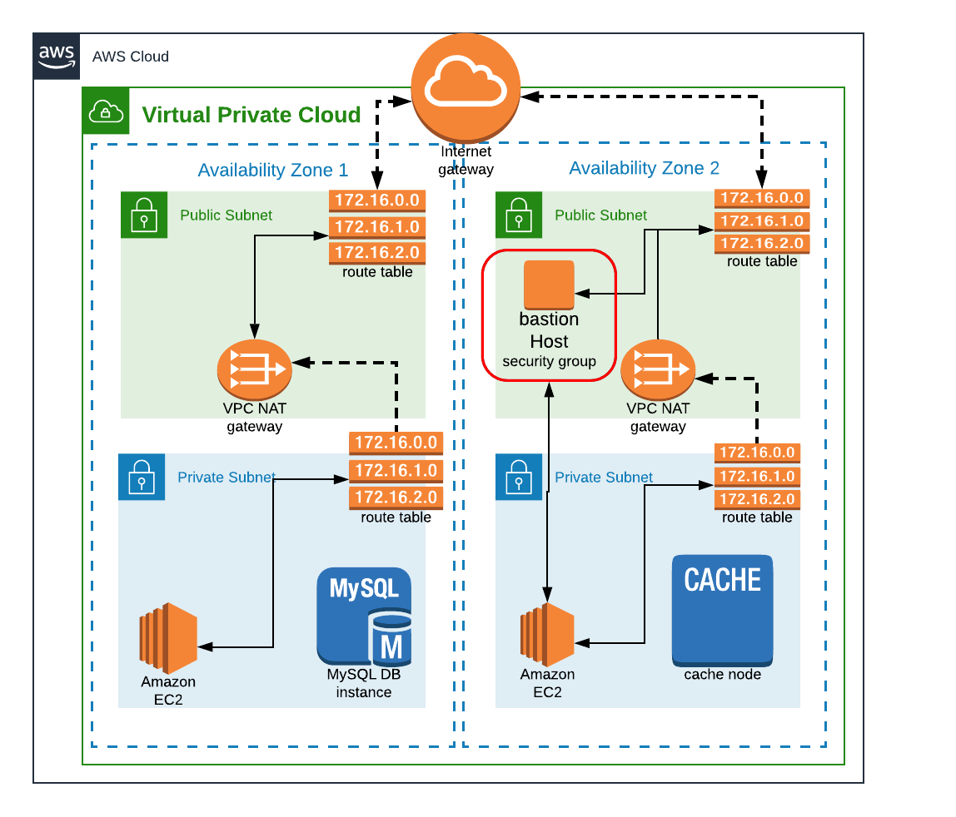
Region: us-west-1
VPC Range 172.20.0.0/16
4 subnets: 2 pub sub, 2 priv sub
2 zones: us-west-1a, us-west-1b
172.20.1.0/24 => pub-sub1 [us-west-1a]
172.20.2.0/24 => pub-sub-2 [us-west-1b]
172.20.3.0/24 => priv-sub-1 [us-west-1a]
172.20.4.0/24 => priv-sub-2 [us-west-1b]
1 Internet GW
2 NAT Gateway
1 EIP
2 Route Tables : 1 Pub Sub RT, 1 Pub Sub RT
1 Bastion host in Pub subnet

NACL
1 more VPC => VPC Peering

https://docs.aws.amazon.com/vpc/latest/userguide/vpc-network-acls.html

https://docs.aws.amazon.com/elasticloadbalancing/latest/classic/enable-access-logs.html
https://docs.aws.amazon.com/AmazonCloudWatch/latest/logs/QuickStartEC2Instance.html

Build specification reference for CodeBuild - AWS CodeBuild (amazon.com)

