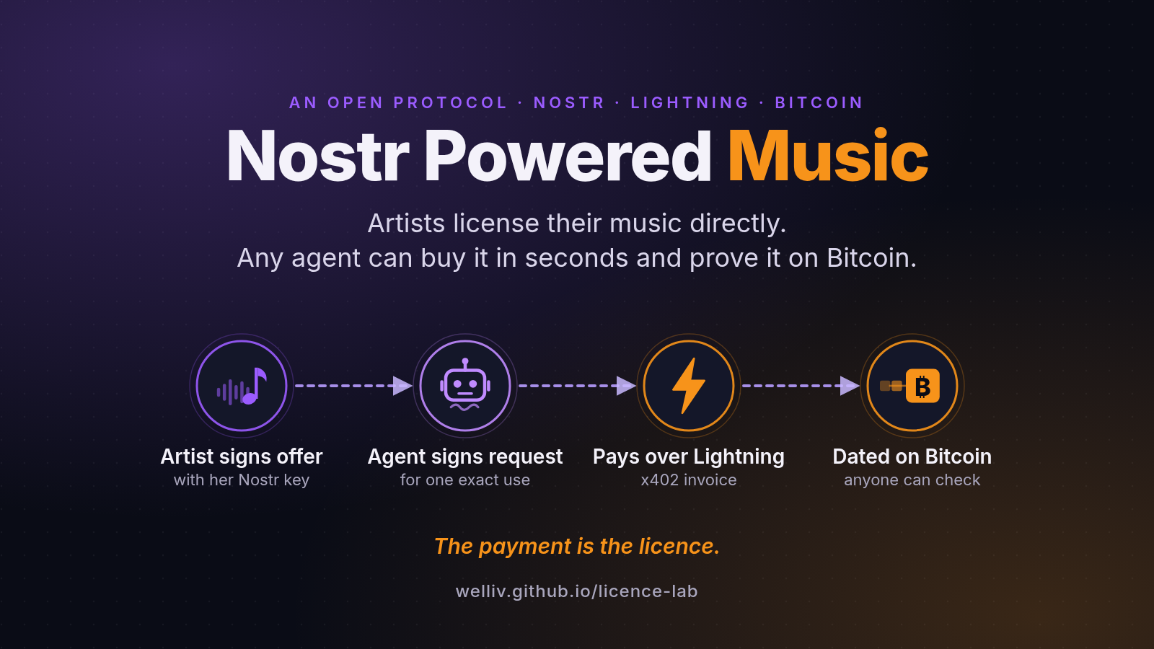

Nostr Powered Music
An open protocol for licensing music. Project overview, 18 October 2026.
By welliv
Nostr: npub1626pdpr8gw0s86m7pccta9qj6k3f6pg243maccx78h9e730ervrstr3hde
Live demo: welliv.github.io/licence-lab · Code: github.com/welliv/licence-lab

1. In one line
Artists license their music directly. Any agent can buy it in seconds and prove it on Bitcoin.
Short form: Music rights, sold directly, bought by any agent, proven on Bitcoin.

2. The problem: why this needs to exist
Music is used everywhere: in videos, adverts, games, apps and now to train AI models. Each of those uses needs a licence, which is permission from the people who own the recording to use it in a stated way.
Today, licences are mostly bilateral contracts: one deal, agreed by two parties, one at a time.
- Big buyers deal with big rights holders. In 2024 the three major labels sued two AI music companies. Since then, some of the labels have settled and licensed them. An AI audio company launched a music model with deals from an independent-label body and a publisher. Every one of these was a contract between large parties.
- Independents are left out. An independent artist who owns her recording and her song has no way to offer a licence to those buyers, or to the many small tools that need one track for one video, except by negotiating alone.
- Small licences cost more to arrange than they are worth. Finding the owner, agreeing terms, writing a contract and sending an invoice cost more than a $5 licence. So the use goes unlicensed, or into a library on the library's terms, or does not happen.
- Software can't buy. AI assistants can already search music libraries, but they cannot buy a licence straight from the artist. Agents (programs that act for a person or a company) are becoming the main buyers of digital things, and today an independent artist cannot sell to them at all.
The core view. At the scale of a global network, every party needs an agent:
Who | Needs | Why
Platforms and companies | Buyer agents | They need thousands of licences a month, one per user video or per track. No team can sign those by hand.
Artists | Seller agents | They can't answer every request in every time zone.
Creators who use AI tools | Small licensing agents | Their editing tool picks a track, and it should license it in the same moment.

So the protocol is machine-first. People set the rules (prices, budgets, allowed uses) once. Agents handle each sale inside those rules.

3. The idea in plain words
1. Alice publishes a signed price list. For each use of each song she states the price, what the buyer may do and who shares the money. Her digital signature proves it came from her.
2. Any agent can pay it. The agent asks to buy, gets a bill tied to exactly that request, and pays it over Lightning (Bitcoin's fast payment network) in seconds. No account and no contract are needed.
3. Paying is the licence. The payment can only complete by handing the buyer a secret code. That secret, together with the signed offer and the buyer's signed request, is the licence. Alice can't take the money and refuse to deliver.
4. The sale is dated on Bitcoin. A short fingerprint of the licence goes into a Bitcoin block, so nobody can move the date later.
5. Anyone can check it with a few calculations, without asking Alice, the buyer or any company.
It runs on Nostr, an open network where every user is a key pair and every message is signed. No single app owns the artist, the buyer or the record of sales.

4. Who uses it

Artists and their seller agents
What they get: one shop for every kind of licence, at their own price, with co-owners paid straight away.
Story. Alice puts "Rain" on sale. Carol (producer, 20%) and Dave (singer, 15%) each sign that they agree to their shares. Echo, Alice's agent, runs her sales inside the rules she signed, day and night. When a licence sells, Alice keeps 65% and Carol and Dave are paid their shares.

Fans and creators
What they get: a cheap licence that fits the use, bought in seconds.
Story. Bob wants "Rain" just for himself, so he buys a Personal licence for $1 (just for him, no money may be made from it). For his video channel he buys a Creator licence for $5 (use in his videos, for ever). Each licence names its use, so a $1 Personal licence can't be stretched into an advert.

Companies and their buyer agents
What they get: licences at scale, inside a budget that a person sets.
- A business licence. Bob's company wants "Rain" in an advert, so his agent buys a Business licence for $50 (use in adverts for one year).
- Licences at scale. ClipAI's agent licenses a song for each of 500 user videos this month. A person at ClipAI sets the monthly budget ($3,000 in the demo, and at most $100 for any one payment). When the budget runs out, the wallet refuses to pay.
- A subscription. ClipAI's agent also subscribes to the Harbour Music catalogue for $99 a month. Harbour keeps 30% and pays its artists, Dave, Erin and Frank, the rest.
- AI training. ModelCo buys an AI-training licence and can later prove to a regulator that it had permission before training began.

Builders
What they get: an open protocol, open code and a checker they can add in a few lines.
Story. A video site adds a "License this" button. It checks the licence of every upload on its own, in milliseconds, without calling anyone.
About subscriptions. A subscription is a draft today. It works as a one-month catalogue licence that the agent buys again each month inside its budget. Nothing is ever pulled from the buyer's wallet. The protocol has no separate subscription message yet.
About the Personal licence. "Personal" is also a draft licence type that the demo adds. Creator and Business are uses the demo already had. The draft specification leaves the names of uses open.

5. How it works, in five steps
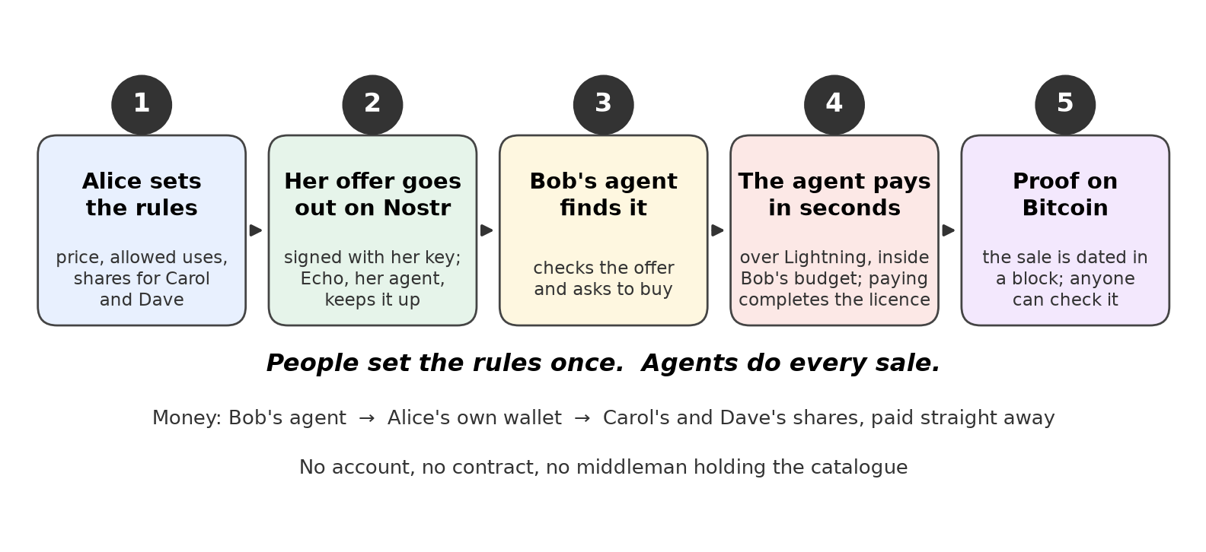
How a sale works, in five steps
Step | What happens | Plain explanation
1. Set the rules | Alice chooses prices, allowed uses and shares. Her co-owners sign their agreement. | People decide once.
2. Publish the offer | The offer is signed with Alice's key and published on Nostr. It names the exact recording by its fingerprint (a SHA-256 hash: change one bit of the audio and it changes completely). It also names Alice's own Lightning wallet. | Anyone, anywhere, can read it.
3. Ask to buy | Bob's agent checks the offer and signs a request: this song, this use, this price. | The request is the buyer's side of the deal.
4. Pay | Alice's wallet sends a bill (an invoice) that is locked to that exact request. The agent checks the bill against its own request and its budget, then pays. Paying reveals the secret that completes the licence. Co-owners are paid their shares. | The agent never pays more than the offer or the budget allows.
5. Prove | A fingerprint of the whole licence is dated in a Bitcoin block, either free through OpenTimestamps (a service that bundles many fingerprints into one Bitcoin transaction) or in its own small Bitcoin record (OP_RETURN). | Anyone can check the licence later with maths alone.

A checker runs ten checks. Nine prove that this key sold this licence, was paid and dated it. The tenth, ownership, says whether someone the checker trusts (for example a distributor) has confirmed that this key owns the recording: verified, unverified or disputed.

6. What is real today, what is draft, what is not built
Status | What
Real today (test money only) | Licence Lab, the live demo. Stop 1: Alice sells and Bob's agent buys, with Personal $1 / Creator $5 / Business $50, a price stepper and a wallet strip that is always on screen. Stop 2: ClipAI's agent licenses songs for 500 videos within a monthly budget, and subscribes to Harbour Music. Stop 3: anyone can check. The scenarios and code are on GitHub.
 | Real test payments in the demo go through faucet.nwc.dev, a public test wallet: Stop 1's sales and the first month of Stop 2's Harbour Music subscription. The 500 video licences and the subscription renewal use practice money. These are test sats only. Prices are shown in dollars at a fixed demo rate (1 test sat = $0.05), not a market rate.
 | Live proofs on Mutinynet, a Bitcoin test network, dated by OpenTimestamps and OP_RETURN. On 17 October 2026 the real "Rain" recording sold for 100 test sats, with Carol paid 20 and Dave 15. Each step can be seen on mutinynet.com (links in §10).
 | Alby Hub as the artist's own seller node. On 18 October 2026, on Mutinynet, an artist's own Alby Hub (LDK backend) signed the binding with its node key and issued an invoice tied to the licence request. Bob's agent paid 100 test sats, and the licence passed checks 0 to 7, every check that depends on the seller's wallet. It must be the artist's own Hub, not a shared wallet or sub-wallet (links in §10).
 | Reference code: 289 tests pass in the protocol library, and 124 in Licence Lab. An independent conformance check of the payment step gave 44 passed, 0 failed and 1 expected warning.
Draft | The Personal licence type. Subscriptions (one-month catalogue licences renewed by the agent). Rights transfer and inheritance (selling the rights to a song, or a plan in which 2 of 3 people Alice trusts can take over after her death). Prices set in dollars, through a separate pricing key that can only quote inside a price band Alice signed. The message type numbers are placeholders, and the draft specification has not yet been reviewed by Nostr maintainers.
Open issues, not solved yet | A trusted root for ownership. The protocol proves what a key sold, not who owns the song. That needs a partner such as a distributor to confirm ownership.
 | Real demand and real users. No outside artist, buyer or agent has used it yet. Nothing runs on the main Bitcoin network.
 | Others: no lawyer has reviewed the licence wording; exclusive licences are designed but not built; a light checker still needs a full Bitcoin node, or trust in one, to confirm that an offer was not withdrawn. In the test run, one person ran every party on one computer.

Independent audits. A red-team audit (12 October 2026) found 27 issues and 24 were fixed, each with a regression test. An independent audit (17 October 2026) found the demo's first sale was staged and that ownership and demand were the biggest risks; the demo now makes real test payments and links to the real Mutinynet proof. A vision audit asked for personal licences, subscriptions, a wallet strip and people setting the rules, all of which are now in the demo. The audits are published: https://github.com/welliv/licence-lab/tree/main/docs/references

7. Why now
Jack Dorsey's Nostr post of 20 March 2025 named three use cases (human and agent interaction and transaction; private and public micro-communities; creator-friendly distribution) and three differentiators (high-agency identity, built-in micropayments, a highly connected app ecosystem), ending: "nostr is where people and their agents learn and get stuff done." This project serves two of the use cases directly (agent transactions; creator-friendly distribution) and uses all three differentiators: the artist's key, Lightning payment as the licence, and a licence any app can check (jack, post on Nostr, 20 March 2025).
- Agents can now pay over Lightning. Block joined the x402 Foundation and contributed Lightning payments on 24 September 2026, the day after x402, an open standard for payments inside web requests, gained a Lightning specification.
- Agent payments are real but small. About $24 million moved across 75 million agent payments in the 30 days reported in July 2026. What is missing is something worth buying: a licence an agent can buy without a contract.
- AI companies need proven permission. AI music already makes up more than half of daily uploads on one large streaming service (July 2026), and AI companies must now show they had permission. So far they have got it only through deals with large rights holders.

8. What it is not
- Not DRM (copy protection). A buyer can copy a file. Licences are enforced by law and by records, as they are today. The protocol makes the record clear and hard to dispute.
- It does not establish ownership by itself. A signature proves control of a key, not ownership of a song. Ownership comes from someone the buyer trusts confirming it, and in the end from the law.
- It does not replace composition royalties. A track has two copyrights: the recording and the song. Song royalties still flow through publishers and collecting societies. The protocol works only where the seller controls the rights for the use sold.
- Not a new coin, and not one more app. It uses Bitcoin, Lightning and Nostr, and any app can build on it.

9. Next steps
1. User test: 5 artists, 5 buyers and 5 builders, about 15 minutes each, using the demo's built-in timer. Success means each group gets its first licence in under 60 seconds and at least 4 of 5 people can say the idea back in one sentence.
2. Give ownership a root: a distributor voucher (a signed statement that "this recording belongs to this key") plus audio fingerprinting, so a re-encoded copy can't dodge the check.
3. One market first: AI music companies. One buyer, 20 to 50 real artists, and small real licences with permission that can be proven.
4. Close the remaining technical gap: have the seller and buyer agents use dollar price quotes.
5. Get legal review of the licence wording. The questions are already written.

10. Links
What | Where
Live demo (Licence Lab) | welliv.github.io/licence-lab
Code | github.com/welliv/licence-lab
Alby Hub seller test (18 October 2026) | github.com/welliv/licence-lab/blob/main/docs/alby-hub-seller.md
Live "Rain" sale, step 1: Alice's wallet link and next-key commitment | mutinynet.com/tx/475afe663dc1…4ff602
Live "Rain" sale, step 2: the licence, dated on the test chain | mutinynet.com/tx/9d7ed8bbb8d8…9f53bd
Live "Rain" sale, step 3: Alice withdraws the offer | mutinynet.com/tx/26cf26989c4b…56b4bd

All payments described here used test coins on test networks. No real money has moved.

