Nostr Powered Music: Music Rights Sold Directly, Bought by Any Agent, Proven on Bitcoin
welliv
github.com/welliv
October 2026

Abstract. An open method of licensing recorded music would let artists license their music directly, let any software agent buy a licence in seconds, and let anyone prove the sale on Bitcoin, without a negotiated contract and without an intermediary holding the catalogue. Today music is licensed for video, advertising and AI training through bilateral contracts with large rights holders, and an independent artist cannot sell to software at all. At the scale of a global network every party needs an agent: platforms need buyer agents, artists need seller agents, and creators who use AI tools need small licensing agents. We therefore design for machines first, and let people set the rules: prices, budgets and allowed uses. The artist signs an offer for one use of one recording and binds it to a Lightning node that she alone controls. A buyer's agent signs a request, the node returns an invoice that commits to that request, and paying it releases a secret that completes the licence, so payment and grant are one act. The licence is dated in a Bitcoin block, and anyone can check it with ten checks. Nine prove that a key sold the licence, was paid and dated it. The tenth reports whether a party the checker trusts says that key owns the recording. Keys can be committed to their successors before any theft, prices can be set in dollars within a signed band, offers can be withdrawn without voiding honest sales, and rights can be sold or inherited. A live run on a test network sold a real recording for 100 test sats. The system does not prevent copying, does not establish ownership by itself and does not replace composition royalties.

1. Introduction
Recorded music on the Internet is paid for mainly through streaming services. The largest reports paying roughly two-thirds of its music revenue to rights holders, more than $11 billion in 2025, and keeping about 30% [1, 2, 3]. The money is pooled each month and divided by streamshare; there is no per-stream rate [4]. Since April 2024 a track must reach 1,000 streams in 12 months to earn recording royalties. The same service reports that tracks below that line averaged $0.03 a month and made up 0.5% of streams [5]. The sums at stake in the threshold are small, and the pool is not where the missing mechanism lies.
Artist-set prices also exist. Bandcamp and similar stores let artists price downloads. One streaming service lets independent US artists sell music directly to fans through its parent's payment processor [6], and on 31 August 2026 it cut its fee on those sales from 10% to 0% [7, 8]. Lightning music services let fans pay artists in bitcoin from their own wallets [9]. Each of these is a price for a person at a checkout, or a term in a negotiated contract.
The use growing fastest is licensing by software. In 2024 the three major labels sued two AI music companies. In October 2025 one major settled with one of them and licensed it; another major settled with both by November 2025; in September 2026 one company released a model trained on music licensed from a major, an independent publisher and a distributor, while the other two majors sued it again [10, 11, 12]. An AI audio company launched a music model in August 2025 with opt-in agreements from an independent-label licensing body and an independent publisher [13]. Every one of these is a bilateral contract with a large rights holder. An independent artist who owns her master and her song has no way to offer a licence to such a buyer, or to the many smaller tools that make video and need a track, except by negotiating.
Meanwhile payment by software has acquired a standard. x402, governed since July 2026 by a foundation at the Linux Foundation, gained a Lightning specification on 23 September 2026, and Block joined and contributed Lightning payments the next day [14, 15, 16]. Agent payments are still small, about $24 million across 75 million payments in the 30 days reported in July 2026 [17], but the rail exists. What is missing is something worth buying: a licence that software can buy from the artist.
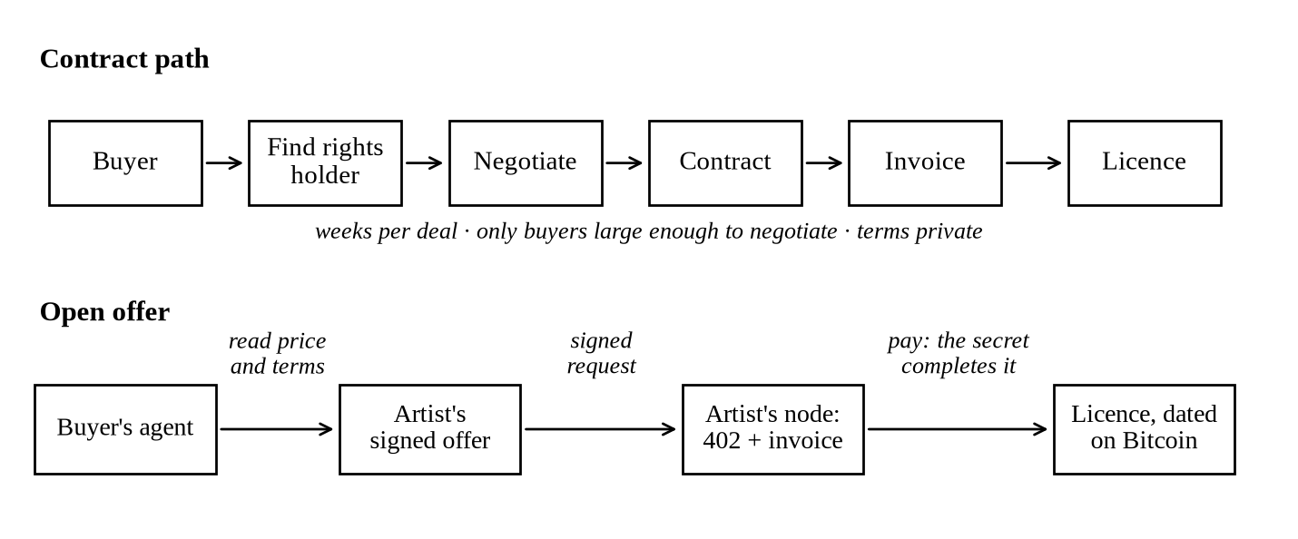
Figure 1. The contract path and the open offer. The offer replaces negotiation with a signed price and terms that software can read, pay and check.
We start from one view. A global network of artists and buyers cannot license by hand. A platform whose users post thousands of videos a month needs a buyer agent, a program that acts for it, to license each one. An artist cannot answer every request in every time zone, so she needs a seller agent. A creator whose editing tool picks a track needs a small licensing agent inside that tool. The protocol must therefore be machine-first. People do not handle each sale; they set the rules once: the price of each use, the uses allowed, the shares of co-owners, and how much each agent may spend. Agents then act inside those rules, and every act leaves a record that anyone can check.
The goal fits in one line: artists license their music directly; any agent can buy it in seconds and prove it on Bitcoin. In this paper we define the keys (§2), the offer (§3), payment as grant (§4), timestamps (§5) and verification (§6), then ownership (§7), keys and rights over time (§8), prices and licence types (§9), agents and budgets (§10), splits and other payers (§11), incentives (§12), compliance (§13), limits (§14), status and evidence (§15) and an example (§16).

2. Keys
Every party is a key pair. The secret key (nsec) signs; the public key (npub) identifies its holder in every application [18]. The network is active: community dashboards counted roughly 250,000–340,000 daily active public keys in March–June 2026, with large differences by method [19]. Four kinds of key take part in a sale.
- The artist key K_a is the root of authority. It signs her offers and her binding, and it should stay offline in a remote signer (NIP-46) [18].
- The node key K_n is the identity of the Lightning node that signs her invoices. It must be her node alone: one node per artist (§4).
- The buyer key K_b signs a request. By default the buyer's agent derives a fresh key for each licence, so purchases cannot be linked; a private link signed by both keys proves later that the main key holds the licence.
- Co-owner keys sign their consent to each offer and their share of it, so a co-owner's work cannot be sold without them.
A key proves control, not identity in the world. NIP-05 maps a key to a name on a domain the artist controls, and NIP-39 links her existing profiles. A distributor or collective that already knows her can issue a NIP-58 badge, or publish a NIP-32 label (kind 1985) stating that this key is the artist on a list of recordings [18]. NIP-85 trusted assertions carry web-of-trust metrics such as rank, follower counts and reports [20]. They are a useful spam signal, but they have no result type for identity. A Lightning address (LUD-16) may share the artist's name but is a separate system [21]. Keys are portable, and the cost is that there is no password reset; keys should live in a signer or be stored encrypted, as an earlier reference library did with AES-256-GCM and a passphrase [22]. Section 7 turns these labels into a check, and §8 deals with lost and stolen keys.

3. The Offer
An offer O is a signed, replaceable listing (NIP-99, kind 30402) [23]. One offer covers one use of one recording. A shortened example for Alice's track "Rain":
{ "kind": 30402,
"tags": [ ["d", "rain:creator-video"], ["title", "Rain"],
["x", "54bdd620…5695"], // SHA-256 of the master
["use", "creator-video", "worldwide", "perpetual", "non-exclusive"],
["terms", "<sha256 of licence text>"], ["terms-text", "<licence text>"],
["price", "100", "SATS"],
["pay-link", "https://pay.alice.example/rain", "x402:exact:lnbtc", "http:1"],
["binding", "<id of Alice's binding>"], ["valid-until", "<block height>"],
["p", "<carol>", "producer", "2000"], ["p", "<dave>", "singer", "1500"] ] }
The x tag fixes the recording by the hash of the master: change one bit of the audio and the hash changes completely, and the hash reveals nothing about the audio. The terms tag carries the hash of the exact licence text, so a licence names exactly the words it grants. The text contains a grant rule: the artist grants the licence to the holder of the key that signed any request naming this offer, when an invoice signed by the node in her binding, whose description hash commits to that request, is paid. The valid-until tag is a Bitcoin block height after which the offer lapses. Each p tag names a co-owner and a share in basis points, and the offer is valid only if each of them has signed a consent (kind 3413) naming the offer id, the terms hash, the share and a payout target. All other objects point to the offer's id, never to its replaceable address, so a changed offer orphans old consents rather than borrowing them.
A binding B (kind 3411) links K_a to K_n. It is signed by K_a, and K_n co-signs the message "MLL-BIND:" followed by K_a in the node's own message format. B is a regular event, not a replaceable one, so it cannot be swapped silently. It names a recent block (not-before), from which a checker counts revocations, and it may carry next, a commitment to the artist's next key (§8). Files may be stored on Blossom servers, which address files by SHA-256 [24]. Buyers find offers with tag filters and, on relays that support it, NIP-50 search. Relays may drop events, so offers go to several. These tags and kinds 3410–3419 are conventions proposed in a draft NIP [53]; the numbers are placeholders. The offer states the price. It does not collect it.

4. Payment as Grant
A Lightning invoice is a payment request signed by the payee's node. It carries a payment hash p = SHA-256(s), where at first only the payee knows the secret s, the preimage. Paying the invoice reveals s to the payer. The invoice's signature also covers a description hash h, meant to commit to what is bought. We set h to a hash of the buyer's request. A licence is sold as follows (Figure 2):
1) The buyer's agent fetches O, B and the consents, and checks them (§6).
2) It signs a request R (kind 3410, never published): O's id, the terms and master hashes, the use within the offer's scope, the licensor K_a, the node K_n, the amount, the network, a 32-byte random nonce and the hash of a recent Bitcoin block. It posts R to the pay link, serialised as canonical JSON (RFC 8785).
3) The seller's node answers 402 Payment Required with an invoice I signed by K_n, whose h commits to the exact request, as in the x402 Lightning specification [15].
4) The agent decodes I strictly and checks that it recovers to K_n, that h equals the hash it computes from R, and that the amount is the price and within its budget.
5) It pays I and receives s. The licence is L = (O, B, C…, R, I, s), and its grant digest D = SHA-256(O, B, R, I, s) is dated on Bitcoin (§5).
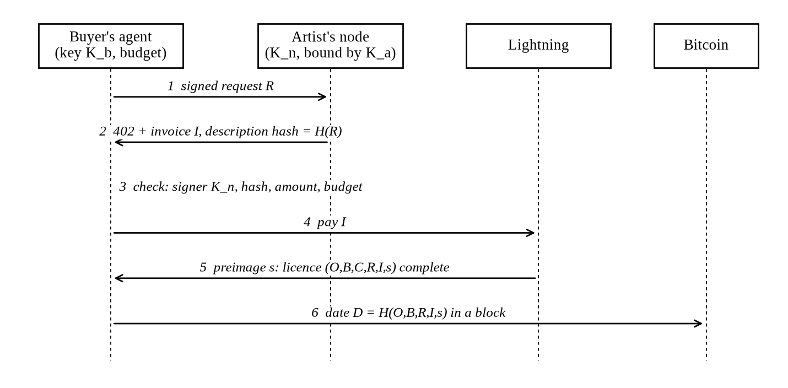
Figure 2. Payment as grant. The invoice commits to the buyer's signed request, so the secret that settles the payment completes the licence.
If the buyer is charged, she holds s, because the payment can be claimed only by revealing it. She already held every signature, so by the grant rule the licence exists once she holds s. No later act of the seller is needed, so none can be withheld; a seller who refuses to issue an invoice makes no sale and takes nothing. The x402 specification fixes the remaining rules: the network is named lnbtc, the invoice amount is the amount settled, there is no refund path, and replay protection is stateful, keyed on network and payment hash [15]. The seller also refuses a second invoice for a request already licensed. L402 is an older scheme that answers with an invoice and a macaroon [25].
Two limits follow. The seller and every routing node also learn s, so s does not prove who paid; it proves that the seller is bound by her own rule, and the licensee is whoever controls K_b. And K_n must be the artist's alone, because on a shared or custodial node the operator or another user could sign invoices with the same key and take the money while every check passes. A shared wallet can buy licences but cannot sell them. Buyers connect wallets with Nostr Wallet Connect (NIP-47) [18], and a node run for one person can make the binding's signature through NIP-47's sign_message method; the binding records which method was used (§15).

5. Timestamps
Signatures show who agreed, but not when. The times written in events and invoices are set by their authors, so we use Bitcoin blocks instead [27]. R contains the hash of a recent block, which nobody could know in advance, so the grant came after it. Once she holds s, the buyer dates D in a block, in one of two ways. OpenTimestamps calendars gather many digests into a Merkle tree and write its root into one Bitcoin transaction, free, within hours [26]; the checker needs the proof file and block headers. Or D goes into its own small OP_RETURN output, "MLA1" followed by D, 36 bytes, either from the buyer's own wallet or through a pay-per-proof service paid over Lightning. A checker refuses a proof that is still pending. The grant lies between the request's block and the anchor's block, and "was it granted before the use?" becomes a comparison of heights.
The artist dates her release the same way (Figure 3): she hashes the master on her own device, signs the hash with her key, and anchors the event. NIP-03 events for OpenTimestamps proofs are marked "unrecommended: vulnerable to one specific attack, needs update" [28], so the standalone proof file is kept. The proof shows that this exact file existed, signed by this key, no later than that block. It does not show who wrote, performed or owns the music, and anyone who obtains a file can timestamp it, so the proof is strongest when made before the file leaves her device.
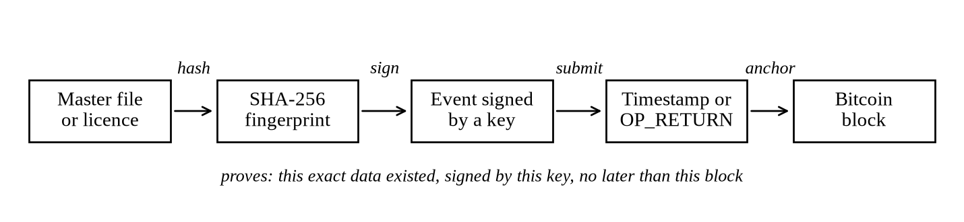
Figure 3. Proof of release, and of each licence: a chain of hash, signature and timestamp.
The proof is evidence, not copyright. In the US copyright arises when a work is fixed in tangible form [29], and Berne countries may not require formalities [30]. Registration is still required before suing over a US work [31], and the Supreme Court has held that this means the Copyright Office has acted on the application [32]. The Office calls the "poor man's copyright" no substitute for registration [29]; a blockchain timestamp is a stronger version of that idea and still no substitute. Courts weigh such evidence case by case. In June 2018 the Hangzhou Internet Court accepted evidence anchored in the Bitcoin and Factom blockchains after examining how it was captured [33]. The Supreme People's Court's 2018 provisions name blockchain among ways to authenticate electronic data [34], and its 2021 Online Litigation Rules presume data was not altered after it went on-chain [35]. In Vermont a blockchain record with a qualified declaration is self-authenticating, but the presumption "does not extend to the truthfulness, validity, or legal status of the contents" [36]. Federal Rule of Evidence 902(14) allows authentication by hash with a certification [37]. A timestamp helps in a dispute. It does not replace registration, contracts or counsel.

6. Verification
Anyone holding L, the licence text and a proof for D can check the licence without asking the seller, a platform or a relay. The reference verifier runs ten checks and fails closed with a coded reason:
1) The offer is signed by K_a, and the hash of the licence text equals the terms tag.
2) Every co-owner in the offer has a valid consent naming it.
3) The binding is signed by K_a, names K_n, covers the offer, and its node signature is valid.
4) The request is signed by K_b and matches the offer: id, terms, master hash, use within scope, licensor, node, amount and network.
5) Rebuilding the canonical request gives the invoice's description hash.
6) The invoice recovers to K_n, has exactly one description hash and no plain description, and asks the right amount.
7) SHA-256(s) equals the invoice's payment hash.
8) The proof dates D in a block at or after the request's block and no later than the offer's lapse height plus 144 blocks.
9) No revocation of the binding or the offer was mined from the binding's not-before block up to that block, except an offer withdrawal that the licence came before (§8).
10) Ownership: verified, unverified or disputed (§7).
Checks 1–8 need a few signatures, about ten hashes and block headers, much as a light Bitcoin wallet checks a payment [27]. Check 9 is different. It proves an absence, so it needs every block from the binding's not-before to the anchor, from a full node or from indexes the checker trusts, and the checker must say which it used. The browser verifier caps this scan at 300 blocks. A signed daily status record that would let a light checker trust only the artist is specified but not built. A self-dealer can buy her own licences for free, since she knows each s, so licence counts prove nothing about demand.

7. Ownership
Checks 1–9 prove that the key K_a sold this licence and was paid. They do not prove that K_a owns the recording. An independent audit showed why this matters: two unrelated keys, each with its own node, selling the same master hash, both passed the nine checks [54]. Who owns a coin is defined by the protocol; who owns a song is defined by law, outside it. So check 10 does not guess. It reports what parties the checker trusts have said:
- verified: a voucher the checker trusts has signed an owner vouch for K_a and this master hash, or a chain of title (§8) starting from a key such a voucher named says that K_a held the rights at the licence's block;
- unverified: nobody the checker trusts has said who owns the recording. The licence may be shown as paid and dated, but never as owned, and the verifier says so in words;
- disputed: a trusted vouch or the chain of title names another key, and the licence is refused (rights_not_holder, rights_transferred or rights_key_retired).
An owner vouch is a NIP-32 label (kind 1985) with L = mll.owner, l = owner, p = the owner's key and x = the master hash; its content may hold a registry reference such as an ISRC [18]. The natural voucher is a distributor, which already knows its artists and their recordings. A checker that needs ownership, such as a video site, treats unverified as a failure. In the live run, check 10 returned verified with the distributor's vouch and unverified without it (§15). Two weaknesses remain. The root is trust in a voucher, so a distributor at that point is a trusted party. And a hash covers exact bytes, so a copycat who re-encodes a file gets a new hash; catching that needs audio fingerprinting and reputation, not hashes.

8. Keys and Rights over Time
Withdrawal and revocation. The artist signs a revocation (kind 3412) of an offer or a binding and writes a short record of it into an OP_RETURN output ("MLR1", or a compact 80-byte "MLR2"), so the revocation has a date nobody can move and a relay cannot hide it. Two rules apply (Figure 4). When she withdraws an offer (retire), a licence stays valid if its invoice time is earlier than the time of the withdrawal block and the licence was dated on Bitcoin no more than 144 blocks, about 24 hours, after that invoice time. There is no extra margin. A licence left undated for longer is void, because nothing then shows that the invoice came first. When a key is stolen (compromise), the rule is strict: only licences dated before the revocation block count, because a thief can write any invoice time. An earlier rule kept a two-hour margin that voided honest sales; it was dropped after an audit and the change was tested live.
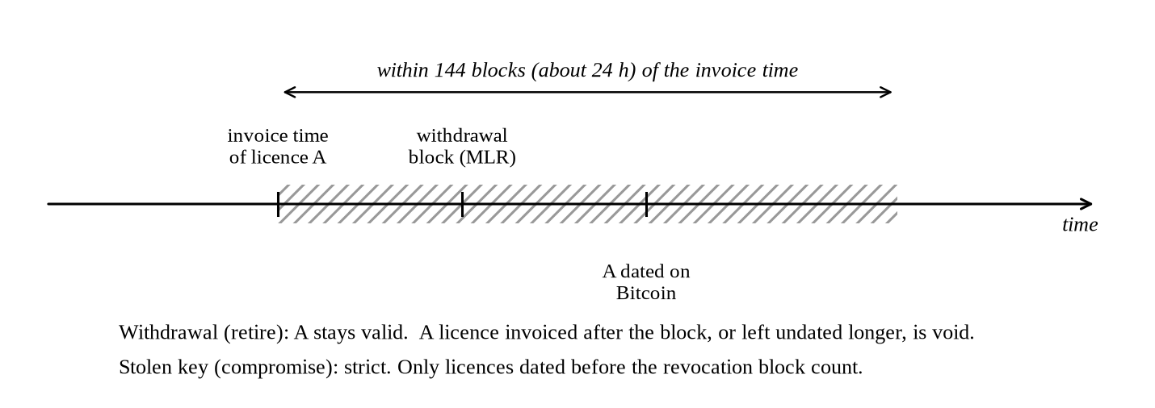
Figure 4. The withdrawal rule. A licence invoiced before the withdrawal block survives if it is dated within 144 blocks of its invoice.
Pre-rotation. Revoking a stolen binding does not stop a thief from signing a new one with the stolen K_a. So the binding may carry next = SHA-256 of the artist's next key, which she keeps offline. Once the binding is dated with a title timestamp ("MLT1" followed by a digest, 36 bytes), only that next key can retire K_a. A thief holding K_a cannot rotate it away or out-race her.
Rights transfer and succession. A work, named by its master hash, or every work of a key (x = *), moves only by title records. A transfer (kind 3417) names from, to and a reason: sale, rotation, succession or court. A sale is signed by the holder and co-signed (kind 3419) by every co-owner it names. A succession plan (kind 3418), signed by the holder while alive and well, names plan keys with roles such as heir or executor, a threshold, for example 2 of 3, and owner-needs, the number of plan keys that must co-sign any sale or rotation of the rights that the holder signs, so that a stolen key cannot sell the rights. A record counts only once dated: MLT1 commits to the record and the co-signatures collected so far. A checker walks the records from a key a voucher named as the original owner. The first dated transfer wins, so a second sale of the same rights is void. Licences sold before a transfer stay valid, with the same 144-block grace as a withdrawal, except for rotations; after it, only the new key can sell. With no plan, the protocol cannot decide who inherits. The estate signs a court transfer, and it counts only for a checker that trusts a voucher, such as a court registry, that labels it as following a court order. This is an honest limit: a court decides, and checkers may differ in which registries they trust.

9. Prices and Licence Types
Prices in a signed offer are in sats. An artist who wants a dollar price would otherwise have to re-sign offers every day, which needs her root key online. Instead the offer may name a pricing key K_p and a band: price is the lowest price in sats and price-max the highest. The online K_p signs short-lived quotes (kind 3416) naming the offer, a price inside the band and an expiry height. The request names the quote, and its amount must equal the quoted price. K_a stays offline, and a stolen pricing key can only move the price inside the band she signed. The quote may explain its rate in words, which is not checked. The library implements and tests quotes; the seller and buyer-agent code do not use them yet.
A use is part of the signed offer, so each licence type is its own offer with its own price, terms and consents, and a licence cannot be stretched to a use it does not name. The demonstration sells "Rain" three ways [55]: Personal, $1, for private and non-commercial use, with no money made from it; Creator, $5, for use in online videos; and Business, $50, for adverts for one year. Creator and Business use the demonstration's existing creator-video and advert uses. Personal is a draft licence type that it adds; the specification leaves use names open. An agent that shows a $1 Personal licence to an advert platform is refused, because the use does not match. Prices in the demonstration are shown in dollars at a fixed demo rate of 1 test sat = $0.05, not a market rate.

10. Agents and Budgets
Every step is a signed event or an HTTP request, so software can do all of it (Figure 5). Three roles share the same formats.
- Seller agents. Echo, Alice's agent, publishes her offers, answers requests, collects payment on her node and pays co-owners. It works inside rules she signed, such as the uses she sells and her price band, and it never holds her root key.
- Buyer agents. A platform's agent discovers offers, checks them, pays and verifies each licence, inside limits a person set. Bob's agent buys one licence; ClipAI's agent licenses a song for each of 500 user videos a month; StreamCo's agent licenses its users' posts; ModelCo's agent buys a training licence before training begins.
- Small licensing agents. A creator's editing tool picks a track and licenses it in the same moment, with a small budget.
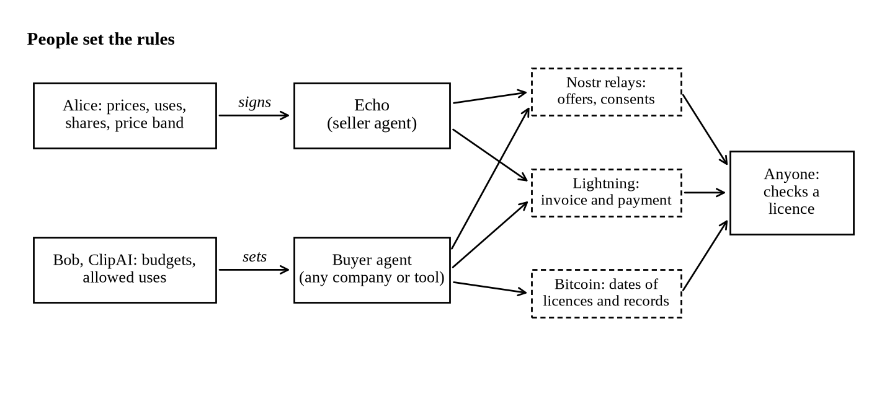
Figure 5. People set the rules; agents do the sales. Each agent acts within limits a person signed or set, and every act can be checked.
Budgets have two layers, and both are needed. The agent's own caps refuse a payment before the wallet is asked. The wallet's caps, enforced by the NIP-47 wallet service, refuse even a compromised agent; budgets are a feature of wallet implementations that NIP-47 permits, not a protocol guarantee [18]. The agent decodes every invoice and pays only the offer's price, so an inflated invoice is refused; it records the payment hash before paying and, on a timeout, looks the payment up and never pays twice. The amount and the use are read from the signed offer's tags, never chosen by a language model from offer text, so an order hidden in an offer by Mallory cannot make the agent overpay. In the demonstration a person at ClipAI sets a monthly budget ($3,000 by default, at most $100 for any one payment), and the wallet refuses once it is spent.
Subscriptions and recurring licences (draft). The protocol has no subscription event. A subscription is a recurring licence: a one-month licence for a catalogue, which the buyer's agent buys again each month inside its budget. Nothing is pulled from the buyer's wallet; each month is a new payment and a new licence that anyone can check. The demonstration's Harbour Music catalogue costs $99 a month for use of any of its recordings in online creator videos. The offer names the catalogue by a hash of its recordings' sorted file hashes, Harbour keeps 30%, and its artists Dave, Erin and Frank consent to their shares of the rest. A renewal starts on the day the old month ends, so the dates line up.

11. Splits and Other Payers
One Lightning payment pays one node, so splits are separate payments, not one atomic transaction. The seller's node receives the full price and pays each co-owner's share as its own payment; a failed share is retried, not undone. The artist then signs a statement (kind 3414) of sales and payouts for each co-owner, and any buyer proof missing from a statement is evidence of under-reporting. With collection, Alice's node briefly holds Carol's share, which is trust between collaborators, as today. Splits may also be published as weighted zap tags (NIP-57 Appendix G) [38], and a third-party BOLT12 "prism" can automate forwarding [39]. Composition royalties are separate and still flow through publishers and collecting societies.
Table 1. Who pays whom.
Payer | Payee | What is paid | Rail | Status
Buyer's agent | Artist's node | Licence for a stated use | x402 (lnbtc) | Built; run on a test network
Artist's node | Co-owners | Shares, with signed statements | Separate Lightning payments | Built; run on a test network
Platform's agent | Catalogue seller | Monthly catalogue licence | x402, renewed within budget | Draft; first month paid with test money
Buyer's agent | Proof service | OP_RETURN anchor | Lightning | Built; run on a test network
Platform | Artist | Batched settlement of plays | x402 against signed reports | Designed, not built
Platform or licensee | Publishers, collecting societies | Composition royalties | Existing licensing | Unchanged

Streaming platforms are a later, optional payer. A platform must hold the clear audio to serve it, so it can under-report; a signed usage report paid in batches makes an under-report a signed false statement, not an impossibility. History bounds the claim. Square, renamed Block, bought 86.23% of TIDAL in 2021 [40]; TIDAL launched direct artist payouts in late 2021 and ended them around March 2023 after paying about $500,000 [41]; in November 2024 Block wrote that it was "scaling back our investment in TIDAL" [42]. Reallocating a platform's own subscription money did not sustain itself. Per-stream figures are third-party estimates [50, 41]. Fans may also be rewarded for verified listening, but never per play: streaming services treat paid plays as artificial streams and may remove the track [43], another excludes manipulated streams from royalties [44], and paid promotion is a material connection that must be disclosed [45].
Lightning suits licences, not plays. A network snapshot dated 30 August 2026 shows a median fee rate of 100 ppm and a median base fee of 500 millisatoshis per hop; the means are 823 ppm and 904 millisatoshis [46]. An earlier snapshot reported a 300-millisatoshi median base fee [47]. Each channel accepts at most 483 pending payments [48], and a new artist has no inbound liquidity. Let a be the payment size in sats, h the hops, b the base fee and r the rate; fees take f = h·(b + r·a)/a. At $82,907 a bitcoin on 10 October 2026 [49], 1 sat ≈ $0.000829:
Table 2. Fee share by payment size (derived from the 30 August 2026 snapshot).
Payment | Size a | Median, 1 hop | Mean, 1 hop | Mean, 3 hops
One play | 5 sats | 10.0% | 18.2% | 54.5%
Personal licence ($1) | ≈ 1,206 sats | 0.051% | 0.16% | 0.47%
Creator licence ($5) | ≈ 6,031 sats | 0.018% | 0.097% | 0.29%
Business licence ($50) | ≈ 60,309 sats | 0.011% | 0.084% | 0.25%
Catalogue month ($99) | ≈ 119,411 sats | 0.010% | 0.083% | 0.25%
Sync licence ($150) | ≈ 180,900 sats | 0.010% | 0.083% | 0.25%

Per-play payments fail on fees alone, which is why the system sells licences. A licence of a dollar or more costs well under one percent even at mean fees over three hops. A deployment should measure its own routes.

12. Incentives
No operator enforces good behaviour, so each party must find honest participation in its own interest.
- Artists gain a sales channel for uses they cannot sell today, to buyers they could never negotiate with, at their own price, with a dated record of every sale. Overpricing corrects itself, because no buyer must pay.
- Co-owners consent to each offer and receive a signed statement; a missing sale is evidence against the artist's key.
- Buyers and their operators get a licence in seconds and a record that is their own evidence in a dispute. It pays them to check before paying and to keep their licences, which is also what keeps sellers honest.
- Distributors can sell vouching, the one input the protocol cannot supply. A false vouch is signed evidence against its signer.
- Builders need no permission: the formats are open, and a checker is a few lines of code.
Two deviations remain profitable. A pseudonymous seller who lacks the rights loses nothing by selling them, because a new key costs nothing; only vouching and buyers who require it answer her. And a seller can grant licences to her own keys for free, so licence counts and sales history can be faked. Reputation must therefore rest on vouched keys and on buyers that are themselves known.

13. Compliance for Regulated Payers
A regulated company that pays artists must know whom it pays. In the US it collects a W-9 or W-8BEN before paying royalties and reports royalties of $10 or more on Form 1099-MISC; payments in bitcoin are reported at their fair market value in dollars when paid [51]. It screens payees against sanctions lists. A pseudonymous key satisfies none of this, and a service that receives and forwards other people's money may be a money transmitter. These are handled once, at onboarding: the artist verifies her identity with a licensed provider, signs an event binding her key to that verified account, and regulated payers pay only keys bound this way. The permissionless path remains for buyers who are not regulated payers, such as an individual creator's agent; their operators carry their own obligations. The design does not remove compliance. It moves it to one step that a payment provider already performs.

14. Limits and Threat Model

14.1 What the system does not do
- Rights come first. A track has two copyrights, the recording and the composition. The system works only where the seller controls both for the use sold. Artists signed to labels usually cannot opt in alone.
- Not DRM. A licensee can copy a file. Licences are enforced by law and by records, as now.
- Not ownership. A signature proves control of a key, and a timestamp proves existence by a block. Check 10 reports what a trusted voucher said; it does not establish ownership.
- Not a replacement for publishing. Composition royalties remain owed through existing channels.
- Not demand. A price does not create a buyer. No outside artist, buyer or agent has used the system, and an audit found market signals that favour bulk, indemnified deals over sales of single tracks [54].

14.2 Attackers
A copycat (Mallory) offers Alice's track under her own key and node. Checks 1–9 pass; check 10 reports unverified, or disputed once a trusted voucher names Alice. A re-encoded copy has a new hash and needs fingerprinting to catch. A thief of K_n can sign invoices until Alice revokes the binding; licences dated after the revocation fail. A thief of K_a can sign a new binding, but cannot rotate her key away if she committed to a next key, and cannot sell her rights if her plan requires plan keys to co-sign. Once she rotates to her committed next key, every later sale by the stolen key fails check 10. A seller who takes the money and refuses cannot, because the buyer already holds the licence. A replayed proof fails against the spent-payment store and the request binding; a second invoice for the same request is refused. A runaway or tricked agent is bounded by its own caps, the wallet's caps and the signed offer; in the first live run a 90-fold overpayment was refused with nothing paid, and 40 simultaneous payments of 1,000 sats against a 20,000-sat daily wallet budget settled exactly 20. A relay can hide offers and title records, so they go to several relays and revocations go on-chain. A shared node lets its operator invoice in an artist's name, which is why one node per artist is a rule.

14.3 Privacy
The chain sees only digests. The request is sent only to the seller and never published. A buyer who uses a fresh key per licence cannot be linked across purchases by an observer such as Eve reading public relays, and can still show one licence when she wants to by a link signed with her main key. Timing remains visible: an anchor's block hints at when someone bought. The seller sees every request she answers, and an OP_RETURN anchor is public for good.

15. Status and Evidence
The reference library is written in TypeScript and its 289 tests pass. It has strict BOLT11 decoding, the x402 seller and the budgeted buyer agent, all ten checks, OpenTimestamps verification, the owner vouch, pre-rotation, pricing quotes, the rights records and the NWC binding. A red-team audit on 12 October 2026 found 27 issues, 24 of them fixed with regression tests [56]. A third-party x402 Lightning conformance suite gave 44 passed, 0 failed and 1 expected warning [57]. An earlier commerce library [22] and demonstration [52] explored a wider design; the licence path here replaces theirs.
Licence Lab is the live demonstration [55], and its code includes a byte-for-byte copy of the library's core [58]; its 124 tests pass. Stop 1: Alice sells and Bob's agent buys, with Personal, Creator and Business licences, a price stepper and a wallet strip that stays on screen; its test payments are real, through a public test wallet that holds test sats only [59]. Stop 2: ClipAI's agent licenses songs for 500 user videos within a monthly budget a person sets and subscribes to the Harbour Music catalogue. The first month of the subscription is paid with real test sats through the same test wallet; the 500 video licences and the renewal use practice money, while their signatures, invoices, budget checks and verification are real. Stop 3: anyone can check a licence, and the demonstration links to the real test-network licence below. The scenarios and code are on GitHub [58]. The test wallet is a shared node and refuses sign_message, so its sales cannot pass check 3, and the Lab says so.
The live run. On 17 October 2026, on Mutinynet, a Bitcoin test network with 30-second blocks, Alice's own node bound itself to her key with a next-key commitment and offered the real "Rain" master for 100 test sats. Bob's agent paid over NWC from Bob's node in 257 ms. Alice's node paid Carol 20 and Dave 15 by keysend. The licence passed checks 1–9 and returned verified with the distributor's vouch, unverified without it. A second licence was anchored by a third-party OP_RETURN service paid over Lightning by the agent [60]. Alice then withdrew the offer. A third licence, invoiced 30 seconds before the withdrawal block and anchored one block after it, stayed valid under the rule of §8, and new requests were answered 410 Gone. An independent checker using the public explorer's data agreed [54]. Every transaction is public (Table 3) [61]. An earlier run the same day verified an OpenTimestamps proof from a calendar server that we ran on the same network. This is evidence that the protocol works end to end on a real chain. It is not evidence of a market: the coins were test coins, and one operator ran every party on one machine.
Table 3. The live run on Mutinynet, 17 October 2026 (UTC).
Step | Block | Time | Transaction
Binding's next-key commitment (MLT1) | 3,513,266 | 15:28:34 | 475afe66…f602
"Rain" licence #1 anchored (MLA1) | 3,513,267 | 15:29:04 | 9d7ed8bb…53bd
Licence #2 anchored by a third-party service | 3,513,268 | 15:29:37 | 0e1e1305…ba86
Alice withdraws the offer (MLR2, 80 bytes) | 3,513,269 | 15:30:09 | 26cf2698…b4bd
Licence #3 anchored after the withdrawal | 3,513,270 | 15:30:41 | 7e2c02e9…11e1f

Table 4. What exists, 17 October 2026.
Part | Status
Offer, consent, binding, request, payment as grant, ten checks | Built and tested; run end to end on a test network
Splits by separate payments; signed statements | Built; splits run on a test network
OpenTimestamps and OP_RETURN anchors; withdrawal rule | Built; run on a test network
Owner vouch and check 10; pre-rotation | Built and tested; run on a test network
Pricing key and quotes | In the library and its tests; not yet used by the seller or buyer agent
Binding over NWC sign_message | Built; Alby Hub lists the method but has not been tried; a shared test wallet refuses it
Rights transfer and succession (kinds 3417–3419) | Draft; built and tested in the library and the Lab
Personal licence type; subscriptions as monthly licences | Draft; in the Lab only
Exclusive licences; daily status record for light checkers | Specified; not built
Trusted ownership root; fingerprinting; main-network sale; outside users; legal review | Not yet done

The independent audit of 17 October 2026 judged the work competent, "a strong, honest, well-tested piece of work, with one near-magical moment and nothing yet that is exceptional", and named ownership, demand and a staged demonstration as what held it back [54]. A second audit of the demonstration found its first stop close to magical and asked for personal licences, subscriptions, a persistent wallet and rules set by people [62]; those are now in it. No lawyer has yet reviewed whether these signatures form a licence; the questions are written [63].

16. Example
Alice writes, records and owns "Rain". Carol produced it and Dave sang on it; under a written agreement Carol takes 20% and Dave 15% of recording income. No label owns the master, and no publisher controls the song. Her distributor publishes an owner vouch naming her key for the master's hash. Her binding commits to her next key, which she keeps offline, and her succession plan names three people, any two of whom may take over.
Alice sets the rules: Personal at $1, Creator at $5 and Business at $50, each its own offer, with a pricing key allowed to quote within a band. Carol and Dave sign their consents. Echo, her agent, keeps the offers up and answers requests. Bob's agent buys a Creator licence for his videos: it checks the offer, signs a request with a fresh key, receives an invoice bound to it, pays inside Bob's budget and holds the licence; Carol and Dave are paid straight after, and the licence is dated in the next anchor. ClipAI's agent licenses "Rain" for some of its 500 user videos, inside the monthly budget a person at ClipAI set, and renews its Harbour Music catalogue month. ModelCo buys a training licence and dates it before training starts, so it can later show a regulator that permission came first.
Mallory lists "Rain" under her own key. Her licences pass the first nine checks, but check 10 reports them disputed, and a video site that requires ownership refuses them. Eve watches the relays and cannot link Bob's purchases. Later Alice withdraws the Business offer; licences invoiced before the withdrawal block and dated within a day stay valid. Alice set the prices, the uses and the shares, sold to buyers she could never have negotiated with, and holds a dated record of every sale. She is not protected from copying, still needs registration to sue over a US work, and still owes songwriting royalties where they apply.

17. Conclusion
We have proposed an open licence for recorded music that is built for agents. We started from a market in which licences for video, advertising and AI training are bilateral contracts that only large parties can negotiate, and in which software can find music and pay, but cannot buy a licence from the artist. At the scale of a global network every party needs an agent, so people set the rules and agents do the sales. The artist signs an offer and binds it to her own node. The invoice commits to the buyer's signed request, so the secret that settles the payment completes the licence, and no later act of the seller can be withheld. Bitcoin blocks date grants, withdrawals, rotations and transfers, and anyone can check a licence with ten checks. The system proves what keys sold, and when; whether those keys own the music remains an input that trusted vouchers supply and the tenth check reports. It has run end to end on a test network with test coins. What it needs next is a trusted ownership root, real artists and real buyers. Artists license their music directly; any agent can buy it in seconds and prove it on Bitcoin.

References
[1] Spotify, "From $11B in 2025 Payouts: What's Next for Artists," Spotify Newsroom, January 28, 2026. https://newsroom.spotify.com/2026-01-28/2025-music-industry-payouts-whats-next-for-artists/
[2] Spotify, "Loud & Clear: FAQ" (two-thirds payout; streamshare). https://loudandclear.byspotify.com/faq/
[3] Music Business Worldwide, "Spotify says it paid out over $11bn to the music industry in 2025," 2026. https://www.musicbusinessworldwide.com/spotify-says-it-paid-out-over-11bn-to-the-music-industry-in-2025/
[4] Spotify for Artists, "Royalties guide." https://artists.spotify.com/royalties-guide
[5] Spotify for Artists, "Track monetization eligibility" (1,000-stream threshold, 2024). https://support.spotify.com/us/artists/article/track-monetization-eligibility/
[6] Block, "TIDAL launches Direct-to-Fan Sales powered by Square." https://block.xyz/inside/tidal-launches-direct-to-fan-sales-powered-by-square-enabling-independent-artists-to-sell-music-directly-to-fans
[7] TIDAL (@TIDAL), post on X, August 31, 2026: "0% goes to Tidal when artists sell music and merch." https://x.com/TIDAL/status/2094455872873476451
[8] Runtime Wire, "Tidal drops its cut of music and merch sales to 0%," August 31, 2026. https://runtimewire.com/article/tidal-drops-direct-sales-fee-zero-percent
[9] Wavlake, "Wavlake Docs," https://docs.wavlake.com/ ; Fountain, "Introducing Fountain for Artists," https://fountain.fm/blog/introducing-fountain-for-artists
[10] Universal Music Group, "Universal Music Group and Udio announce Udio's first strategic agreements for new licensed AI music creation platform," October 29, 2025. https://www.universalmusic.com/universal-music-group-and-udio-announce-udios-first-strategic-agreements-for-new-licensed-ai-music-creation-platform/
[11] Music Business Worldwide, "Sony Music sues Udio again, asserting over 30,000 recordings," 2026 (Warner settled with Suno, November 2025). https://www.musicbusinessworldwide.com/sony-music-files-new-lawsuit-against-ai-platform-udio-asserting-over-30000-sound-recordings-a-judge-barred-it-from-adding-to-its-original-case/
[12] Los Angeles Times, "Suno made a new AI music model with major labels. Here's what it means," September 21, 2026. https://www.latimes.com/entertainment-arts/business/story/2026-09-21/ai-music-licensing-deals-labels-artists-who-benefits
[13] ElevenLabs, "ElevenLabs Launches Eleven Music in Collaboration with Music Industry Partners," Business Wire, August 5, 2025 (Merlin and Kobalt agreements; opt-in). https://www.businesswire.com/news/home/20250805333301/en/ElevenLabs-Launches-Eleven-Music-in-Collaboration-with-Music-Industry-Partners
[14] Linux Foundation, "Linux Foundation announces operational launch of x402 Foundation," July 14, 2026 (x402 created by Coinbase). https://www.linuxfoundation.org/press/linux-foundation-announces-operational-launch-of-x402-foundation-to-standardize-internet-native-payments-for-ai-agents-and-applications
[15] x402 Foundation, pull request #2861, "Specify exact Lightning" (network lnbtc; request binding via BOLT11 description hash; replay key network:payment_hash; invoice face value is the settled amount), merged September 23, 2026. https://github.com/x402-foundation/x402/pull/2861
[16] Block, "Block Joins the x402 Foundation to Advance Open Agentic Commerce," September 24, 2026. https://block.xyz/inside/block-joins-the-x402-foundation-to-advance-open-agentic-commerce
[17] CoinDesk, "Ripple joins card giants backing x402 as 75 million payments move just $24 million," July 15, 2026. https://www.coindesk.com/tech/2026/07/15/visa-mastercard-and-ripple-join-the-standard-letting-ai-agents-pay-in-stablecoins
[18] Nostr NIPs repository and index (NIP-01, 05, 07, 17, 19, 22, 26, 32, 39, 40, 44, 46, 47, 50, 52, 56, 58, 59, 75, 89, 94, 98), checked October 11, 2026. https://github.com/nostr-protocol/nips
[19] Nostr Biweekly Review, 15–30 May 2026 (daily active public keys). https://nostr.at/naddr1qq24s6njf44xxt2hddars7zd0phhjsjzwphrzq3qwkrfe7kyksfn8s4zmnkr9c9ueakc8hz2fhu4mdayc0gfxa5pnxrsxpqqqp65wcs6aw2
[20] NIP-85, "Trusted Assertions" (web-of-trust metrics in kinds 30382–30385; no identity-attestation result type), draft. https://github.com/nostr-protocol/nips/blob/master/85.md
[21] LNURL documents: LUD-16 (Lightning address), LUD-21 (verify). https://github.com/lnurl/luds
[22] welliv, "nostr-commerce-skill" (TypeScript library; README, src/ and tests/ reviewed at commit 11191f8, May 21, 2026). https://github.com/welliv/nostr-commerce-skill
[23] NIP-99, "Classified Listings" (kind 30402; price tag and frequency). https://nips.nostr.com/99
[24] Blossom, BUD specifications (BUD-01, BUD-02; BUD-07 paid upload and download, draft). https://github.com/hzrd149/blossom
[25] Lightning Labs, "L402 protocol specification." https://github.com/lightninglabs/L402/blob/master/protocol-specification.md
[26] OpenTimestamps (free calendar servers; Bitcoin attestations). https://opentimestamps.org/
[27] S. Nakamoto, "Bitcoin: A Peer-to-Peer Electronic Cash System," 2008. https://bitcoin.org/bitcoin.pdf
[28] NIP-03, "OpenTimestamps Attestations for Events" (kind 1040; marked unrecommended). https://nips.nostr.com/3
[29] U.S. Copyright Office, "Copyright in General" FAQ (protection on fixation; registration before suit; "poor man's copyright"). https://www.copyright.gov/help/faq/faq-general.html
[30] Berne Convention for the Protection of Literary and Artistic Works, Article 5(2). https://www.wipo.int/wipolex/en/text/283698
[31] 17 U.S.C. § 411(a), registration as a prerequisite to infringement suits. https://www.law.cornell.edu/uscode/text/17/411
[32] Fourth Estate Public Benefit Corp. v. Wall-Street.com, LLC, 586 U.S. 296 (2019). https://www.supremecourt.gov/opinions/18pdf/17-571_e29f.pdf
[33] Hangzhou Huatai Yimei v. Shenzhen Daotong, Hangzhou Internet Court, (2018) Zhe 0192 Min Chu No. 81, as reported by the Supreme People's Court. https://english.court.gov.cn/2019-12/04/c_766707.htm
[34] Supreme People's Court, Provisions on Several Issues Related to Trial of Cases by the Internet Courts, Art. 11 (effective September 7, 2018). https://www.court.gov.cn/zixun/xiangqing/116981.html ; English: https://www.chinalawtranslate.com/en/the-supreme-peoples-courts-provisions-on-several-issues-related-to-trial-of-cases-by-the-internet-courts/
[35] Supreme People's Court, Online Litigation Rules of the People's Courts (effective August 1, 2021). https://cicc.court.gov.cn/html/1/219/199/201/2208.html
[36] 12 V.S.A. § 1913, Blockchain enabling (Vermont). https://legislature.vermont.gov/statutes/section/12/081/01913
[37] Federal Rule of Evidence 902(14) and committee note. https://www.law.cornell.edu/rules/fre/rule_902
[38] NIP-57, "Lightning Zaps," Appendix G (zap tags and weights). https://nips.nostr.com/57
[39] gudnuf, "BOLT12 Prism" (Lightning payment splits). https://github.com/gudnuf/bolt12-prism
[40] Music Business Worldwide, "Court dismisses shareholder lawsuit over Block's purchase of TIDAL," May 10, 2023 (closed April 30, 2021; $237.3 million for 86.23%, per Block's 10-Q). https://www.musicbusinessworldwide.com/court-dismisses-shareholder-lawsuit-over-blocks-purchase-of-tidal/
[41] Velveteen, "How Much Does Tidal Pay Per Stream?" (updated July 4, 2026; direct artist payouts and fan-centered royalties launched late 2021, ended around March 2023 after about $500,000; Duetti real-statement rate ≈ $0.0068). https://www.velveteen.fm/guides/streaming-payouts-by-platform/tidal-pay-per-stream
[42] TechCrunch, "Block scales back TIDAL investment and shutters TBD in favor of Bitcoin mining," November 7, 2024 (quoting Block's Q3 2024 shareholder letter). https://techcrunch.com/2024/11/07/block-scales-back-tidal-investment-and-shutters-tbd-in-favor-of-bitcoin-mining/
[43] Spotify for Artists, "Artificial streaming" (streams that do not reflect genuine listening intent; paid stream services prohibited; penalties up to removal of the track). https://artists.spotify.com/artificial-streaming
[44] Deezer Newsroom, "AI music exceeds 50% of daily uploads on Deezer," July 21, 2026 (fraudulent streams excluded from royalties; tracks used for fraud taken down). https://newsroom-deezer.com/2026/07/ai-music-exceeds-50-percent-daily-uploads-deezer/
[45] U.S. Federal Trade Commission, "FTC's Endorsement Guides: What People Are Asking," June 2023 (disclosure of material connections; 16 CFR Part 255). https://www.ftc.gov/business-guidance/resources/ftcs-endorsement-guides-what-people-are-asking
[46] mempool.space, Lightning network statistics, snapshot dated August 30, 2026, retrieved October 11, 2026 (median fee rate 100 ppm, median base fee 500 msat; mean 823 ppm and 904 msat; capacity 3,753.7 BTC). https://mempool.space/api/v1/lightning/statistics/latest
[47] Ampwire, "Lightning graph anatomy: a two-tier network" (median fee snapshot), March 1, 2026. https://ampwire.net/lightning-graph-anatomy-two-tier-network
[48] Lightning BOLT #2, "Peer Protocol for Channel Management" (max_accepted_htlcs at most 483, or 114 with zero-fee commitments; max_htlc_value_in_flight_msat). https://github.com/lightning/bolts/blob/master/02-peer-protocol.md
[49] Basis Desk, "Crypto market close, Oct. 10, 2026: BTC $82,907" (UTC daily close; other trackers report $82,912–$82,918). https://basisdesk.news/news/crypto-market-close-october-10-2026
[50] Ditto Music, "How much does TIDAL pay per stream in 2026" (includes Spotify estimate). https://dittomusic.com/en/blog/how-much-does-tidal-pay-per-stream
[51] Internal Revenue Service, Instructions for Forms 1099-MISC and 1099-NEC (Rev. December 2026) (royalties of $10 or more, Box 2). https://www.irs.gov/instructions/i1099mec ; IRS, "Digital assets." https://www.irs.gov/filing/digital-assets
[52] welliv, "Nostr Powered Music" reference demonstration (public build simulated; a local sidecar can issue real 21-sat NWC invoices). https://welliv.github.io/music-pitch/
[53] welliv, "NIP-XX: Music Licence Offers," draft, 17 October 2026 (event kinds 3410–3419 are placeholders, not yet confirmed with NIP maintainers). https://github.com/welliv/licence-lab/blob/main/docs/references/nip-xx-music-licence-offers-draft.md
[54] Independent audit of the protocol, its live proofs and Licence Lab, 17 October 2026, with a re-check of the second live run against the public explorer. https://github.com/welliv/licence-lab/blob/main/docs/references/independent-audit-2026-10-17.md
[55] welliv, "Licence Lab," live demonstration of the protocol, retrieved 17 October 2026. https://welliv.github.io/licence-lab/
[56] Independent red-team audit of the music licence protocol, 12 October 2026: 27 findings, 24 fixed with regression tests. https://github.com/welliv/licence-lab/blob/main/docs/references/red-team-audit-2026-10-12.md
[57] B. Carman, "x402-ln-tools" (x402-ln check conformance suite), run against the reference seller on 17 October 2026: 44 passed, 0 failed, 1 warning. https://github.com/benthecarman/x402-ln-tools
[58] welliv, "licence-lab" source code, including a byte-for-byte copy of the reference library core (src/lib/mll, from library commit 00038ff). https://github.com/welliv/licence-lab
[59] NWC faucet (test wallets holding test sats only). https://faucet.nwc.dev
[60] B. Carman, "OP-RETURN-Bot" (pay a Lightning invoice, receive an OP_RETURN). https://github.com/benthecarman/OP-RETURN-Bot
[61] Mutinynet block explorer, live run of 17 October 2026, blocks 3,513,266–3,513,270. https://mutinynet.com/tx/475afe663dc1ed3fa99b82c2d914b4903dadaec85e5445e79c4775da574ff602 ; https://mutinynet.com/tx/9d7ed8bbb8d8c2d4ff58d9acab928676eae5606b2d89b1b229f5fd7ab99f53bd ; https://mutinynet.com/tx/0e1e130519c12a43bc4dbc818b6afca1e2fdc2abe82cff56d43bbcbf7069ba86 ; https://mutinynet.com/tx/26cf26989c4b78bb1036727d783f6ac0892d95a0e6ddf16328ff1a87c456b4bd ; https://mutinynet.com/tx/7e2c02e937a1809ad6b36d7f21ef84a93e199f6c5c23dc331d53ed224ce11e1f
[62] Independent audit of Licence Lab against the project vision, 17 October 2026. https://github.com/welliv/licence-lab/blob/main/docs/references/vision-audit-2026-10-17.md
[63] Questions for legal review, 12 October 2026, updated 17 October 2026. https://github.com/welliv/licence-lab/blob/main/docs/references/legal-review-questions.md

