**Report of Instrumentation & Control Design Project**

Class: Electronic Information Engineering 1802

Student name: Yuchen Lu

Student ID: 0802180231

**Introduction:**

A simple circuit with three modes: voltage measurement mode, light’s level measurement mode and temperature and humidity measurement mode. You can

switch mode by press the button as the Figure 1 shows.

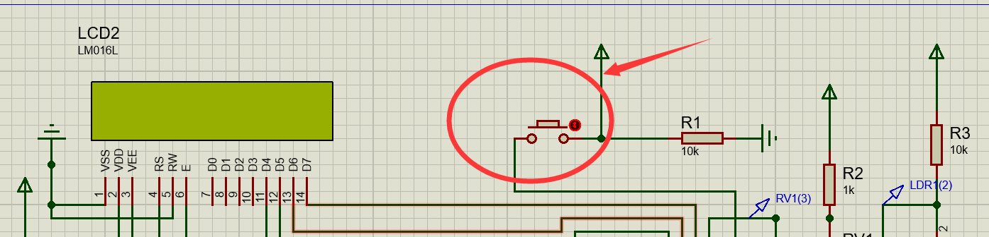

**Figure 1**

**Errors & Solutions &** **Experience:**

There was an error about out of RAM, it's seems that “sprint ()” is a very dangerous function, especially using in microcontroller for converting float to char, float is also a dangerous type due to it will takes too much RAM in microcontroller. Fortunately, google said that “itoa ()” and ”ftoa()” is more suitable for me to realize the function what I need. In addition, make sure the types of value are all correctly which of the great importance on calculation. Software engineer may no need to eyes on the RAM too much because they have such large memory space, but embedded engineer should pay more attention on data types and number of codes, That’s what I learned from this from this experience.

**Some tips:**

**1.**This program is design for the real world, therefore make sure you have pressed the button at least 1 second.

**2.(Important)**The DHT11 sensor may not working on the Proteus as the Figure 2 shows, I believe that it’s a bug of DHT11 on Proteus, it will work correctly in real world.

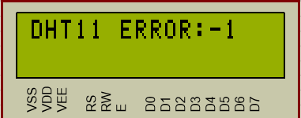

**Figure 2(Error code:-1)**

Under normal situation, the program(Figure 3) and datasheet of DHT11 shows that DHT11 will send “0” to MCU, But it didn’t in simulation.

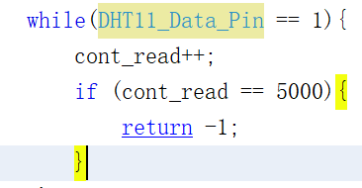 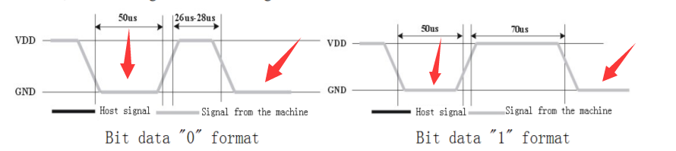

**Figure 3**