**Android Magtek Devices**

**Device Library:**

DCMobileSDK-Magtek.aar

**Supported Devices:**

|  |  |
| --- | --- |
| eDynamo | Tested |
| uDynamo | Tested(Mobile Device must meet uDynamo Compatibility list.) |
| aDynamo | UnTested |
| BulleT | UnTested |
| DynaMag | UnTested |
| DynaMax | UnTested |

**Device Connection Type:**

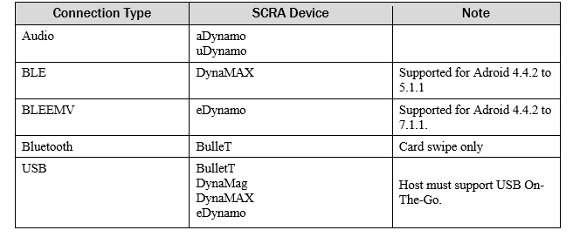

**Android Manifest:**

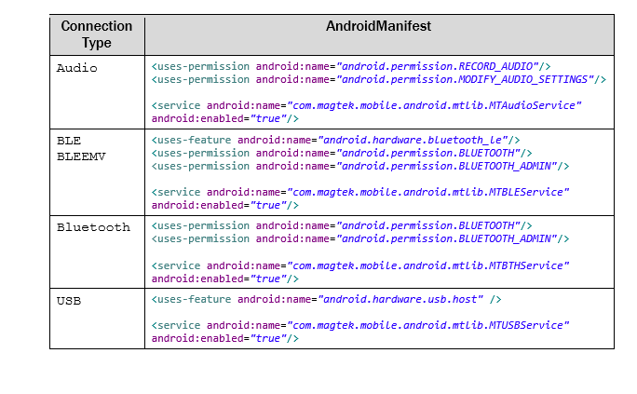

**Device call:**

MagtekDeviceManager(Device device, Context context, String connectionType)

|  |  |
| --- | --- |
| eDynamo | MagtekDeviceManager(**devices**[0], MainActivity2.**this**,**"BLEEMV"**); |
| uDynamo | MagtekDeviceManager(**devices**[0], MainActivity2.**this**,**"Audio"**); |
| aDynamo | MagtekDeviceManager(**devices**[0], MainActivity2.**this**,**"Audio"**); |
| BulleT | MagtekDeviceManager(**devices**[0], MainActivity2.**this**,**"Bluetooth"**); |
| DynaMag | MagtekDeviceManager(**devices**[0], MainActivity2.**this**,**"USB"**); |
| DynaMax | MagtekDeviceManager(**devices**[0], MainActivity2.**this**,**"BLE"**); |

**Troubleshooting:**

* For u and aDynamo Volume / media sound needs to be at max.
* For issues installing, Replace current DCMobileSDK.aar with the the new DCMobileSDK.aar and clean build, to make sure Magtek class was integrated
* .aar files are located in \build\outputs\aar, if names do not match (in case the aar files are named release / debug) rename them to **DCMobileSDK.aar, DCMobileSDK-IDT.aar, DCMobileSDK-Magtek,** and **DCMobileSDK-Miura.**