

gTLV v1

generic-TLV transport protocol specification



Table of Contents
1 Introduction 3
1.1 Scope and objective 3
1.2 Terminology 3
2 Packet transport 4
3 Packet format 5
3.1 Header 5
3.1.1 Application 5
3.1.2 Code 5
3.1.3 Length 5
3.2 Attributes 5
3.2.1 Type 6
3.2.2 Length 6
3.2.3 Value 6

Introduction
This document describes a transport protocol that can be used to exchange generic information between two peers by means of Type-Length-Value (TLV) data encapsulation.
Applications may take advantage of this protocol by extending this specification with their specific requirements.

Scope and objective
The main purpose of this protocol is to allow different applications to exchange TLV-encoded data easily, providing separation between them at the data level.
This document:
- Describes how gTLV interacts with lower network layers.
- Defines gTLV's packet format and supported data types.
- Specifies how different applications may use this protocol to send and receive their data.

Terminology
The key words “must”, “must not”, “required”, “shall”, “shall not”, “should”, “should not”, “recommended”, “not recommended”, “may”, and “optional” in this document are to be interpreted as described in [RFC2119].

Packet transport
gTLV stands on top of TCP/IP networking. IP routing is expected, but no other way of relaying or forwarding is supported.
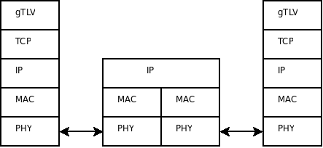Figure 1: Protocol stack
However, in case there is the need to support secure transmission between the peers, VPNs or SSH tunnels may be used.
By default, gTLV servers should listen on TCP port 50000 until gTLV is registered at IANA. UDP is specifically not supported as a means to transport gTLV packets.

Packet format
A summary of the gTLV data format is shown below. The fields are transmitted from left to right.
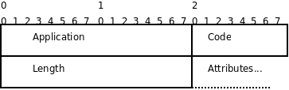Figure 2: Packet format

Header
The header is made up of the Application, Code and Length fields.

Application
The Application field is two octets, and identifies the application that is using gTLV for data transmission. When a packet is received with an invalid Application field, it must be silently discarded.
gTLV applications are assigned as follows:
- 0x0000: No application (used to denote uncompleted or malformed packets)
- 0x0001: Public lighting

Code
The Code field is one octet, and identifies the type of the gTLV packet. The type of a gTLV packet is application-dependent, i.e., the same Code value for two packets that belong to different applications may mean something completely different. When a packet is received with an invalid Code field, it must be rejected or silently discarded.

Length
The Length field is two octets. It indicates the length of the packet including the Application, Code, Length and Attribute fields. Therefore, the end of the attribute list is dictate by the value of this field.
Octets outside the range of the Length field must be treated as padding and ignored on reception. If the packet is shorter than the Length field indicates, it must be silently discarded. Minimum length is 5 and maximum length is 65507.

Attributes
The Attributes field is variable in length, and contains a list of zero or more attributes. A summary of the Attribute format is shown below. The fields are transmitted from left to right. Attributes can be sent in any order after the header.
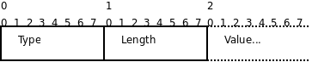Figure 3: Attributes

Type
The Type field is one octet. Attributes with an unknown type may be ignored.
The list of permitted attribute types depends on the packet type (Code field). Allowed types may be mandatory or not for a certain packet type. If a mandatory attribute is not present, the whole packet must be rejected or silently discarded.
Attribute type must be defined in a way that corresponding values can be described by means of one of these four allowed data formats:
- String: 1 – 65534 octets containing ASCII characters. Strings of length zero must not be sent; omit the entire attribute instead. String terminator must not be sent.
- Octets: 1 – 65534 octets containing binary data (values 0 through 255 decimal, inclusive). At least one octet must be present; if this was not going to be the case omit the entire attribute instead.
- Integer: 32 bit signed value, most significant octet first. Integers are represented by using sign and magnitude. The sign bit is the most significant bit in the most significant octet.
- Boolean: 8 bit unsigned value, where 0x00 equals False and any other value equals True.
- Timestamp: 32 bit unsigned value, most significant octet first, meaning seconds since 00:00:00 UTC, January 1, 1970.

Length
The Length field is one octet, and indicates the length of this Attribute including the Type, Length and Value fields. If an Attribute is received with an invalid Length, the complete packet must be rejected or silently discarded.

Value
The Value field is zero or more octets and contains information specific to the Attribute. The format and length of the Value field is determined by the Type and Length fields.
Note that none of the data types in gTLV terminate with a NUL (0x00) octet. The Attribute has a length field and therefore does not require a terminator.

