CMIT 388 CMIT 388 Model Red Hat Linux System Administration I
Project 2 Work Product

Name: Diamond Wellons
Section: CMIT 388 7381

Instructions
Type the exact command used to complete each step after the corresponding number below and the paste the screenshot as outlined in the project instructions.

Part One – Users and Groups - Server2

- Sudo groupadd -g 6000 lnxgrps2

- Sudo useradd -u 5000 -g 6000 userp1s2

- Sudo chage -m 4 -M 30 -W 10 -E 2025-12-20 userp1s2

- Visudo (userp1s2 ALL=(ALL) NOPASSWD:ALL) :WQ

5a. id -u userp1s2

Screenshot 1:
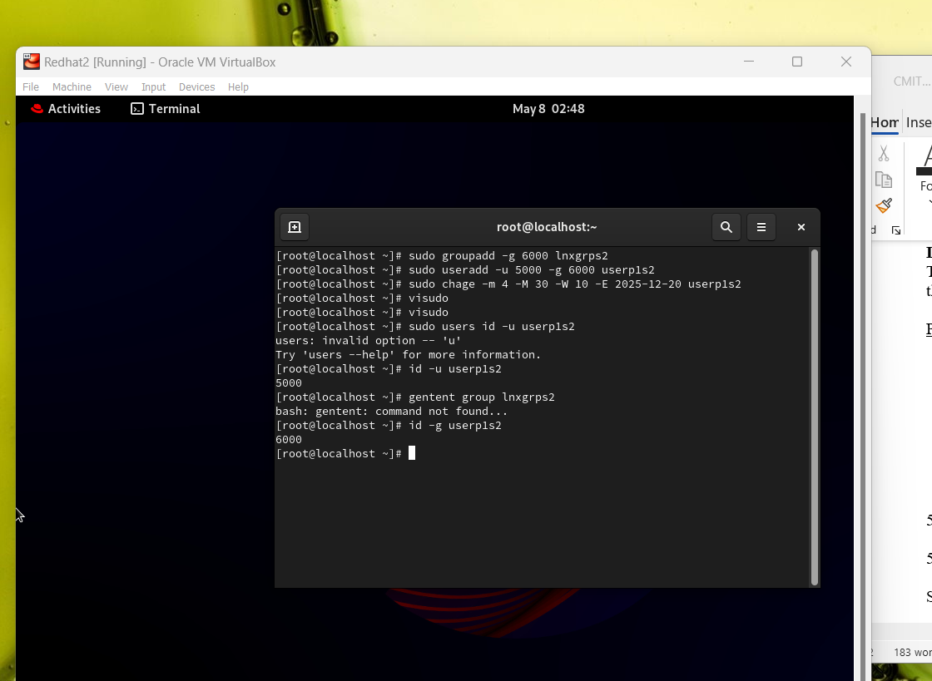

Part One – Users and Groups - Server3

- Sudo groupadd -g 6000 lnxgrps3

2. sudo useradd -u 5000 -g 6000 userp1s3

3. sudo chage -m 4 -M 30 -W 10 -E 2025-12-20 userp1s3

4. visudo (userp1s3 ALL=(ALL) NOPASSWD:ALL :wq

5a. sudo users id -u userp1s3

5b.

Screenshot 2:

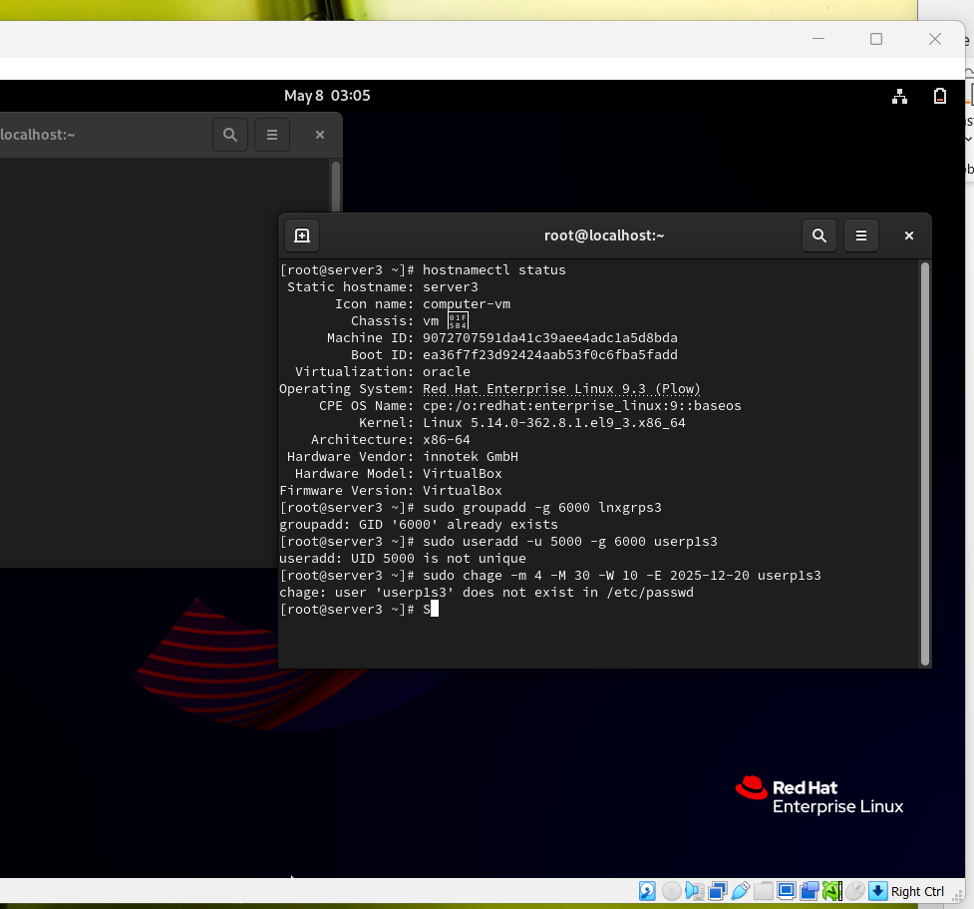

Part Two – Networking – Server2

1.

2.

3.

Screenshot 3:

Part Two – Networking – Server3

1.

2.

3.

Screenshot 3:

Part Three – Security through SSH

1.

2.

3.

4.

Screenshot 4:

5.

6.

7.

8.

Screenshot 5:

