[**Android与服务器端数据交互（基于SOAP协议整合android+webservice）**](http://www.cnblogs.com/zhangdongzi/archive/2011/04/19/2020688.html)

上一节中我们通过http协议，采用HttpClient向服务器端action请求数据。当然调用服务器端方法获取数据并不止这一种。WebService也可以为我们提供所需数据，

﻿那么什么是webService呢？，它是一种基于SAOP协议的远程调用标准，通过webservice可以将不同操作系统平台，不同语言，不同技术整合到一起。

  我们在PC机器java客户端中，需要一些库，比如XFire,Axis2,CXF等等来支持访问WebService，但是这些库并不适合我们资源有限的android手机客户端，做过JAVA ME的人都知道有KSOAP这个第三方的类库，可以帮助我们获取服务器端webService调用，当然KSOAP已经提供了基于android版本的jar包了，那么我们就开始吧：

﻿首先下载KSOAP包：ksoap2-android-assembly-2.5.2-jar-with-dependencies.jar包

然后新建android项目：并把下载的KSOAP包放在android项目的lib目录下：右键->build path->configure build path--选择Libraries，如图：

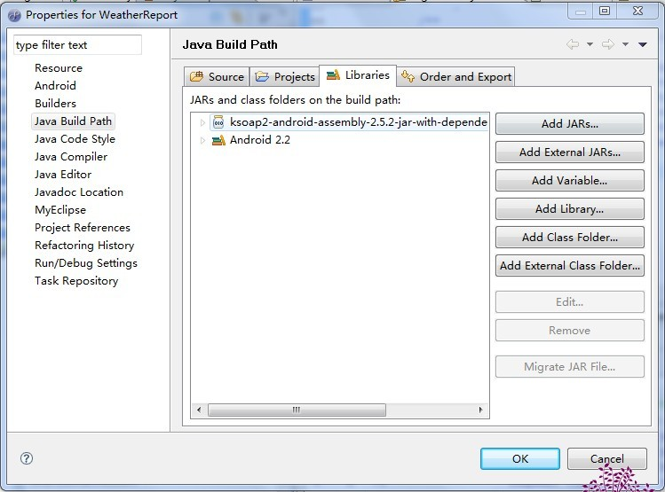

以下分为七个步骤来调用WebService方法：

第一：实例化SoapObject 对象，指定webService的命名空间（从相关WSDL文档中可以查看命名空间），以及调用方法名称。如：

http://images.cnblogs.com/OutliningIndicators/ContractedBlock.gifhttp://images.cnblogs.com/OutliningIndicators/ExpandedBlockStart.gifView Code

//命名空间  
 private static final String serviceNameSpace="http://WebXml.com.cn/";  
 //调用方法(获得支持的城市)  
 private static final String getSupportCity="getSupportCity";  
  
//实例化SoapObject对象  
 SoapObject request=new SoapObject(serviceNameSpace, getSupportCity);

第二步：假设方法有参数的话,设置调用方法参数

request.addProperty("参数名称","参数值");

第三步：设置SOAP请求信息(参数部分为SOAP协议版本号，与你要调用的webService中版本号一致):

http://images.cnblogs.com/OutliningIndicators/ContractedBlock.gifhttp://images.cnblogs.com/OutliningIndicators/ExpandedBlockStart.gifView Code

//获得序列化的Envelope  
 SoapSerializationEnvelope envelope=new SoapSerializationEnvelope(SoapEnvelope.VER11);  
 envelope.bodyOut=request;

第四步：注册Envelope,

﻿(new MarshalBase64()).register(envelope);

第五步：构建传输对象，并指明WSDL文档URL：

http://images.cnblogs.com/OutliningIndicators/ContractedBlock.gifhttp://images.cnblogs.com/OutliningIndicators/ExpandedBlockStart.gifView Code

//请求URL  
 private static final String serviceURL="http://www.webxml.com.cn/webservices/weatherwebservice.asmx";  
//Android传输对象  
 AndroidHttpTransport transport=new AndroidHttpTransport(serviceURL);  
 transport.debug=true;

第六步：调用WebService(其中参数为1：命名空间+方法名称，2：Envelope对象):

http://images.cnblogs.com/OutliningIndicators/ContractedBlock.gifhttp://images.cnblogs.com/OutliningIndicators/ExpandedBlockStart.gifView Code

transport.call(serviceNameSpace+getWeatherbyCityName, envelope);

第七步：解析返回数据：

http://images.cnblogs.com/OutliningIndicators/ContractedBlock.gifhttp://images.cnblogs.com/OutliningIndicators/ExpandedBlockStart.gifView Code

if(envelope.getResponse()!=null){  
 return parse(envelope.bodyIn.toString());  
 }  
  
/**************  
 * 解析XML  
 * @param str  
 * @return  
 */  
 private static List<String> parse(String str){  
 String temp;  
 List<String> list=new ArrayList<String>();  
 if(str!=null && str.length()>0){  
 int start=str.indexOf("string");  
 int end=str.lastIndexOf(";");  
 temp=str.substring(start, end-3);  
 String []test=temp.split(";");  
   
 for(int i=0;i<test.length;i++){  
 if(i==0){  
 temp=test[i].substring(7);  
 }else{  
 temp=test[i].substring(8);  
 }  
 int index=temp.indexOf(",");  
 list.add(temp.substring(0, index));  
 }  
 }  
 return list;  
 }

这样就成功啦。那么现在我们就来测试下吧，这里有个地址提供webService天气预报的服务的，我这里只提供获取城市列表：

http://images.cnblogs.com/OutliningIndicators/ContractedBlock.gifhttp://images.cnblogs.com/OutliningIndicators/ExpandedBlockStart.gifView Code

//命名空间  
 private static final String serviceNameSpace="http://WebXml.com.cn/";  
 //请求URL  
 private static final String serviceURL="http://www.webxml.com.cn/webservices/weatherwebservice.asmx";  
 //调用方法(获得支持的城市)  
 private static final String getSupportCity="getSupportCity";  
 //调用城市的方法(需要带参数)  
 private static final String getWeatherbyCityName="getWeatherbyCityName";  
 //调用省或者直辖市的方法(获得支持的省份或直辖市)  
 private static final String getSupportProvince="getSupportProvince";

 然后你可以在浏览器中输入地址（WSDL）：serviceURL,你会看到一些可供调用的方法：

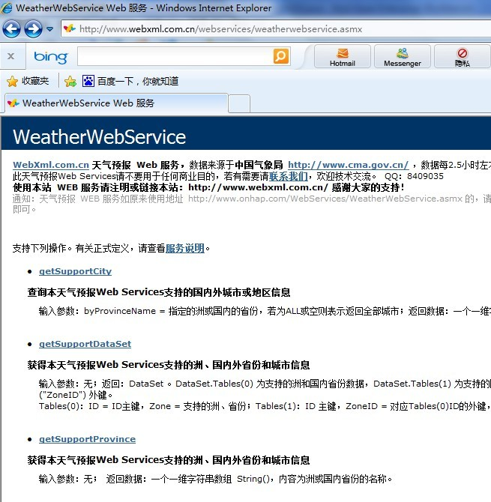

 我们选择获取国内外主要城市或者省份的方法吧：getSupportProvice,然后调用，你会发现浏览器返回给我们的是xml文档：

http://images.cnblogs.com/OutliningIndicators/ContractedBlock.gifhttp://images.cnblogs.com/OutliningIndicators/ExpandedBlockStart.gifView Code

<?xml version="1.0" encoding="utf-8" ?>   
- <ArrayOfString xmlns:xsi="http://www.w3.org/2001/XMLSchema-instance" xmlns:xsd="http://www.w3.org/2001/XMLSchema" xmlns="http://WebXml.com.cn/">  
 <string>直辖市</string>   
 <string>特别行政区</string>   
 <string>黑龙江</string>   
 <string>吉林</string>   
 <string>辽宁</string>   
 <string>内蒙古</string>   
 <string>河北</string>   
 <string>河南</string>   
 <string>山东</string>   
 <string>山西</string>   
 <string>江苏</string>   
 <string>安徽</string>   
 <string>陕西</string>   
 <string>宁夏</string>   
 <string>甘肃</string>   
 <string>青海</string>   
 <string>湖北</string>   
 <string>湖南</string>   
 <string>浙江</string>   
 <string>江西</string>   
 <string>福建</string>   
 <string>贵州</string>   
 <string>四川</string>   
 <string>广东</string>   
 <string>广西</string>   
 <string>云南</string>   
 <string>海南</string>   
 <string>新疆</string>   
 <string>西藏</string>   
 <string>台湾</string>   
 <string>亚洲</string>   
 <string>欧洲</string>   
 <string>非洲</string>   
 <string>北美洲</string>   
 <string>南美洲</string>   
 <string>大洋洲</string>   
 </ArrayOfString>

我们可以用 listview来显示：

那么下面我将给出全部代码：

http://images.cnblogs.com/OutliningIndicators/ContractedBlock.gifhttp://images.cnblogs.com/OutliningIndicators/ExpandedBlockStart.gifView Code

public class WebServiceHelper {  
   
 //WSDL文档中的命名空间  
 private static final String targetNameSpace="http://WebXml.com.cn/";  
 //WSDL文档中的URL  
 private static final String WSDL="http://webservice.webxml.com.cn/WebServices/WeatherWebService.asmx?wsdl";  
   
 //需要调用的方法名(获得本天气预报Web Services支持的洲、国内外省份和城市信息)  
 private static final String getSupportProvince="getSupportProvince";  
 //需要调用的方法名(获得本天气预报Web Services支持的城市信息,根据省份查询城市集合：带参数)  
 private static final String getSupportCity="getSupportCity";  
 //根据城市或地区名称查询获得未来三天内天气情况、现在的天气实况、天气和生活指数  
 private static final String getWeatherbyCityName="getWeatherbyCityName";  
  
  
 /********  
 * 获得州，国内外省份和城市信息  
 * @return  
 */  
 public List<String> getProvince(){  
 List<String> provinces=new ArrayList<String>();  
 String str="";  
 SoapObject soapObject=new SoapObject(targetNameSpace,getSupportProvince);  
 //request.addProperty("参数", "参数值");调用的方法参数与参数值（根据具体需要可选可不选）  
   
 SoapSerializationEnvelope envelope=new SoapSerializationEnvelope(SoapEnvelope.VER11);  
 envelope.dotNet=true;  
 envelope.setOutputSoapObject(soapObject);//envelope.bodyOut=request;  
   
   
 AndroidHttpTransport httpTranstation=new AndroidHttpTransport(WSDL);  
 //或者HttpTransportSE httpTranstation=new HttpTransportSE(WSDL);  
 try {  
   
 httpTranstation.call(targetNameSpace+getSupportProvince, envelope);  
 SoapObject result=(SoapObject)envelope.getResponse();  
 //下面对结果进行解析，结构类似json对象  
 //str=(String) result.getProperty(6).toString();  
   
 int count=result.getPropertyCount();  
 for(int index=0;index<count;index++){  
 provinces.add(result.getProperty(index).toString());  
 }  
   
 } catch (IOException e) {  
 // TODO Auto-generated catch block  
 e.printStackTrace();  
 } catch (XmlPullParserException e) {  
 // TODO Auto-generated catch block  
 e.printStackTrace();  
 }   
 return provinces;  
 }  
   
 /**********  
 * 根据省份或者直辖市获取天气预报所支持的城市集合  
 * @param province  
 * @return  
 */  
 public List<String> getCitys(String province){  
 List<String> citys=new ArrayList<String>();  
 SoapObject soapObject=new SoapObject(targetNameSpace,getSupportCity);  
 soapObject.addProperty("byProvinceName", province);  
 SoapSerializationEnvelope envelope=new SoapSerializationEnvelope(SoapEnvelope.VER11);  
 envelope.dotNet=true;  
 envelope.setOutputSoapObject(soapObject);  
   
 AndroidHttpTransport httpTransport=new AndroidHttpTransport(WSDL);  
 try {  
 httpTransport.call(targetNameSpace+getSupportCity, envelope);  
 SoapObject result=(SoapObject)envelope.getResponse();  
 int count=result.getPropertyCount();  
 for(int index=0;index<count;index++){  
 citys.add(result.getProperty(index).toString());  
 }  
   
 } catch (IOException e) {  
 // TODO Auto-generated catch block  
 e.printStackTrace();  
 } catch (XmlPullParserException e) {  
 // TODO Auto-generated catch block  
 e.printStackTrace();  
 }   
 return citys;  
 }  
   
 /***************************  
 * 根据城市信息获取天气预报信息  
 * @param city  
 * @return  
 ***************************/  
 public WeatherBean getWeatherByCity(String city){  
   
 WeatherBean bean=new WeatherBean();  
  
 SoapObject soapObject=new SoapObject(targetNameSpace,getWeatherbyCityName);  
 soapObject.addProperty("theCityName",city);//调用的方法参数与参数值（根据具体需要可选可不选）  
   
 SoapSerializationEnvelope envelope=new SoapSerializationEnvelope(SoapEnvelope.VER11);  
 envelope.dotNet=true;  
 envelope.setOutputSoapObject(soapObject);//envelope.bodyOut=request;  
   
   
 AndroidHttpTransport httpTranstation=new AndroidHttpTransport(WSDL);  
 //或者HttpTransportSE httpTranstation=new HttpTransportSE(WSDL);  
 try {  
 httpTranstation.call(targetNameSpace+getWeatherbyCityName, envelope);  
 SoapObject result=(SoapObject)envelope.getResponse();  
 //下面对结果进行解析，结构类似json对象  
 bean=parserWeather(result);  
   
 } catch (IOException e) {  
 // TODO Auto-generated catch block  
 e.printStackTrace();  
 } catch (XmlPullParserException e) {  
 // TODO Auto-generated catch block  
 e.printStackTrace();  
 }   
 return bean;  
 }  
   
 /**  
 * 解析返回的结果  
 * @param soapObject  
 */  
 protected WeatherBean parserWeather(SoapObject soapObject){  
 WeatherBean bean=new WeatherBean();  
   
 List<Map<String,Object>> list=new ArrayList<Map<String,Object>>();  
   
   
 Map<String,Object> map=new HashMap<String,Object>();  
   
 //城市名  
 bean.setCityName(soapObject.getProperty(1).toString());  
 //城市简介  
 bean.setCityDescription(soapObject.getProperty(soapObject.getPropertyCount()-1).toString());  
 //天气实况+建议  
 bean.setLiveWeather(soapObject.getProperty(10).toString()+"\n"+soapObject.getProperty(11).toString());  
   
 //其他数据  
 //日期，  
 String date=soapObject.getProperty(6).toString();  
 //---------------------------------------------------  
 String weatherToday="今天：" + date.split(" ")[0];   
 weatherToday+="\n天气："+ date.split(" ")[1];   
 weatherToday+="\n气温："+soapObject.getProperty(5).toString();  
 weatherToday+="\n风力："+soapObject.getProperty(7).toString();  
 weatherToday+="\n";  
   
 List<Integer> icons=new ArrayList<Integer>();  
   
 icons.add(parseIcon(soapObject.getProperty(8).toString()));   
 icons.add(parseIcon(soapObject.getProperty(9).toString()));  
   
 map.put("weatherDay", weatherToday);  
 map.put("icons",icons);  
 list.add(map);  
   
   
   
  
 //-------------------------------------------------  
 map=new HashMap<String,Object>();   
 date=soapObject.getProperty(13).toString();  
 String weatherTomorrow="明天：" + date.split(" ")[0];   
 weatherTomorrow+="\n天气："+ date.split(" ")[1];   
 weatherTomorrow+="\n气温："+soapObject.getProperty(12).toString();  
 weatherTomorrow+="\n风力："+soapObject.getProperty(14).toString();  
 weatherTomorrow+="\n";  
   
 icons=new ArrayList<Integer>();  
   
 icons.add(parseIcon(soapObject.getProperty(15).toString()));   
 icons.add(parseIcon(soapObject.getProperty(16).toString()));  
   
 map.put("weatherDay", weatherTomorrow);  
 map.put("icons",icons);  
 list.add(map);  
 //--------------------------------------------------------------  
 map=new HashMap<String,Object>();   
   
 date=soapObject.getProperty(18).toString();  
 String weatherAfterTomorrow="后天：" + date.split(" ")[0];   
 weatherAfterTomorrow+="\n天气："+ date.split(" ")[1];   
 weatherAfterTomorrow+="\n气温："+soapObject.getProperty(17).toString();  
 weatherAfterTomorrow+="\n风力："+soapObject.getProperty(19).toString();  
 weatherAfterTomorrow+="\n";  
   
 icons=new ArrayList<Integer>();  
 icons.add(parseIcon(soapObject.getProperty(20).toString()));   
 icons.add(parseIcon(soapObject.getProperty(21).toString()));  
   
 map.put("weatherDay", weatherAfterTomorrow);  
 map.put("icons",icons);  
 list.add(map);   
 //--------------------------------------------------------------  
   
 bean.setList(list);  
 return bean;  
 }  
   
 //解析图标字符串  
 private int parseIcon(String data){  
 // 0.gif，返回名称0,  
 int resID=32;  
 String result=data.substring(0, data.length()-4).trim();  
 // String []icon=data.split(".");  
 // String result=icon[0].trim();  
 // Log.e("this is the icon", result.trim());  
   
 if(!result.equals("nothing")){  
 resID=Integer.parseInt(result.trim());  
 }  
 return resID;  
 //return ("a_"+data).split(".")[0];   
 }   
}

以及帮助类：

http://images.cnblogs.com/OutliningIndicators/ContractedBlock.gifhttp://images.cnblogs.com/OutliningIndicators/ExpandedBlockStart.gifView Code

public class WebServiceUtil {  
   
 //命名空间  
 private static final String serviceNameSpace="http://WebXml.com.cn/";  
 //请求URL  
 private static final String serviceURL="http://www.webxml.com.cn/webservices/weatherwebservice.asmx";  
 //调用方法(获得支持的城市)  
 private static final String getSupportCity="getSupportCity";  
 //调用城市的方法(需要带参数)  
 private static final String getWeatherbyCityName="getWeatherbyCityName";  
 //调用省或者直辖市的方法(获得支持的省份或直辖市)  
 private static final String getSupportProvince="getSupportProvince";  
   
 /*************  
 * @return城市列表  
 *************/  
 public static List<String> getCityList(){  
 //实例化SoapObject对象  
 SoapObject request=new SoapObject(serviceNameSpace, getSupportCity);  
 //获得序列化的Envelope  
 SoapSerializationEnvelope envelope=new SoapSerializationEnvelope(SoapEnvelope.VER11);  
 envelope.bodyOut=request;  
 (new MarshalBase64()).register(envelope);  
 //Android传输对象  
 AndroidHttpTransport transport=new AndroidHttpTransport(serviceURL);  
 transport.debug=true;  
   
 //调用  
 try {  
 transport.call(serviceNameSpace+getWeatherbyCityName, envelope);  
 if(envelope.getResponse()!=null){  
 return parse(envelope.bodyIn.toString());  
 }  
   
 } catch (IOException e) {  
 // TODO Auto-generated catch block  
 e.printStackTrace();  
 } catch (XmlPullParserException e) {  
 // TODO Auto-generated catch block  
 e.printStackTrace();  
 }  
   
   
 return null;  
 }  
   
   
 public static List<String> getProviceList(){  
 //实例化SoapObject对象  
 SoapObject request=new SoapObject(serviceNameSpace, getSupportProvince);  
 //获得序列化的Envelope  
 SoapSerializationEnvelope envelope=new SoapSerializationEnvelope(SoapEnvelope.VER11);  
 envelope.bodyOut=request;  
 (new MarshalBase64()).register(envelope);  
 //Android传输对象  
 AndroidHttpTransport transport=new AndroidHttpTransport(serviceURL);  
 transport.debug=true;  
   
 //调用  
 try {  
 transport.call(serviceNameSpace+getWeatherbyCityName, envelope);  
 if(envelope.getResponse()!=null){  
 return null;  
 }  
   
 } catch (IOException e) {  
 // TODO Auto-generated catch block  
 e.printStackTrace();  
 } catch (XmlPullParserException e) {  
 // TODO Auto-generated catch block  
 e.printStackTrace();  
 }  
   
   
 return null;  
 }   
   
 /*************  
 * @param cityName  
 * @return  
 *************/  
 public static String getWeather(String cityName){  
   
 return "";  
 }  
   
 /**************  
 * 解析XML  
 * @param str  
 * @return  
 */  
 private static List<String> parse(String str){  
 String temp;  
 List<String> list=new ArrayList<String>();  
 if(str!=null && str.length()>0){  
 int start=str.indexOf("string");  
 int end=str.lastIndexOf(";");  
 temp=str.substring(start, end-3);  
 String []test=temp.split(";");  
   
 for(int i=0;i<test.length;i++){  
 if(i==0){  
 temp=test[i].substring(7);  
 }else{  
 temp=test[i].substring(8);  
 }  
 int index=temp.indexOf(",");  
 list.add(temp.substring(0, index));  
 }  
 }  
 return list;  
 }  
   
 /*********  
 * 获取天气  
 * @param soapObject  
 */  
 private void parseWeather(SoapObject soapObject){  
 //String date=soapObject.getProperty(6);  
 }   
}

以上就是我所作的查询天气预报的全部核心代码了，读者可以根据注释以及本文章了解下具体实现，相信很快就搞明白了，运行结果如下：

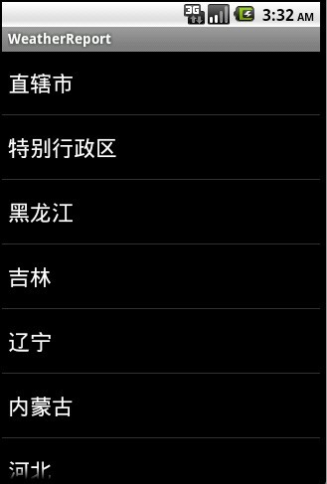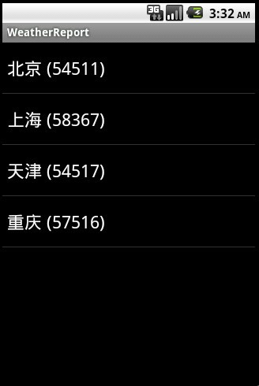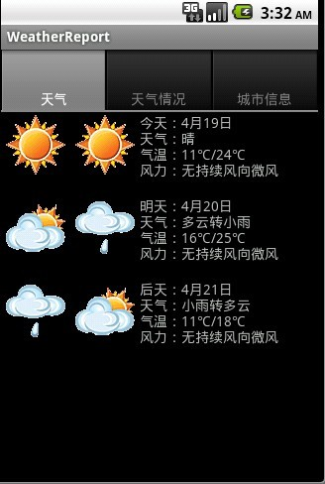

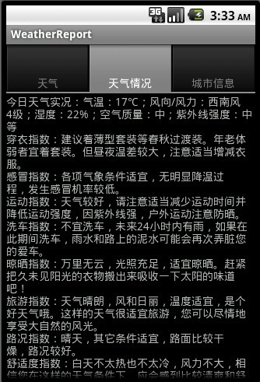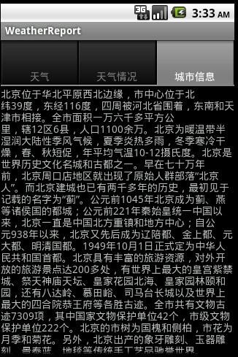

 到此结束.