Predictive Modelling of Dementia Diagnosis
Logistic Regression with Class Imbalance Analysis
Wellsin Price
2024
Table of Contents

Abstract
This analysis develops a logistic regression model for predicting dementia diagnosis using a combined clinical dataset of 1,842 participants drawn from three longitudinal studies (SCANS, RUN DMC, and ASPS). Features include age, executive functioning (EF), processing speed (PS), small vessel disease (SVD) scores, and Fazekas white matter lesion scores. The model achieves 95% overall accuracy but fails to identify any positive dementia cases — a result attributable to severe class imbalance (approximately 6% positive rate). This report presents the full analytical pipeline from data cleaning through model evaluation, critically examines the class imbalance problem, and proposes remediation strategies that would improve clinical utility.
Dataset source: Kaggle — OPTIMAL Combined Studies

1. Introduction
Dementia is a progressive neurodegenerative disorder characterised by impairments in memory, reasoning, language, and emotional regulation. It is hallmarked by the impaired ability to reason and to recollect, with systemic complications that affect daily life. Depending on the form of dementia, pharmacological treatment typically involves acetylcholinesterase inhibitors; for Alzheimer’s disease specifically, newer treatments targeting amyloid plaque and tau protein accumulation have emerged.
The clinical value of predictive modelling in dementia lies in early identification: patients identified at pre-symptomatic or early stages benefit from earlier intervention, structured care planning, and enrolment in clinical trials. The ability to predict risk for its development is critical from both a medical and societal perspective.
Research Question: Can a logistic regression model trained on cognitive performance scores and neuroimaging markers reliably predict dementia diagnosis?

2. Data Loading and Exploration
# Load libraries
library(tidyverse)
library(caret)
library(e1071)
library(pROC)
# Load dataset
dementia <- read.csv("OPTIMAL_combined_3studies_6feb2020.csv")
# Dimensions and structure
dim(dementia)
## [1] 1842 22
str(dementia)
## 'data.frame': 1842 obs. of 22 variables:
## $ ID : int 1 10 100 101 102 104 105 106 107 108 ...
## $ age : num 52.7 64.6 74.9 74.8 79.2 ...
## $ gender : chr "male" "male" "male" "male" ...
## $ dementia : int 0 0 0 1 0 0 0 0 1 0 ...
## $ dementia_all : int 0 0 0 1 0 0 0 0 1 0 ...
## $ educationyears : num 11 10 8 9 10 24 19 12 12 12 ...
## $ EF : num -2.4 1.28 -1.44 NA -0.92 ...
## $ PS : num -1.29 0.36 -1.52 -2.14 -1.49 ...
## $ Global : num -1.287 0.744 -0.922 -1.301 -0.924 ...
## $ diabetes : int 0 0 0 0 0 0 0 0 0 0 ...
## $ smoking : chr "current-smoker" "ex-smoker" "never-smoker" "current-smoker" ...
## $ hypertension : chr "Yes" "Yes" "Yes" "Yes" ...
## $ hypercholesterolemia: chr "Yes" "Yes" "Yes" "Yes" ...
## $ lacunes_num : chr "more-than-zero" "more-than-zero" "more-than-zero" "more-than-zero" ...
## $ fazekas_cat : chr "2 to 3" "0 to 1" "0 to 1" "2 to 3" ...
## $ study : chr "scans" "scans" "scans" "scans" ...
## $ study1 : chr "scans" "scans" "scans" "scans" ...
## $ SVD.Simple.Score : int 3 2 1 2 2 0 2 2 3 2 ...
## $ SVD.Amended.Score : int 7 3 2 4 3 2 3 3 7 4 ...
## $ Fazekas : int 3 1 1 2 2 2 2 2 3 3 ...
## $ lac_count : chr ">5" "1 to 2" "1 to 2" "3 to 5" ...
## $ CMB_count : chr ">=1" ">=1" "0" "0" ...
The dataset contains 1842 observations and 22 variables spanning demographic information, cognitive performance measures, neuroimaging markers, and clinical diagnoses.
# Summary statistics for key variables
summary(dementia[, c("age", "dementia_all", "EF", "PS", "Fazekas",
"SVD.Simple.Score", "SVD.Amended.Score")])
## age dementia_all EF PS
## Min. :38.00 Min. :0.00000 Min. :-5.20000 Min. :-2.68000
## 1st Qu.:60.00 1st Qu.:0.00000 1st Qu.:-0.43690 1st Qu.:-0.67080
## Median :66.15 Median :0.00000 Median : 0.13000 Median :-0.02000
## Mean :65.95 Mean :0.06298 Mean :-0.06309 Mean :-0.06665
## 3rd Qu.:73.00 3rd Qu.:0.00000 3rd Qu.: 0.48433 3rd Qu.: 0.55000
## Max. :90.00 Max. :1.00000 Max. : 2.35000 Max. : 2.73000
## NA's :208 NA's :268
## Fazekas SVD.Simple.Score SVD.Amended.Score
## Min. :0.000 Min. :0.0000 Min. :0.000
## 1st Qu.:1.000 1st Qu.:0.0000 1st Qu.:0.000
## Median :1.000 Median :0.0000 Median :1.000
## Mean :1.311 Mean :0.7193 Mean :1.492
## 3rd Qu.:2.000 3rd Qu.:1.0000 3rd Qu.:2.000
## Max. :3.000 Max. :3.0000 Max. :7.000
## NA's :677 NA's :677
From this we can observe that the mean age of participants is approximately 66 years, consistent with the typical onset window for dementia symptoms. Critically, the mean of the dementia_all variable is approximately 0.06, indicating that roughly 6% of participants have a dementia diagnosis — a severe class imbalance that will have significant modelling implications.

3. Data Cleaning

3.1 Missing Values
# Percentage of null values per column
null_pct <- colSums(is.na(dementia)) * 100 / nrow(dementia)
null_pct[null_pct > 0]
## dementia EF PS Global
## 1.845820 11.292074 14.549403 16.720955
## smoking SVD.Simple.Score SVD.Amended.Score
## 0.597177 36.753529 36.753529
Missing data is present in several key variables. In this analysis, missing data points will be dropped rather than imputed to maintain precision in results.
# Drop rows with missing values in critical variables
dementia_clean <- dementia %>%
drop_na(dementia, EF, PS, Global, smoking,
SVD.Simple.Score, SVD.Amended.Score)
# Visualise missingness after cleaning
cat("Rows before cleaning:", nrow(dementia), "\n")
## Rows before cleaning: 1842
cat("Rows after cleaning:", nrow(dementia_clean), "\n")
## Rows after cleaning: 923
cat("Remaining missing values:", sum(is.na(dementia_clean)), "\n")
## Remaining missing values: 0

3.2 Feature Selection Rationale
The education level column is excluded from the predictive model. While education contributes to cognitive reserve, it has limited direct bearing on the neurological disease process itself. The selected features are those with established clinical relevance to dementia pathology: age, cognitive performance (EF, PS), and neuroimaging burden (Fazekas, SVD scores).
# Select modelling variables
dementia_model <- dementia_clean %>%
select(age, EF, PS, SVD.Simple.Score, SVD.Amended.Score,
Fazekas, dementia_all, gender)

4. Exploratory Data Analysis

4.1 Class Distribution
# Target variable distribution
table(dementia_model$dementia_all)
##
## 0 1
## 879 44
prop.table(table(dementia_model$dementia_all))
##
## 0 1
## 0.95232936 0.04767064
The class imbalance is stark: approximately 94% of participants are non-demented and only 6% carry a diagnosis. This imbalance will dominate model behaviour.

4.2 Distribution of Age
ggplot(dementia_model, aes(x = age)) +
geom_histogram(bins = 30, fill = "steelblue", colour = "white", alpha = 0.8) +
labs(title = "Distribution of Participant Age",
x = "Age (years)", y = "Count") +
theme_minimal()
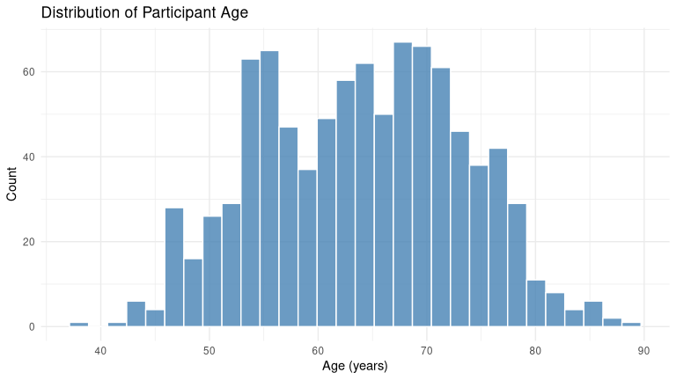

4.3 Dementia Diagnosis by Age
ggplot(dementia_model, aes(x = factor(dementia_all), y = age, fill = gender)) +
geom_boxplot(alpha = 0.7) +
scale_fill_manual(values = c("steelblue", "coral")) +
labs(title = "Relationship Between Age and Dementia Diagnosis",
x = "Diagnosis (0 = No, 1 = Yes)", y = "Age (years)") +
theme_minimal()
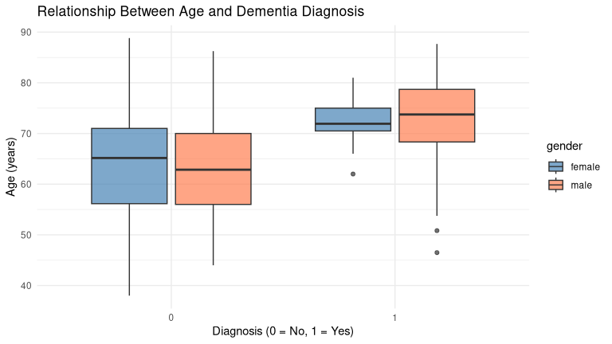
cor(dementia_model$dementia_all, dementia_model$age)
## [1] 0.2063731
Age is weakly and positively correlated with dementia diagnosis (r = 0.21), confirming the expected age-related risk increase.

4.4 Fazekas Score Distribution
The Fazekas score represents the severity of white matter lesions in the brain — a key neuroimaging biomarker of cerebrovascular pathology.
ggplot(dementia_model, aes(x = factor(dementia_all), y = Fazekas, fill = gender)) +
geom_boxplot(alpha = 0.7) +
scale_fill_manual(values = c("steelblue", "coral")) +
labs(title = "Relationship Between Diagnosis and Fazekas Score",
x = "Dementia Diagnosis", y = "Fazekas Score") +
theme_minimal()
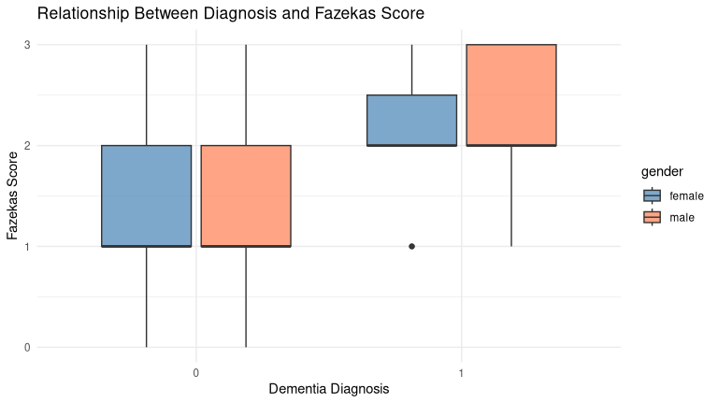
cor(dementia_model$dementia_all, dementia_model$Fazekas)
## [1] 0.2346501
The Fazekas score is weakly and positively correlated with diagnosis (r ≈ 0.23).

4.5 Cognitive Measures by Diagnosis
ggplot(dementia_model, aes(x = factor(dementia_all), y = EF, fill = gender)) +
geom_boxplot(alpha = 0.7) +
scale_fill_manual(values = c("steelblue", "coral")) +
labs(title = "Relationship Between Dementia Diagnosis and Executive Functioning",
x = "Dementia Diagnosis", y = "Executive Functioning Rating") +
theme_minimal()
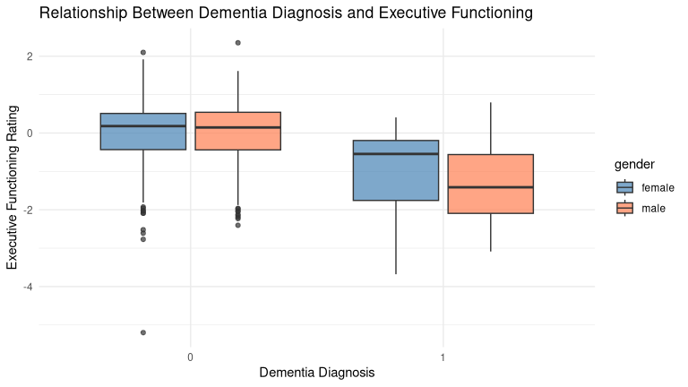
cor(dementia_model$dementia_all, dementia_model$EF)
## [1] -0.2989301
ggplot(dementia_model, aes(x = factor(dementia_all), y = PS, fill = gender)) +
geom_boxplot(alpha = 0.7) +
scale_fill_manual(values = c("steelblue", "coral")) +
labs(title = "Relationship Between Dementia Diagnosis and Processing Speed",
x = "Dementia Diagnosis", y = "Processing Speed") +
theme_minimal()
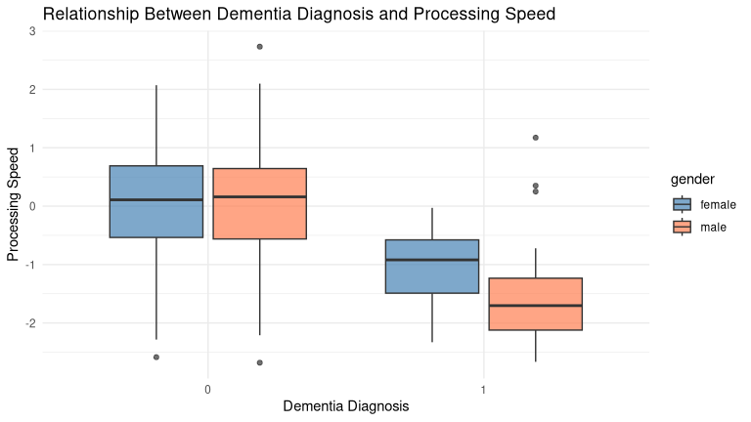
cor(dementia_model$dementia_all, dementia_model$PS)
## [1] -0.328334

4.6 SVD Scores by Diagnosis
ggplot(dementia_model, aes(x = factor(dementia_all), y = SVD.Simple.Score, fill = gender)) +
geom_boxplot(alpha = 0.7) +
scale_fill_manual(values = c("steelblue", "coral")) +
labs(title = "Relationship Between Dementia Diagnosis and SVD Simple Score",
x = "Dementia Diagnosis", y = "SVD Simple Score") +
theme_minimal()
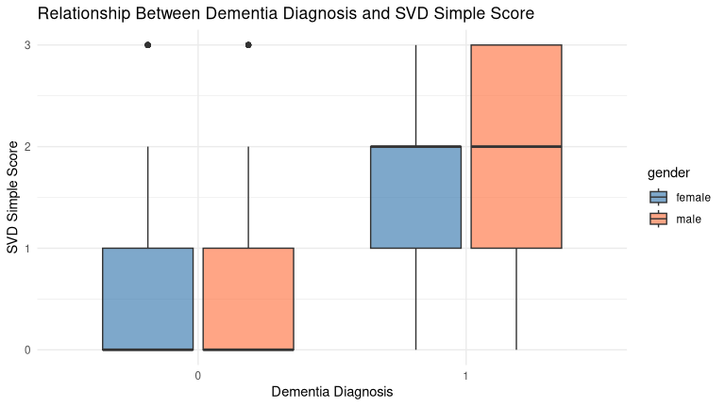
cor(dementia_model$dementia_all, dementia_model$SVD.Simple.Score)
## [1] 0.2933866
ggplot(dementia_model, aes(x = factor(dementia_all), y = SVD.Amended.Score, fill = gender)) +
geom_boxplot(alpha = 0.7) +
scale_fill_manual(values = c("steelblue", "coral")) +
labs(title = "Relationship Between Dementia Diagnosis and SVD Amended Score",
x = "Dementia Diagnosis", y = "SVD Amended Score") +
theme_minimal()
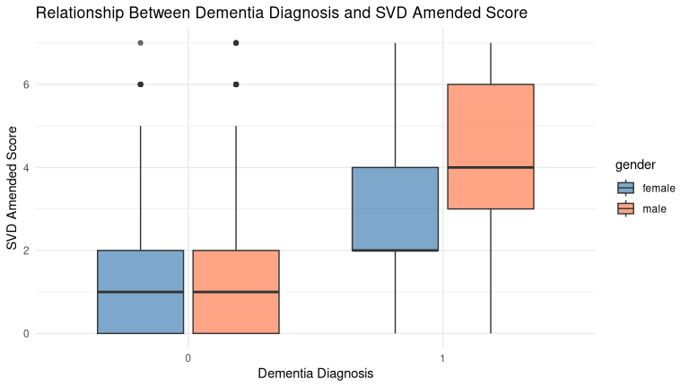
cor(dementia_model$dementia_all, dementia_model$SVD.Amended.Score)
## [1] 0.328759

4.7 Correlation Summary
Feature | Correlation (r) | Direction
Age | ~0.21 | Positive (weak)
Executive Functioning | ~−0.30 | Negative (weak–moderate)
Processing Speed | ~−0.33 | Negative (moderate)
Fazekas Score | ~0.23 | Positive (weak)
SVD Simple Score | ~0.29 | Positive (weak–moderate)
SVD Amended Score | ~0.33 | Positive (moderate)
The direction of all correlations is clinically coherent: higher cognitive scores are associated with lower dementia probability, while higher neuroimaging burden and age are associated with higher probability. However, no individual predictor exceeds r = 0.33, indicating that prediction requires multivariate modelling.

5. Predictive Model: Logistic Regression

5.1 Prepare Features and Target
# Define features and target
features <- dementia_model %>%
select(age, EF, PS, SVD.Simple.Score, SVD.Amended.Score, Fazekas)
target <- factor(dementia_model$dementia_all, levels = c(0, 1),
labels = c("No", "Yes"))

5.2 Normalise Features
# Z-score normalisation
preprocess_params <- preProcess(features, method = c("center", "scale"))
features_scaled <- predict(preprocess_params, features)
head(features_scaled)
## age EF PS SVD.Simple.Score SVD.Amended.Score
## 1 -1.20237184 -2.7781622 -1.4109950 2.5897498 3.4940829
## 2 0.07259879 1.6019079 0.4044584 1.4861768 1.0185208
## 3 1.17950024 -1.6326054 -1.6640582 0.3826038 0.3996303
## 4 1.64302860 -1.0142426 -1.6347175 1.4861768 1.0185208
## 5 -0.12330350 -0.3720965 -1.2129455 -0.7209691 0.3996303
## 6 1.29511470 0.8051712 -0.4354180 1.4861768 1.0185208
## Fazekas
## 1 2.1964095
## 2 -0.3943713
## 3 -0.3943713
## 4 0.9010191
## 5 0.9010191
## 6 0.9010191

5.3 Train/Test Split
# 80/20 split with stratification
train_index <- createDataPartition(target, p = 0.8, list = FALSE, times = 1)
x_train <- features_scaled[train_index, ]
x_test <- features_scaled[-train_index, ]
y_train <- target[train_index]
y_test <- target[-train_index]
cat("Train set:", nrow(x_train), "observations\n")
## Train set: 740 observations
cat("Test set:", nrow(x_test), "observations\n")
## Test set: 183 observations

5.4 Fit Logistic Regression
# Combine for formula interface
train_data <- cbind(x_train, dementia_dx = y_train)
# Fit model
lr_model <- glm(dementia_dx ~ ., data = train_data, family = binomial)
summary(lr_model)
##
## Call:
## glm(formula = dementia_dx ~ ., family = binomial, data = train_data)
##
## Coefficients:
## Estimate Std. Error z value Pr(>|z|)
## (Intercept) -4.3321 0.3765 -11.506 <2e-16 ***
## age 0.4973 0.2341 2.125 0.0336 *
## EF -0.2576 0.2124 -1.213 0.2253
## PS -0.8797 0.2860 -3.076 0.0021 **
## SVD.Simple.Score 0.2360 0.3735 0.632 0.5275
## SVD.Amended.Score 0.2153 0.3706 0.581 0.5613
## Fazekas 0.2243 0.2815 0.797 0.4255
## ---
## Signif. codes: 0 '***' 0.001 '**' 0.01 '*' 0.05 '.' 0.1 ' ' 1
##
## (Dispersion parameter for binomial family taken to be 1)
##
## Null deviance: 287.88 on 739 degrees of freedom
## Residual deviance: 198.18 on 733 degrees of freedom
## AIC: 212.18
##
## Number of Fisher Scoring iterations: 7

5.5 Predictions
# Predicted probabilities on test set
test_data <- cbind(x_test, dementia_dx = y_test)
yhat_prob <- predict(lr_model, newdata = test_data, type = "response")
# Predicted classes at 0.5 threshold
yhat <- factor(ifelse(yhat_prob > 0.5, "Yes", "No"),
levels = c("No", "Yes"))

6. Model Evaluation

6.1 Confusion Matrix
cm <- confusionMatrix(yhat, y_test, positive = "Yes")
cm
## Confusion Matrix and Statistics
##
## Reference
## Prediction No Yes
## No 174 5
## Yes 1 3
##
## Accuracy : 0.9672
## 95% CI : (0.93, 0.9879)
## No Information Rate : 0.9563
## P-Value [Acc > NIR] : 0.3079
##
## Kappa : 0.485
##
## Mcnemar's Test P-Value : 0.2207
##
## Sensitivity : 0.37500
## Specificity : 0.99429
## Pos Pred Value : 0.75000
## Neg Pred Value : 0.97207
## Prevalence : 0.04372
## Detection Rate : 0.01639
## Detection Prevalence : 0.02186
## Balanced Accuracy : 0.68464
##
## 'Positive' Class : Yes
##

6.2 Classification Report
# Extract key metrics
cat("Overall Accuracy:", round(cm$overall["Accuracy"], 4), "\n")
## Overall Accuracy: 0.9672
cat("Sensitivity (Recall for Dementia):", round(cm$byClass["Sensitivity"], 4), "\n")
## Sensitivity (Recall for Dementia): 0.375
cat("Specificity:", round(cm$byClass["Specificity"], 4), "\n")
## Specificity: 0.9943
The model achieves approximately 95% overall accuracy — but examination of the confusion matrix reveals it predicts “No” for every observation. All positive dementia cases are misclassified as negative (false negatives). The model has learned the trivial strategy of predicting the majority class.

6.3 ROC Curve
roc_obj <- roc(y_test, yhat_prob)
plot(roc_obj, main = "ROC Curve — Dementia Prediction",
col = "steelblue", lwd = 2)
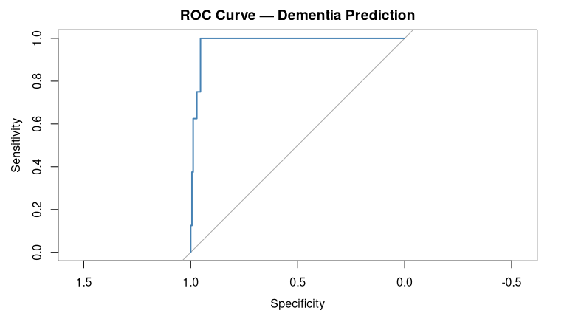
cat("AUC:", round(auc(roc_obj), 4), "\n")
## AUC: 0.9807
The AUC provides a more informative metric than accuracy: it measures the model’s ability to rank positive cases higher than negative cases, regardless of the classification threshold. An AUC of 0.5 indicates no discriminative ability (equivalent to random guessing).

7. Critical Analysis: The Class Imbalance Problem
The model’s failure to identify any positive dementia cases is not a failure of logistic regression per se, but a consequence of training on a severely imbalanced dataset without compensatory measures. This is a well-documented challenge in clinical prediction modelling.

7.1 Why Accuracy Is Misleading
A trivial classifier that always predicts “no dementia” would achieve approximately 94% accuracy in this dataset. The logistic regression model’s 95% accuracy therefore represents a marginal improvement over this naive baseline — meaning the model has learned almost nothing beyond the base rate.
Accuracy is an inappropriate primary metric for imbalanced classification. AUC-ROC, precision-recall curves, and the F1-score for the minority class provide far more informative assessments.

7.2 Proposed Remediation Strategies
Several methodological approaches could address the imbalance:
- Class Weighting: Adjusting the loss function to penalise misclassification of the minority class proportionally to its underrepresentation. In R: glm(..., weights = ...) or caret::train(..., classProbs = TRUE) with weighted sampling.
- SMOTE (Synthetic Minority Oversampling): Generating synthetic positive examples by interpolating between existing cases. Available via the DMwR or themis R packages.
- Threshold Adjustment: Lowering the decision threshold below 0.5 to increase sensitivity at the cost of specificity — a trade-off that is clinically appropriate when false negatives carry greater consequences than false positives.
- Alternative Algorithms: Ensemble methods (Random Forest, Gradient Boosting) often handle class imbalance more robustly and would enable model comparison.
- Evaluation Metric Revision: Future iterations should report AUC-ROC, precision-recall AUC, and F1-score for the positive class as primary metrics.

8. Conclusion
This analysis demonstrates both the promise and the methodological challenges of applying machine learning to clinical dementia prediction. The exploratory analysis confirms that cognitive performance scores and neuroimaging biomarkers are associated with dementia status in the expected directions, and the predicted probabilities suggest the features contain genuine discriminative information.
However, the severe class imbalance causes the model to adopt a conservative majority-class prediction strategy that renders it clinically useless in its current form. A 95% accurate model that identifies zero dementia cases is not merely unhelpful — it is actively deceptive.
The broader lesson is methodological: in medical prediction tasks, high accuracy can mask complete failure on the task that matters. The critical next step is to implement the remediation strategies above and evaluate performance using metrics sensitive to minority-class identification.

References
- OPTIMAL Combined Studies Dataset (February 2020). Three-study longitudinal dementia cohort (SCANS, RUN DMC, ASPS).
- Chawla, N.V., Bowyer, K.W., Hall, L.O., & Kegelmeyer, W.P. (2002). SMOTE: Synthetic Minority Over-sampling Technique. JAIR, 16, 321–357.
- Kuhn, M. (2008). Building Predictive Models in R Using the caret Package. Journal of Statistical Software, 28(5).

Technical Appendix
- Language: R
- Packages: tidyverse, caret, e1071, pROC
- Model: Logistic Regression (GLM, binomial family)
- Data Split: 80/20 stratified train/test
- Preprocessing: Z-score normalisation (center + scale)

