4/23/2026
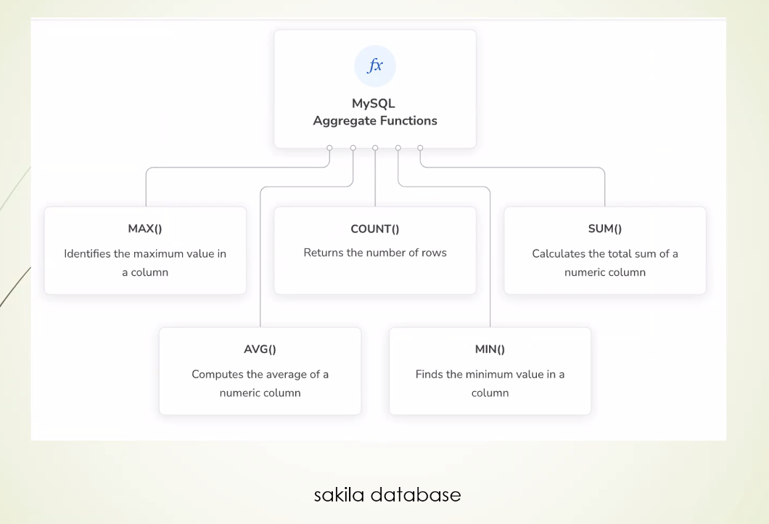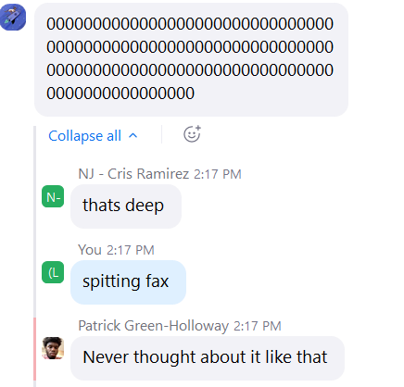HAHAHA
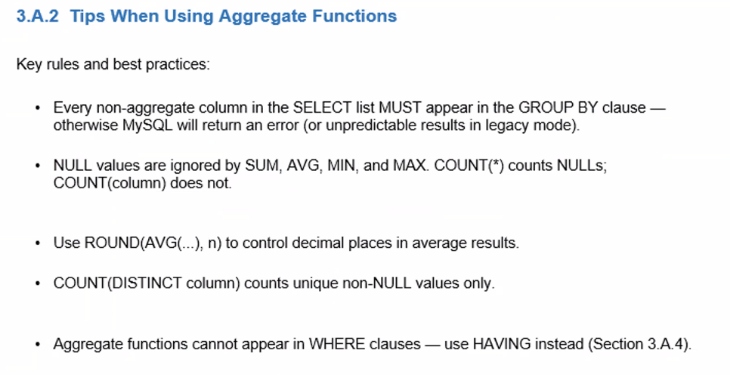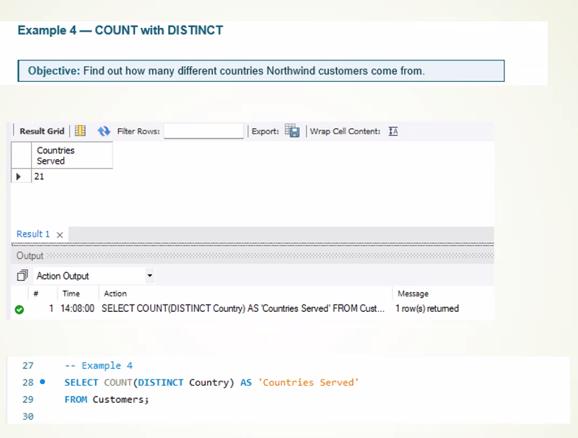
One piece of the capstone project is due on 8 30 AM Friday
Submit everything by Thursday so you can have time for practicing
2 presentations – one in live classroom, one submitted to Brightspace

