Vue免打包浏览器上测试：ipconfig 查询电脑ip 在webpack中配置ip地址 然后
http://+ip地址+路径 在浏览器上运行即可 手机连在与网线同一个网络下面 即可进行同步测试

Vue行内样式 px转vw 配置https://github.com/hyy1115/style-vw-loader
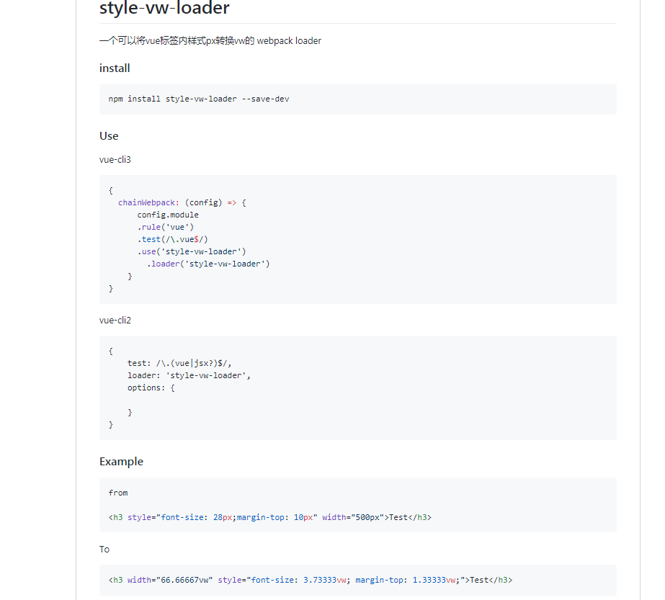
Vue px转vw
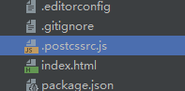
// https://github.com/michael-ciniawsky/postcss-load-config
module.exports = {
"plugins": {
"postcss-import": {},
"postcss-url": {},
// to edit target browsers: use "browserslist" field in package.json
"autoprefixer": {},
// "postcss-aspect-ratio-mini": {},
// "postcss-write-svg": {utf8: false},
// "postcss-cssnext": {},
"postcss-px-to-viewport": {
viewportWidth: 1280, // (Number) The width of the viewport.
viewportHeight: 752, // (Number) The height of the viewport.
unitPrecision: 3, // (Number) The decimal numbers to allow the REM units to grow to.
viewportUnit: 'vw', // (String) Expected units.
fontViewportUnit: 'px', // TODO 字体仍然会转换？
selectorBlackList: ['.ignore', '.hairlines'], // (Array) The selectors to ignore and leave as px.
minPixelValue: 1, // (Number) Set the minimum pixel value to replace.
mediaQuery: false // (Boolean) Allow px to be converted in media queries.
},
// "postcss-viewport-units": {}, // vw兼容处理
}
};

