targeter analyis

welovedatascience - targeter

2025-03-05

Table of contents

## Analysis parameters

* Data used: adult
* Descrition of data: no description provided.
* Analysis performed the: 2025-03-05
* Target: ABOVE50K [binary]
* Number of variables: 12
* Analysed population contains: 32561 records.
* Analysis performed on: R version 4.4.2 (2024-10-31) with targeter 1.3.2

## Introduction

This report contains a snapshot of the specific subpopulation **«var: ABOVE50K » == 1`**.

This subpopulation is characterized by performing bivariate analyses, crossing the variable of interest (target) with potential explanatory variables. Only most relevant (highest discriminative power) may be retained.

Report contains:

* A summary overview table with selected retained criteria with some available information such as one statistic called information value (IV) that provides an idea of the explanatory power of the criteria.
* Detailed analyses per criteria with graphics that highlight the reation between one of the candidate criteria and the *target*.

It can happen that one criteria contains some missing values. If such, we will introduce value *“[Missing]”* in the report, eventually with a cross **[x]**. Also, if two few data are available, we would use a minus **[-]** instead of reporting value.

### Summary table interpretation

Criteria are sorted by decreasing importance order, which one is determined by the IV. One modality (value) index is also computed as the proportion of target «var: ABOVE50K» within the modality, that is the target penetration in the subpopulation selected by the specific modality of a criteria. A value near 1 would indicate a non-discriminative modality: selecting the corresponding subpopulation would result in the overall average target penetration. On the other way, the hightest the index (>1), the more target is over-representated in the subpopulation. Low index (<1) would be interpreted as under-representation. So high index modalities are of interest as they characterize subpopulation with high target penetration.

Note that index will always be computed for segments (modalities): continuous variables are cut into buckets. If a criteria/variable has no segment with any high index, it will not be of interest at all. Also, having one segment with an index greater than 1 implies that there are counterparts segments with index lower 1.

There is no special rule to say that an index is a **good** one as its interpretation has to take into account the natural (average) target pourcentage (penetration). Indeed, when the penetration is low, it is easier to observe eventually high index. Think that for a global penetration of 50% of target, maximal index is 2 (and more generally, index is bounded by 1/(target penetration))

For every criteria, summary table presents its possible value (modality) having the highest index along with the corresponding number of records. Pay attention that you might observe high index dealing with very restrictive sub-populations.

## Populations

* **Population**

No description of the global population (data) have been provided during the analysis. Analyzed population contains 32561 records.

* **Target**

No description of the target has been provided during the analysis.

Target used: var: ABOVE50K [ABOVE50K]

| value | count | nNA | percNA | perc |
| --- | --- | --- | --- | --- |
| 0 | 24720 | 0 | 0 | 0.7591904 |
| 1 | 7841 | 0 | 0 | 0.2408096 |

## Summary

| variable | type | IV | Level | #Records | %Records | Index |
| --- | --- | --- | --- | --- | --- | --- |
| RELATIONSHIP | character | 1.536 | Wife | 745 | 47.51 | 1.97 |
| MARITALSTATUS | character | 1.339 | Married-civ-spouse | 6,692 | 44.68 | 1.86 |
| AGE | numeric | 1.218 | [j] from 48 to 52 | 926 | 39.97 | 1.66 |
| OCCUPATION | character | 0.776 | Exec-managerial | 1,968 | 48.40 | 2.01 |
| EDUCATION | character | 0.754 | Doctorate | 306 | 74.09 | 3.08 |
| EDUCATIONNUM | numeric | 0.662 | [f] from 13 to 16 | 3,909 | 48.46 | 2.01 |
| HOURSPERWEEK | numeric | 0.462 | [f] from 50 to 56 | 1,670 | 44.77 | 1.86 |
| SEX | character | 0.303 | Male | 6,662 | 30.57 | 1.27 |
| WORKCLASS | character | 0.167 | Self-emp-inc | 622 | 55.73 | 2.31 |
| NATIVECOUNTRY | character | 0.081 | Iran | 18 | 41.86 | 1.74 |
| RACE | character | 0.069 | Asian-Pac-Islander | 276 | 26.56 | 1.10 |
| FNLWGT | numeric | 0.010 | [e] from 141067 to 162343 | 721 | 26.59 | 1.10 |

## Variables

### relationship

var: RELATIONSHIP

**IV: 1.536**

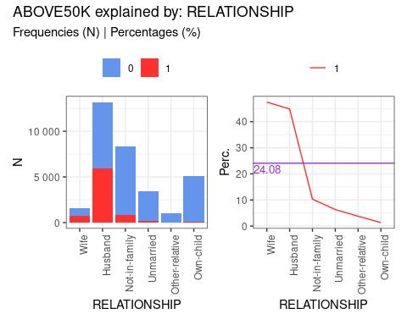

### relationship [table]

|  | N0 | N1 | Ntot | perc0 | perc1 | target% |
| --- | --- | --- | --- | --- | --- | --- |
| Husband | 7275 | 5918 | 13193 | 55.143% | 44.857% | 75.475% |
| Not-in-family | 7449 | 856 | 8305 | 89.693% | 10.307% | 10.917% |
| Other-relative | 944 | 37 | 981 | 96.228% | 3.772% | 0.472% |
| Own-child | 5001 | 67 | 5068 | 98.678% | 1.322% | 0.854% |
| Unmarried | 3228 | 218 | 3446 | 93.674% | 6.326% | 2.78% |
| Wife | 823 | 745 | 1568 | 52.487% | 47.513% | 9.501% |

### maritalstatus

var: MARITALSTATUS

**IV: 1.339**

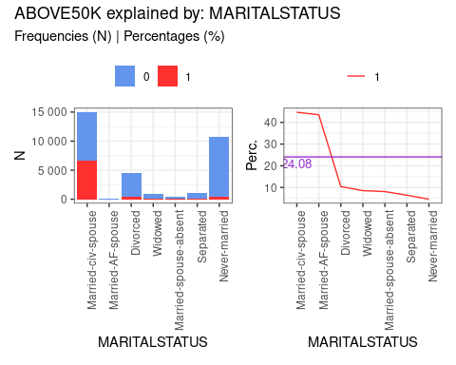

### maritalstatus [table]

|  | N0 | N1 | Ntot | perc0 | perc1 | target% |
| --- | --- | --- | --- | --- | --- | --- |
| Divorced | 3980 | 463 | 4443 | 89.579% | 10.421% | 5.905% |
| Married-AF-spouse | 13 | 10 | 23 | 56.522% | 43.478% | 0.128% |
| Married-civ-spouse | 8284 | 6692 | 14976 | 55.315% | 44.685% | 85.346% |
| Married-spouse-absent | 384 | 34 | 418 | 91.866% | 8.134% | 0.434% |
| Never-married | 10192 | 491 | 10683 | 95.404% | 4.596% | 6.262% |
| Separated | 959 | 66 | 1025 | 93.561% | 6.439% | 0.842% |
| Widowed | 908 | 85 | 993 | 91.44% | 8.56% | 1.084% |

### age

var: AGE

**IV: 1.218**

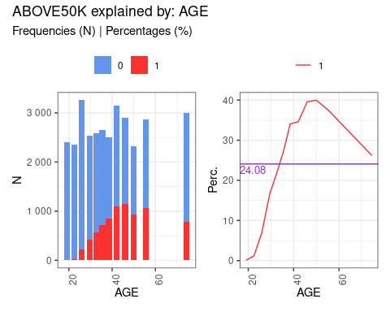

### age [table]

|  | N0 | N1 | Ntot | perc0 | perc1 | target% |
| --- | --- | --- | --- | --- | --- | --- |
| [a] from 17 to 21 | 2408 | 2 | 2410 | 99.917% | 0.083% | 0.026% |
| [b] from 21 to 24 | 2334 | 28 | 2362 | 98.815% | 1.185% | 0.357% |
| [c] from 24 to 28 | 3031 | 228 | 3259 | 93.004% | 6.996% | 2.908% |
| [d] from 28 to 31 | 2117 | 424 | 2541 | 83.314% | 16.686% | 5.407% |
| [e] from 31 to 34 | 2028 | 563 | 2591 | 78.271% | 21.729% | 7.18% |
| [f] from 34 to 37 | 1937 | 723 | 2660 | 72.82% | 27.18% | 9.221% |
| [g] from 37 to 40 | 1649 | 852 | 2501 | 65.934% | 34.066% | 10.866% |
| [h] from 40 to 44 | 2062 | 1090 | 3152 | 65.419% | 34.581% | 13.901% |
| [i] from 44 to 48 | 1754 | 1149 | 2903 | 60.42% | 39.58% | 14.654% |
| [j] from 48 to 52 | 1391 | 926 | 2317 | 60.035% | 39.965% | 11.81% |
| [k] from 52 to 59 | 1795 | 1071 | 2866 | 62.631% | 37.369% | 13.659% |
| [l] from 59 to 90 | 2214 | 785 | 2999 | 73.825% | 26.175% | 10.011% |

### occupation

var: OCCUPATION

**IV: 0.776**

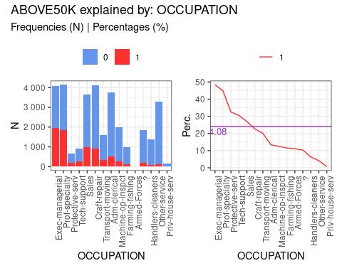

### occupation [table]

|  | N0 | N1 | Ntot | perc0 | perc1 | target% |
| --- | --- | --- | --- | --- | --- | --- |
| ? | 1652 | 191 | 1843 | 89.636% | 10.364% | 2.436% |
| Adm-clerical | 3263 | 507 | 3770 | 86.552% | 13.448% | 6.466% |
| Armed-Forces | 8 | 1 | 9 | 88.889% | 11.111% | 0.013% |
| Craft-repair | 3170 | 929 | 4099 | 77.336% | 22.664% | 11.848% |
| Exec-managerial | 2098 | 1968 | 4066 | 51.599% | 48.401% | 25.099% |
| Farming-fishing | 879 | 115 | 994 | 88.431% | 11.569% | 1.467% |
| Handlers-cleaners | 1284 | 86 | 1370 | 93.723% | 6.277% | 1.097% |
| Machine-op-inspct | 1752 | 250 | 2002 | 87.512% | 12.488% | 3.188% |
| Other-service | 3158 | 137 | 3295 | 95.842% | 4.158% | 1.747% |
| Priv-house-serv | 148 | 1 | 149 | 99.329% | 0.671% | 0.013% |
| Prof-specialty | 2281 | 1859 | 4140 | 55.097% | 44.903% | 23.709% |
| Protective-serv | 438 | 211 | 649 | 67.488% | 32.512% | 2.691% |
| Sales | 2667 | 983 | 3650 | 73.068% | 26.932% | 12.537% |
| Tech-support | 645 | 283 | 928 | 69.504% | 30.496% | 3.609% |
| Transport-moving | 1277 | 320 | 1597 | 79.962% | 20.038% | 4.081% |

### education

var: EDUCATION

**IV: 0.754**

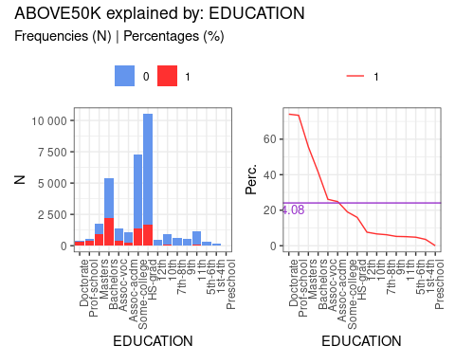

### education [table]

|  | N0 | N1 | Ntot | perc0 | perc1 | target% |
| --- | --- | --- | --- | --- | --- | --- |
| 10th | 871 | 62 | 933 | 93.355% | 6.645% | 0.791% |
| 11th | 1115 | 60 | 1175 | 94.894% | 5.106% | 0.765% |
| 12th | 400 | 33 | 433 | 92.379% | 7.621% | 0.421% |
| 1st-4th | 162 | 6 | 168 | 96.429% | 3.571% | 0.077% |
| 5th-6th | 317 | 16 | 333 | 95.195% | 4.805% | 0.204% |
| 7th-8th | 606 | 40 | 646 | 93.808% | 6.192% | 0.51% |
| 9th | 487 | 27 | 514 | 94.747% | 5.253% | 0.344% |
| Assoc-acdm | 802 | 265 | 1067 | 75.164% | 24.836% | 3.38% |
| Assoc-voc | 1021 | 361 | 1382 | 73.878% | 26.122% | 4.604% |
| Bachelors | 3134 | 2221 | 5355 | 58.525% | 41.475% | 28.325% |
| Doctorate | 107 | 306 | 413 | 25.908% | 74.092% | 3.903% |
| HS-grad | 8826 | 1675 | 10501 | 84.049% | 15.951% | 21.362% |
| Masters | 764 | 959 | 1723 | 44.341% | 55.659% | 12.231% |
| Preschool | 51 | 0 | 51 | 100% | 0% | 0% |
| Prof-school | 153 | 423 | 576 | 26.562% | 73.438% | 5.395% |
| Some-college | 5904 | 1387 | 7291 | 80.977% | 19.023% | 17.689% |

### educationnum

var: EDUCATIONNUM

**IV: 0.662**

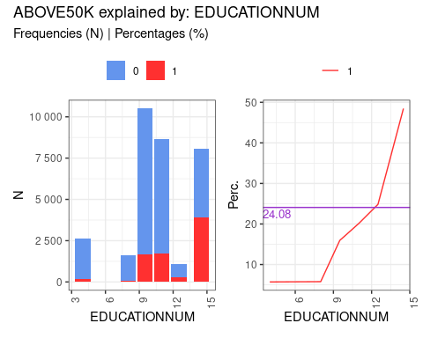

### educationnum [table]

|  | N0 | N1 | Ntot | perc0 | perc1 | target% |
| --- | --- | --- | --- | --- | --- | --- |
| [a] from 1 to 7 | 2494 | 151 | 2645 | 94.291% | 5.709% | 1.926% |
| [b] from 7 to 9 | 1515 | 93 | 1608 | 94.216% | 5.784% | 1.186% |
| [c] from 9 to 10 | 8826 | 1675 | 10501 | 84.049% | 15.951% | 21.362% |
| [d] from 10 to 12 | 6925 | 1748 | 8673 | 79.845% | 20.155% | 22.293% |
| [e] from 12 to 13 | 802 | 265 | 1067 | 75.164% | 24.836% | 3.38% |
| [f] from 13 to 16 | 4158 | 3909 | 8067 | 51.543% | 48.457% | 49.853% |

### hoursperweek

var: HOURSPERWEEK

**IV: 0.462**

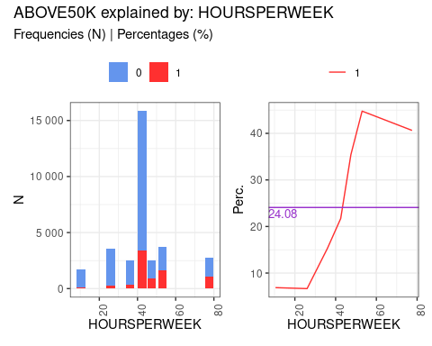

### hoursperweek [table]

|  | N0 | N1 | Ntot | perc0 | perc1 | target% |
| --- | --- | --- | --- | --- | --- | --- |
| [a] from 1 to 20 | 1587 | 117 | 1704 | 93.134% | 6.866% | 1.492% |
| [b] from 20 to 32 | 3310 | 236 | 3546 | 93.345% | 6.655% | 3.01% |
| [c] from 32 to 40 | 2128 | 385 | 2513 | 84.68% | 15.32% | 4.91% |
| [d] from 40 to 45 | 12398 | 3437 | 15835 | 78.295% | 21.705% | 43.834% |
| [e] from 45 to 50 | 1615 | 886 | 2501 | 64.574% | 35.426% | 11.3% |
| [f] from 50 to 56 | 2060 | 1670 | 3730 | 55.228% | 44.772% | 21.298% |
| [g] from 56 to 99 | 1622 | 1110 | 2732 | 59.37% | 40.63% | 14.156% |

### sex

var: SEX

**IV: 0.303**

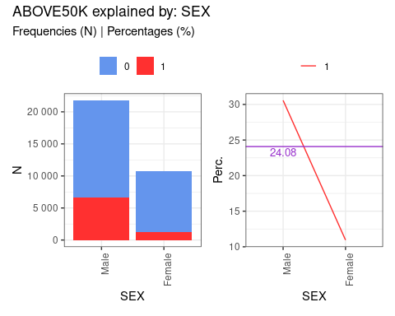

### sex [table]

|  | N0 | N1 | Ntot | perc0 | perc1 | target% |
| --- | --- | --- | --- | --- | --- | --- |
| Female | 9592 | 1179 | 10771 | 89.054% | 10.946% | 15.036% |
| Male | 15128 | 6662 | 21790 | 69.426% | 30.574% | 84.964% |

### workclass

var: WORKCLASS

**IV: 0.167**

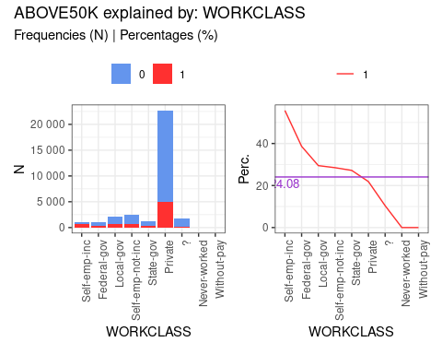

### workclass [table]

|  | N0 | N1 | Ntot | perc0 | perc1 | target% |
| --- | --- | --- | --- | --- | --- | --- |
| ? | 1645 | 191 | 1836 | 89.597% | 10.403% | 2.436% |
| Federal-gov | 589 | 371 | 960 | 61.354% | 38.646% | 4.732% |
| Local-gov | 1476 | 617 | 2093 | 70.521% | 29.479% | 7.869% |
| Never-worked | 7 | 0 | 7 | 100% | 0% | 0% |
| Private | 17733 | 4963 | 22696 | 78.133% | 21.867% | 63.295% |
| Self-emp-inc | 494 | 622 | 1116 | 44.265% | 55.735% | 7.933% |
| Self-emp-not-inc | 1817 | 724 | 2541 | 71.507% | 28.493% | 9.234% |
| State-gov | 945 | 353 | 1298 | 72.804% | 27.196% | 4.502% |
| Without-pay | 14 | 0 | 14 | 100% | 0% | 0% |

### nativecountry

var: NATIVECOUNTRY

**IV: 0.081**

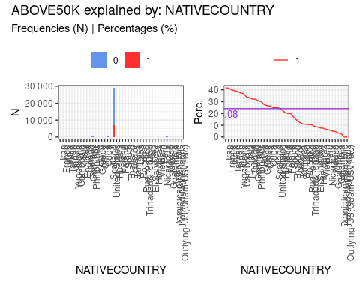

### nativecountry [table]

|  | N0 | N1 | Ntot | perc0 | perc1 | target% |
| --- | --- | --- | --- | --- | --- | --- |
| ? | 437 | 146 | 583 | 74.957% | 25.043% | 1.862% |
| Cambodia | 12 | 7 | 19 | 63.158% | 36.842% | 0.089% |
| Canada | 82 | 39 | 121 | 67.769% | 32.231% | 0.497% |
| China | 55 | 20 | 75 | 73.333% | 26.667% | 0.255% |
| Columbia | 57 | 2 | 59 | 96.61% | 3.39% | 0.026% |
| Cuba | 70 | 25 | 95 | 73.684% | 26.316% | 0.319% |
| Dominican-Republic | 68 | 2 | 70 | 97.143% | 2.857% | 0.026% |
| Ecuador | 24 | 4 | 28 | 85.714% | 14.286% | 0.051% |
| El-Salvador | 97 | 9 | 106 | 91.509% | 8.491% | 0.115% |
| England | 60 | 30 | 90 | 66.667% | 33.333% | 0.383% |
| France | 17 | 12 | 29 | 58.621% | 41.379% | 0.153% |
| Germany | 93 | 44 | 137 | 67.883% | 32.117% | 0.561% |
| Greece | 21 | 8 | 29 | 72.414% | 27.586% | 0.102% |
| Guatemala | 61 | 3 | 64 | 95.312% | 4.688% | 0.038% |
| Haiti | 40 | 4 | 44 | 90.909% | 9.091% | 0.051% |
| Holand-Netherlands | 1 | 0 | 1 | 100% | 0% | 0% |
| Honduras | 12 | 1 | 13 | 92.308% | 7.692% | 0.013% |
| Hong | 14 | 6 | 20 | 70% | 30% | 0.077% |
| Hungary | 10 | 3 | 13 | 76.923% | 23.077% | 0.038% |
| India | 60 | 40 | 100 | 60% | 40% | 0.51% |
| Iran | 25 | 18 | 43 | 58.14% | 41.86% | 0.23% |
| Ireland | 19 | 5 | 24 | 79.167% | 20.833% | 0.064% |
| Italy | 48 | 25 | 73 | 65.753% | 34.247% | 0.319% |
| Jamaica | 71 | 10 | 81 | 87.654% | 12.346% | 0.128% |
| Japan | 38 | 24 | 62 | 61.29% | 38.71% | 0.306% |
| Laos | 16 | 2 | 18 | 88.889% | 11.111% | 0.026% |
| Mexico | 610 | 33 | 643 | 94.868% | 5.132% | 0.421% |
| Nicaragua | 32 | 2 | 34 | 94.118% | 5.882% | 0.026% |
| Outlying-US(Guam-USVI-etc) | 14 | 0 | 14 | 100% | 0% | 0% |
| Peru | 29 | 2 | 31 | 93.548% | 6.452% | 0.026% |
| Philippines | 137 | 61 | 198 | 69.192% | 30.808% | 0.778% |
| Poland | 48 | 12 | 60 | 80% | 20% | 0.153% |
| Portugal | 33 | 4 | 37 | 89.189% | 10.811% | 0.051% |
| Puerto-Rico | 102 | 12 | 114 | 89.474% | 10.526% | 0.153% |
| Scotland | 9 | 3 | 12 | 75% | 25% | 0.038% |
| South | 64 | 16 | 80 | 80% | 20% | 0.204% |
| Taiwan | 31 | 20 | 51 | 60.784% | 39.216% | 0.255% |
| Thailand | 15 | 3 | 18 | 83.333% | 16.667% | 0.038% |
| Trinadad&Tobago | 17 | 2 | 19 | 89.474% | 10.526% | 0.026% |
| United-States | 21999 | 7171 | 29170 | 75.417% | 24.583% | 91.455% |
| Vietnam | 62 | 5 | 67 | 92.537% | 7.463% | 0.064% |
| Yugoslavia | 10 | 6 | 16 | 62.5% | 37.5% | 0.077% |

### race

var: RACE

**IV: 0.069**

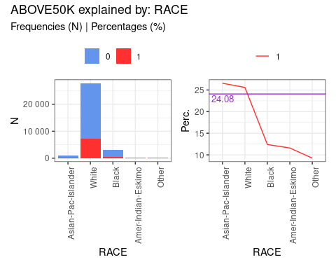

### race [table]

|  | N0 | N1 | Ntot | perc0 | perc1 | target% |
| --- | --- | --- | --- | --- | --- | --- |
| Amer-Indian-Eskimo | 275 | 36 | 311 | 88.424% | 11.576% | 0.459% |
| Asian-Pac-Islander | 763 | 276 | 1039 | 73.436% | 26.564% | 3.52% |
| Black | 2737 | 387 | 3124 | 87.612% | 12.388% | 4.936% |
| Other | 246 | 25 | 271 | 90.775% | 9.225% | 0.319% |
| White | 20699 | 7117 | 27816 | 74.414% | 25.586% | 90.766% |

### fnlwgt

var: FNLWGT

**IV: 0.01**

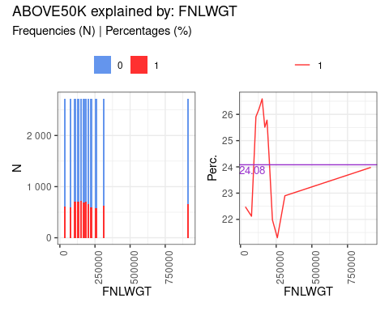

### fnlwgt [table]

|  | N0 | N1 | Ntot | perc0 | perc1 | target% |
| --- | --- | --- | --- | --- | --- | --- |
| [a] from 12285 to 55900 | 2104 | 610 | 2714 | 77.524% | 22.476% | 7.78% |
| [b] from 55900 to 98253 | 2113 | 600 | 2713 | 77.884% | 22.116% | 7.652% |
| [c] from 98253 to 117827 | 2010 | 703 | 2713 | 74.088% | 25.912% | 8.966% |
| [d] from 117827 to 141067 | 2003 | 711 | 2714 | 73.803% | 26.197% | 9.068% |
| [e] from 141067 to 162343 | 1991 | 721 | 2712 | 73.414% | 26.586% | 9.195% |
| [f] from 162343 to 178356 | 2021 | 692 | 2713 | 74.493% | 25.507% | 8.825% |
| [g] from 178356 to 193160 | 2015 | 700 | 2715 | 74.217% | 25.783% | 8.927% |
| [h] from 193160 to 210474 | 2053 | 657 | 2710 | 75.756% | 24.244% | 8.379% |
| [i] from 210474 to 237051 | 2119 | 597 | 2716 | 78.019% | 21.981% | 7.614% |
| [j] from 237051 to 279465 | 2136 | 578 | 2714 | 78.703% | 21.297% | 7.372% |
| [k] from 279465 to 342730 | 2091 | 621 | 2712 | 77.102% | 22.898% | 7.92% |
| [l] from 342730 to 1484705 | 2064 | 651 | 2715 | 76.022% | 23.978% | 8.303% |