Takehome Case | 
OOP using Java Project
Periode Berlaku Semester Genap 2025/2026  Valid on Even Year 2025/2026 | Software Laboratory Center Assistant Recruitment 26-2

Materi
Material
- Eclipse
- Java 11
Soal
Case
Yu-GJ-Oh
You decided to join New Assistant Recruitment 26-2, but on the way someone abducted you and you wake up in an island. To escape, you have to defeat the four horsemen of the island in a cardgame known as Yu -GJ -Oh. Will you prevail, or will you fall to the hands of the four horsemen.

Landing Page
  - This menu contains of 3 menus, which are Login, Register, and Exit.
  - Prompt user to input chosen menu. Validate the input must between 1 and 3 inclusively.

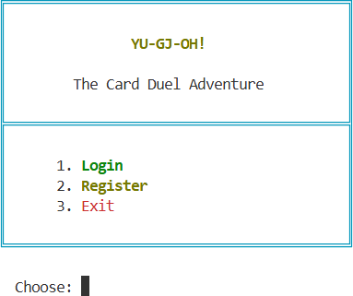
Figure 1. Home Page

- If user choose Login (Menu 1), then:

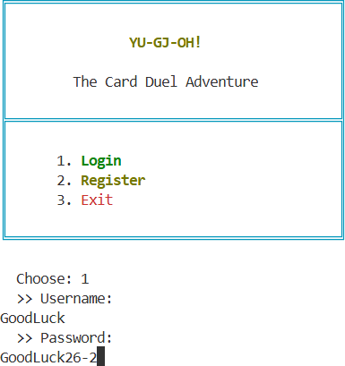
  - Prompt user to input Username and Password. Redirect to the select deck menu if the user exists in user.txt. Else display an error message.
Figure 4. Login Menu

- If user choose Register(Menu 2), then:
  - Prompt user to input Username and Password. Validate the username to be unique and at least 5 letters long.
  - Make sure the password satisfy the validation below :
    - Minimum 8 characters in length
    - Must contain at least one uppercase letter (A-Z)
    - Must contain at least one lowercase letter (a-z)
    - Must contain at least one digit (0-9)
    - Must contain at least one symbol (special character)
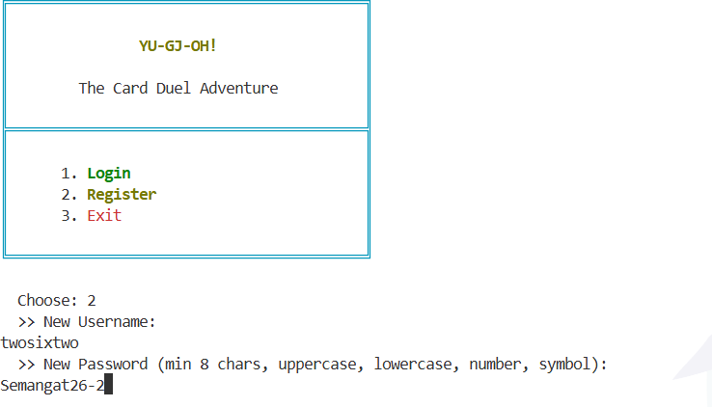

Figure 5. Register Menu

- Upon successful registration, hash the password using djb2 algorithm and save to user.txt
- Redirect back to home page
- If user choose Exit(Menu 3), then:
  - Display Exit Screen and Terminate the program
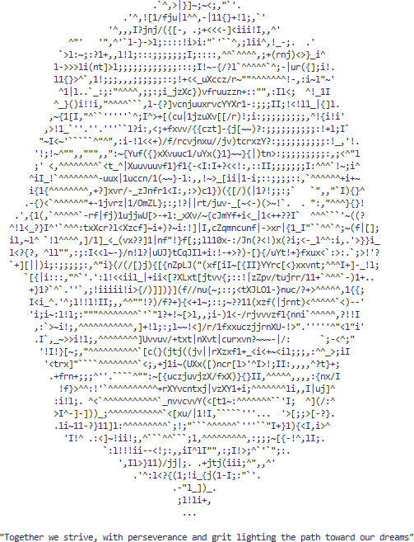

Figure 6. Exit Screen

Home Page
  - This page consists of 3 Menus. Which are Explore Map, How to Play, and exit
  - Display the current user
  - Validate input to be between 1-3 inclusively, display an error message if it’s an invalid choice

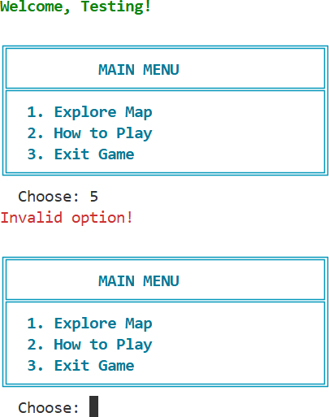

Figure 7. Error Message

    - If user chooses option 1, redirect to Deck Selection Page
    - If user chooses option 2, redirect to How to Play Page
    - If user chooses option 3, Display Exit Screen

Deck Selection Page
  - Parse cards data from cards.txt.
cardType#cardId#cardName#cardFlavorText#cardAtk#cardLevel#EffectType#EffectValue

Figure 8. MonsterCard Format

cardType#cardId#cardName#cardFlavorText#EffectType#EffectValue
Figure 9. Spell and Trap Format

  - Load each decks with the cards based on the id. Each deck.txt contains card ids, ignore empty lines.
  - Each card can exist multiple times in one deck. Make sure each instance creates a copy of the card in the deck
  - After Loading the cards and decks, display the deck selection page, there are four decks, prompt user to select a deck. Validate the input to be between 1-4 inclusively.

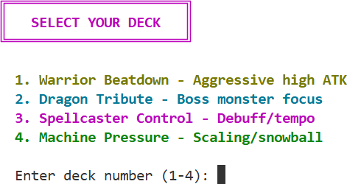

Figure 10. Deck Selection Menu

  - Display error message and redirect back to home page if user enters an invalid input
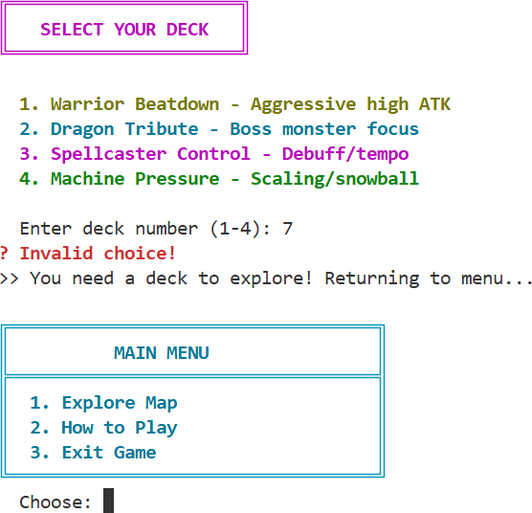

Figure 11. Error Message

  - Upon successful input, display a how to play message and redirect to the game page

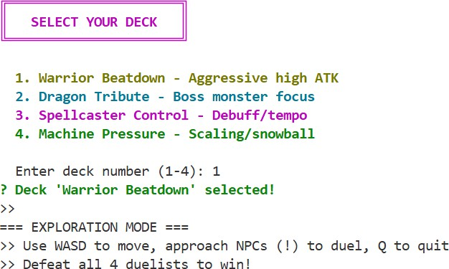

Figure 12. Successful Input

How to Play Page
  - Display how to play in a circular paginated format. Make sure to create 5 pages
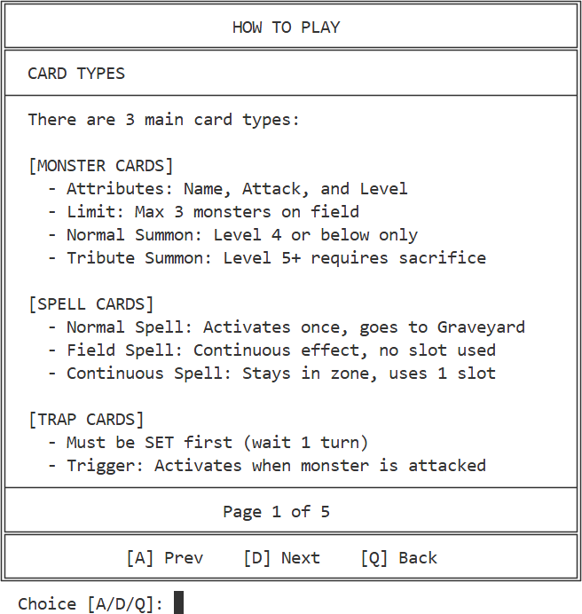

Figure 13. How to Play Page

  - Use A/D to navigate between pages, validate the input to be between A/D/Q.

  - When user inputs Q, redirect to the home page

Game Page

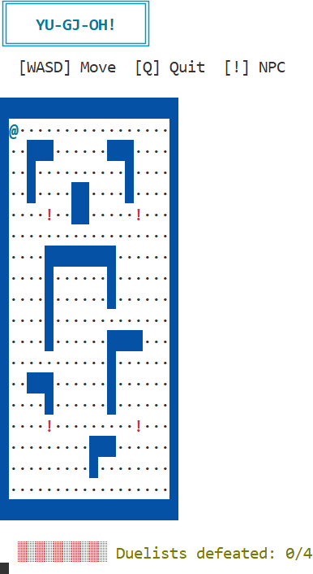
  - Load the map from map.txt. Make sure to spawn 4 enemies with ‘!’

Figure 15. Main Map

  - The player is represented as a ‘@’, make sure to spawn the player at the upper left corner of the map.
  - Each enemies is marked as ‘!’ for undefeated

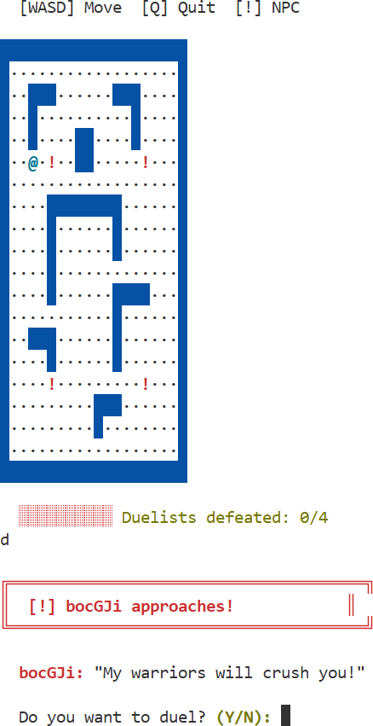
  - Prompt user to duel the NPC when they are at a one block distance from the npc. Validate the input to be Y or N

Figure 16 Duel Prompt

  - If the user selects ‘Y’, redirect ot the Duel Page
  - Change the npc marker from ‘!’ to ‘X’ for defeated NPCs
  - Increment the number of defeated duelists according to the number of NPCs player defeated

Duel System
  - Card Types :
- The game consists of three main card types: Monster Cards, Spell Cards, and Trap Cards.
- Monster Cards :
  - Monster cards are used to attack the opponent and protect the player.
  - Each monster has the following attributes:
  - Name
  - Type
  - Attack value
  - Level
  - A maximum of 3 monsters can exist on the field at any time.
  - Monsters with level 4 or below can be summoned normally.
  - Monsters with level above 4 require a tribute, where monsters on the field must be sacrificed.
  - Monster cards are divided into Normal Monsters and Effect Monsters.
- Spell Cards :
  - Spell cards provide special effects that can influence the duel.
  - Each spell card has the following attributes:
  - Name
  - Type
  - Effect
  - Value
  - There are three types of spell cards:
    - Normal Spell: Effect activates immediately and the card is sent to the Graveyard after use.
    - Field Spell: Only one Field Spell can exist on the field at a time and its effect is continuous.
    - Continuous Spell: Effect remains active while the card stays on the field and occupies a Spell/Trap Zone.

- Trap Cards :
  - Trap cards are defensive cards that must be set before activation.
  - Trap cards cannot be activated on the same turn they are set.
  - Trap cards can only be activated when a monster is attacked.
  - After activation, trap cards are sent to the Graveyard.

Effect Type | Effect Description
BOOST_SELF_ATK | Increase self attack when attacking
BOOST_ALL_WARRIOR | Increase Warrior’s Attack
DEBUFF_ENEMY_ATK | Lower Enemy Attack
BOOST_ALL_MACHINE | Increase Machine’s attack(based on  description)
BOOST_PER_MACHINE | Increase Machine Attack based on  Machine Number

BOOST_SPELL_VALUE | Increases the effectiveness of spell card  effects.
DEBUFF_ENEMY_ATK | Reduces the Attack value of enemy  monsters
DEBUFF_ALL_ENEMY | Reduces the Attack value of all enemy  monsters on the field.
BURN_DAMAGE | Deals direct damage to the opponent’s  Life Points.
DESTROY_MONSTER | Destroys a selected monster on the field.
DOUBLE_ATTACK | Allows a monster to attack more than  once in a single turn.
NEGATE_DAMAGE | Negates incoming attack damage.
NEGATE_BOOST_WARRIOR | Negates an attack and increases a  Warrior-type monster’s Attack value.
NEGATE_DEBUFF | Negates or reduces the effect of a debuff.
REFLECT_DAMAGE | Reflects received damage back to the  attacker
DRAIN_ATK | Reduces the Attack value of the  attacking monster.
PROTECT_BOOST | Prevents destruction of a monster and  increases its Attack value.
Figure 16. Card Effects Description

  - Each Player starts with 4000 life points and 5 cards in hand. Make sure to shuffle each deck
  - You win if your opponent’s life points is equal or under 0
  - All effects that involve monster type are determined from the description. Example : BOOST_WARRIOR_ATTACK
Boost the monsters with “warrior” in their description/flavor text.
  - You can lose life points from monster’s attacks, spell, or trap cards
  - Each player field has 3 monster zones for monsters, one field spell zone and 3 spell/trap zones.
  - At the start of the duel, both players draw their initial 5 cards and the player takes the first turn.
  - The duel is conducted in a turn-based system where players take turns performing actions.
  - Each turn consists of :
- Draw Phase :
  - Player draws one card from their deck.
  - The draw phase is skipped if there’s no cards left in the deck
- Main Phase:
  - The player can summon 1 monster per turn, including tribute summons.

  - Monsters with level 4 or below can be summoned normally.
  - Monsters with level above 4 require 1 or 2 monster on the field to be sacrificed.
  - The player can activate spell cards as long as there is an available Spell/Trap Zone.
  - The player can set trap cards into empty Spell/Trap Zones.
  - Trap cards cannot be activated on the same turn they are set.
  - The player cannot activate spells or set traps if all Spell/Trap Zones are occupied.
- Battle Phase :
  - The player can attack if there is at least one monster on the field.
  - Each monster can attack once per turn.
  - If the opponent has no monsters on the field, the player can attack the opponent’s Life Points directly.
  - Damage is calculated using the following formula:
  - Damage = Attacking Monster ATK – Defending Monster ATK
  - If the defending monster has higher ATK, the attacking monster is destroyed and the damage is applied to the attacker’s Life Points.
  - During an attack, the defending player may activate set trap cards if available.
- End Phase :
  - The current turn ends
  - Control is passed to the opponent
  - Enemy Behaviour :
During a duel, the opponent NPC is controlled by an AI system designed using a strategy-based approach. Each NPC uses a predefined AI strategy based on the deck selected by the NPC.
- Aggressive AI(Warrior Deck)
  - Prioritizes summoning monsters with high Attack values.
  - Uses spell cards to immediately increase damage output.
  - Performs attacks whenever possible.
- Tribute AI(Dragon Deck)
  - Prepares tribute materials using low-level monsters.
  - Delays aggressive actions until powerful monsters are available.
  - Prioritizes summoning high-level monsters when conditions are met.
- Control AI(Spellcaster Deck)
  - Prioritizes reducing enemy monster strength
  - Uses spell and trap cards to limit opponent actions.
- Scaling AI(Machine Deck)
  - Prioritizes activating continuous effects.
  - Builds multiple monsters on the field to benefit from stacking effects.

Duel Page
  - Display yours and your opponent’s name, field details(zones), cards left in deck, cards in hand, and lifepoints.
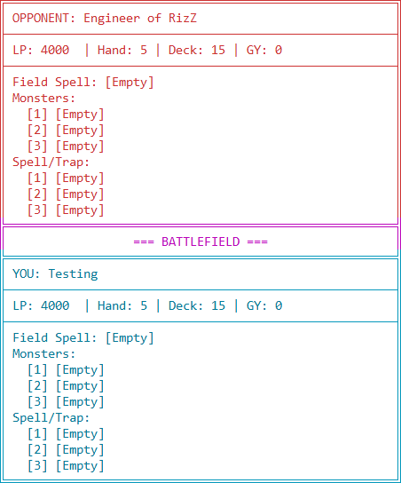

Figure 17. Duel Field

  - Display the player’s hand and the actions available. Make sure to display the card type, name, spell type if spell, attack and level if monster. Prompt the user to input their choice, validate the input to be 0-7 inclusively.

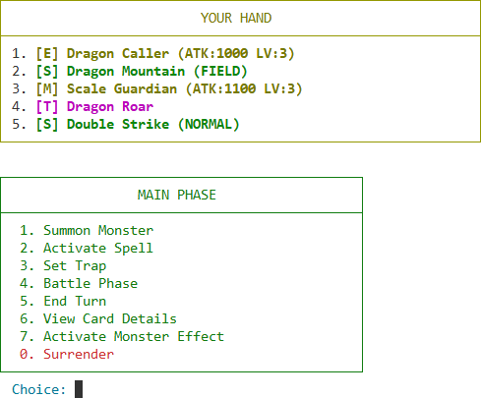
Figure 18. Hand and Player Options

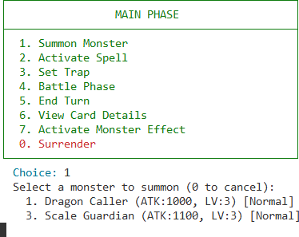
- If user input 1, prompt user to choose a monster to summon. Display all monster cards and validate the option to be the monsters to summon. Then display the monster name in one of the monster zone and disable the summon menu

Figure 19. Summon Menu

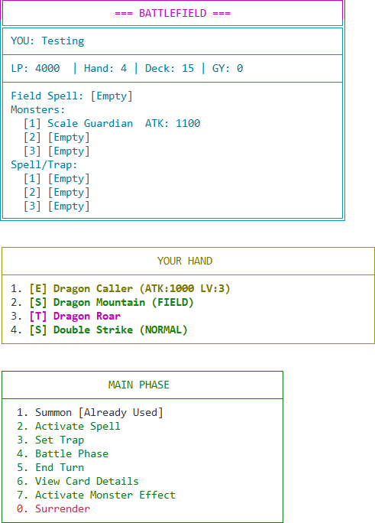

Figure 20. After Summoning

- If the user inputs 2, show the spells to be used. The player can then choose the spell to activate. After that apply the effects and display the spell in one of the zones. Validate the spell zone to at least have one slot available.

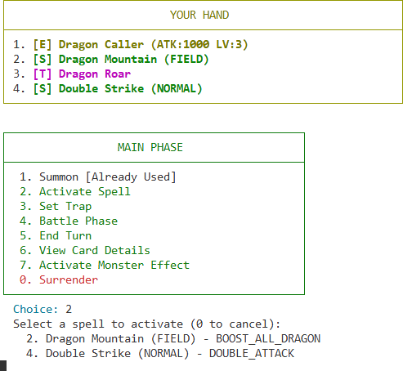
Figure 21. Activate Spell Menu

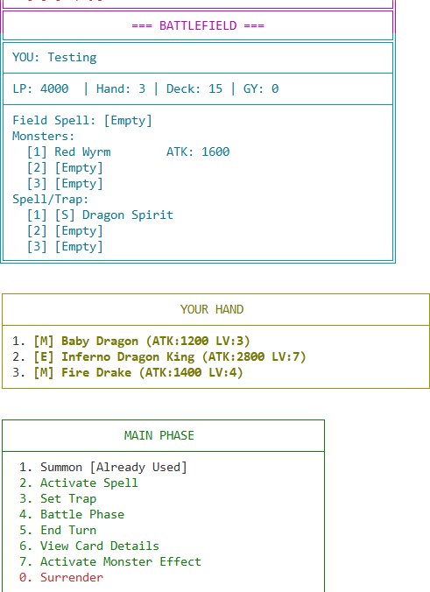
Figure 22. After Spell Activation

- If the user inputs 3, show the traps to be set. The player can then choose the trap to activate. Validate at least one of the spell/trap zones are available.

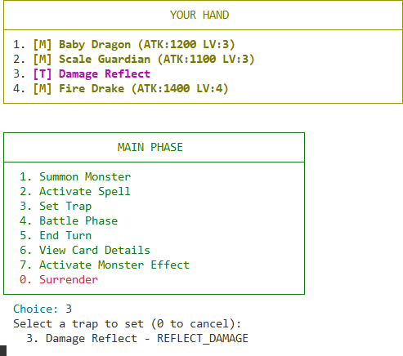

Figure 23. Set Trap Menu
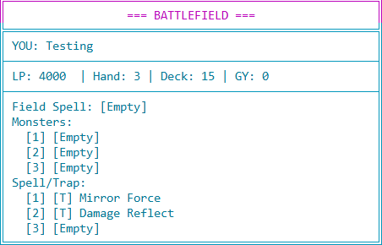

Figure 24. Trap in Field

- If user chooses input 4, redirect the user to battle phase. Validate the turn to be the second turn or more and for the player to have at least one monster. If its the first turn end the turn immediately, else redirect to battle phase menu

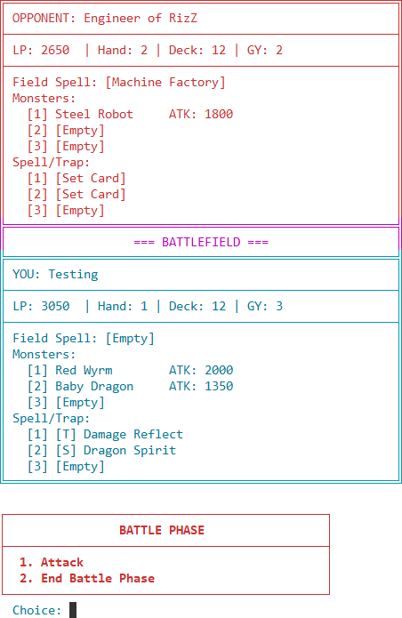

Figure 26. Battle Phase Menu

  - Prompt the user to input between 1 or 2. Validate the input to be 1-2 inclusively.
  - If the user Inputs 1 show the list of monsters along with their attack

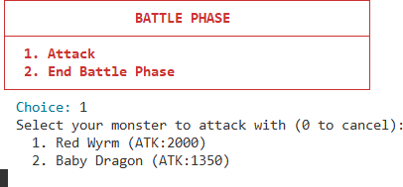
Figure 27. Monster Selection

  - Then Display all enemy monsters and prompt user to choose which monster to attack
  - If there’s no monster to attack, attack the lifepoints directly
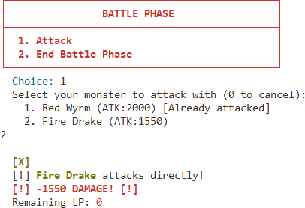
Figure 28. attack lifepoints directly

  - If the user chooses 2 end the turn immediately.

- If user chooses input 5, end the turn immediately.
- If user chooses input 6, display the view card detail menu

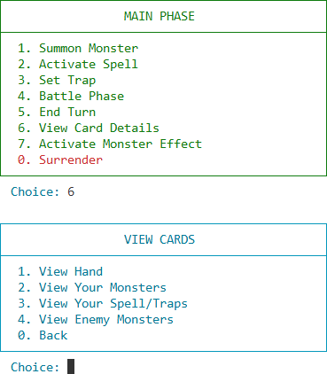
Figure 29. View Card Detail Menu

- Validate the input to be between 0-4.
  - If user inputs 1 show the list of cards in the hand
Promp the user to choose a card from the hand with the number, validate the number to exist in the hand. Then print out the name, type, attack level, flavor text. If the monster is above level 5 display the tribute amount.

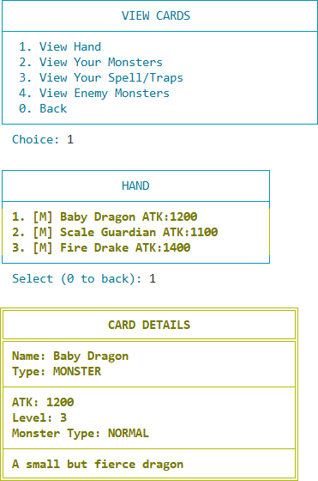
Figure 30. View Hand Details

  - If the user inputs 2 display all the monsters on the field. Allow users to select monsters on the field and validate the selected number. Display information of the monsters like the one stated in Card Details.
  - If the user inputs 3 display all spell/trap cards in the field. Allow users to select spell/trap cards on the field and validate the selected number. Display all the information of the cards.
  - If the user inputs 4 display all monsters on the opponent field. Allow users to select the monsters and validate the selected number. Display the information of the opponent monster
  - If the user selects 0 redirect back to Duel Page
- If the user inputs 7, display all the monster with effects that can be activated

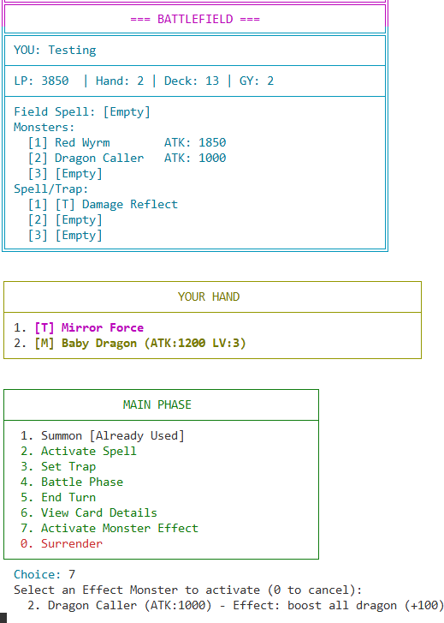

Figure 31. Card Effect Activation

- Prompt the user to input the monster number, validate the number exists. Then apply the selected effect.

- During the enemy turn print out all their actions such as drawing, summoning cards, and activating spell/traps.

Please run the EXE file to see the sample program.

Good Luck!

