Kevin Welsh
CIS 452 - Operating Systems
December 8, 2011
Assignment Three

Disk Analysis

Assignment

Our assignment was to design a program that reports filesystem statistics. Our program would have to traverse a filesystem, gather data on files and directories, and output that data. We were to do an analysis on the filesystem (using our tool), documenting our results.

Approach

I decided to write this project in C. The reason behind this is because I feel most comfortable with the language and because many of the relevant examples I found were written in C. We already did a useful Lab (Lab 11) that gently looked into the filesystem. I used a basic text-editor for my IDE (gedit).

This assignment evolved from four test.c examples I found randomly on the Internet. None of them were particularly 'complete', but all of them contained bits-and-pieces of code that I heavily modified. I don't recall the source of each, but they can be found on my Github (welshk91) for further examination. Each example offered valuable insight into how I would code my project.

My first task was to traverse a filesystem. I originally thought I would have to code this in C from scratch, using 'opendir', 'readdir', and 'closedir' (similar to test2.c). I was not looking forward to this. The approach seemed overly complicated. Upon further research, I stumbled across file tree walk (ftw). FTW is a function that iterates through a filesystem, calling a function at each entry.

Once I found ftw, I used the example found in the man page to get started on my project. The example uses ftw to call 'stat' on each entry, printing out the results of the 'stat' structure. I added more 'stat' values to the default example (such as inode, blocks, blocksize...). After I added these, I realized there were a lot of statistics missing (especially useful ones and ones I would expect to see in a file analysis tool).

I used the 'stat' information to track a multitude of different metrics. I tracked the total number of different types of files and the max depth of the traversal. I noted the total size and number of files for root, the user, and others. I kept track of the last modified file, the last accessed file, and the last file to change it's status. The statistics can be seen in the terminal when the program is run, but for a more in-depth look you can view the 'directories.dat' and 'display_info.dat' file that the program creates after executing.

Using GNUPlot, I also added graphs to display the size and number of files per user. I'm not sure if this is installed on a basic Fedora installation, so you might have to install the package to get the program to graph properly.

Data Structures

Not including the usual suspects, I used two unique data structures in this program. For the file tree walk, I called 'stat' on each entry. To do this, I had to use the 'stat' structure to read each files information.

Another structure that was used was a dynamic array of DATA's. The DATA structure held a directory's path and it's size. This was used to hold all the directories sizes for statistics.

An idea I wanted to implement was to use two threads/processes to traverse the directory faster. One thread could search the left side of the tree while the other could do the right side. It seemed to be more complicated than it was worth, as the ftw seemed to be hard to divide into two groups to work.

Assumptions & Limitations

The program can traverse the entire filesystem and output the entries. The limitations of my program are really the limitations of 'stat'. One of these I found out early was the size it grabs from a file isn't always the most accurate way to measure size. This is very evident when you run the program on the 'dev' directory. The 'du' command reports the actual size used, while the 'stat' command will report the size allocated to the file. The file /dev/core in particular threw-off the statistics when I ran the program on root. For this reason, I have the program avoid the 'dev' directory when totaling the size. It still isn't accurate, but I imagine it's more accurate than totaling dev files which are devices and don't use space on the hard drive.

UPDATE: The 'dev' directory is uncommented, but can easily be commented out to run the program sans 'dev'. I just found out why the sizes are different from 'du'. See more below.

I wanted to use the 'file' command to get more information out of files (such as whether or not they were pictures, PDF's, text files, video files). I thought that would be particularly interesting from a user stand-point to see how much size was used by videos or how many pictures he had on his filesystem. I simply ran out of time to implement this (and might attempt to do it and turn the project in later for possible extra-credit).

The program does require the GNUPlot package to be installed to graph the data.

What I Accomplished

- Was able to set up and use source control (Github)
- Was able to output terminal & extra information to external files (directories.dat, display_info.dat)
- Was able to traverse the filesystem (ftw)
- Was able to call 'stat' on each file/directory
- Was able to read and output the 'stat' data
- Was able to gather extra data
- Was able to graph some of the important user data

Wish List

- Wasn't able to replicate the exact memory usage 'du' reports (replicated ls info instead)
- Wasn't able to use the 'file' command to get the basic file mime types (such as PDF, MPEG, or Text file).
- Wasn't able to provide as many graphs as I wanted

What I Learned

While I used version control in the previous projects, it was the critical in the project. In the other projects, I had the ability to copy-paste the project to an external hard drive if portability was needed. This time around, I used an older computer which had it's USB ports broken. It forced me to rely on Github much more than I would normally have to.

I learned that Linux comes with a library to traverse the filesystem easier (ftw). This came in handy, as I wasn't looking forward to doing this manually. It really was fortunate that ftw allowed me to call a function on each entry, as it made calling 'stat' on each file incredibly easy.

I learned a great deal about the differences between 'du', 'df', 'ls', and 'stat'. I learned this late in the project, around the time everything was finished and I was debugging & looking for abnormal behavior. I noticed when I ran the program on root, that the total size used was over a hundred gigabytes. This is odd because this computer just got a fresh install days before I started my project. When I noticed that the biggest file reported was over fifty gigabytes large, I knew something was wrong. I compared the 'dev' directory with 'stat' and 'du' commands and found a difference in the order of magnitudes. The 'stat' command I used gave the size allocated to the file, while the 'du' command told how much space is actually used by the file. The 'dev/core' file on my file system was being reported as gigabytes large, but 'du' gave me the actual size the file was taking up. The 'df' command can also differ in the way it reports size when compared with 'du'. It seems each command calculates and reports the size of a file differently. I'm still wondering as to why someone doesn't standardize it, though each method seemed to be valid in reason.

I learned how to plot data using GNUPlot. I initially struggled with getting the data into the correct format for the graphs to work. I finally got the data to be plotted correctly (after a few hours searching for documentation which was unclear). Overall, I'm pretty happy with the way the graphs turned-out (though I do wish there were more of them).

I learned while doing the system analysis that there can be a massive difference between a file's size (found by 'du') and what a file is allocated (found by 'ls' or my program). I certainly was stumped for many hours wondering why my program was reporting large sizes for certain files. The 'dev' directory seems to be the biggest culprit here, as '/dev/core' on my system was reported as nothing with 'du' but 131GB with my program. This could be because it is a link to /proc/kcore though, so 'du' might just note the link's size.

I learned that there's no creation date for files. Coming from Windows, this seems odd. While having access time, modified time, and status changed time is nice, I was hoping to analyze the system by looking at the age of each file. I wonder if there's a trick to figure it out, as it seems like it would be something worth knowing.
User Manual

To Compile:
gcc -Wall -g myDu.c
To Run:
./a.out [file path] [depth] (depth is optional, as is filepath as it defaults to root)

To use, enter a path you wish to analyze. Depth can be entered with -d=#. This allows you to see the directory number and sizes at that level, but doesn't change the output as it still goes through the full depth. This is intentional.

When run, the program will make a directories.dat, display_info.dat, graph_files.ps, and a graph_size.ps. These are miscellaneous outputs and can be viewed and discarded as pleased.
System Analysis

I decided to run a system analysis on an older laptop in the house (the same one which I programmed the project on). It uses the ext4 filesystem. Running Fedora 16, it came with a multitude of developer tools of which to test my program's output against. One of the programs that came by default was called Disk Usage Analyzer. I also decided to run my program against 'du'. I was to include 'stat', but seeing how that was the base for my program values didn't drastically differ.

Using Disk Usage Analyzer, I scanned my filesystem (choosing to avoid a few 'dev' directories as my program completely ignores them). It outputted that the biggest directory was the 'usr' directory (with 4.1GB used). Running my program on /usr resulted in 6.8GB used, enough of a difference to have me curious. The directories with the largest size, /usr/lib64 and /usr/share, were reported as 1.4GB and 2.0GB by Disk Analyzer. My program reported 1.98GB and 2.43GB respectively. Upon inspection, I noticed the largest file my program reports (an icon-cache file) wasn't even listed in Disk Usage Analyzer. I have a hunch that Disk Usage Analyzer doesn't report these types of files, while mine does. This would lead to a significant difference in the total sizes reported by both programs.

With the results of the 'usr' directory available, I ran 'du -sk /usr/share' out of curiosity to see if it omitted certain files like Disk Usage Analyzer. I was expecting it to report a size in-between the previous programs, but was wrong again. The 'du -sh /usr/share' command reported 1.9GB, not exactly either of the previous results. It reported 1.4GB for /usr/lib64, making it accurate with Disk Usage Analyzer's results.

I've come to the conclusion that my program doesn't output the actual size of a file, but rather what it is allocated. I came to this conclusion when I noticed the difference in reported size of /usr/share/icons/oxygen. The 'du' command gave a much smaller value for icon-cache than mine did. This leads me to believe that the cache was allocated more space than it actually used. If this is true, my program actually became quite cool as you can calculate the difference between allocated size and actual size to find out how much space your operating system is assigning for things such as a cache.

To prove this theory, I ran the commands 'a.out /usr/share/icons/oxygen/icon-theme.cache', 'du /usr/share/icons/oxygen/icon-theme.cache', and 'ls -l /usr/share/icons/oxygen/icon-theme.cache' and compared the results. The my program and 'du' differed, but I had the exact value 'ls' returned. This also proved why I had to omit the 'dev' directory. This finally set my mind at ease, as my program wasn't wrong, it was just outputting what 'ls' outputs and not 'du'.

Interestingly enough, where Disk Usage Analyzer is graphical interface to 'du', my program (unintentionally) became the graphical interface to 'ls'. It is more appropriate to have named my program myLs than myDu.

Some surprises came with this analysis. I wasn't expecting root to be so dominant when it came to number of files. When my program ran on root, it reported that root owned about 93% of the files on my system. While I knew root had more, I expected users to put up a little more of a fight. This does make sense though; the only files a user owns are usually in his home directory and that directory is only a small portion of the overall filesystem. The size results are skewed (see above for why), but the user only had approximately 2.2GB. If Disk Usage Analyzer's data is to be trusted, my total size of my system is 5.2GB. This means the root is about 3GB, which is to be expected of a newly installed operating system.

I was also surprised to see files owned by 'other' (anyone not the root or current user), While it was only 6 files out of the entire system (13,000 files total), the mere fact that there are only two users on this laptop (root and myself) makes me wonder who that 'other' user is.

I logged the most recent files to be changed, modified, or accessed and their times. The times are what are interesting here, as all of them are very recent. The /dev/fd/1 and /dev/fd/2 (floppy disk drives) seem to be the usual culprits of last modified and last accessed. I ran my program repeatedly over a period of an hour and never saw a time that wasn't within a few minutes. This tells me that even when I don't use my computer, it's busy changing files.

Analysis of /usr/share
Size in Kb
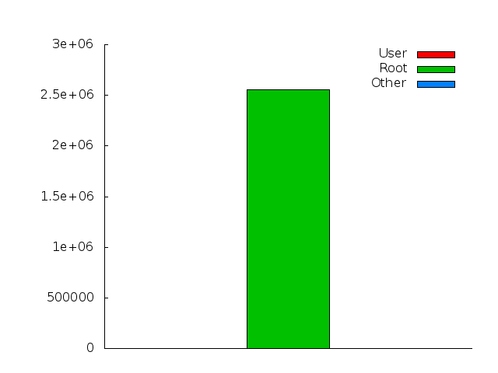

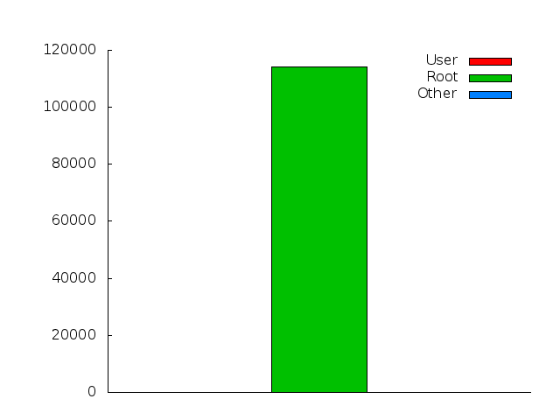
Number of Files

Sample Output
(For Directory information about this example, see attached file 'display_info.dat')
(Graphs will also be attached)

$ ./a.out /home/kev/Programs/abc/
(Directory info goes here)
...
...
...

Statistics
Directories: 4 (16384bytes) (16.000000 KB) (0.015625 MB) (0.000015 GB)
Files: 7 (156bytes) (0.152344 KB) (0.000149 MB) (0.000000 GB)
Directories (cannot be read): 0 (0bytes) (0.000000 KB) (0.000000 MB)
Directories (specified depth): 0 (0bytes) (0.000000 KB) (0.000000 MB)
Symbolic Links: 0 (0bytes) (0.000000 KB) (0.000000 MB)
Non-Symbolic Links: 0 (0bytes) (0.000000 KB) (0.000000 MB)
Symbolic Links (nonexistent file): 0 (0bytes) (0.000000 KB) (0.000000 MB)

Depth: 3
Number of files owned by Root: 0 (0.000000%)
Number of files owned by User: 7 (100.000000%)
Number of files owned by Others: 0 (0.000000%)

Last Modified File: /home/kev/Programs/abc/def/jkl/meh Wed Dec 7 18:15:08 2011
Last Accessed File: /home/kev/Programs/abc/def/jkl/meh Wed Dec 7 18:15:09 2011
Last File to Change Status: /home/kev/Programs/abc/def/jkl/meh Wed Dec 7 18:15:08 2011

Biggest File: /home/kev/Programs/abc/def/jkl/meh (79bytes) (0.077148 KB) (0.000075 MB) (0.000000 GB)
Biggest Directory (depth>0): /home/kev/Programs/abc/def (4096bytes) (4.000000 KB) (0.003906 MB) (0.000004 GB)

Size of Root: 0 bytes 0.000000 KB 0.000000 MB 0.000000 GB
Size of User: 156 bytes 0.152344 KB 0.000149 MB 0.000000 GB
Size of Other:0 bytes 0.000000 KB 0.000000 MB 0.000000 GB
Total Size: 156 bytes 0.152344 KB 0.000149 MB 0.000000 GB

