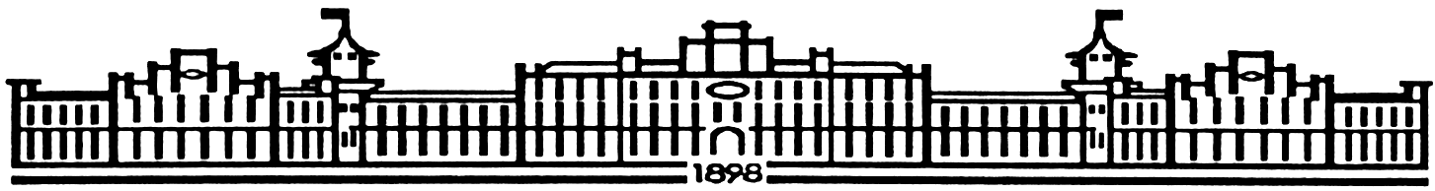

МIНIСТЕРСТВО ОСВIТИ І НАУКИ УКРАЇНИ

НАЦІОНАЛЬНИЙ ТЕХНІЧНИЙ УНІВЕРСИТЕТ УКРАЇНИ

“КИЇВСЬКИЙ ПОЛІТЕХНІЧНИЙ ІНСТИТУТ”

Факультет прикладної математики

Кафедра програмного забезпечення комп’ютерних систем

**Лабораторна робота № 3**

з дисципліни “ МАОКГ”

|  |  |  |
| --- | --- | --- |
| Виконав  студент III курсу  групи КП-72  Божко Володимир Сергійович  (*прізвище, ім’я, по батькові*)  Варіант № 3 |  | Зарахована  “____” “____________” 2020  р.  викладачем  Шкурат О. С.  (*прізвище, ім’я, по батькові*) |

Київ-2020

Результат :

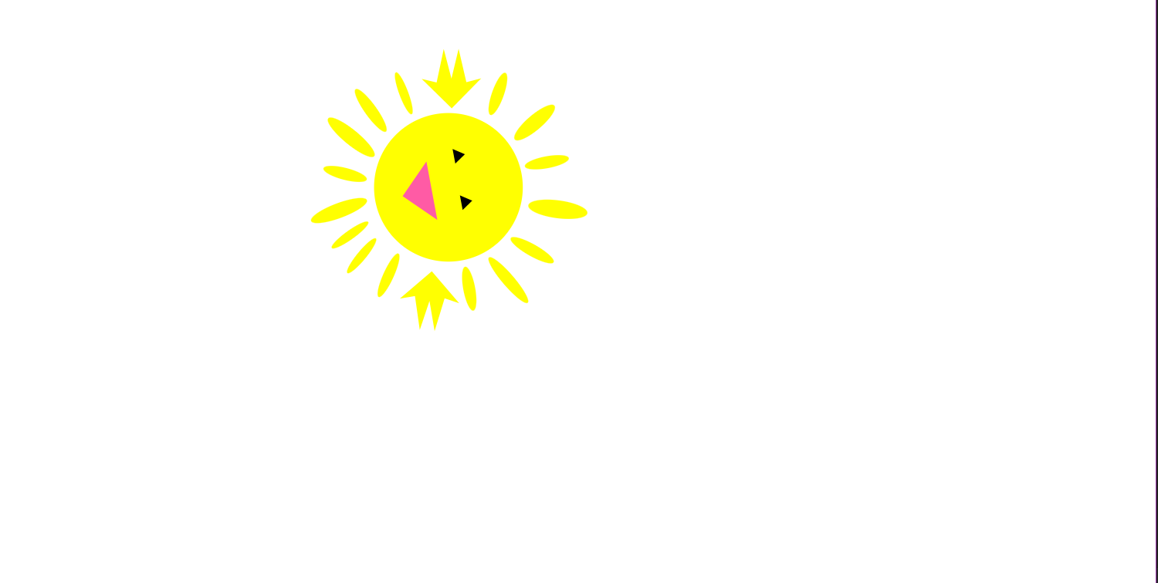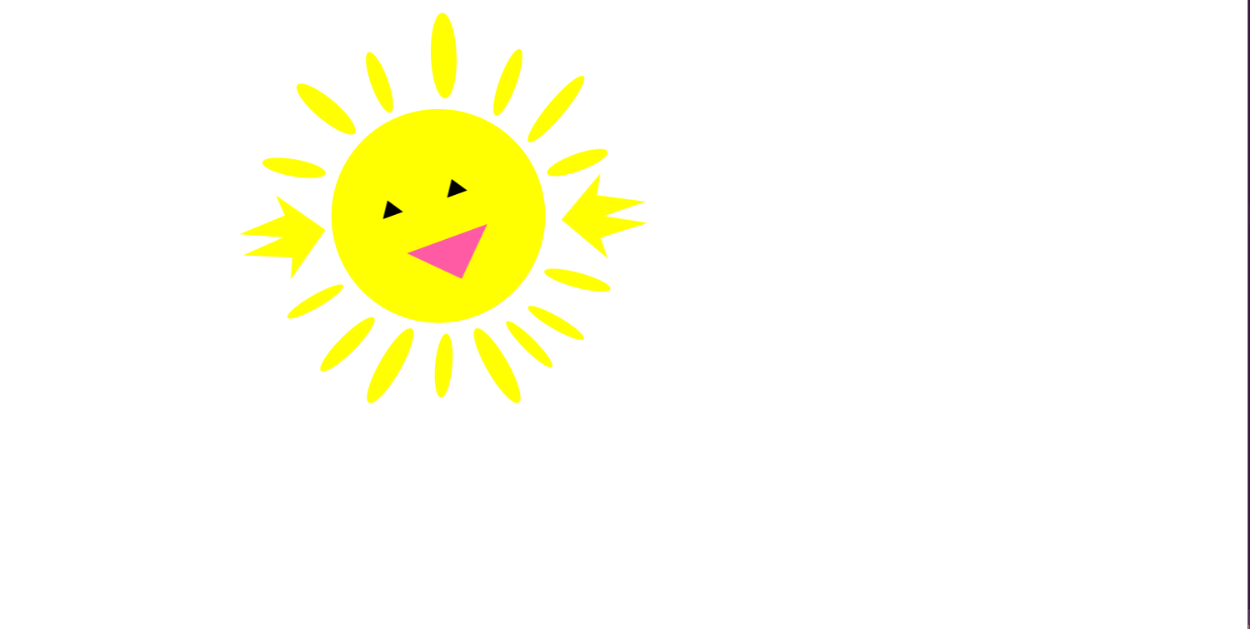

Лістинг коду програми (class Sun):

|  |
| --- |
| import javafx.animation.*; |
|  | import javafx.application.Application; |
|  | import javafx.scene.Group; |
|  | import javafx.scene.Scene; |
|  | import javafx.scene.paint.Color; |
|  | import javafx.scene.shape.*; |
|  | import javafx.stage.Stage; |
|  | import javafx.util.Duration; |
|  | import javafx.scene.paint.Color; |
|  | import javafx.scene.paint.Paint; |
|  |  |
|  | public class Sun extends Application { |
|  |  |
|  | private static double X (double originalX){ |
|  | return originalX + 300; |
|  | } |
|  | private static double Y (double originalY){ |
|  | return originalY + 200; |
|  | } |
|  |  |
|  | public static void main(String[] args) { |
|  | launch(args); |
|  | } |
|  |  |
|  | public void start(Stage primaryStage) { |
|  | Group root = new Group(); |
|  | Scene scene = new Scene(root, 1200, 600); |
|  |  |
|  | //head |
|  | Ellipse head = new Ellipse(X(45), Y(0), 100, 100); |
|  | head.setFill(Color.rgb(255, 255, 1)); |
|  | root.getChildren().add(head); |
|  |  |
|  | Polygon mouth = new Polygon(); |
|  | mouth.getPoints().addAll(320.0, 220.0, |
|  | 400.0, 220.0, |
|  | 360.0, 260.0); |
|  | mouth.setFill(Color.rgb(255,91,165)); |
|  | mouth.setRotate(-20); |
|  | root.getChildren().add(mouth); |
|  |  |
|  | Polygon eye1 = new Polygon(); |
|  | eye1.getPoints().addAll(290.0, 200.0, |
|  | 310.0, 200.0, |
|  | 300.0, 185.0); |
|  | eye1.setFill(Color.rgb(0,0,0)); |
|  | eye1.setRotate(-20); |
|  | root.getChildren().add(eye1); |
|  |  |
|  | Polygon eye2 = new Polygon(); |
|  | eye2.getPoints().addAll(350.0, 180.0, |
|  | 370.0, 180.0, |
|  | 360.0, 165.0); |
|  | eye2.setFill(Color.rgb(0,0,0)); |
|  | eye2.setRotate(-20); |
|  | root.getChildren().add(eye2); |
|  |  |
|  |  |
|  | //lower beams |
|  | Ellipse beam1 = new Ellipse(X(-40), Y(120), 8, 35); |
|  | beam1.setRotate(45); |
|  | beam1.setFill(Color.rgb(255, 255, 1)); |
|  | root.getChildren().add(beam1); |
|  |  |
|  | Ellipse beam2 = new Ellipse(X(-70), Y(80), 6, 30); |
|  | beam2.setRotate(60); |
|  | beam2.setFill(Color.rgb(255, 255, 1)); |
|  | root.getChildren().add(beam2); |
|  |  |
|  | Ellipse beam3 = new Ellipse(X(0), Y(140), 10, 40); |
|  | beam3.setRotate(30); |
|  | beam3.setFill(Color.rgb(255, 255, 1)); |
|  | root.getChildren().add(beam3); |
|  |  |
|  | Ellipse beam4 = new Ellipse(X(50), Y(140), 8, 30); |
|  | beam4.setRotate(5); |
|  | beam4.setFill(Color.rgb(255, 255, 1)); |
|  | root.getChildren().add(beam4); |
|  |  |
|  | Ellipse beam5 = new Ellipse(X(100), Y(140), 10, 40); |
|  | beam5.setRotate(-30); |
|  | beam5.setFill(Color.rgb(255, 255, 1)); |
|  | root.getChildren().add(beam5); |
|  |  |
|  | Ellipse beam6 = new Ellipse(X(130), Y(120), 6, 30); |
|  | beam6.setRotate(-45); |
|  | beam6.setFill(Color.rgb(255, 255, 1)); |
|  | root.getChildren().add(beam6); |
|  |  |
|  | Ellipse beam7 = new Ellipse(X(155), Y(100), 6, 30); |
|  | beam7.setRotate(-60); |
|  | beam7.setFill(Color.rgb(255, 255, 1)); |
|  | root.getChildren().add(beam7); |
|  |  |
|  | Ellipse beam8 = new Ellipse(X(175), Y(60), 7, 32); |
|  | beam8.setRotate(-75); |
|  | beam8.setFill(Color.rgb(255, 255, 1)); |
|  | root.getChildren().add(beam8); |
|  |  |
|  | //upper beams |
|  | Ellipse beam9 = new Ellipse(X(175), Y(-50), 8, 30); |
|  | beam9.setRotate(-110); |
|  | beam9.setFill(Color.rgb(255, 255, 1)); |
|  | root.getChildren().add(beam9); |
|  |  |
|  | Ellipse beam10 = new Ellipse(X(155), Y(-100), 8, 40); |
|  | beam10.setRotate(-140); |
|  | beam10.setFill(Color.rgb(255, 255, 1)); |
|  | root.getChildren().add(beam10); |
|  |  |
|  | Ellipse beam11 = new Ellipse(X(110), Y(-125), 8, 33); |
|  | beam11.setRotate(-160); |
|  | beam11.setFill(Color.rgb(255, 255, 1)); |
|  | root.getChildren().add(beam11); |
|  |  |
|  | Ellipse beam12 = new Ellipse(X(50), Y(-150), 12, 40); |
|  | beam12.setRotate(-182); |
|  | beam12.setFill(Color.rgb(255, 255, 1)); |
|  | root.getChildren().add(beam12); |
|  |  |
|  | Ellipse beam13 = new Ellipse(X(-10), Y(-125), 8, 30); |
|  | beam13.setRotate(-200); |
|  | beam13.setFill(Color.rgb(255, 255, 1)); |
|  | root.getChildren().add(beam13); |
|  |  |
|  | Ellipse beam14 = new Ellipse(X(-60), Y(-100), 10, 35); |
|  | beam14.setRotate(-230); |
|  | beam14.setFill(Color.rgb(255, 255, 1)); |
|  | root.getChildren().add(beam14); |
|  |  |
|  | Ellipse beam15 = new Ellipse(X(-90), Y(-45), 8, 30); |
|  | beam15.setRotate(-260); |
|  | beam15.setFill(Color.rgb(255, 255, 1)); |
|  | root.getChildren().add(beam15); |
|  |  |
|  | //arms |
|  |  |
|  | Polygon arm_left = new Polygon(); |
|  | arm_left.getPoints().addAll(240.0, 220.0, |
|  | 200.0, 180.0, |
|  | 205.0, 200.0, |
|  | 160.0, 210.0, |
|  | 200.0, 220.0, |
|  | 160.0, 230.0, |
|  | 205.0, 240.0, |
|  | 200.0, 260.0); |
|  | arm_left.setFill(Color.rgb(255, 255, 1)); |
|  | arm_left.setRotate(-10); |
|  | root.getChildren().add(arm_left); |
|  |  |
|  | Polygon arm_right = new Polygon(); |
|  | arm_right.getPoints().addAll(460.0, 200.0, |
|  | 500.0, 160.0, |
|  | 495.0, 180.0, |
|  | 540.0, 190.0, |
|  | 500.0, 200.0, |
|  | 540.0, 210.0, |
|  | 495.0, 220.0, |
|  | 500.0, 240.0); |
|  | arm_right.setFill(Color.rgb(255, 255, 1)); |
|  | arm_right.setRotate(-5); |
|  | root.getChildren().add(arm_right); |
|  |  |
|  |  |
|  |  |
|  | //Animation |
|  | int cycleCount = 2; |
|  | int time = 2000; |
|  |  |
|  | ScaleTransition scaleTransition = new ScaleTransition(Duration.millis(time), root); |
|  | scaleTransition.setToX(2); |
|  | scaleTransition.setToY(2); |
|  | scaleTransition.setAutoReverse(true); |
|  |  |
|  | RotateTransition rotateTransition = new RotateTransition(Duration.millis(time), root); |
|  | rotateTransition.setByAngle(360f); |
|  | rotateTransition.setCycleCount(cycleCount); |
|  | rotateTransition.setAutoReverse(true); |
|  |  |
|  | TranslateTransition translateTransition = new TranslateTransition(Duration.millis(time), root); |
|  | translateTransition.setFromX(150); |
|  | translateTransition.setToX(50); |
|  | translateTransition.setCycleCount(cycleCount+1); |
|  | translateTransition.setAutoReverse(true); |
|  |  |
|  | TranslateTransition translateTransition2 = new TranslateTransition(Duration.millis(time), root); |
|  | translateTransition2.setFromX(50); |
|  | translateTransition2.setToX(150); |
|  | translateTransition2.setCycleCount(cycleCount+1); |
|  | translateTransition2.setAutoReverse(true); |
|  |  |
|  | ScaleTransition scaleTransition2 = new ScaleTransition(Duration.millis(time), root); |
|  | scaleTransition2.setToX(0.1); |
|  | scaleTransition2.setToY(0.1); |
|  | scaleTransition2.setCycleCount(cycleCount); |
|  | scaleTransition2.setAutoReverse(true); |
|  |  |
|  | ParallelTransition parallelTransition = new ParallelTransition(); |
|  | parallelTransition.getChildren().addAll( |
|  | rotateTransition, |
|  | scaleTransition, |
|  | scaleTransition2, |
|  | translateTransition |
|  | ); |
|  | parallelTransition.setCycleCount(Timeline.INDEFINITE); |
|  | parallelTransition.play(); |
|  | //End of animation |
|  |  |
|  | primaryStage.setResizable(false); |
|  | primaryStage.setTitle("Lab 3"); |
|  | primaryStage.setScene(scene); |
|  | primaryStage.show(); |
|  | } |
|  |  |
|  | } |