

МIНIСТЕРСТВО ОСВIТИ І НАУКИ УКРАЇНИ

НАЦІОНАЛЬНИЙ ТЕХНІЧНИЙ УНІВЕРСИТЕТ УКРАЇНИ

“КИЇВСЬКИЙ ПОЛІТЕХНІЧНИЙ ІНСТИТУТ”

Факультет прикладної математики

Кафедра програмного забезпечення комп’ютерних систем

**Лабораторна робота № 4**

з дисципліни “ МАОКГ”

|  |  |  |
| --- | --- | --- |
| Виконав  студент III курсу  групи КП-72  Божко Володимир Сергійович  (*прізвище, ім’я, по батькові*)  Варіант № 3 |  | Зарахована  “____” “____________” 2020  р.  викладачем  Шкурат О. С.  (*прізвище, ім’я, по батькові*) |

Київ-2020

Результат: :

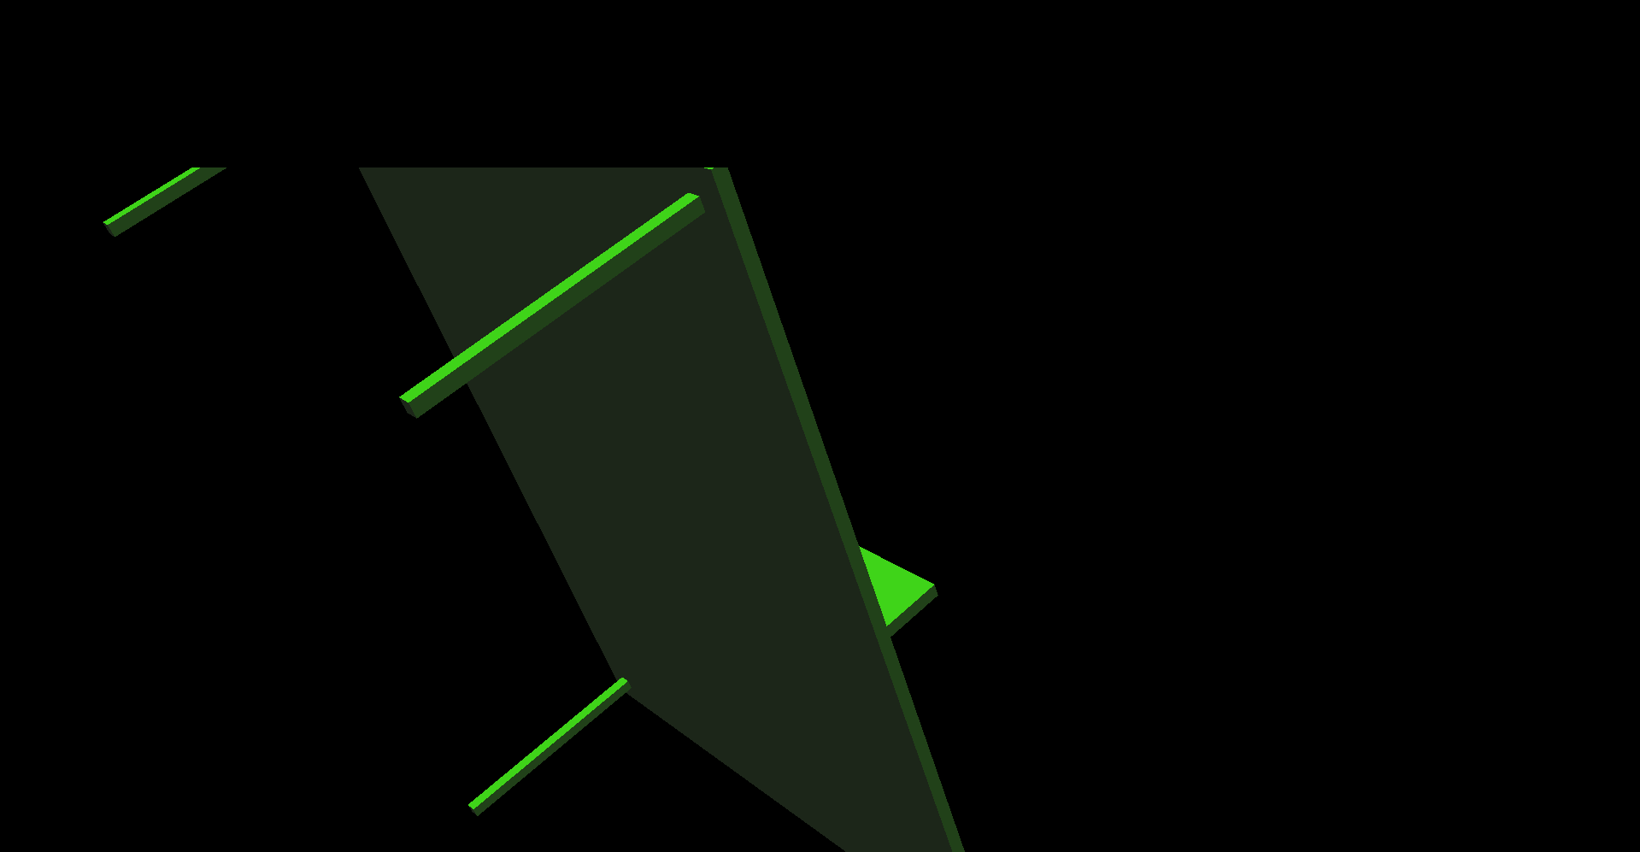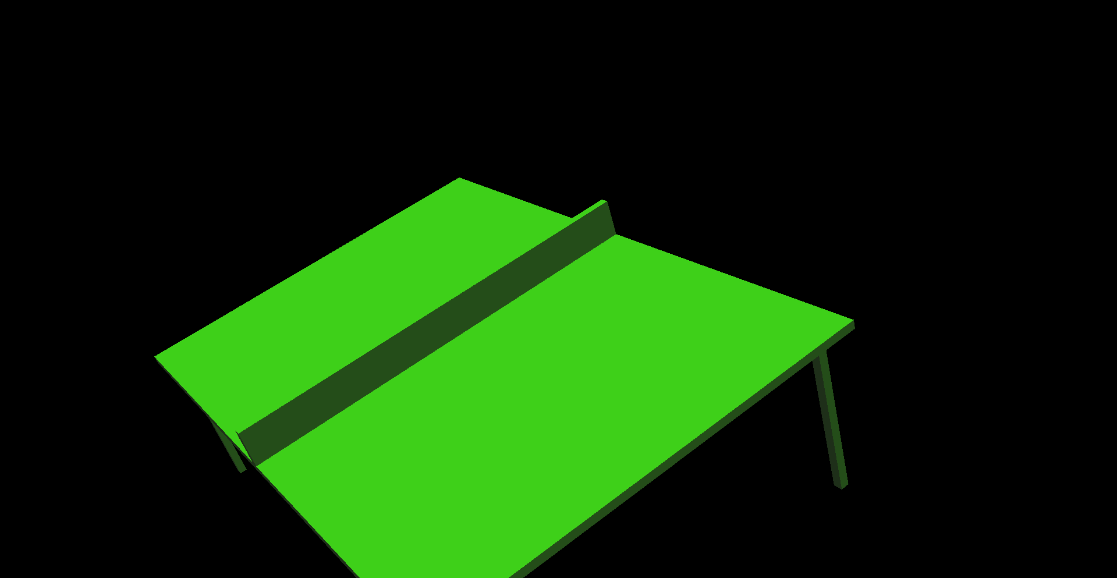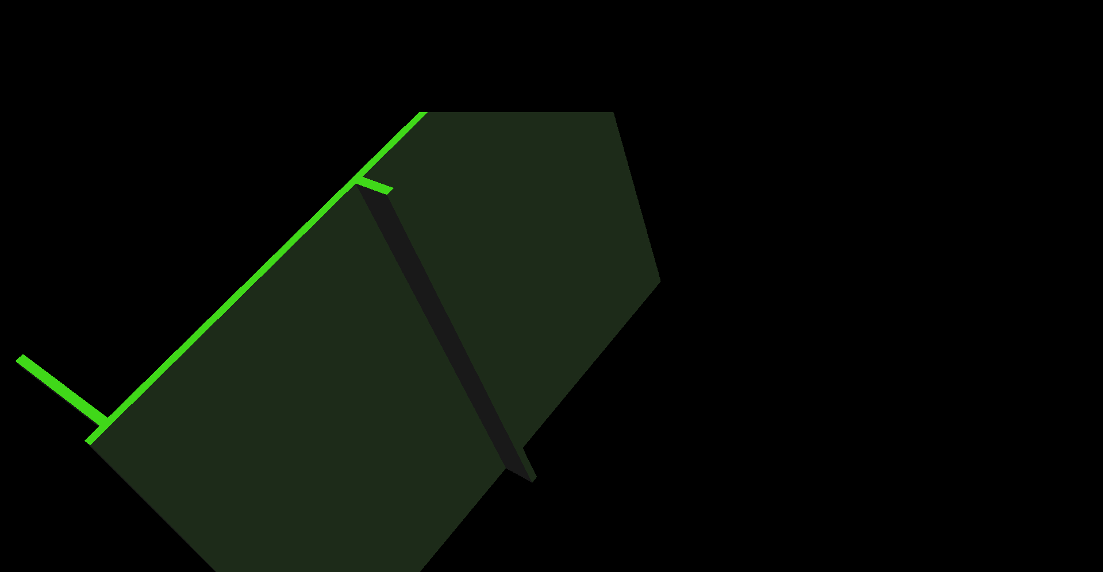

Лістинг коду програми (class Table):

|  |
| --- |
| package pack; |
|  |  |
|  | import javax.media.j3d.*; |
|  | import javax.vecmath.*; |
|  |  |
|  | public class Table { |
|  | private TransformGroup objectTransformGroup; |
|  | private Transform3D tableTransform3D = new Transform3D(); |
|  | private TransformGroup transformGroupLegs = new TransformGroup(); |
|  | private TransformGroup transformGroupBase = new TransformGroup(); |
|  | private float angle = 0; |
|  |  |
|  |  |
|  | public BranchGroup createSceneGraph() { |
|  |  |
|  | BranchGroup objRoot = new BranchGroup(); |
|  | objectTransformGroup = new TransformGroup(); |
|  | objectTransformGroup.setCapability(TransformGroup.ALLOW_TRANSFORM_WRITE); |
|  | buildObject(); |
|  | objRoot.addChild(objectTransformGroup); |
|  |  |
|  |  |
|  | BoundingSphere bounds = new BoundingSphere(new Point3d(0.0, 0.0, 0.0),100.0); |
|  | Color3f light1Color = new Color3f(1.0f, 5f, 0f); |
|  | Vector3f light1Direction = new Vector3f(4.0f, -10.0f, -12.0f); |
|  | DirectionalLight light1 = new DirectionalLight(light1Color, light1Direction); |
|  | light1.setInfluencingBounds(bounds); |
|  | objRoot.addChild(light1); |
|  |  |
|  | Color3f ambientColor = new Color3f(1.0f, 1.0f, 1.0f); |
|  | AmbientLight ambientLightNode = new AmbientLight(ambientColor); |
|  | ambientLightNode.setInfluencingBounds(bounds); |
|  | objRoot.addChild(ambientLightNode); |
|  |  |
|  | return objRoot; |
|  | } |
|  |  |
|  | private void buildObject() { |
|  |  |
|  |  |
|  | transformGroupBase.setCapability(TransformGroup.ALLOW_TRANSFORM_WRITE); |
|  | transformGroupBase.addChild(TableComponets.getBase()); |
|  | objectTransformGroup.addChild(transformGroupBase); |
|  |  |
|  | Transform3D transform3D = new Transform3D(); |
|  | double[] array = new double[]{0, 0.05, 0}; |
|  | transform3D.setTranslation(new Vector3d(array)); |
|  | TransformGroup transformGroup = new TransformGroup(); |
|  | transformGroup.setTransform(transform3D); |
|  | transformGroup.addChild(TableComponets.getMesh()); |
|  | objectTransformGroup.addChild(transformGroup); |
|  |  |
|  |  |
|  |  |
|  | Transform3D transformLeg1 = new Transform3D(); |
|  | array = new double[]{0.45, -0.2, -0.65}; |
|  | transformLeg1.setTranslation(new Vector3d(array)); |
|  | TransformGroup transformGroupLeg1 = new TransformGroup(); |
|  | transformGroupLeg1.setTransform(transformLeg1); |
|  | transformGroupLeg1.addChild(TableComponets.getLeg()); |
|  |  |
|  |  |
|  | Transform3D transformLeg2 = new Transform3D(); |
|  | array = new double[]{0.45, -0.2, 0.65}; |
|  | transformLeg2.setTranslation(new Vector3d(array)); |
|  | TransformGroup transformGroupLeg2 = new TransformGroup(); |
|  | transformGroupLeg2.setTransform(transformLeg2); |
|  | transformGroupLeg2.addChild(TableComponets.getLeg()); |
|  |  |
|  | Transform3D transformLeg3 = new Transform3D(); |
|  | array = new double[]{-0.45, -0.2, 0.65}; |
|  | transformLeg3.setTranslation(new Vector3d(array)); |
|  | TransformGroup transformGroupLeg3 = new TransformGroup(); |
|  | transformGroupLeg3.setTransform(transformLeg3); |
|  | transformGroupLeg3.addChild(TableComponets.getLeg()); |
|  |  |
|  | Transform3D transformLeg4 = new Transform3D(); |
|  | array = new double[]{-0.45, -0.2, -0.65}; |
|  | transformLeg4.setTranslation(new Vector3d(array)); |
|  | TransformGroup transformGroupLeg4 = new TransformGroup(); |
|  | transformGroupLeg4.setTransform(transformLeg4); |
|  | transformGroupLeg4.addChild(TableComponets.getLeg()); |
|  |  |
|  |  |
|  |  |
|  | objectTransformGroup.addChild(transformGroupLeg1); |
|  | objectTransformGroup.addChild(transformGroupLeg2); |
|  | objectTransformGroup.addChild(transformGroupLeg3); |
|  | objectTransformGroup.addChild(transformGroupLeg4); |
|  | } |
|  |  |
|  |  |
|  | public void rotateForw() { |
|  | tableTransform3D.setRotation(new AxisAngle4f(angle, angle, angle, angle)); |
|  | angle += 0.05; |
|  | objectTransformGroup.setTransform(tableTransform3D); |
|  | } |
|  |  |
|  | public void rotateBack() { |
|  | tableTransform3D.setRotation(new AxisAngle4f(angle, angle, angle, angle)); |
|  | angle -= 0.05; |
|  | objectTransformGroup.setTransform(tableTransform3D); |
|  | } |
|  |  |
|  |  |
|  | } |