|  |  |
| --- | --- |
| **The impact of Monetary Policy on the Stock Market in Switzerland** | |
|  |  |
| Author: | Matthias Wenger  Frauenfelderstrasse 81  CH-8404 Winterthur  [matthias.wenger@stud.hslu.ch](mailto:matthias.wenger@stud.hslu.ch) |
|  | Valentin Arbenz  XX  CH-XXXX XX  [valentin.arbenz@stud.hslu.ch](mailto:valentin.arbenz@stud.hslu.ch) |
| Hochschule Luzern  **Master in Applied Information and Data Science (MScIDS)**  Spring Semester 2021  Winterthur, 30. Mai 2021 | |

**Table of Contents**

1. Introduction and Motivation 3

2. Literature Review 4

3. Main Research Questions 4

4. Methodology 5

5. Visual Analysis 5

6. Results 5

7. Conclusion 7

8. Structured and Annotated List of Sources and Literature 8

9. Appendix 9

9.1. Declaration of Originality 9

**List of Figures**

Figure 1: Overview of Monetary Supply, Interest Rate & SMI-Index 3

Figure 2 Correlations of SMI, M2 and Interest Rate. 6

Figure 3 Granger Causality Tests with different lags 7

**List of Abbreviations**

|  |  |
| --- | --- |
| DCF | Discounted Cash Flow |
| VAR | Vector Autoregressive Model |
|  |  |
|  |  |

# Introduction and Motivation

This project was influenced by the idea and goal to analyze the Swiss monetary policy and its impact on the SMI. As the efficient market hypothesis states that a current price of assets incorporates all relevant information, it would be interesting to see how the SMI reacts to monetary policy decisions made by the SNB. Ioannidis & Kontonikas (2006) stated in their research, that identifying a link between financial prices and monetary policy is important, to better understand transmission mechanisms of monetary policy. Based on the aspect, that changes in asset prices play a key role in multiple channels, financial markets such as the stock, foreign exchange, mortgage, government, and corporate bond market are quick to incorporate new information available on the market.

Based on these ideas and descriptions, the following figure (1) already gives a first insight in how markets are impacted by monetary policy decisions:

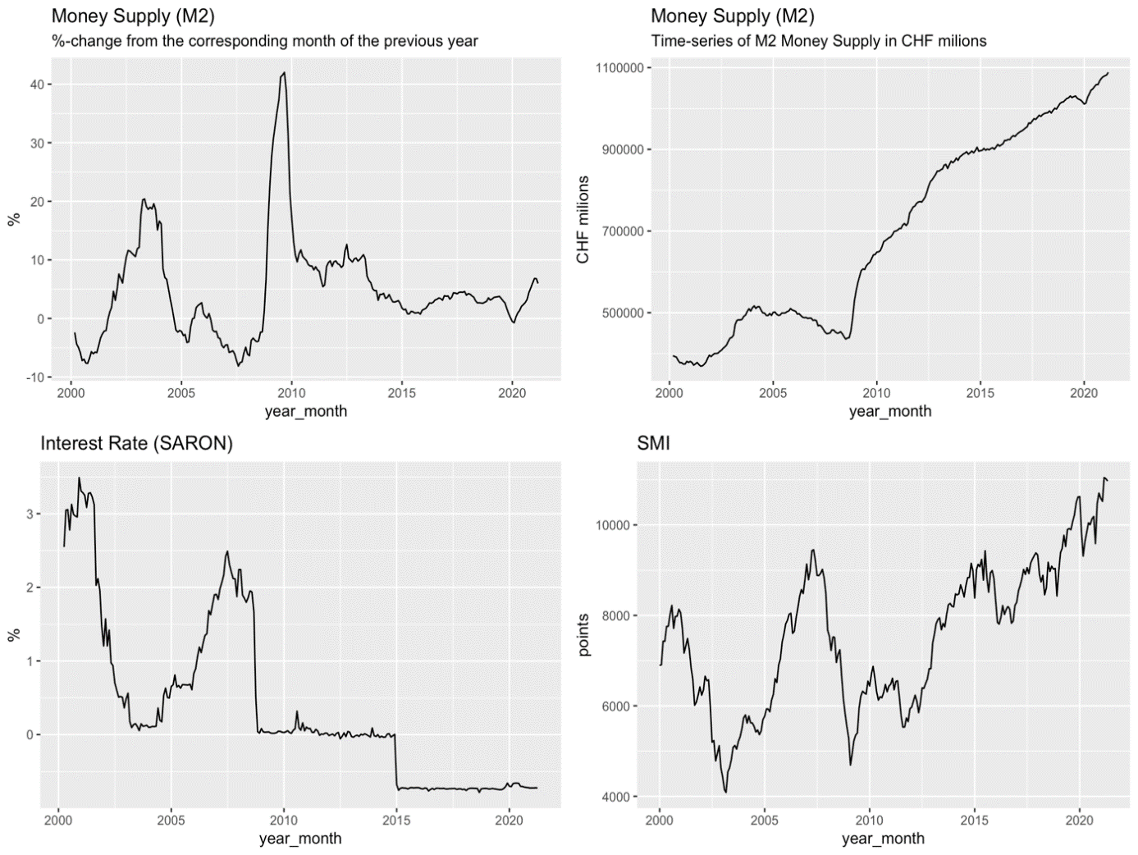

Figure 1: Overview of Monetary Supply, Interest Rate & SMI-Index

As shown in figure (1), the financial crisis around 2008 resulted in a large negative impact on international markets. The crisis was mainly, triggered by the inflated real estate market in the USA. Therefore, several central banks around the world hat to adjust their monetary policies. One of these changes can be seen during 2008, as the SNB increased the money supply available on the market. Combined with lowered interest rates, the financial markets then had the ability to recover.

This visual example gives an idea on how financial markets are interacting with the money supply and the interest rate. This paper aims to investigate these relationships in the following chapters.

# Literature Review

The discounted cashflow (DCF) model shows that there is a direct relationship between interest rates and stock prices. In the DCF Model the stock price ( is the present value of expected future dividends . (Ioannidis & Kontonikas, 2006). We use the simplified DCF-model:

Where is conditional expectation at time *t, R* is the rate of return used to discount future cashflows and *K* is the time horizon. The formula implies a direct effect of changing interest rate on the stock price. If the interest rate is increasing, future cashflows are discounted with a higher rate and thus the present value of the stock price lower.

Accordingly, monetary policy is linked to stock prices by altering expected future cash flows. (Ioannidis & Kontonikas, 2006). Thorbecke (1997) found that expansionary monetary policy exerts a large significant positive effect on stock returns. He also provides support for the hypothesis that monetary policy, at least in the short run, has real and quantitatively important effects on the economy. This indicates and indirect effect on stock prices, since an increase in economic output means higher profits and thus dividends of the individual firms.

Kohout (2010) found that in the long-term money supply is the most significant variable, out of all macroeconomic variables, in influencing the development of stock prices. This aligns with the previous statements concerning the interest rate, since a higher money supply lowers interest rate and vice versa. Additionally, money supply can also affect stock prices directly, when the greater supply of money is allocated in stock market investments. (Sirucek, 2012).

# Main Research Questions

The following research questions will be tried to answer.

1. *Is there granger causality between the interest rate (SARON) and SMI?*

Null hypothesis: The interest rate (SARON) does not Granger Cause SMI.

1. *Is there granger causality between the money supply (M2) and SMI?*

Null hypothesis: The money supply (M2) does not Granger Cause SMI.

# Methodology

Visual & Residual anlysis (LITERATURE??)

To determine the relationship between SMI, M2 and SARON we use Vector Autoregressive (VAR) Models. VAR-Models were proposed by Sims (1980) to capture the dynamic structure of (economic) variables without making the exogeneity assumption, since VAR models typically treat all variables as endogenous.

VAR Models are traditionally designed for stationary variable without Trend. Dicky and Fuller (1979) suggested a test of the unit root. The null hypothesis in the test is that a root is present and thus the series nonstationary. The alternative hypothesis is that a series is stationary.

Granger causality testing is applied to answer the research questions. Granger (1969) writes:

“The definition of causality used … is based entirely on the predictability of some series, say X(t),. If some other series Y(t), contains information in past terms that helps in the prediction of X(i) and if this information is contained in no other series used in the predictor, then Y(t):is said to cause X(t).” (p. 430)

Thus, by Granger causality we mean that past values of Y contain useful information on future values of X that is not contained in past and current X-values alone.

# Visual Analysis

VISUAL Analysis: Looking for decisions by SNB that had an effect on SMI.

<https://www.snb.ch/en/iabout/snb/hist/id/hist_wpc#t14>

random example:

# Results

Figure 1 already indicates the presence of strong correlations between the variables. The left-hand side of Figure 2 confirms this notion. Both M2 and SARON are strongly correlated with the SMI. However, since strong deterministic trends are present, these correlations could be spurious.

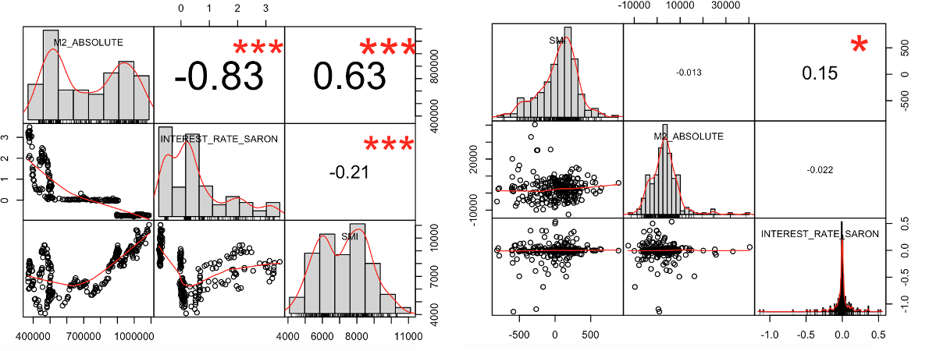

Figure 2 Correlations of SMI, M2 and Interest Rate.

Left: Original series / Right: First difference of the series (Returns)

To avoid wrong conclusion by statistically deviated results, we are testing for stationarity by applying the augmented Dickey-Fuller test. After taking the first difference of M2 and SARON, both tests yield p-values below 0.01, indicating stationarity for the two time-series.

The right-hand side of Figure 2 side shows the correlation between the returns of the series. The approximatively, normally distributed returns indicate that a log transformation is not needed. The correlations of the returns are much weaker.

Testing for Granger causality between lagged SARON with lag 1 and SMI leads to a p-value of 0.00134 and thus strong evidence to reject the 0-hypothesis of no granger causality.

Applying the test with lagged M2 with lag 8 and SMI leads to a p-value of 0.00745 and thus to the same conclusion of rejecting the 0-hypothesis of no granger causality. Figure 3 shows the p-values for the a range of lags for both M2 and SARON. The latter is the most significant at lag 1 with increasing p-values at higher lags. Contrary, Granger Test M2’s p-values elbow (sharp decrease) at lag 4 and are lowest at lag 8.



Figure 3 Granger Causality Tests with different lags

The results confirm the assumption suggested by the literature that the interest rate and money supply have predictable influence on stock prices. More precisely, the granger tests suggest that it is useful to include M2 and SARON for predicting SMI when the SMI’s own history is already used for prediction.

We use the information from Figure 3 to estimate the final model, using a multivariate VAR-Model including SMI, M2 and SARON. According to the model output, previous values of the SMI add no additional information to predict future values of the SMI. This aligns with the efficient market hypothesis. The most suitable model consists of past values of SARON and M2 as well as an intercept. It is defined as follows:

It is worth mentioning, that is not the intention to have a model with a high predictive power but to estimate the effect of M2 and SARON on the SMI. To increase predictive power, more variables would have to be considered. Furthermore, according to the VAR-model output, SMI, SARON and M2 seem to granger cause M2 and thus indicating more complex feedback effects, the discussion of which is out of the scope of this paper.

# Conclusion

The reviewed literature suggests that stock-prices are depending on the interest rate and money supply. The DCF-Model includes a direct link between stock prices and the interest rate. Money supply seems to influence stock prices, firstly, by being correlated with the interest rate (and thus by the described link of the DCF-Model) and secondly, if an increase in money supply is allocated in the stock market.

Aligning with the literature we showed that both variables granger cause SMI. However, there is a difference in the response time. The tests indicate a quick response to changes in the interest rate and a lagged response to changes of the money supply. It would be interesting, to further analyze the role of money supply. To what extend does an increase in money supply flow into the stock market and to what extend does it flow into the economy? For example, a comparison with a baseline (which represents “normal” conditions) could indicate whether the Swiss stock markets are significantly driven by the allocation of excess money not used in the economy.

# Structured and Annotated List of Sources and Literature

Dickey, A. D. & Fuller A. W. (1979). Distribution of the Estimators for Autoregressive Time Series with a Unit Root. <https://www.tandfonline.com/doi/abs/10.1080/01621459.1979.10482531>  
**=> Citation for Stationarity Testing**

Granger, C. W. J. (1969). Investigating causal relations by econometric models and cross-spectral methods. <https://www.jstor.org/stable/1912791?seq=1>  
**=> Citation for Granger Causality**

Ioannidis, C. & Kontonikas, A. (2006). Monetary Policy and the Stock Market: Some International evidence.   
<https://www.gla.ac.uk/media/Media_219105_smxx.pdf>  
**=> Citation for DCF-Model**

Thorbecke, W. (1997). On Stock Market Returns and Monetary Policy. ECONSTOR. <https://www.econstor.eu/bitstream/10419/186821/1/wp139.pdf>.   
**=> Citation for monetary policy and stock returns**

Kohout, P. (2010) Investiční strategie pro třetí tisíciletí. 6. vyd. Praha: Grada Publishing 2010. ISBN: 978-80-247-3315-9.  
**=> Citation for money supply and stock returns**

Sims, C. A. (1980) Maccroeconomics and reality, Econometrica 48: 1-48.  
**=> Citation for VAR**

Sirucek, S. (2012). The impact of money supply on stock prices and stock bubbles. MPRA.   
<https://mpra.ub.uni-muenchen.de/40919/1/MPRA_paper_40919.pdf>.   
**=> Citation for money supply and stock returns**

# Appendix

## Declaration of Originality

﻿

The undersigned hereby declares that he or she

- wrote the work in question independently and without the help of any third party,

- has provided all the sources and cited the literature used,

- will protect the confidentiality interests of the client and respect the copyright regulations of  
 Lucerne University of Applied Sciences and Arts.

Date and signature

26.05.2021 Matthias Wenger

Ein Bild, das Insekt enthält.
