МИНИСТЕРСТВО ЦИФРОВОГО РАЗВИТИЯ, СВЯЗИ И МАССОВЫХ КОММУНИКАЦИЙ РОССИЙСКОЙ ФЕДЕРАЦИИ

ФЕДЕРАЛЬНОЕ ГОСУДАРСТВЕННОЕ БЮДЖЕТНОЕ ОБРАЗОВАТЕЛЬНОЕ УЧРЕЖДЕНИЕ ВЫСШЕГО ОБРАЗОВАНИЯ
«САНКТ-ПЕТЕРБУРГСКИЙ ГОСУДАРСТВЕННЫЙ УНИВЕРСИТЕТ ТЕЛЕКОММУНИКАЦИЙ ИМ. ПРОФ. М.А. БОНЧ-БРУЕВИЧА»
(СПбГУТ)

Лабораторная работа №3
по курсу
«Программное обеспечение инфокоммуникационных сетей и систем»

Выполнил:
студент группы ИКПИ-14
Хохлов Т.В.

Принял:
Тарабанов И.В.

Санкт-Петербург
2025 г.
Цель работы:
Освоить принципы работы с сокетами в сетевом программировании, разработать простое клиент-серверное приложение и протестировать его работу в локальной сети.

Результаты работы:
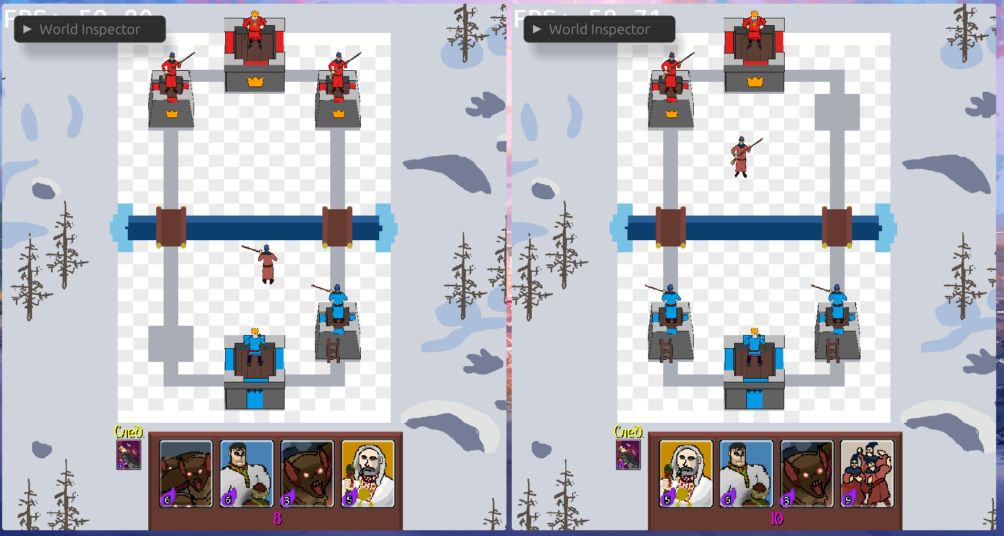
Рисунок 1. Пример работы программы

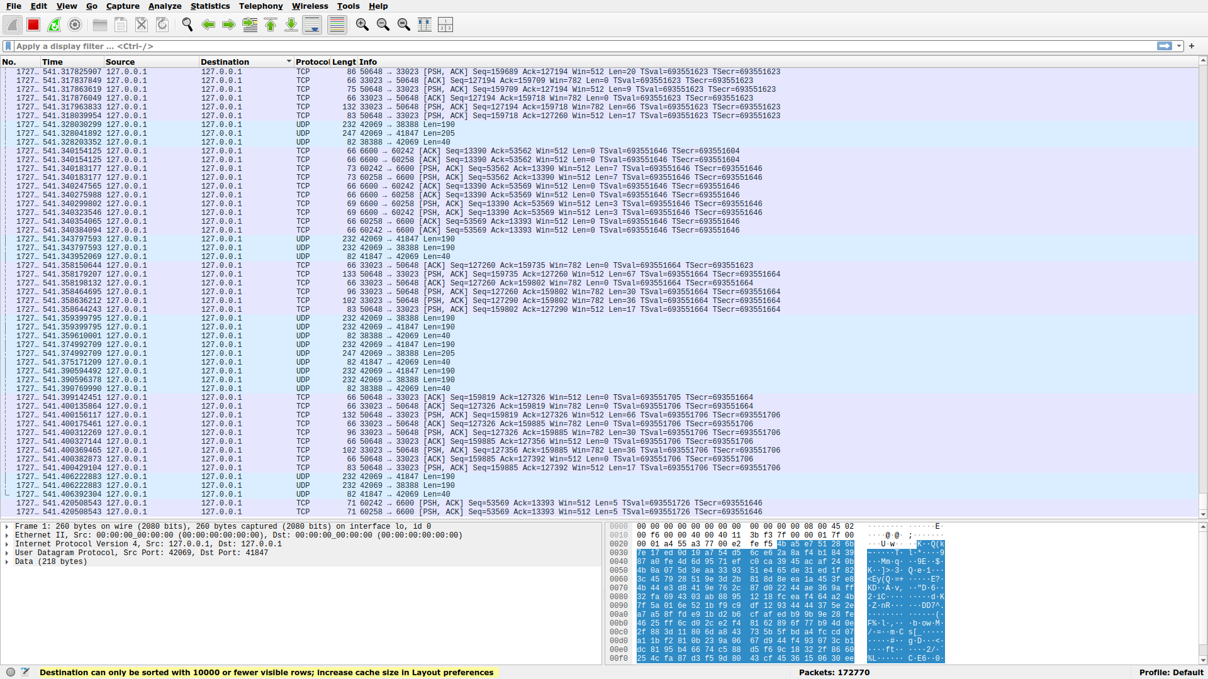
Рисунок 2. Wireshark

Код сервера:
use core::f32;

use bevy::{prelude::*, utils::HashMap};
use bevy_quinnet::{
server::{
certificate::CertificateRetrievalMode, ConnectionEvent, QuinnetServer,
QuinnetServerPlugin, ServerEndpointConfiguration,
},
shared::ClientId,
};
use common::{
ArenaPos, Card, ClientMessage, Direction, Health, PlayerNumber, ServerChannel,
ServerMessage, Unit, UnitState, LOCAL_BIND_IP, SERVER_HOST, SERVER_PORT,
};

use crate::{
ai::{Attack, Movement, StunnedTimer},
units::{Giant, SpawnUnit},
};

pub(super) fn plugin(app: &mut App) {
app.add_plugins(QuinnetServerPlugin::default());

app.init_resource::<Lobby>();
app.add_systems(Startup, start_listening);
app.add_systems(Update, (handle_connection_events, handle_client_messages));

app.add_systems(FixedPostUpdate, sync_entities);
}

fn start_listening(mut server: ResMut<QuinnetServer>) {
server
.start_endpoint(
ServerEndpointConfiguration::from_ip(LOCAL_BIND_IP, SERVER_PORT),
CertificateRetrievalMode::GenerateSelfSigned {
server_hostname: SERVER_HOST.to_string(),
},
ServerChannel::channels_config(),
)
.unwrap();
}

#[derive(Resource, Default, Deref, DerefMut)]
pub struct Lobby(HashMap<ClientId, PlayerNumber>);

fn handle_connection_events(
mut connection_events: EventReader<ConnectionEvent>,
mut lobby: ResMut<Lobby>,
mut server: ResMut<QuinnetServer>,
mut cmd: Commands,
) {
let lobby_len = lobby.len() as u8;
for client in connection_events.read() {
if lobby_len >= 2 {
server.endpoint_mut().disconnect_client(client.id).unwrap();
continue;
}
use PlayerNumber::*;

let player_num = match lobby_len {
0 => One,
1 => Two,
_ => unreachable!(),
};
lobby.insert(client.id, player_num);

if lobby.len() == 2 {
// Отправить каждому игроку его PlayerNumber
for (client_id, player_num) in lobby.iter() {
server
.endpoint_mut()
.send_message_on(
*client_id,
ServerChannel::OrderedReliable,
ServerMessage::StartGame(*player_num),
)
.unwrap();
}

Unit::ArcherTower.spawn(ArenaPos(-5.5, -9.5), One, &mut cmd);
Unit::KingTower.spawn(ArenaPos(0., -13.), One, &mut cmd);
Unit::ArcherTower.spawn(ArenaPos(5.5, -9.5), One, &mut cmd);

Unit::ArcherTower.spawn(ArenaPos(-5.5, 9.5), Two, &mut cmd);
Unit::KingTower.spawn(ArenaPos(0., 13.), Two, &mut cmd);
Unit::ArcherTower.spawn(ArenaPos(5.5, 9.5), Two, &mut cmd);
}
}
}

fn handle_client_messages(
mut server: ResMut<QuinnetServer>,
lobby: Res<Lobby>,
mut cmd: Commands,
) {
let endpoint = server.endpoint_mut();
for client_id in endpoint.clients() {
while let Some((_, message)) =
endpoint.try_receive_message_from::<ClientMessage>(client_id)
{
let player_num = lobby.get(&client_id).unwrap();
match message {
ClientMessage::PlayCard { card, placement } => match card {
Card::Rus => Unit::Rus.spawn(placement, *player_num, &mut cmd),
Card::Musketeer => Unit::Musketeer.spawn(placement, *player_num, &mut cmd),
Card::ThreeMusketeers => {
let ArenaPos(x, y) = placement;
Unit::Musketeer.spawn(ArenaPos(x, y + 0.8), *player_num, &mut cmd);
Unit::Musketeer.spawn(ArenaPos(x + 0.8, y), *player_num, &mut cmd);
Unit::Musketeer.spawn(ArenaPos(x - 0.8, y), *player_num, &mut cmd);
}
Card::Bats => {
let ArenaPos(x, y) = placement;
Unit::Bat.spawn(ArenaPos(x, y + 0.8), *player_num, &mut cmd);
Unit::Bat.spawn(ArenaPos(x + 0.8, y), *player_num, &mut cmd);
Unit::Bat.spawn(ArenaPos(x - 0.8, y), *player_num, &mut cmd);
}
Card::BatHorde => {
let ArenaPos(x, y) = placement;
Unit::Bat.spawn(ArenaPos(x + 0.5, y + 0.5), *player_num, &mut cmd);
Unit::Bat.spawn(ArenaPos(x + 0.8, y), *player_num, &mut cmd);
Unit::Bat.spawn(ArenaPos(x + 0.5, y - 0.5), *player_num, &mut cmd);
Unit::Bat.spawn(ArenaPos(x - 0.5, y - 0.5), *player_num, &mut cmd);
Unit::Bat.spawn(ArenaPos(x - 0.8, y), *player_num, &mut cmd);
Unit::Bat.spawn(ArenaPos(x - 0.5, y + 0.5), *player_num, &mut cmd);
}
Card::Priest => Unit::Priest.spawn(placement, *player_num, &mut cmd),
Card::Bomber => Unit::Bomber.spawn(placement, *player_num, &mut cmd),
Card::Giant => Unit::Giant.spawn(placement, *player_num, &mut cmd),
},
}
}
}
}

trait DefaultDirection {
fn default_direction(&self) -> Direction;
}
impl DefaultDirection for PlayerNumber {
fn default_direction(&self) -> Direction {
match self {
PlayerNumber::One => Direction::Up,
PlayerNumber::Two => Direction::Down,
}
}
}

fn calc_direction(direction: &ArenaPos) -> Direction {
let mut angle = direction.0.acos() * 180. / f32::consts::PI;
if direction.1 < 0. {
angle = -angle + 360.;
}

match angle {
0.0..20. | 340.0..360. => Direction::Right,
20.0..160. => Direction::Up,
160.0..200. => Direction::Left,
200.0..340. => Direction::Down,
_ => Direction::Right,
}
}

fn sync_entities(
units: Query<(
Entity,
&ArenaPos,
&UnitState,
&Attack,
Option<&Movement>,
&PlayerNumber,
&Health,
Option<&StunnedTimer>,
)>,
giants: Query<(
Entity,
&ArenaPos,
&UnitState,
&Giant,
&Movement,
&PlayerNumber,
&Health,
Option<&StunnedTimer>,
)>,
projectiles: Query<(Entity, &ArenaPos), Without<PlayerNumber>>,
positions: Query<&ArenaPos>,
mut server: ResMut<QuinnetServer>,
) {
let mut u = Vec::new();
for (entity, pos, state, attack, movement, player_num, health, stun) in &units {
let direction = match state {
UnitState::Idle => player_num.default_direction(),
UnitState::Moving => {
let movement = movement.unwrap();
match movement.target {
Some(m) => {
let Ok(target_pos) = positions.get(m) else {
continue;
};
calc_direction(&pos.direction(target_pos))
}
None => player_num.default_direction(),
}
}
UnitState::Attacking => match attack.target {
Some(a) => {
let Ok(target_pos) = positions.get(a) else {
continue;
};
calc_direction(&pos.direction(target_pos))
}
None => player_num.default_direction(),
},
};
let mut state = *state;
if let Some(_) = stun {
state = UnitState::Idle
}
u.push((entity, *pos, direction, state, *health));
}
for (entity, pos, state, giant, movement, player_num, health, stun) in &giants {
let direction = match state {
UnitState::Idle => player_num.default_direction(),
UnitState::Moving => match movement.target {
Some(m) => {
let Ok(target_pos) = positions.get(m) else {
continue;
};
calc_direction(&pos.direction(target_pos))
}
None => player_num.default_direction(),
},
UnitState::Attacking => match giant.target {
Some(a) => {
let Ok(target_pos) = positions.get(a) else {
continue;
};
calc_direction(&pos.direction(target_pos))
}
None => player_num.default_direction(),
},
};
let mut state = *state;
if let Some(_) = stun {
state = UnitState::Idle
}
u.push((entity, *pos, direction, state, *health));
}

let mut p = Vec::new();
for (entity, position) in &projectiles {
p.push((entity, *position));
}

server
.endpoint_mut()
.broadcast_message_on(
ServerChannel::Unreliable,
ServerMessage::SyncEntities {
units: u,
projectiles: p,
},
)
.unwrap();
}
Код клиента:
use bevy::{prelude::*, utils::HashMap};
use bevy_quinnet::client::{
certificate::CertificateVerificationMode, connection::ClientEndpointConfiguration,
QuinnetClient, QuinnetClientPlugin,
};
use common::{
ArenaPos, ClientChannel, Direction, Health, PlayerNumber, ServerMessage, UnitState,
LOCAL_BIND_IP, SERVER_HOST, SERVER_PORT,
};

use crate::screens::GameState;

use super::{
projectiles::SpawnProjectile,
units::{AssociatedTower, SpawnUnit},
};

pub(super) fn plugin(app: &mut App) {
app.add_plugins(QuinnetClientPlugin::default());

app.init_resource::<PlayerNumber>();
app.init_resource::<NetworkMapping>();
app.register_type::<NetworkMapping>();

app.add_systems(OnEnter(GameState::Gameplay), start_connection);
app.add_systems(
Update,
handle_server_messages.run_if(in_state(GameState::Gameplay)),
);
}

fn start_connection(mut client: ResMut<QuinnetClient>) {
client
.open_connection(
ClientEndpointConfiguration::from_ips(SERVER_HOST, SERVER_PORT, LOCAL_BIND_IP, 0),
CertificateVerificationMode::SkipVerification,
ClientChannel::channels_config(),
)
.unwrap();
}

trait AdjustForPlayer {
fn adjust_for_player(&self, player_num: PlayerNumber) -> Self;
}
impl AdjustForPlayer for ArenaPos {
fn adjust_for_player(&self, player_num: PlayerNumber) -> Self {
match player_num {
PlayerNumber::One => *self,
PlayerNumber::Two => ArenaPos(-self.0, -self.1),
}
}
}
impl AdjustForPlayer for Direction {
fn adjust_for_player(&self, player_num: PlayerNumber) -> Self {
match player_num {
PlayerNumber::One => *self,
PlayerNumber::Two => self.opposite(),
}
}
}

fn handle_server_messages(
mut client: ResMut<QuinnetClient>,
mut player_num: ResMut<PlayerNumber>,
mut cmd: Commands,
mut network_mapping: ResMut<NetworkMapping>,
mut units_query: Query<(&mut ArenaPos, &mut Direction, &mut UnitState, &mut Health)>,
mut projectiles_query: Query<&mut ArenaPos, Without<UnitState>>,
towers: Query<&AssociatedTower>,
) {
while let Some((_, message)) = client
.connection_mut()
.try_receive_message::<ServerMessage>()
{
match message {
ServerMessage::StartGame(n) => *player_num = n,
ServerMessage::SpawnUnit {
server_entity,
unit,
pos,
owner,
} => {
unit.spawn(
server_entity,
pos.adjust_for_player(*player_num),
owner,
&mut cmd,
);
}
ServerMessage::SpawnProjectile {
server_entity,
projectile,
attacker,
receiver,
pos,
} => projectile.spawn(
server_entity,
attacker,
receiver,
pos.adjust_for_player(*player_num),
&mut cmd,
),
ServerMessage::Despawn(server_entity) => {
let Some(entity) = network_mapping.remove(&server_entity) else {
continue;
};
if let Ok(tower) = towers.get(entity) {
cmd.entity(tower.0).despawn();
}
cmd.entity(entity).despawn();
}
ServerMessage::SyncEntities { units, projectiles } => {
for (server_entity, pos, direction, state, health) in &units {
let Some(&entity) = network_mapping.get(server_entity) else {
continue;
};
let (mut p, mut d, mut s, mut h) = units_query.get_mut(entity).unwrap();
*p = pos.adjust_for_player(*player_num);
*d = direction.adjust_for_player(*player_num);
*s = *state;
*h = *health;
}

for (server_entity, pos) in &projectiles {
let Some(&entity) = network_mapping.get(server_entity) else {
continue;
};
let mut p = projectiles_query.get_mut(entity).unwrap();
*p = pos.adjust_for_player(*player_num);
}
}
}
}
}

#[derive(Resource, Reflect, Default, Deref, DerefMut)]
#[reflect(Resource)]
// Сопоставление Entity сервера и клиента
pub struct NetworkMapping(HashMap<Entity, Entity>);

Выводы:
Разработана программа использующая сокеты в контексте игрового программирования для реализации взаимодействия между сервером и клиентом.

