Software Requirements Specification
for
Virtual Tour Group
Version 1.0 approved
Prepared by Nathaniel Ragadale, Stephen Morris, Drake Wempe
WWU CS Department
2/9/15

Revision History
Version | Description | Date
1.0 | Original document finished | 2/13/15

Contents
Revision History 2
1. Introduction 4
1.1 Purpose 4
1.2 Intended Audience 4
1.3 Project Scope and Product Features 4
1.4 ​Major Features 4
1.5 References 4
2. Overall Description 4
2.1 Product perspective 4
2.2 Context Diagram 4
2.3 User Classes 5
2.4 Operating Environment 5
2.5 Constraints 5
2.6 Assumptions and Dependencies 5
3. System Features 6
3.1 Functional Requirements 6
3.2 Use Cases Definitions 6
4. External Interface Requirements 7
4.1 User Interfaces 7
4.2 Software Interfaces 7
5. Other Nonfunctional Requirements 7
5.1 Performance requirements 7
5.2 Security Requirements 7
5.3 Project Documentation 7
5.4 User Documentation 7
5.5 Software Quality Attributes 8
Appendix A: Glossary 8
Appendix B: Data Dictionary 8
Appendix C: …etc… 8

Introduction

Purpose

This project is a redesign and a port of the prior WWU CS Dept. Virtual Tour application for android and iPhone devices.

Intended Audience

The intended audience of this document are the representatives of the CS Department at Western Washington University.

Project Scope and Product Features
For prospective CS Majors and/or Western students who are interested in learning more about WWU's CS department and what goes on in the various rooms within. The Virtual Tour app is a redesigned mobile application that connects to a database via a web API to fetch and display content concerning the WWU Computer Science department and a full fledged iPhone app that works the same.

​Major Features
- FE1: An interactive map of the department.
- FE2: Each room has it's own page with specific content related to it, such as videos, descriptions, and pictures.
- FE3: Scannable QR capabilities with codes outside of the rooms.
- FE4: Has a “Western” look and feel, much like the website.
- FE5: iPhone compatibility.

References
- Software Requirements 2nd Edition, Karl E Weigers Microsoft Press, Redmond, Washington, 2003
- Vision and Scope Document <1.1, 1/30/15>
- Use case Document<version and date>

Overall Description

Product perspective
The representative of the CS Department at WWU are in charge of many functions for the department, including making information about the department readily available for students. But they can't be around all the time to give details to visitors. So they would like an app that gives visitors a virtual tour of the department, showing the visitor what rooms are what, and providing a descripiton and maybe some pictures/videos related to the room, such that visitors that stop by while the representatives are unavailable will still be able to get a good feel for what goes on in the department.

Context Diagram
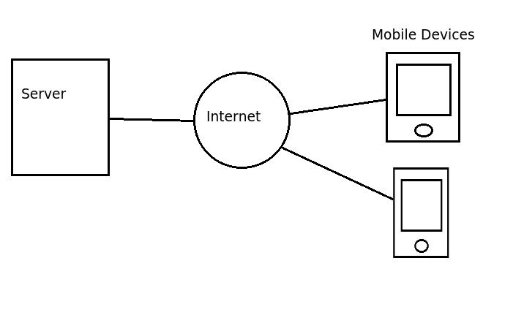

User Classes
- UCR-1 Prospective/current WWU CS Majors and/or their parents: These users will access the app in order to get a feel for the department and a guided tour without a representative present.
- UCR-2 Department Staff: To inform UCR-1 about the existence of the app and to update the content of the stops.

Operating Environment
This product will be operating on iOS and Android enabled devices that are able to connect to the Internet, and the only known constraints on the use of the product at this time happen to be the user's lack of iOS/Android compatible device and a lack of Internet access.

Constraints TBD
- OC-1 Apple app store my not be accepting of our app.

Assumptions and Dependencies
- AS1: A semi-functioning android app already exists with majority of features implemented and without major errors.
- AS2: Content will be provided by customers

System Features

Functional Requirements
- FR-01
  - FE1
  - UC-01
  - An interactive map of the department.
  - The app shall display a map with selectable rooms
- FR-02
  - FE2
  - UC-02, UC-03
  - Each room has it's own page with specific content related to it.
  - The app shall retrieve and display content related to selected room on screen
- FR-03
  - FE3
  - TBD
  - Scannable QR capabilities with codes outside of the rooms.
  - TBD
- FR-04
  - FE4
  - TBD
  - Has a “Western” look and feel, much like the website.
  - The app's design shall reflect that of the Western website.
- FR-05
  - FE5
  - TBD
  - The app will need to work on iPhones as well
  - The app shall function the same, and look the same, on an iPhone.

Use Cases Definitions
Use Case ID: | UC-01
Use Case Name: | Open App
  Created By: | Virtual Tour Team(VTT)
  Date Created: | 2/9/15
  Last Updated By: | VTT
  Date Last Updated: | 2/9/15
Actors: | User
Description: | When the user attempts to open the app, it will display the overview map.

Use Case ID: | UC-02
Use Case Name: | Select Stop
  Created By: | VTT
  Date Created: | 2/9/15
  Last Updated By: | VTT
  Date Last Updated: | 2/9/15
Actors: | User
Description: | The user taps on a stop(a room) from the map, and the system displays a new screen about the stop.

Use Case ID: | UC-03
Use Case Name: | Next/Previous Stop
  Created By: | VTT
  Date Created: | 2/9/15
  Last Updated By: | VTT
  Date Last Updated: | 2/9/15
Actors: | User
Description: | The user selects next/previous stop from current page, and the system displays a new screen about the next/previous stop.

Use Case ID: | UC-04
Use Case Name: | QR code use
  Created By: | VTT
  Date Created: | 2/13/15
  Last Updated By: | VTT
  Date Last Updated: | 2/13/15
Actors: | User
Description: | The user scans QR code outside of a stop and the content for the stop is displayed.

External Interface Requirements

User Interfaces
- UI-1 All pages of the app shall follow Western's Style Guide, found here: http://www.wwu.edu/sites/default/files/brand/Style_Guide_2012.pdf

Hardware Interfaces
- HI-1 All content shall be usable on Android and iPhone mobile devices.

Software/System Interfaces

TBD

User Inputs
- UIP-1 QR code scans.

System Outputs
- SO-1 A page with content for each room.

Other Nonfunctional Requirements

Performance requirements TBD

Safety Requirements
N/A

Security Requirements
N/A

Project Documentation
- PD-1: Vision and Scope Document
- PD-2: Software Requirements Specification
- PD-3: Traceability Matrix/Change Log
- PD-4: Use Case Document

User Documentation
TBD

Software Quality Attributes TBD

Appendix A: Glossary

Appendix B: Analysis Models

Appendix C: …etc…

