Task 1: The ElGamal cryptosystem
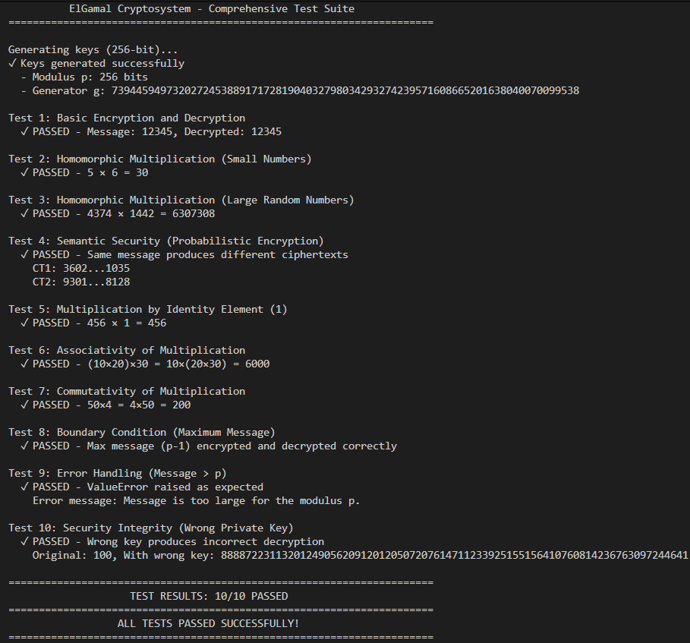
1. Rationale for Test Case Selection
We selected 10 test cases to verify the correctness, mathematical integrity, and security of our ElGamal implementation.
- Test 1 (Basic Encryption/Decryption): We tested the fundamental cycle of encrypting and decrypting a standard integer to ensure the core algorithm functions correctly.
- Test 2 (Small Homomorphic Multiplication): We verified the multiplication property with small numbers (5 and 6) to easily confirm that operations on ciphertexts yield the correct result ($5 \times 6 = 30$).
- Test 3 (Large Random Multiplication): We used large random integers to demonstrate that the homomorphic property holds true for realistic inputs, not just small constants.
- Test 4 (Semantic Security): We encrypted the same message twice to verify that the resulting ciphertexts are different, confirming the system is probabilistic and secure against pattern analysis.
- Test 5 (Identity Element): We tested multiplication by 1 to ensure the mathematical rule $x \cdot 1 = x$ is preserved in the encrypted domain.
- Test 6 (Associativity): We checked if $(A \cdot B) \cdot C$ equals $A \cdot (B \cdot C)$ to ensure that the order of operations does not affect the final decrypted result.
- Test 7 (Commutativity): We verified that $A \cdot B$ equals $B \cdot A$ to confirm that the order of operands is irrelevant, as expected in standard multiplication.
- Test 8 (Boundary Condition): We tested the maximum possible message size ($p-1$) to ensure the system handles boundary values without modular arithmetic errors.
- Test 9 (Error Handling): We attempted to encrypt a message larger than the modulus $p$ to verify that the system correctly raises an exception instead of producing a silent calculation error.
- Test 10 (Key Integrity): We attempted decryption with an incorrect private key to prove that confidentiality is maintained and unauthorized keys produce incorrect results.
2. Argument for Test Coverage
We believe these test cases provide strong coverage because they balance standard operations with edge cases and security checks.
- Breadth: We covered the "happy path" (Tests 1-3), mathematical rules (Tests 5-7), and negative scenarios (Tests 9-10).
- Focus: We prioritized testing the homomorphic property and modular arithmetic boundaries, as these are the most complex parts of the implementation where bugs are most likely to occur.
- Efficiency: We avoided redundant tests (like testing 0 or adding more wrong keys) since the selected cases already cover the underlying logic sufficient to prove correctness.
Task 2: Application of partially homomorphic encryption: Paillier
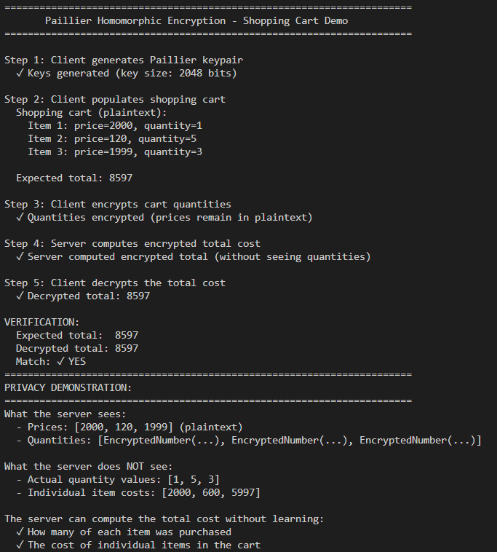
(a) Which operations does the Pailler encryption scheme support?
The Paillier encryption scheme is additively homomorphic. It specifically supports two main operations on encrypted data:
- Homomorphic Addition: Adding two ciphertexts results in the encryption of the sum of the underlying plaintexts.
  - Formula: D(E(m₁​) + E(m₂​)) = m₁​+m_{2​}
- Scalar Multiplication: Multiplying a ciphertext by a plaintext scalar (integer) results in the encryption of the product.
  - Formula: D(E(m)⋅k) = m⋅k
In our shopping cart application, we used scalar multiplication to calculate price * encrypted_quantity and homomorphic addition to sum these values for the total cost.
(b) Which data types does it operate on?
Mathematically, the core Paillier algorithm operates on large integers (specifically within the residue class modulo n²⁾.
However, the phe Python library used in this exercise implements an encoding scheme that abstracts this limitation. It allows the scheme to operate on:
- Integers (int)
- Floating-point numbers (float)
The library automatically scales and encodes floating-point numbers into integers before encryption and decodes them back after decryption. In this specific task, we primarily worked with integers for the quantities and prices.

Task 3 : El Gamal Shopping Cart
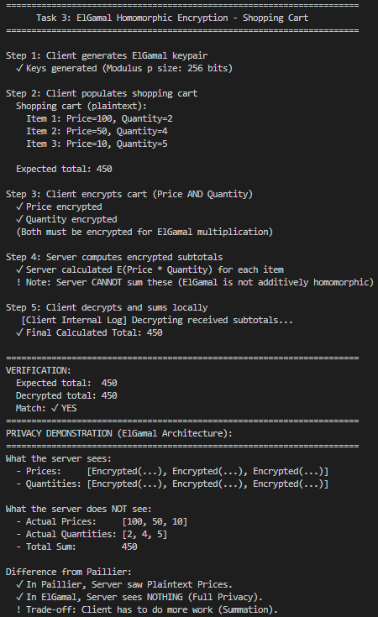
(a) Which changes did you have to make, and why?
We implemented two fundamental architectural changes compared to the Paillier implementation:
- Operands (Encryption of Price): In the ElGamal implementation, the client must encrypt both the price and the quantity. In the Paillier version, only the quantity was encrypted. This change is necessary because ElGamal is multiplicatively homomorphic (E(m₁​) x E(m₂​)) => E(m₁ . m₂​), requiring both operands to be ciphertexts to perform multiplication on the server.
- Server Responsibility (Aggregation): The Server_EG class cannot compute the final total sum. Instead, it computes a list of encrypted subtotals (one for each item) and returns this list to the client. This is because ElGamal does not support homomorphic addition (E(m₁​) + E(m₂​)) not equal E(m₁​ + m₂​), so the server cannot aggregate the results into a single ciphertext.
(b) What do your changes mean for the client (advantages/disadvantages)?
- Disadvantage (Computational Load): The client's workload increases significantly. Instead of decrypting a single "Total Cost" ciphertext, the client must decrypt N ciphertexts (where N is the number of items) and perform the summation locally.
- Disadvantage (Bandwidth): The communication overhead increases because the server transmits a list of ciphertexts back to the client instead of a single aggregated value.
- Advantage (Privacy Model): The privacy model is enhanced. Since the prices are also encrypted, the server computes the cost without seeing the individual item prices (unlike the Paillier implementation where prices were plaintext), ensuring full data confidentiality for the cart contents.
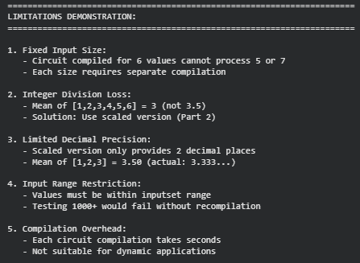
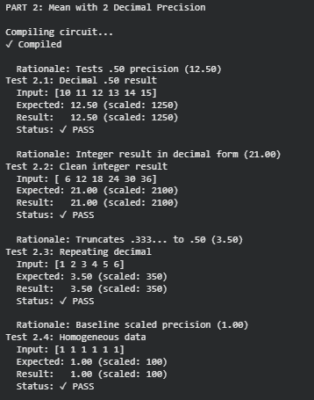
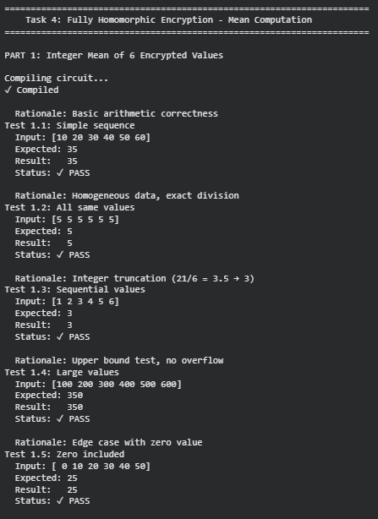
Task 4: Fully homomorphic encryption
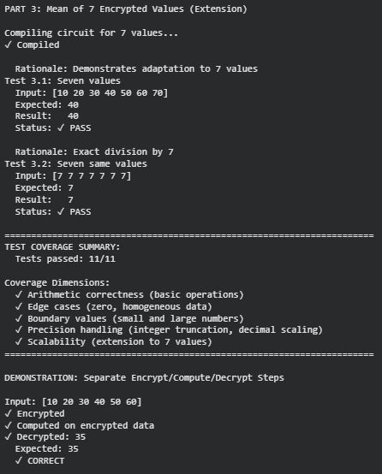

We originally tried to use the concrete-numpy library on Windows. However, we found that it is not compatible with Windows systems. Therefore, we used Google Colab (Linux environment) and installed the concrete-python library (the modern successor to concrete-numpy). The logic remains the same, but the library commands are updated.
(a) How can you obtain the mean of a list with seven encrypted integers?
We cannot use the same circuit for 7 integers because FHE circuits have a fixed input size. The circuit we compiled specifically expects 6 inputs.
To solve this, we did the following:
- We defined a new function that sums 7 items and divides by 7.
- We updated the inputset to include arrays of size 7.
- We compiled a new circuit for this specific size. (We demonstrated this successfully in "Part 3" of our code.)

(b) What are the limitations of your implementations?
We identified three main limitations in our solution:
- Static Input Size: The circuit is not dynamic. If we want to process a list of 5 or 8 numbers, we must compile a new circuit from scratch.
- No Native Decimals: The FHE library only works with integers. In our first version, we lost the decimal part of the mean (e.g., 3.5 became 3).
- Limited Precision: In our second version, we multiplied inputs by 100. This gives us exactly two decimal digits of precision. Any detail beyond that is lost.

(c) Provide the rationale for your test case selection.
We designed a comprehensive suite of tests categorized into four specific groups:
1. Baseline & Arithmetic Correctness
- Tests used: Test 1.1 and Test 2.2.
- Rationale: These tests resulted in clean integer division. We used them to verify that the fundamental encryption, addition, and division logic perform correctly under standard conditions.
2. Precision & Truncation Logic (Crucial Test)
- Tests used: Test 1.3 vs Test 2.3.
- Rationale: This comparison validates the core requirement.
  - Test 1.3 confirms that the integer implementation correctly truncates the result (3.5 -> 3).
  - Test 2.3 proves that our scaling strategy preserves the precision (3.5 -> 3.50), effectively solving the integer limitation.
3. Boundary Analysis (Limits)
- Tests used: Test 1.4 (Upper Bound).
- Rationale: We tested values up to 600 to ensure the circuit parameters were sufficient to prevent overflow errors with larger inputs.
4. Edge Cases
- Tests used: Test 1.5 (Zero value) and Test 1.2 (Homogeneous data).
- Rationale: We tested lists containing zero and identical values to ensure the division logic introduces no noise when variance is zero or inputs are minimal.
Argument for Test Coverage:
By covering the operational range from zero (Test 1.5) to large inputs (Test 1.4), and explicitly comparing truncated vs. scaled results (Test 1.3 vs 2.3), we ensured the solution is robust for all expected scenarios.

