2026 CQU_MCM

Problem B Sand Control is Meticulous Work

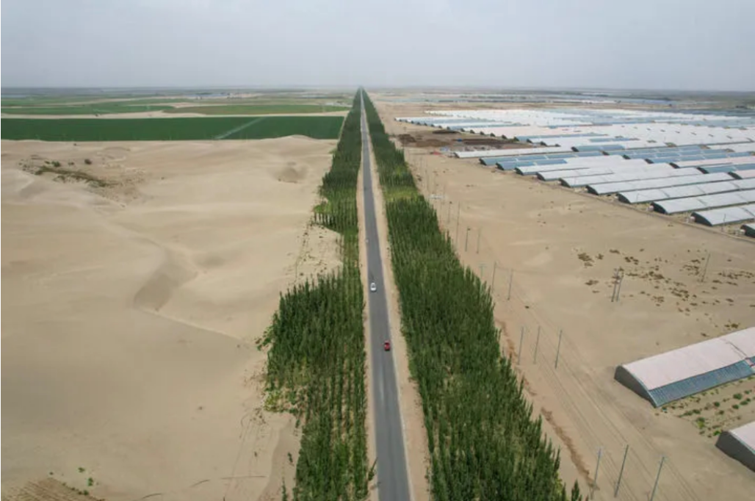

Background
The Taklamakan Desert covers about 337,600 square kilometers. It is China’s largest desert and one of the most arid regions in the world. In November 2024, the green sand-blocking protective belt around the desert, with a total length of about 3,046 kilometers, achieved “full-line closure,” marking the spatial completion of the “edge-locking” project. However, “locking” does not mean “holding.” Sand control is not a one-time construction effort, but a system that continues to operate under disturbances from water, funding, labor, and disasters.
Modeling Tasks
Task 1: Coupled Vegetation–Water–Sand Dynamic Model
Select a representative section of the edge-locking belt (along the desert margin, tens of meters to several kilometers wide and tens to hundreds of kilometers long), and establish a coupled dynamic model of vegetation coverage and effective soil moisture content. Consult relevant data to study changes in the state variables and their influencing factors.
Task 2: Optimal Process Design for Investment, Scheduling, and Human Resources
Based on the water constraints and vegetation dynamics determined in Task 1, treat the construction process of the edge-locking project as an optimal control or dynamic optimization problem. The decision variables should include at least: the annual newly treated area; the annual ecological water replenishment scheduling volume; the allocation ratio of investment among construction, operation and maintenance (O&M), and revenue-generating supporting facilities such as photovoltaics; and labor input. The objective function needs to make an explicit trade-off between ecological benefits and economic costs. On this basis, consider the following questions:
- Solve for the optimal construction trajectory under a given total budget and planning horizon (recommended: 10–20 years).
- Analyze the sensitivity of the investment structure (including photovoltaics, O&M, and other aspects).
- Provide an actionable process criterion.
Task 3: Resilience Assessment and Long-Term Benefit Prediction under Disaster Shocks
The edge-locking belt in the Taklamakan is not in a steady-state environment. Sandstorms, extreme droughts, wind erosion, and sand burial can destroy years of construction achievements in a short time, while climate change trends themselves are changing the baselines of wind speed and humidity index. You are required to introduce stochastic disaster processes and long-term projections into the models from Tasks 1–2.
Task 4: Based on the above research, write a one-page brief to explain to relevant departments and the public whether China’s sand-control projects are feasible, how they should be implemented, the fiscal burden, expected benefits, and other issues of general concern.

Your PDF solution of no more than 25 total pages should include:

1. One-page Summary Sheet
2. Table of Contents
3. Your complete solution
4. Executive Summary (may be integrated into the complete solution)
5. In-text Citations and Reference List
6. AI Use Report (if used, does not count toward the 25-page limit)

