**2021 Logic Design- Final**

1. Design the logic circuit for the Boolean function F(A, B, C, D) = Σ(1, 3, 4, 11, 12, 13, 14, 15) with (1) a 4-to-16-line decoder and OR gates and (2) a 8-to-1Multiplexer. (20%)

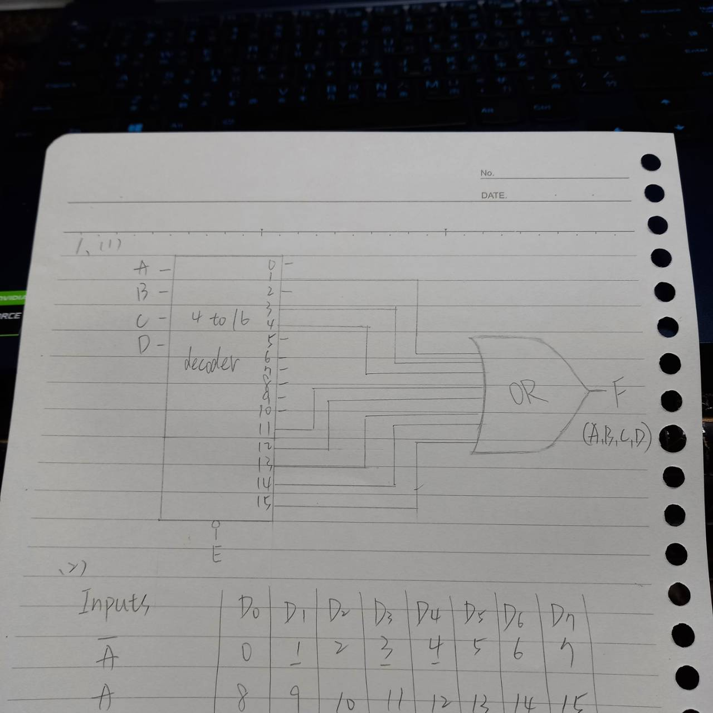

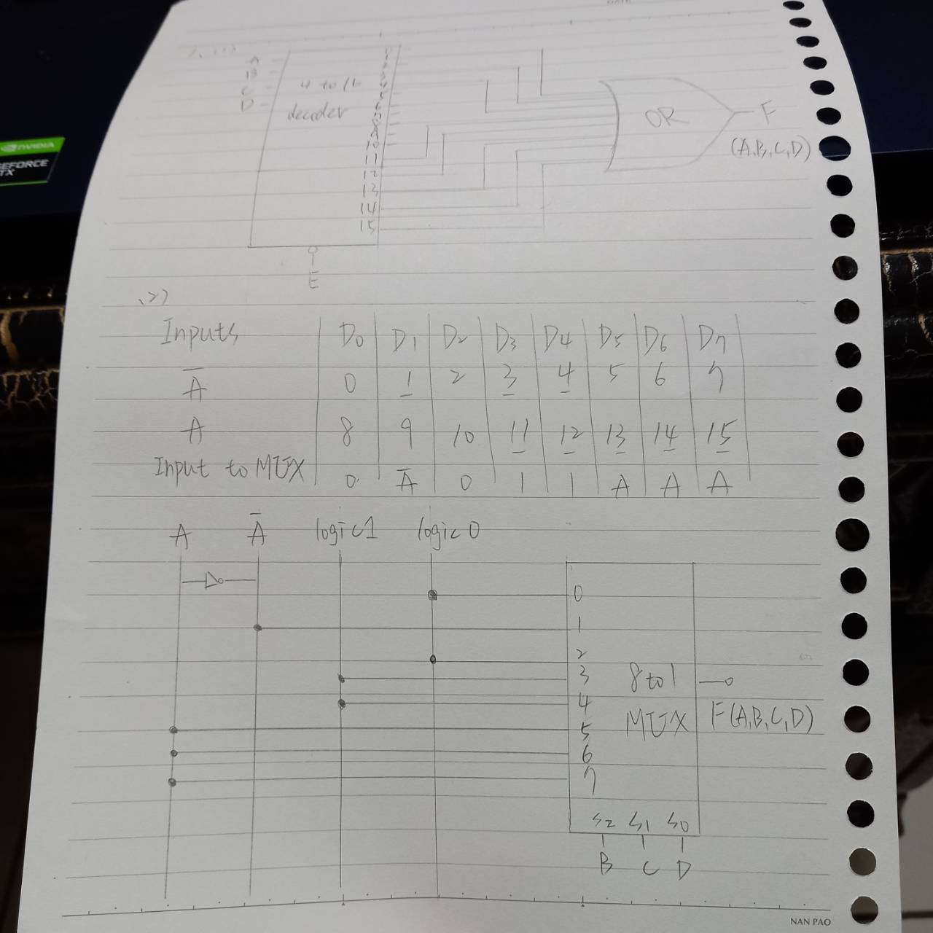

1. Analysis the following sequential circuit. (40%)

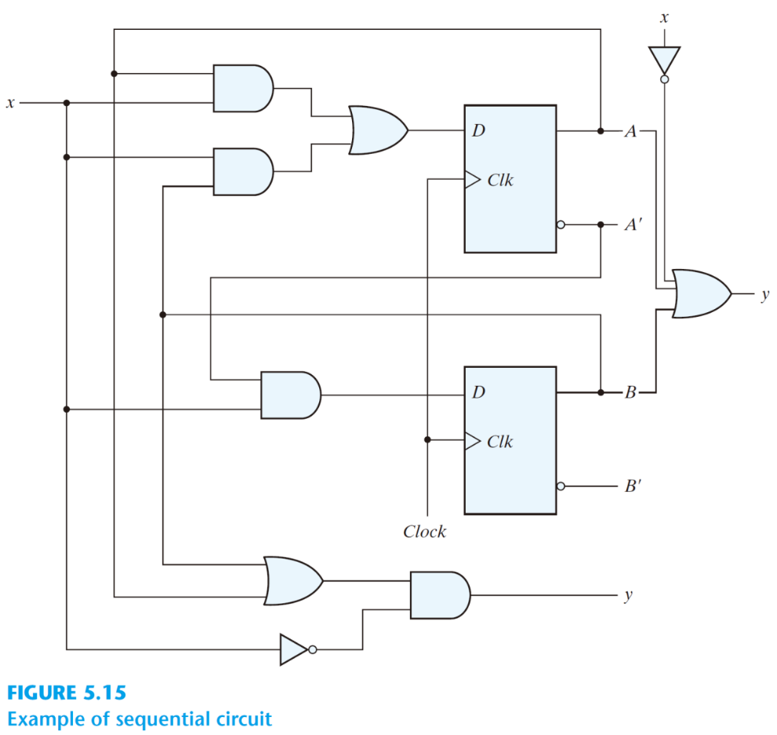

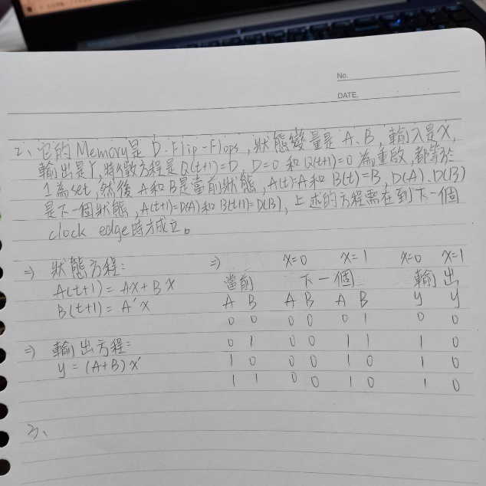

1. Design a circuit that detects a sequence of three or more consecutive 1’s in a string of bits coming through an input line. (40%)



