AI acknowledgement coversheet
This coversheet is designed to help you acknowledge any AI use in your assessment. If your course coordinator provides a course-specific template, please use that instead.

The AI Student Hub has more information about using AI in assessment.

Your details
Name: Jie Wen
Student Number: 48559489

Assessment details
Course: DECO7230 Digital Prototyping and Extended Reality
Assignment: Design Concept Report

AI use
Select the option that applies:
Yes, AI tools have been used to generate or edit material in this document
No, AI tools have not been used to generate or edit material in this document

Details of use
Record the following information when acknowledging the use of AI tools:
- AI tool (e.g. Copilot, ChatGPT, Claude, Gemini)
- description of how you used the tool (e.g. edited, corrected, translated, planned, brainstormed)
- prompt(s) used
- relevant part, section, or page of the assessment
- date.
Complete the table below with this information.
Tool | Use | Prompt(s) | Section | Date
ChatGPT | Used to check spelling  and grammar and edit  my final document | Ensure my report’s grammatical accuracy | Entire work | 06 October 2026

This coversheet has been adapted with thanks to BIOM3020 Integrated Endocrinology.

MiroXR: Embodied Sticky Note Organisation
Concept Overview
Prototype 2 is an XR-based interactive environment in which users interact with virtual sticky notes using a Meta Quest controller. Based on findings from the first design evaluation, the second prototype focuses on improving interaction clarity, reducing unnecessary complexity, and providing more direct spatial interaction.
The second evaluation investigates whether the refined XR interactions are understandable, usable, and reliable when experienced on an actual Meta Quest 3S device.

Evaluation Goals / Research Questions
RQ1 — Interaction
Can users understand how to select and interact with virtual notes using the Quest controller?
RQ2 — Usability
Can users complete the main interaction tasks with minimal errors or assistance?
RQ3 — Experience
Does the revised XR environment provide a clearer and more manageable experience than the previous prototype?

Research Method
Participants：4 participants were recruited for the evaluation ( in week9 studio).
Equipment：Meta Quest 3S / Unity prototype / Quest controllers / Observation sheet / Post-test interviews
Procedure：1 Introduction + consent ；2 Brief explanation of the XR environment；3 Participant wears Quest 3S；4 Complete predefined tasks；5 Researcher observes performance；6 Short post-test interview/questionnaire
Think-aloud was not used as the primary method in Evaluation 2 because participants in the previous evaluation reported discomfort with continuously verbalising their actions. Instead, behavioural observation was combined with post-task interviews to reduce interference with the XR experience.
The Design Evaluation 2 usability testing was conducted during the Week 9 Studio session with four student participants.

Task
Task 1: Identify a note that can be interacted with.
Task 2: Select/pick up the target note using the controller.
Task 3: Move or interact with the note as intended.
Task 4: Release/complete the interaction without researcher assistance.
Success Criteria / Metrics
Metric | Target
Task completion rate | ≥ 80%
Successful interaction without assistance | ≥ 75%
Major errors | ≤ 1 per participant
Researcher assistance | ≤ 1 time per participant
Overall usability rating | ≥ 3/4

Result
Four classmates participated in the evaluation during the Week 9 Studio. All participants completed all four tasks, giving an overall task completion rate of 100% (16/16), including tasks completed with assistance. Fifteen tasks were completed independently (93.75%), and three participants completed the entire task sequence without assistance. P02 initially pressed the grip button when attempting to select a note and required one prompt to use the index trigger. No other errors or researcher interventions were recorded. The mean usability rating was 4.75/5, with individual ratings of 5, 4, 5 and 5. All four participants completed the four tasks successfully, with only one participant requiring assistance during the selection task. Detailed records are provided in Appendix A, Figure A1.
Findings
Observation and interview records indicated that the interactive notes were easy to identify and that the existing visual feedback clearly communicated interaction states. The main observed usability issue concerned controller button mapping: P02 understood the interaction after a brief prompt but did not initially identify the correct button.
Discussion
These results suggest that the core interaction sequence was usable within this small studio sample. However, successful completion did not always indicate independent first-use understanding. P02’s difficulty highlights an opportunity to make the required controller input more explicit. Placement and additional feedback suggestions represent opportunities for refinement despite successful task performance. The evaluation involved only four classmates, all with some previous VR experience, so the findings may not represent first-time VR users. These results alone also do not establish improvement over the previous prototype.
Proposed Design Changes
The next iteration will prioritise a contextual “Pull Trigger to Pick Up” hint to address the observed button confusion. Placement guidelines or optional soft snapping will be considered in response to alignment and depth-positioning feedback. Subtle haptic or audio cues will also be considered as supplementary confirmation. Follow-up testing will examine whether these changes improve independent selection and placement precision.
Appendix A Observation Data
Figure A1. Design Evaluation 2 observation results collected during the Week 9 Studio session.
This table summarises the observational data collected from four participants during the Week 9 Studio usability testing session using the Meta Quest 3S prototype. It records task completion, independent completion, errors, researcher assistance, observed behaviour, and overall performance across four interaction tasks. These observations were later analysed to identify usability issues and support the findings presented in the main report.
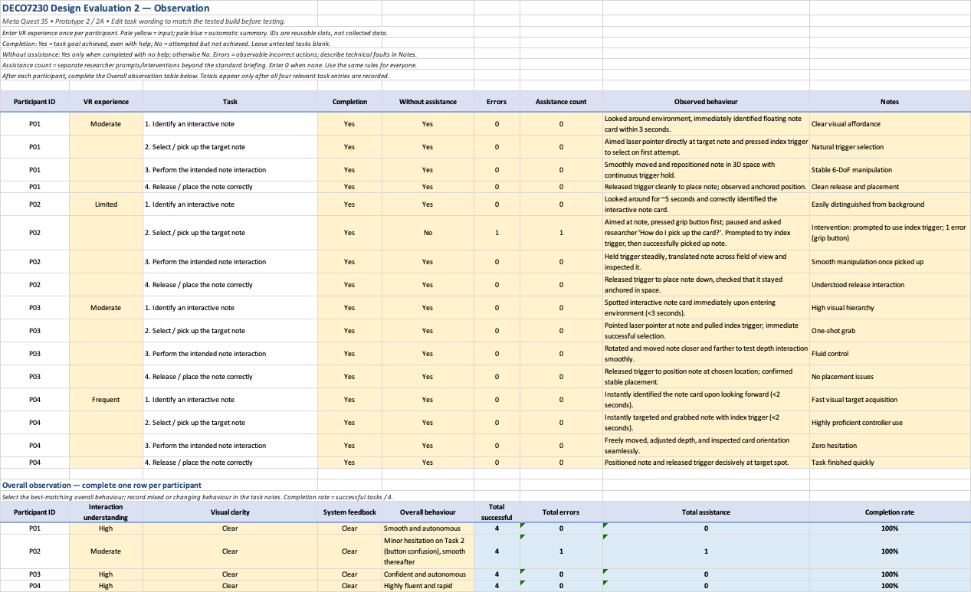

Appendix B Interview Data
Figure. Design Evaluation 2 post-test interview results collected during the Week 9 Studio session.
This table summarises the post-test interview responses from the same four participants who took part in the Week 9 Studio usability evaluation. The interview focused on interaction clarity, controller usability, system feedback, areas of confusion or desired improvement, and overall usability ratings. These responses were analysed together with the observation data to support the qualitative findings and design recommendations.
