AI acknowledgement coversheet
This coversheet is designed to help you acknowledge any AI use in your assessment. If your course coordinator provides a course-specific template, please use that instead.

The AI Student Hub has more information about using AI in assessment.

Your details
Name: Jie Wen
Student Number: 48559489

Assessment details
Course: DECO7230
Assignment: Design Evaluation 1

AI use
Select the option that applies:
Yes, AI tools have been used to generate or edit material in this document
No, AI tools have not been used to generate or edit material in this document

Details of use
Record the following information when acknowledging the use of AI tools:
- AI tool (e.g. Copilot, ChatGPT, Claude, Gemini)
- description of how you used the tool (e.g. edited, corrected, translated, planned, brainstormed)
- prompt(s) used
- relevant part, section, or page of the assessment
- date.
Complete the table below with this information.
Tool | Use | Prompt(s) | Section | Date
Chatgpt5o | Report structure and written content creation | Based on the testing plan and usability test results, draft a Design Evaluation 1 Report | Objective and Validation Metrics; Method; Results; Reflection | 31 August
Gemini | Used to modify the written tone | Rewrite this paragraph so that the tone is appropriate for a university assignment | Entire work | 1 September

This coversheet has been adapted with thanks to BIOM3020 Integrated Endocrinology.

Objective and Validation Metrics
Concept under evaluation. IdeaSpace XR reimagines a Miro-like brainstorming workspace as an immersive spatial environment in which ideas are represented as moveable cards and organised across labelled boards. Prototype 1 was a horizontal Unity prototype focused on the higher-level user goal of organising ideas, rather than treating select, move and place as separate tasks.
Aim | What was tested | Operational success criterion | Evidence collected
A1 Spatial comprehension | Whether users understand the role of Unsorted and category boards. | Participant can identify the intended spatial organisation logic and explain where an idea belongs without corrective explanation. | Observed interpretation, hesitation, post-test Q1-Q3.
A2 Interaction discoverability | Whether a new user can work out how to move a card. | Participant completes the card move without evaluator assistance or repeated failed attempts. | Task completion, help, time, hesitation, post-test Q4-Q5.
A3 Concept comprehension | Whether the interaction communicates the purpose of IdeaSpace XR. | Participant can explain the overall idea as organising/categorising ideas after the task. | Task 3 explanation and overall rating.

Method
Five peer participants (P1-P5) completed a short task-based usability test in a controlled setting. Think-aloud had been planned, but participants preferred not to verbalise their actions, so the actual session relied on direct observation and a five-question post-test interview. Participants first interpreted the spatial zones, then moved a problem card from Unsorted to Problems. Recorded measures included completion, time, assistance, hesitation/errors, purpose comprehension and a 1-5 overall assessment.

Result
Observed result | Raw outcome
Core card movement | 5/5 completed successfully.
Assistance | 4/5 completed without help; P5 required one gentle nudge.
Completion time | Mean 2:07; median 2:14; range 1:00-3:15.
Initial hesitation | 4/5 showed a pause, uncertainty or hesitation before/around the first interaction.
Zone/label interpretation | P1, P2 and P4 were unambiguous; P3 questioned the meaning of “Problems”; P5 understood “Unsorted” but did not immediately realise the cards were interactive.
Overall purpose | All 5 participants could explain the organising/categorising purpose after completing the interaction; P5 reached this understanding after the prompt.
Overall assessment | 2 participants rated 5/5 and 3 rated 4/5; mean = 4.4/5.
Post-test comments | P1 requested visible user hands; P2 requested multi-select and noted overlap between “Positive Finding” and “Opportunity”; P3 requested category descriptions/examples; P4 and P5 requested interaction highlighting/prompts.

Analysis and Insights
Insight 1 - The spatial metaphor is understandable, but category semantics are not fully self-explanatory.
The strongest pattern is that participants generally understood the board-based spatial organisation, yet three participants raised semantic issues: P1 was sometimes unsure what an idea meant, P2 saw overlap between “Positive Finding” and “Opportunity”, and P3 interpreted “Problems” as possibly meaning unfinished tasks. The structure therefore works better than the vocabulary. The design needs to reduce interpretation effort at the category level rather than redesigning the entire spatial layout.
Insight 2 - The main usability bottleneck is discovering how to interact, not deciding where to place a card.
All participants completed the move, but 4/5 showed some first-interaction hesitation and P5 needed a hint. P5 explicitly said the categories were understandable while moving the card was harder; P4 and P5 independently suggested highlights/prompts. This indicates an affordance and feedforward problem: the card looks understandable as content, but not sufficiently actionable as an interactive object.
Insight 3 - Users expect stronger embodied and system feedback in an XR concept.
The earlier paper-prototype test already raised questions about whether cards would snap into place and whether successful categorisation would provide visual feedback. The Unity test reinforced this expectation: P1 wanted visible user hands and P4/P5 wanted interaction highlighting. The repeated request across prototype stages suggests that visible hands/controller cues, hover feedback and placement confirmation are part of the interaction model, not cosmetic polish.
Insight 4 - A one-card workflow demonstrates feasibility but not scalable organisation.
P2 requested multi-selection because moving notes one-by-one becomes time-consuming. Since the recorded task used one representative card, the current data support basic usability but cannot validate efficiency for organising many ideas. Scalability remains a design question for the next prototype.

Evaluation of Aims
Aim | Evaluation | Why | Implication
A1 Spatial comprehension | PARTIALLY VALIDATED | The spatial board logic was broadly understood, but category labels created ambiguity for P1-P3. | Keep the spatial-board structure; clarify category meaning.
A2 Interaction discoverability | NOT YET VALIDATED | Although 5/5 succeeded, 4/5 hesitated and P5 required assistance. | Add explicit feedforward and proximity feedback before retesting.
A3 Concept comprehension | VALIDATED | All participants could explain the organising/categorising purpose after the task. | Retain spatial organisation as the concept’s core workflow.
Overall concept evaluation: Partially confirmed. Prototype 1 validates the high-level idea of spatially organising cards, but it does not yet validate that the interaction is immediately discoverable, more efficient than a 2D workflow, or suitable for collaboration.

Concept Iteration
The iteration below keeps what the test supported and changes only elements for which there is direct evidence. This creates a traceable chain from result → insight → design change.
Evidence | Design issue | Iteration | Reason / expected effect
P5 needed a hint; P4/P5 requested highlights/prompts. | Weak interaction discoverability. | Add proximity highlight plus an in-world grab cue (e.g., “Press E to pick up” in desktop testing; controller/hand cue in XR). | Makes the first possible action visible before the user has to guess.
Paper test asked about snap/confirmation; P4/P5 wanted feedback. | Unclear placement state. | Add snap-to-board behaviour, hover state and brief confirmation after placement. | Creates a clear action-response loop and reduces uncertainty about successful categorisation.
P1-P3 reported label/meaning ambiguity. | Category semantics overlap. | Add a one-line descriptor/example under each board title and stronger visual differentiation between categories. | Preserves the spatial model while reducing interpretation effort.
P1 requested visible hands. | Prototype feels less embodied than the XR concept promises. | Use visible virtual hands/controllers and direct grab/release interaction in the next vertical prototype. | Aligns the interaction with the intended immersive, embodied concept.
P2 requested multi-select. | One-by-one organisation may not scale. | Prototype grouped selection / multi-card movement for a later test. | Tests whether spatial organisation remains efficient with realistic numbers of ideas.
IdeaSpace XR is an immersive brainstorming workspace where ideas exist as graspable spatial cards rather than items on a flat canvas. Users create and organise ideas across clearly explained spatial boards, with immediate feedforward and feedback through proximity highlights, grab cues and snap-to-board confirmation. Future iterations extend the validated organising metaphor into direct hand-based manipulation, grouped movement and collaborative idea refinement.

Reflection and Next Steps
The combination of observation, task completion data and short post-test questions was still effective, but not using think-aloud reduced access to participants' reasoning during the interaction. I therefore relied more on visible hesitation, task behaviour and post-test explanations, and avoided inferring motives that were not directly supported. The session also showed why completion rate alone is insufficient: a 100% completion rate would have hidden the discoverability problem revealed by hesitation and assistance. However, the study used only five peer participants in a controlled Unity setup, the recorded workflow centred on one card, and one participant received a prompt. The test therefore cannot support claims that IdeaSpace XR is faster or more intuitive than Miro, that multi-card organisation is efficient, or that collaboration works.
For the next prototype, I will move from the already-supported question “Do users understand spatial organisation?” to a more focused vertical interaction question: “Can direct XR manipulation plus feedforward/feedback make organising multiple ideas immediately discoverable and controllable?” The next test should measure first-action success, mis-drops, time for multi-card organisation and perceived control, while comparing the interaction before and after the added snap/highlight feedback. Collaboration remains part of the wider concept but should only be tested after the single-user manipulation is reliable.
Appendix A – Testing Photos
Participant 2 was the Week 5 studio tutor; a Zoom recording was ongoing, so no photos were taken. Participants 3 and 4 declined to be photographed, resulting in no photo records. During this testing session, photographic records were retained only for the first and fifth participants.
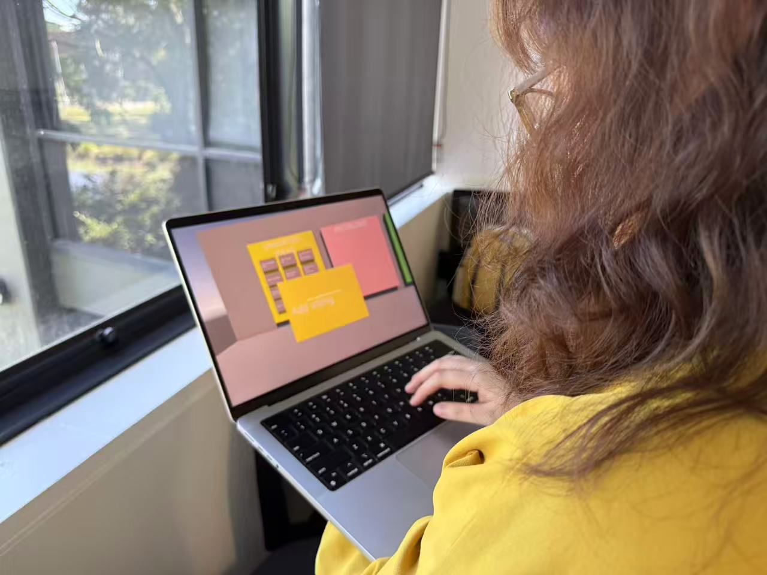
P1

P2

Appendix B - Raw Observation Summary

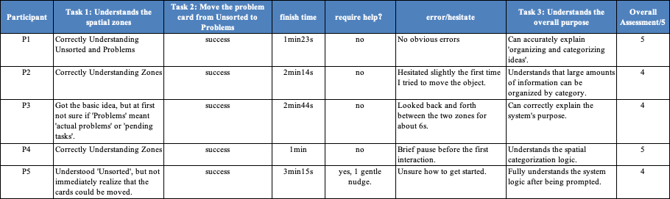

Appendix C - Raw Post-Test Responses
P1
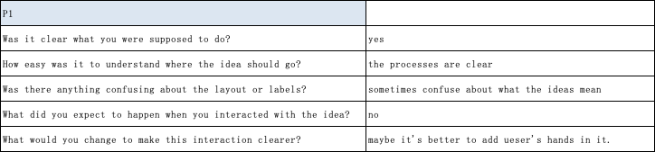

P2
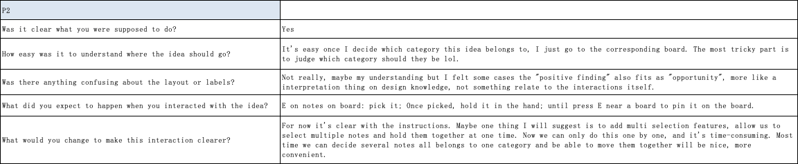

P3
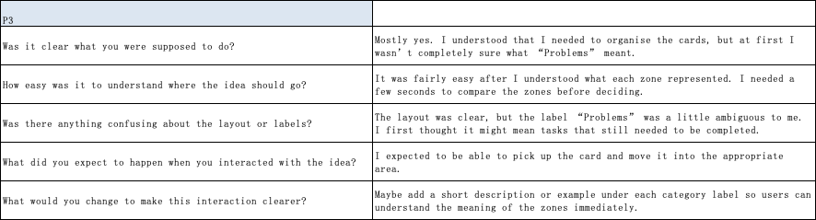

P4
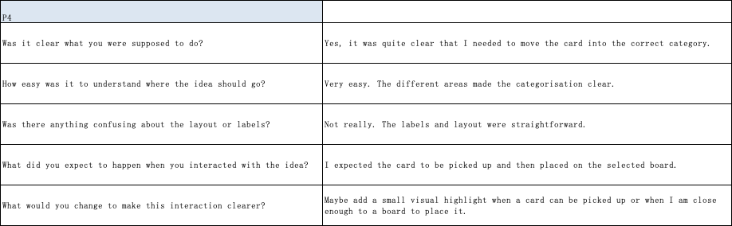

P5
