1.Configuration

Hardware：Jetson TX2

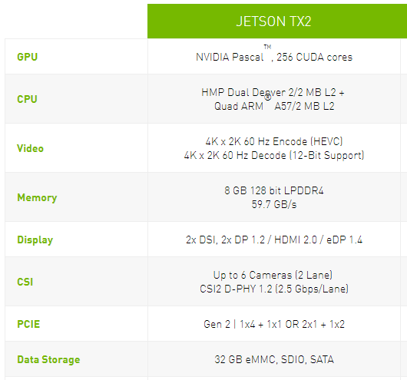

Software：#see jetson TX2_configuration_setting_1.0.docx

Cuda8.6

Cudnn

Opencv3.4.0

Tensorflow1.3.0

Caffe-ssd

Mxnet1.1.0

2.Network Specification

(1) face detect #tensorflow

(2) face detect extract #opencv+mxnet

(3) pedestrian detect #caffe-ssd

(4) pedestrian detect extract #mxnet

3.main.py

Face recognition

Pedestrian recognition

Face feature extraction

Pedestrian feature extraction

Face and Pedestrian Recognition

A Camera monitor the people number for entering and exiting

Save frames that successfully identify front or back

4. Edition

1.0+1.1 camera only monitors entrance

2.0+2.1+2.2 entering and exiting, but it exists bug

3.1+3.2 functional integrity

5. warning

Caffe and cam_observer in a common filedir