# Straightforward price difference

When studying price differences, one intuitive subject is the straightforward difference between the prices or the log value of the prices. Following this idea, we first investigate the difference from the raw prices or their log values. Denote and to be the (foreign exchange adjusted) A- and H- price of the i-th stock at time t. And define

as the absolute price difference, log price and log price difference, respectively.

## Difference of raw price

After looking into the ACFs of of all the stocks, we find a very strong serial correlation. For instance, the ACF plots of China Construction Bank (A: 601939.SH, H: 00939.HK, Sector: Banking) and China Life (H: 02628.HK, A: 601628.SH, Sector: Insurance) are as follows with lag 20 (monthly lag).

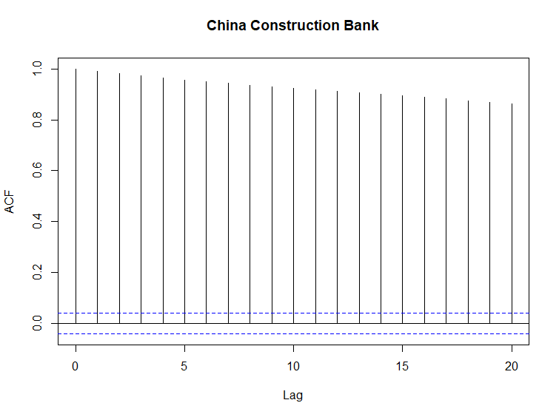

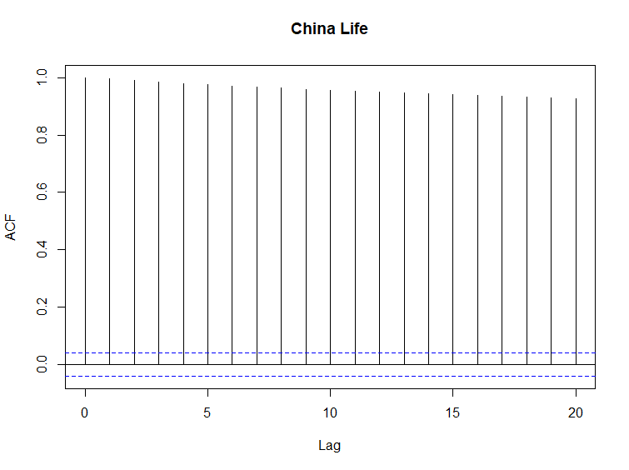

Difference of log price

Given the strong serial correlation of , we turn to study the ACF of . Strong serial correlation can also be observed for all the stock pairs. Again, taking China Life and China Construction Bank as examples,

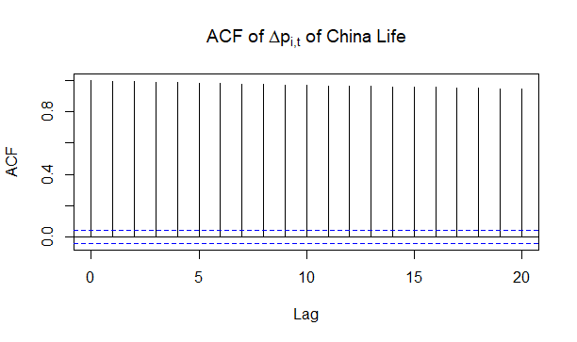

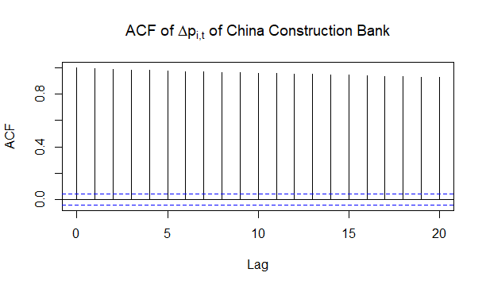

### First-order and Lag-1 Differenced Series of

Considering the high series correlation of direct analysis of price difference and log price difference, we try to check the first-order and lag-1 differenced series of the log price difference, i.e.