服务器性能分析、学会判断服务器瓶颈
服务器工程能力
服务器工程师
│
├─Linux系统
│ ├top
│ ├ps
│ ├vmstat
│ └iostat
│
├─CPU架构
│ ├NUMA
│ ├CPU topology
│ └CPU affinity
│
├─PCIe架构
│ ├PCIe Root Port
│ ├PCIe Switch
│ └PCIe Link Speed
│
├─存储系统
│ ├NVMe
│ ├SAS
│ └RAID
│
├─网络系统
│ ├NIC
│ ├RDMA
│ └IRQ
│
└─自动化
├Python
└测试脚本
百日学习计划是为了看到服务器 → 能分析结构
看到性能问题 → 能定位瓶颈
看到设备异常 → 能排查原因
后面的课程会按照以下版块来：
Day1 Linux基础
Day2 服务器硬件识别
Day3 NUMA架构
Day4 PCIe架构
Day5 NVMe存储
Day6 SAS / RAID
Day7 网络 / RDMA
Day8 性能分析
Day9 IRQ与CPU调度
Day10 故障排查
10天其实是 一个小循环。
后面会不断加深。
Day1 Linux基础
Day2 硬件识别
Day3 NUMA
Day4 PCIe
Day5 Storage
Day6 Network
Day7 Performance
Day8 IRQ
Day9 Troubleshooting
Day10 Automation

硬件方向：PCIe / NUMA / NVMe / 服务器整机
AI方向：GPU / RDMA / 分布式训练
系统方向：Linux内核 / 调度 / 系统架构

DAY3
模块1 服务器负载 load average
模块2 CPU使用率 top
模块3 CPU进程分析
模块4 内存分析 free
模块5 内存细节 /proc/meminfo
模块6 IO分析 iostat
模块7 进程资源 pidstat
模块8 系统运行时间 uptime
模块9 CPU中断 /proc/interrupts
模块10 watch实时监控
1、系统整体负载

[root@bogon ~]# uptime
12:42:40 up 22:25, 2 users, load average: 0.00, 0.00, 0.00
[root@bogon ~]#
三个值分别是
1分钟平均负载
5分钟平均负载
15分钟平均负载
Stress-ng --cpu 256

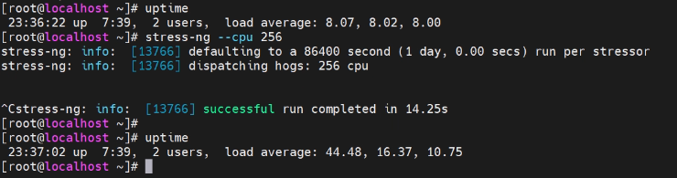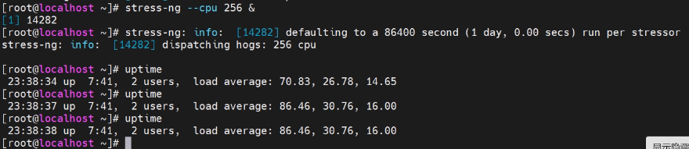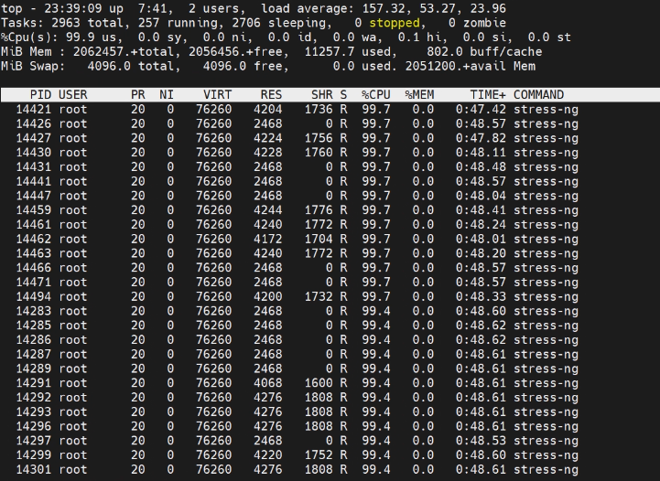
下面是未跑stress的状态
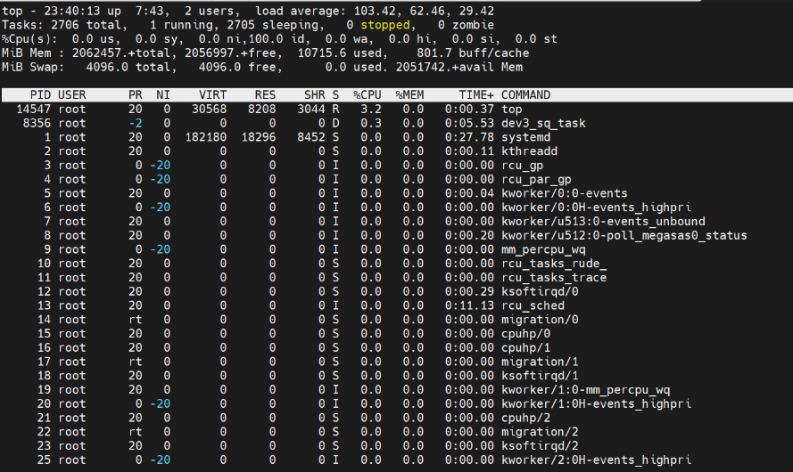
2、 CPU使用率分析

us 用户进程
sy 内核
id 空闲
wa IO等待
[root@bogon ~]# top
top - 12:32:52 up 22:15, 2 users, load average: 0.00, 0.00, 0.00
Tasks: 832 total, 2 running, 830 sleeping, 0 stopped, 0 zombie
%Cpu(s): 0.0 us, 0.0 sy, 0.0 ni,100.0 id, 0.0 wa, 0.0 hi, 0.0 si, 0.0 st
MiB Mem : 255968.2 total, 253765.1 free, 3330.2 used, 829.1 buff/cache
MiB Swap: 4096.0 total, 4096.0 free, 0.0 used. 252638.0 avail Mem

PID USER PR NI VIRT RES SHR S %CPU %MEM TIME+ COMMAND
50500 root 20 0 27720 5260 3072 R 0.7 0.0 0:00.15 top
48715 root 20 0 0 0 0 I 0.3 0.0 0:00.20 kworker/u160:4-hclge
1 root 20 0 174244 17552 9640 S 0.0 0.0 0:04.15 systemd
2 root 20 0 0 0 0 S 0.0 0.0 0:00.08 kthreadd
3 root 0 -20 0 0 0 I 0.0 0.0 0:00.00 rcu_gp
4 root 0 -20 0 0 0 I 0.0 0.0 0:00.00 rcu_par_gp
6 root 0 -20 0 0 0 I 0.0 0.0 0:00.00 kworker/0:0H-events_highpri
8 root 0 -20 0 0 0 I 0.0 0.0 0:00.00 mm_percpu_wq
9 root 20 0 0 0 0 S 0.0 0.0 0:00.00 rcu_tasks_rude_
10 root 20 0 0 0 0 S 0.0 0.0 0:00.00 rcu_tasks_trace
11 root 20 0 0 0 0 S 0.0 0.0 0:00.00 ksoftirqd/0
12 root 20 0 0 0 0 I 0.0 0.0 0:04.67 rcu_sched
13 root rt 0 0 0 0 S 0.0 0.0 0:00.00 migration/0
14 root 20 0 0 0 0 S 0.0 0.0 0:00.00 cpuhp/0
15 root 20 0 0 0 0 S 0.0 0.0 0:00.00 cpuhp/1
16 root rt 0 0 0 0 S 0.0 0.0 0:00.00 migration/1
17 root 20 0 0 0 0 S 0.0 0.0 0:00.00 ksoftirqd/1
18 root 20 0 0 0 0 I 0.0 0.0 0:00.00 kworker/1:0-events
19 root 0 -20 0 0 0 I 0.0 0.0 0:00.00 kworker/1:0H-events_highpri
20 root 20 0 0 0 0 S 0.0 0.0 0:00.00 cpuhp/2
21 root rt 0 0 0 0 S 0.0 0.0 0:00.02 migration/2
22 root 20 0 0 0 0 S 0.0 0.0 0:00.03 ksoftirqd/2
24 root 0 -20 0 0 0 I 0.0 0.0 0:00.00 kworker/2:0H-events_highpri
25 root 20 0 0 0 0 S 0.0 0.0 0:00.00 cpuhp/3
26 root rt 0 0 0 0 S 0.0 0.0 0:00.01 migration/3
27 root 20 0 0 0 0 S 0.0 0.0 0:00.02 ksoftirqd/3
29 root 0 -20 0 0 0 I 0.0 0.0 0:00.00 kworker/3:0H-events_highpri
30 root 20 0 0 0 0 S 0.0 0.0 0:00.00 cpuhp/4
31 root rt 0 0 0 0 S 0.0 0.0 0:00.01 migration/4
32 root 20 0 0 0 0 S 0.0 0.0 0:00.04 ksoftirqd/4
34 root 0 -20 0 0 0 I 0.0 0.0 0:00.00 kworker/4:0H-events_highpri
35 root 20 0 0 0 0 S 0.0 0.0 0:00.00 cpuhp/5
36 root rt 0 0 0 0 S 0.0 0.0 0:00.01 migration/5
37 root 20 0 0 0 0 S 0.0 0.0 0:00.04 ksoftirqd/5
39 root 0 -20 0 0 0 I 0.0 0.0 0:00.00 kworker/5:0H-events_highpri
40 root 20 0 0 0 0 S 0.0 0.0 0:00.00 cpuhp/6
41 root rt 0 0 0 0 S 0.0 0.0 0:00.01 migration/6
42 root 20 0 0 0 0 S 0.0 0.0 0:00.04 ksoftirqd/6
44 root 0 -20 0 0 0 I 0.0 0.0 0:00.00 kworker/6:0H-events_highpri
45 root 20 0 0 0 0 S 0.0 0.0 0:00.00 cpuhp/7
46 root rt 0 0 0 0 S 0.0 0.0 0:00.01 migration/7
47 root 20 0 0 0 0 S 0.0 0.0 0:00.04 ksoftirqd/7

按h查看help
Help for Interactive Commands - procps-ng 4.0.2
Window 1:Def: Cumulative mode Off. System: Delay 3.0 secs; Secure mode Off.

Z,B,E,e Global: 'Z' colors; 'B' bold; 'E'/'e' summary/task memory scale
l,t,m,I Toggle: 'l' load avg; 't' task/cpu; 'm' memory; 'I' Irix mode
0,1,2,3,4 Toggle: '0' zeros; '1/2/3' cpu/numa views; '4' cpus two abreast
f,X Fields: 'f' add/remove/order/sort; 'X' increase fixed-width fields

L,&,<,> . Locate: 'L'/'&' find/again; Move sort column: '<'/'>' left/right
R,H,J,C . Toggle: 'R' Sort; 'H' Threads; 'J' Num justify; 'C' Coordinates
c,i,S,j . Toggle: 'c' Cmd name/line; 'i' Idle; 'S' Time; 'j' Str justify
x,y . Toggle highlights: 'x' sort field; 'y' running tasks
z,b . Toggle: 'z' color/mono; 'b' bold/reverse (only if 'x' or 'y')
u,U,o,O . Filter by: 'u'/'U' effective/any user; 'o'/'O' other criteria
n,#,^O . Set: 'n'/'#' max tasks displayed; Show: Ctrl+'O' other filter(s)
V,v,F . Toggle: 'V' forest view; 'v' hide/show children; 'F' keep focused

d,k,r,^R 'd' set delay; 'k' kill; 'r' renice; Ctrl+'R' renice autogroup
^G,K,N,U View: ctl groups ^G; cmdline ^K; environment ^N; supp groups ^U
W,Y,!,^E Write cfg 'W'; Inspect 'Y'; Combine Cpus '!'; Scale time ^E'
q Quit
( commands shown with '.' require a visible task display window )
Press 'h' or '?' for help with Windows,
Type 'q' or <Esc> to continue

3、CPU进程分析
鲲鹏920
按p进不去？？
4、内存使用分析

[root@bogon ~]# free -h
total used free shared buff/cache available
Mem: 249Gi 3.2Gi 247Gi 9.9Mi 834Mi 246Gi
Swap: 4.0Gi 0B 4.0Gi
[root@bogon ~]#
##available 很低说明内存不够用
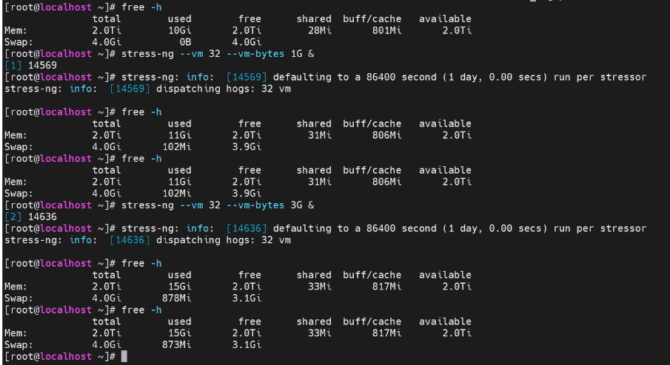

5、模块5：查看内存细节：关注
MemTotal
MemFree
MemAvailable
cat /proc/meminfo | head
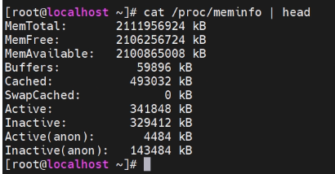

6、模块6 IO分析 iostat
IO性能分析
[root@bogon ~]# iostat -x 1（-x 1每一秒输出一次）
Linux 5.10.0-216.0.0.115.oe2203sp4.aarch64 (bogon) 2026年03月11日 _aarch64_ (80 CPU)

avg-cpu: %user %nice %system %iowait %steal %idle
0.01 0.00 0.01 0.00 0.00 99.99

Device r/s rkB/s rrqm/s %rrqm r_await rareq-sz w/s wkB/s wrqm/s %wrqm w_await wareq-sz d/s dkB/s drqm/s %drqm d_await dareq-sz f/s f_await aqu-sz %util
dm-0 0.13 3.06 0.00 0.00 0.23 24.26 1.03 21.02 0.00 0.00 0.02 20.43 0.00 0.00 0.00 0.00 0.00 0.00 0.00 0.00 0.00 0.09
dm-1 0.00 0.03 0.00 0.00 0.30 70.40 0.00 0.00 0.00 0.00 0.00 0.00 0.00 0.00 0.00 0.00 0.00 0.00 0.00 0.00 0.00 0.00
dm-2 0.00 0.05 0.00 0.00 0.10 27.41 0.00 0.01 0.00 0.00 0.00 4.00 0.00 0.00 0.00 0.00 0.00 0.00 0.00 0.00 0.00 0.00
sda 0.11 3.90 0.05 33.10 0.41 35.81 0.68 21.03 0.46 40.69 0.24 31.12 0.00 0.00 0.00 0.00 0.00 0.00 0.00 0.00 0.00 0.00

avg-cpu: %user %nice %system %iowait %steal %idle
0.01 0.00 0.01 0.00 0.00 99.98

Device r/s rkB/s rrqm/s %rrqm r_await rareq-sz w/s wkB/s wrqm/s %wrqm w_await wareq-sz d/s dkB/s drqm/s %drqm d_await dareq-sz f/s f_await aqu-sz %util
dm-0 0.00 0.00 0.00 0.00 0.00 0.00 0.00 0.00 0.00 0.00 0.00 0.00 0.00 0.00 0.00 0.00 0.00 0.00 0.00 0.00 0.00 0.00
dm-1 0.00 0.00 0.00 0.00 0.00 0.00 0.00 0.00 0.00 0.00 0.00 0.00 0.00 0.00 0.00 0.00 0.00 0.00 0.00 0.00 0.00 0.00
dm-2 0.00 0.00 0.00 0.00 0.00 0.00 0.00 0.00 0.00 0.00 0.00 0.00 0.00 0.00 0.00 0.00 0.00 0.00 0.00 0.00 0.00 0.00
sda 0.00 0.00 0.00 0.00 0.00 0.00 0.00 0.00 0.00 0.00 0.00 0.00 0.00 0.00 0.00 0.00 0.00 0.00 0.00 0.00 0.00 0.00
%util 100说明磁盘已经跑满
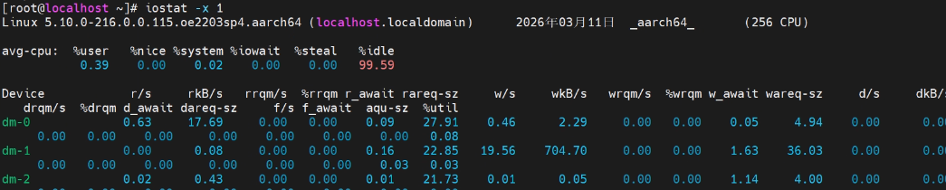
先下载yum install sysstat

7、模块进程资源 pidstat
系统提示无Pidstat命令
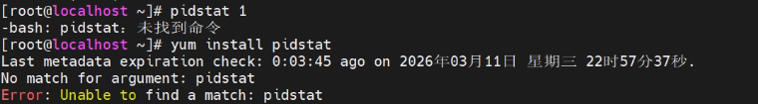
- 模块8 系统运行时间 uptime
Uptime
模块9 CPU中断 /proc/interrupts
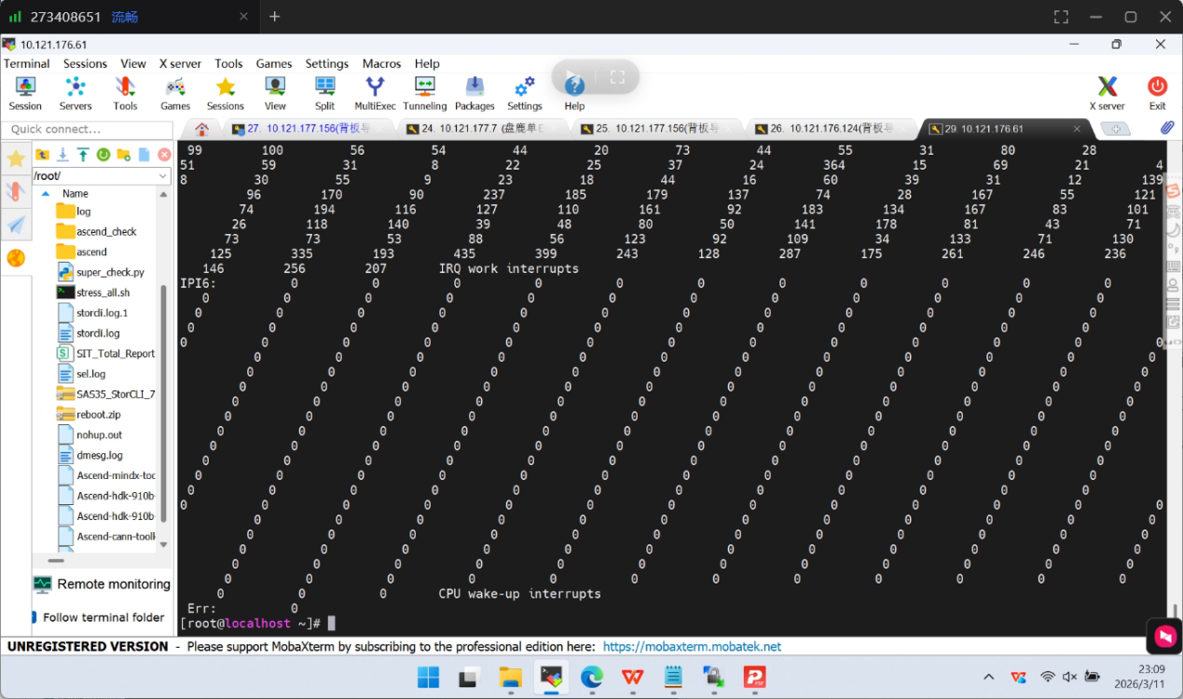

模块10 watch实时监控
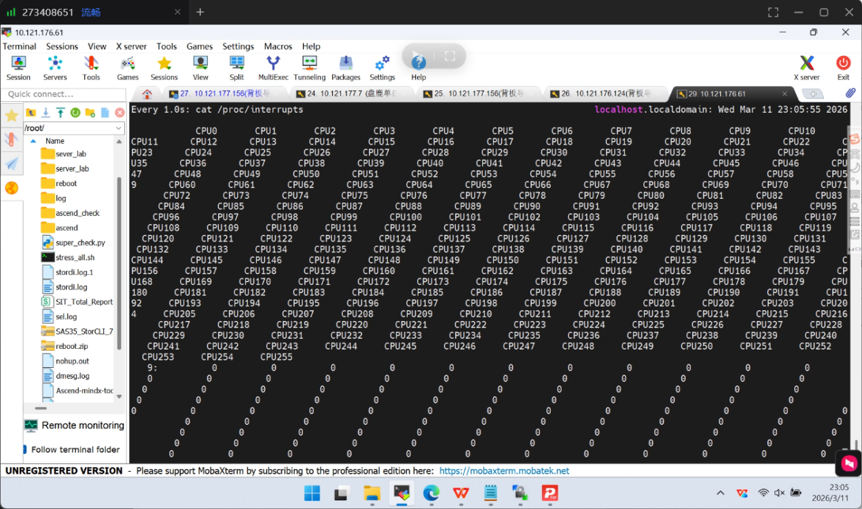
Day3 Python模块（服务器工程版本）

用python读取服务器信息
import subprocess

result = subprocess.run(["lscpu"], capture_output=True, text=True)

print(result.stdout)
功能等同于lscpu

读取cpu数

import subprocess

result = subprocess.run(["lscpu"], capture_output=True, text=True)

for line in result.stdout.split("\n"):
if "CPU(s):" in line:
print(line)
等同于：
lscpu | grep -i cpu：
Cpu: 256

读取NVME数量

vim nvme_check.py
import subprocess

result = subprocess.run(["nvme", "list"], capture_output=True, text=True)

count = result.stdout.count("/dev/nvme")

print("NVMe devices:", count)

可以看到nvme数量是2
同意nvme list也可以看到有几个nmve

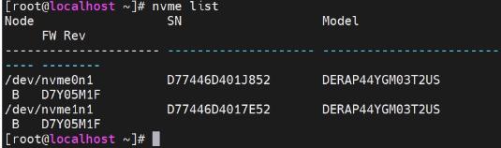

综合脚本

import subprocess

print("=== CPU ===")
print(subprocess.run(["lscpu"], capture_output=True, text=True).stdout)

print("=== Memory ===")
print(subprocess.run(["free","-h"], capture_output=True, text=True).stdout)

print("=== NVMe ===")
print(subprocess.run(["nvme","list"], capture_output=True, text=True).stdout)

