**Wireless IP CAM Setups and Additional Application**

**Project Description**

This project is about setting up a fully customized camera / video recording equipment in author’s own household without spending huge amount of money. All equipments are either bought or coded by author.

**Project Requirements**

* A fully working IP CAM
* A fully connected laptop / computer / server that monitors through IP Camera
* A fully working application on iOS / Android, which ever is more preferred.
* A testable environment where you can connect to the monitor from anywhere
  + Requires Network Security
  + Requires AAA...etc

**Project Estimated WorkLoad**

* Research - 3 Days
* Setup and Coding - 20 Days
  + CCTV that fits our requirements (from coding to infrastructure)
    - Can be replaced by other camera / video recording utility (such as iphone?)
  + Basic CCTV infrastructure setup
    - Including Application coding
  + Security Implementation and Testing
* Bug Testing and Fixing - 10 Days

**Project Estimated Working Hours**

* Based on above’s requirements
  + 1 month
    - 6 Hours / Day

**Project Required Equipment**

* CCTV / IP Camera / iphone
* Coding IDE
* Network Security
* Router
  + Dynamic IPs
* Controller and client stations

**Project Researches**

Example

<http://www.laptopmag.com/articles/laptop-webcam-home-security-system>

iOS Coding <http://stackoverflow.com/questions/22877382/ip-camera-live-video-stream-to-ios-device>

<https://developer.apple.com/streaming/?Can>

<http://stackoverflow.com/questions/15063720/how-to-display-rtsp-from-ip-camera-cctv-in-ios>

Security Standards:

<https://www.security.honeywell.com/documents/IP_Video_Standards.pdf>

<https://en.wikipedia.org/wiki/IP_camera>

IP Camera Capturing(OpenCV)

<http://answers.opencv.org/question/24012/reading-video-stream-from-ip-camera-in-opencv-java/> 4

<http://stackoverflow.com/questions/11186105/capturing-video-from-ip-camera/>

<http://stackoverflow.com/questions/19833386/capturing-video-from-ip-camera-that-really-work>

<http://stackoverflow.com/questions/26535645/ip-camera-with-opencv-in-java>

<http://webcam-capture.sarxos.pl/>

<http://www.coderanch.com/t/569500/sockets/java/Ip-camera-view>

<https://community.oracle.com/thread/2050665?start=0&tstart=0>

<http://stackoverflow.com/questions/21324785/ip-camera-access-using-opencv>

IP Forwarding and Remote Controlling

<http://www.tp-link.us/faq-304.html>

<http://www.trendnet.com/support/view_faq_question.asp?ToDo=view&questId=2575&catId=552&iframe=true>

<https://ipcamnetwork.wordpress.com/2010/09/23/acessing-your-camera-from-the-internet/>

<http://answers.opencv.org/question/3664/ip-network-camera-access/>

**Project Infrastructure**

* Design 1:

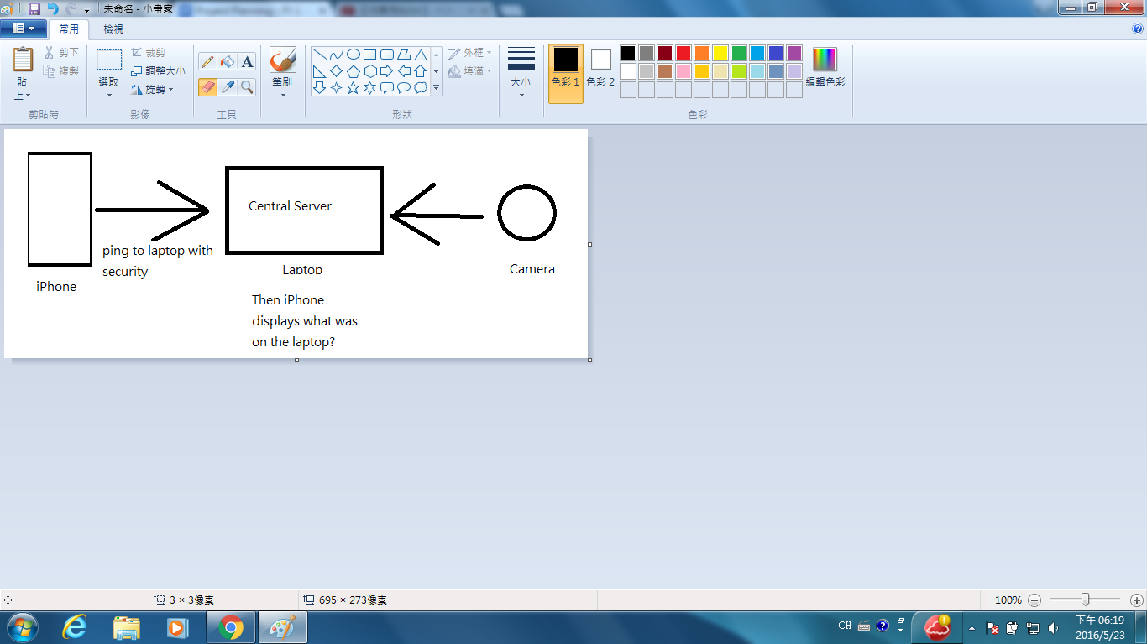

* Design 2 (Best Case Scenario):

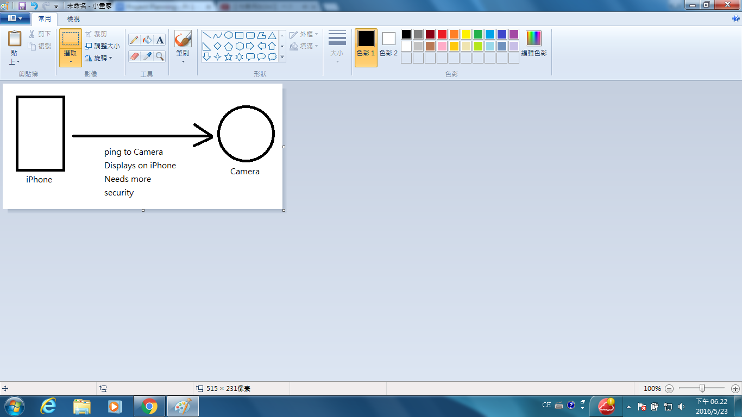

* Design 3:

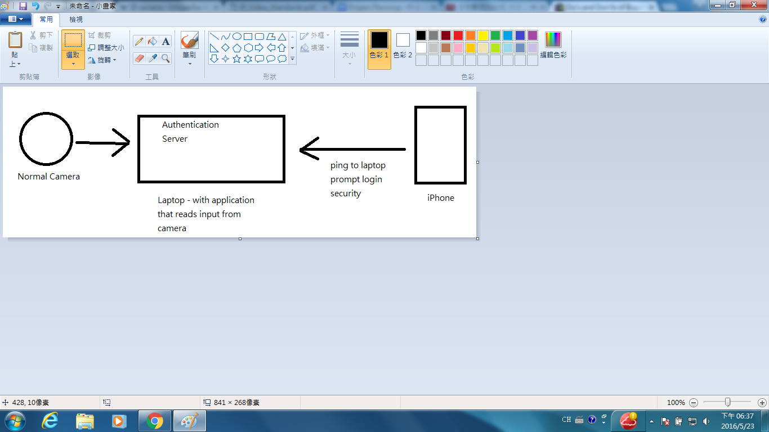

**Additional Features**

* Remote (Carryon) IP Camera