REPORT FOR CS 133 PROJECT

By
Weizhe Shi, Wenchuan Weng,
William Leibzon, Brandon Fratello

SUBMITTED June 03, 2011

1. Guide to source code

1.1. Algorithm explanation:

Addition and subtraction both use a similar parallel algorithm. Addition first performs a parallel addition with carries being stored in one of two separate array’s. Once this is done the carry’s are added into the result and any carries generated are added into the other carry array. If no carries where generated the function returns the results. Otherwise it repeats the combining of the carries with the result, switching back and forth between reading from one carry array and storing the generates in the other. A problem with this algorithm is if a number results in a carry to i+1 location and i+1 through n (where n is much larger than i+1) will result in a large ripple up effect that will slow the algorithm to a crawl. I have considered implementing a check if this appears to be happening and breaking out of the parallel subtract and calling the sequential version. As of this writeup this has not been implemented.

Subtraction works on the same principles as addition. It also performs a parallel subtraction (when two ints are subtracted, if a borrow is needed it assumes one is available and does the calculation with the borrow and then marks a separate array to indicate the borrow occurred). Once this is done the borrows are subtracted from the result in parallel and any new borrows are marked in the second borrow array. This process continues until there are no more borrows left. Like addition this also can slow to a crawl, but this time if a borrow needs to ripple up the result (through many 0’s).

The multiplication algorithm, which we call multiplication by reduction. Work the following ways. The inputs are two array of 32bit integers. Similar to doing a hand multiplication, the algorithm perform a multiplication between each 32bit integer from the first input and the second input. The 32bit integer multiplication can be carried out by 32bit machine’s internal instruction, which means they are fast. Each result of 32bit multiplications is a 64bit integer. A utility function longlong2ints is used to convert 64bit integers into 32bit integers. After that step, the result is an new array of 32bit integers each have different weights. Visually, the integers share the same weight are in the same column, as it is shown in presentation slides. The next step is to perform summation within same column. A 64bit integer is large enough to store the sum of one column. This reduction part can also be performed parallelly. Again, the 64bit integers are broke into pair of 32bit integers, with half of them represent the higher part of 64bit, and half represent the lower part of 64bit integer. Putting these parts together creates two large integer. Calling large integer addition obtain the result. To parallelize the program, each of the three stages of the algorithm can be parallelized, because there are no data dependency.

Karatsuba multiplication is a divide and conquer algorithm which splits numbers into halves and does multiplication of those halves afterward adding these together with appropriate shift. There are two functions mul_kar which does divide and conquer when one of the numbers is at least twice larger than the other by splitting this A number into A1 and A0 and multiplying each by B producing result as A1*B*(2^N)+A0*B. Each of these multiplications is a recursive call to the same function. If numbers are approximately equal in size, the function will call mul_car_eqsize which will perform Karakuba multiplication and both A and B into A0, A1, B0, B1 and doing 3 multiplications A1*B1, A0*B0 and (A1+A0)*(B1+B0) and thereafter producing result as A1*B1*2^2N+[(A1+A0)*(B1+B0)-A1*B1-A0*B0]*2^N+A0*B0. Each of the 3 multiplications is recursive call to mul_car_eqsize. However if numbers are smaller then 4 in size (the number 4 is configurable as #define) the algorithm has to revert to standard multiplication. Parallel version will call sequential multiplication here because there is no speedup from multiplying by reduction when numbers are this small. As each function recursively calls itself 2 or 3 times and each of these could call itself 2 or 3 times and so on. If all of these were to be parallelized we could have 10,000 threads on the lowest level when trying to multiple two numbers of size 1000. The speedup could be enormous but in practice this many threads is difficult to manage properly and this algorithm also has potential of using a large amount of memory and so memory copying would become a performance issue.

“Octal” parallel search is base on the observation that if m is the bit number of dividend and n is the bit number of divisor, then the quotient is ensured to be in the interval of [2^m-n-1, 2^m-n+1),
so we have these 3*2^m-n-1 candidates for the quotient, if you have only one thread, you do the classic binary search, but what if you have 8 threads? So we can have seven pivots in this interval, then each thread pick one to evaluate whether it’s the quotient, bigger or smaller. Then whether you got the quotient or you have a ⅛ new interval to search from.

Newton’s method division works this way, first use the Newton’s method iteration to get the estimation of the reciprocal of divisor, then multiply this estimation by the dividend gets the correct quotient. The iteration is Ei+1 = Ei(2 - Ei*B).

1.3. Code Compilation

All the source code does compile. We have Makefile to make this easier.

1.4 Working Code

All of the sections of code work and complete. There are some code that is not in use and is redundant (such as version of word-size shift that was implemented with a call to bitwise shift, new version is doing memcpy and therefore faster).

1.5 Location of Thread initialization and Control in the code

In the addition function, #omp pragma parallel for is used twice. The first time it is used to parallelize a for loop that iterates from zero to the size of the larger integer and adds the two integers together, checks to see if there is a carry, and if so stores it in one of the two separate carry arrays. The second instance occurs inside a while loop (so the #pragma may occur multiple times even though its only written once) and is also used to iterate from zero to the size of the larger integer and adds in the carries that were stored previously into the result, and any newly generated carries are stored in the opposite carry array (so arrays A & B, the first time through the while loop it adds in from carry A and stores generated in B and then switches back and forth each time, in this way no race conditions are created when adding and generating carries in parallel.

In the subtraction function, #omp pragma parallel for is used twice. It is used in the same fashion as in addition. The first usage is on a for loop from zero to the size of the integer to be subtracted from (note: code assumes that user is subtracting a smaller number from a larger number) and performs a subtraction between each integer in the unsigned int array. If the subtraction causes a borrow to be needed it is marked in one of the two separate carry arrays. The second use is used to resolve the borrows, and is performed on a for loop from zero to the size of the integer to be subtracted from and subtracts off the value of the borrow array, and stores any newly generated borrows in the other borrow array. If any new borrows are generated a while loop will run the parallelized for loop again. This while loop almost always only iterates a couple of times, but numbers where the initial subtraction (for the single integer) results in 0 occurs many times in a row will cause the while loop to iterate as many times as the 0 appears in the row (assuming an initial borrow is needed) which can cause very poor performance in some cases.

In multiplication function, #pragma omp parallel for is used three times, calling the parallelized addition also cause more parallel constructs. The first pragma is used to parallelize each 32bit multiplication, and break up the 64bit results into two 32bit numbers. The second pragma parallelize the process of reduction by column. Each thread work on one column, use a 64bit long long integer to accumulate the summation of each column. After all the threads are done, the third pragma is applied on each 64bit accumulator result, break them into two large integer, one consists of all the higher 32bit part of the accumulator, the other contains all the lower 32bit part of the accumulator. Then the two large integer is summed with parallelized addition. The addition result is just the final product.

Karasuba multiplication uses #pragma omp sections to parallelize recursive calls and calls to additions. The function mul_kar() does not actually implement Karasba algorithm but standard divide and conquer. It is used when one of the numbers is at least twice in size larger than then other and in such a case it splits processing into two calls involving upper and lower halves of this number multiplied by the smaller operand. There is therefore only one #pragma omp sections with two sections for each recursive call to mul_kar(). Now if operands are about the same size then mul_car() calls mul_kar_eqsize() which does implement Karasuba algorithm. This function has two parallel sections, in the first addition is called in parallel to find a1+a0 and b1+b0. In the 2nd section that closely follows the first, the function recursively calls itself to find multiplication results for a1*a0, b1*b0 and (a1+a0)*(b1+b0). In all of the parallel sections above there are no private variables, in fact all are just direct calls to a function returning results to different variable. If OpenMP nesting were to have worked properly, we should have had a number of parallel processes corresponding to each of these calls and each recursively called function would launch its out recursive threads and so on. OpenMP was not able to handle case like this and for numbers larger then 100 in size (3200 bits) the program crashes with openmp memory errors. This algorithm may possibly have worked as expected if it was implemented with posix threads and with custom code to control level of parallelization.

In division function: for “octal” parallel search I put #pragma omp for before the iteration to evaluate the seven pivots. for Newton’s method, actually there is no #pragma because the iteration in Newton’s method is strictly data dependent, so the parallelism of Newton’s method division is totally depend on the sub function call.

1.6. Explanation for our choice of algorithms

For addition and subtraction we were originally going to do a carry select implementation where each thread would get its own section and then run sequential addition twice, once with a carry in and once without. The reason we switched from this model is because debugging proved very problematic and we would have minor errors prop up every once in a while that were hard to track down to a source. By switching to the current method debugging could be done with the pragma’s commented out to make sure the results were correct and then put them back in and verified.

For multiplication by reduction. The parallelization just fall out of the algorithm naturally. The three stages of this multiplication by reduction algorithm all can be parallelized. The two operartions each thread does are 32bit multiplications and break up 64bit number into two 32bit numbers. The Karatsuba algorithm was originally proposed as algorithm for division but version of Karatsuba for division is too difficult to implement and we decided to first try it with multplication which proved quite challenging too. At the time when first code for it was ready the reduction multiplication was not yet working and code was started to be written to do multiplication for very small numbers directly as a final step for Karatsuba in case this becomes our primary multiplication algorithm. In the end both multiplications algorithms were finished about same time and Karatsuba switched to using standard multiplication for its final steps. We also decided to keep both algorithms to compare the results. Karatsuba multiplication also proved to be a very good test bench for other code as its using addition, substruction, multiplication and shifts.

For “octal” parallel search, the iteration to evaluate the seven pivots is the only chance to do the parallel. This was not giving good enough performance gain and we decided to try Newton’s method. For Newton’s method division, the data dependency forced us to rely on the parallelism of subtraction and multiplication.

1.7 Synchronization

The only synchronization needed was barriers to join the threads, which OpenMP takes care of for us. No further synchronization was needed and no locks are used by our code.

1.8 Breakdown of source code by team member

Brandon worked on: add.c , add_s.c, sub.c, sub_s.c, largeint.h
Wenchuan worked on: Makefile, mult.c, utils.c, test.c, largeint.h
Wiliam worked on: main.c, test_utils.c, mult_kar.c, mult_kar_s.c, largeint.h
Weizhe worked on: div.c utils.c bitwise.c largeint.h

These breakdown is approximate as all team members have helped each other on their work and have changed files other than the ones listed. This was a total collaboration of all members of a team to produce one unified product. We are proud of our achievements and our code.

1.9 Sacrificed features:
None

2. Bugs & Challenges

2.1 Bugs

For subtraction, their was a bug where the first integer of the resulting array is fairly often corrupted. No other elements of the array are bothered by this problem and for a while we had a manual work around where right before the function returned I would simply recalculate that first integer. Later it was discovered that we simply forgot to initialize borrow1[0] because its originally set to 0 or 1 in the first parallel for loop (which is faster than calling memset and setting it to zero), but the loop always sets i+1 which missed the first element, and was causing the later subtracting of the borrowing to produce undefined behavior in the borrow for loop. This bug has since been resolved.

Also another bug that was never resolved is that the parallel Karatsuba version of multiplication doesn’t produce the correct answers when coupled with the parallel addition but works fine with sequential addition (still uses parallel subtraction). This is a very weird problem because parallel add works on its own and also in our implementation of multiplication by reduction, and division. The work around was simply to have the parallel Karatsuba use sequential addition.

The most confusing bug was a case where multiplication failed in speed testing only on 4 threads and only when doing 10 rounds for each operation. It was very confusing because changing the number of threads to 2 or 8 fixed the problem and changing the number of rounds from 10 to 11 or 9 also resolved the problem. It was later discovered that srand(NULL(time()) was being called after main called the latest batch test function so it was always testing that same number, but if the number of iterations where different a different random number would be generated than that sequence and crashes would not occur. Isolating and testing that number directly (not in batch test) once it was realized that that number was causing an incorrect answer proved futile as well as when done in isolation the multiplication succeeded on that input. The underlying issue has not been resolved.

For multiplication by reduction, the bug happened when converting serial into parallelized code. The contents of the int array in our representation is thrashed. It happens because private clause is not included in the pragma. With indices i, j, k all declared as top level variables, different thread might get the same index, and thrash the memory content. It’s a bug easily fixed.

2.2 What we have learned on this project

Brandon: I learned that even some operations which would seem very straight forward can become fairly complicated once any dependencies occur. Also I learned that thread overhead is fairly large (as can be seen by the parallel operations on relatively small numbers of integers). I also learned that parallelizing a depth first search is not always a good idea because the memory required skyrockets (making the memory usage resemble that of a breadth first search) and can quickly run out even on modern machines.

Wenchuan: I learned that data structures are very important to parallelism. Program can benefit greatly with carefully designed data structure which avoid accessing same memory location simultaneously.

Weizhe: I learned that even if you have evenly distributed work for each threads, if they have to reach a barrier every time in a loop like the code of “Octal” parallel code, then the overhead of synchronization is quite big. And if your code have strict data dependency like the iterations of Newton’s methods, then you really have nothing to do with parallel in the logic of your code.

William: I sometimes plan to do more than what can potentially be done. Even Karatsuba multiplication took a while to implement and debug. Doing 10x more complex version of division would have been impossible given our time constraints. This was also a good collaborating experience as I tend to be a lone-worker. We each have helped each other and from each other.

3. Final Results
- Addition
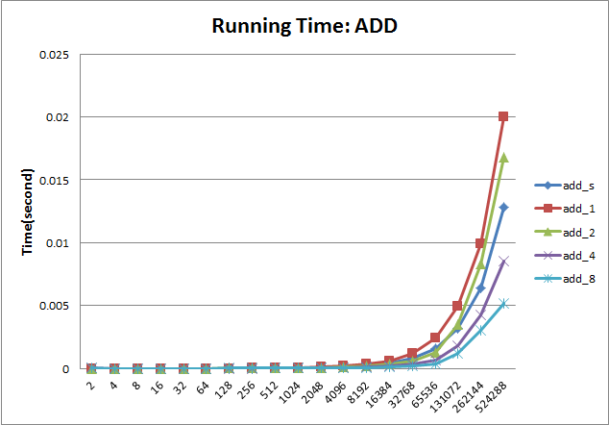
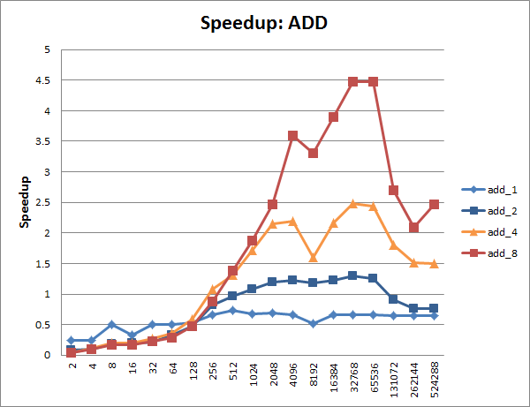

- Subtraction
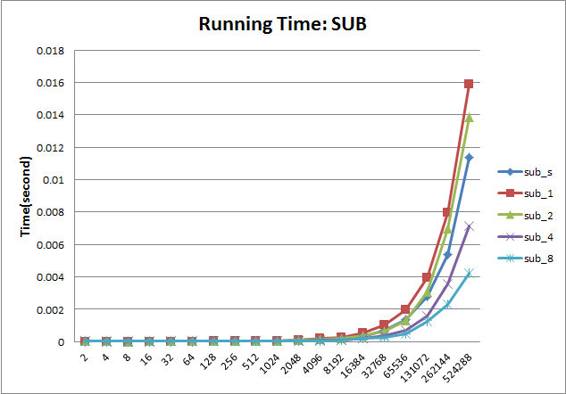
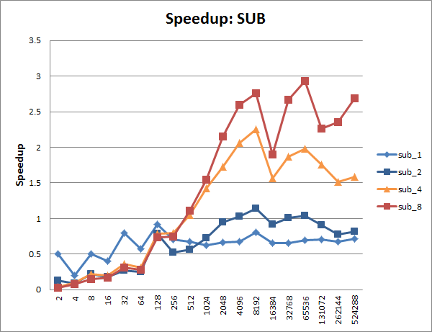

- Division(Newton’s Method)
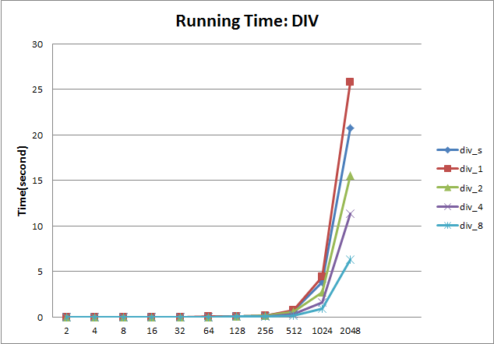
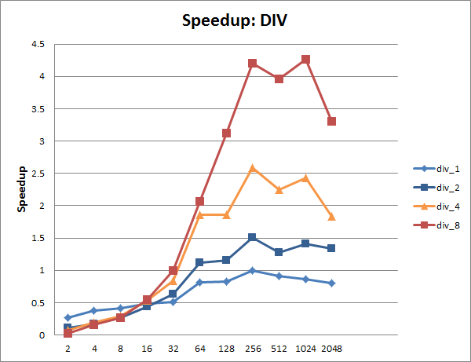

- Multiplication(by Reduction)
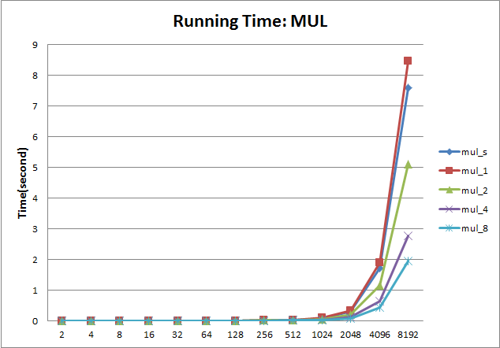
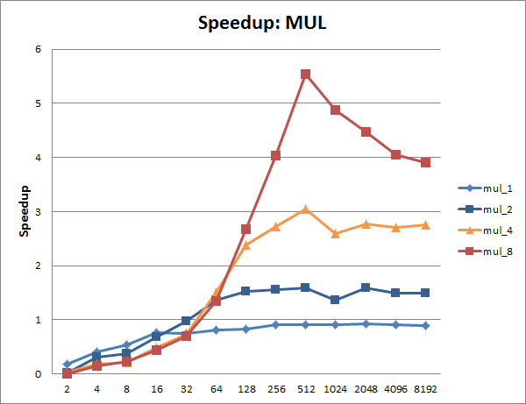

- Multiplication(Karatsuba)
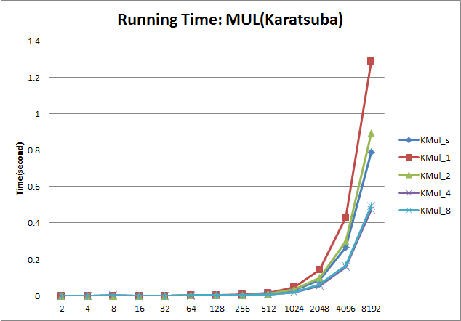
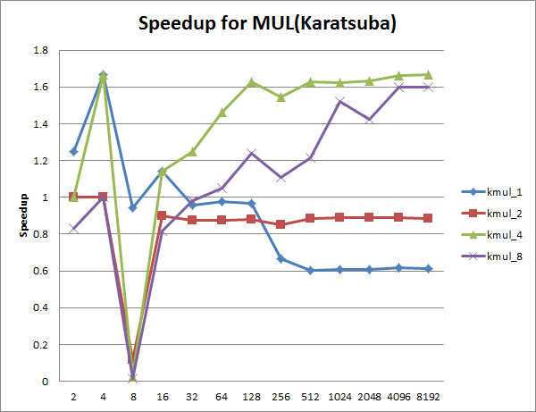

- MUL(by Reduction) vs. MUL(Karatsuba)
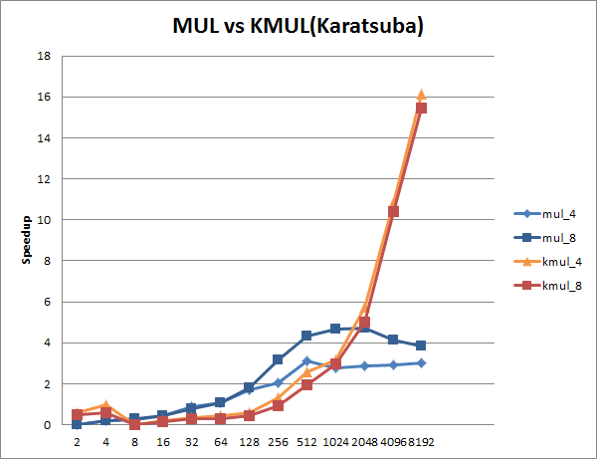
- And
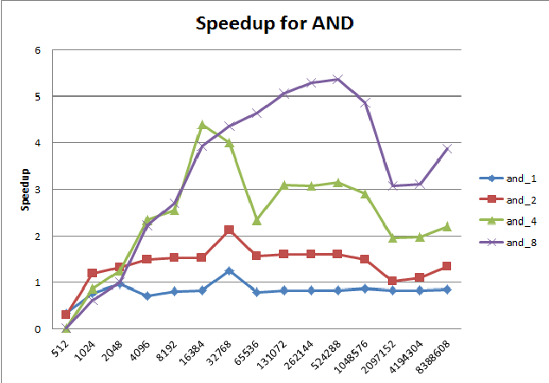
- Or
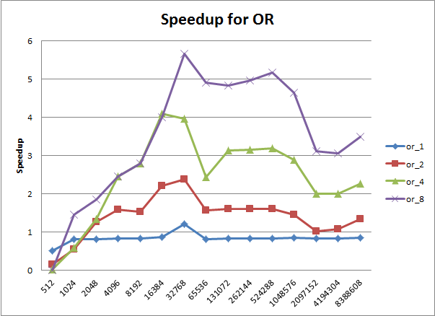
- Lshift
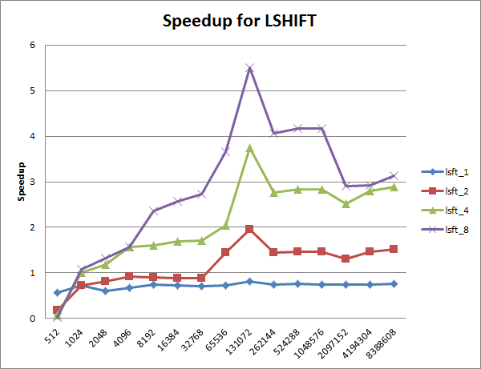
- Rshift
