VMA GLOBAL COLLEGE ENTRY FORM

|  |  |  |  |  |  |
| --- | --- | --- | --- | --- | --- |
|  |  |  |  |  |  |
|  |  |  |  |  |  |
|  |  |  |  |  |  |
|  |  |  |  |  |  |
|  |  |  |  |  |  |

**2ND SEMESTER 2023-2024**

Academic Year

|  |  |  |  |  |  |  |  |  |  |
| --- | --- | --- | --- | --- | --- | --- | --- | --- | --- |
|  | **EVENT** | **SENIOR**  (Number of Players per Event) | | | **YOUTH**  (Number of Players per Event) | | | **SENIOR**  **18-25** | **YOUTH**  **13-17** |
|  | TEAM SPORTS | **M** | **W** | **C** | **B** | **G** | **C** |  |  |
| 1 | BASKETBALL (5 X 5) | {b5v5m} | {b5v5w} | {b5v5c} | {b5v5b} | {b5v5g} | {yb5v5c} |  |  |
| 2 | BASKETBALL (3 X 3) | {b3v3m} | {b3v3w} | {b3v3c} | {b3v3b} | {b3v3g} | {yb3v3c} |  |  |
| 3 | BEACH VOLLEYBALL | {bvm} | {bvw} | {bvc} | {bvb} | {bvg} | {ybvc} |  |  |
| 4 | FOOTBALL | {fm} | {fw} | {fc} | {fb} | {fg} | {yfc} |  |  |
| 5 | SEPAK TAKRAW | {stm} | {stw} | {stc} | {stb} | {stg} | {ystc} |  |  |
| 6 | VOLLEYBALL | {vm} | {vw} | {vc} | {vb} | {vg} | {yvc} |  |  |
|  | INDIVIDUAL SPORTS |  |  |  |  |  |  |  |  |
| 1 | ATHLETICS | {am} | {aw} | {ac} | {ab} | {ag} | {yac} |  |  |
| 2 | BADMINTON | {bm} | {bw} | {bc} | {bb} | {bg} | {ybc} |  |  |
| 3 | CHESS | {cm} | {cw} | {cc} | {cb} | {cg} | {ycc} |  |  |
| 4 | DANCESPORT | {dm} | {dw} | {dc} | {db} | {dg} | {ydc} |  |  |
| 15 | KARATEDO | {km} | {kw} | {kc} | {kb} | {kg} | {ykc} |  |  |
| 6 | SWIMMING | {sm} | {sw} | {sc} | {sb} | {sg} | {ysc} |  |  |
| 7 | TABLE TENNIS | {tnm} | {tnw} | {tnc} | {tnb} | {tng} | {ytnc} |  |  |
| 8 | TAEKWONDO | {tm} | {tw} | {tc} | {tb} | {tg} | {ytc} |  |  |
|  |  |  |  |  |  |  |  |  |  |

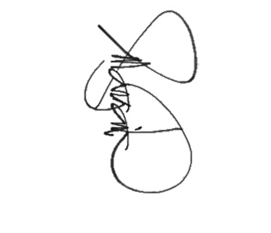

PLEASE CHECK YOUR ENTRY FOR NIR PRISAA MEET. THANK YOU.

**JOEL LESTER G. MANGANTI, LPT, MAEd**

Sports Director/Coordinator/Moderator

(Signature Over Printed Name)

Contact Number:

Email Address:

FB Messenger Account: