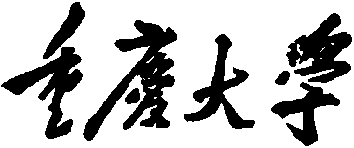 

**Personal Learning Portfolio**

**Course： English Academic Writing Teacher： Zhang Mei**

**Class： 002 Major： Computer Science**

**Name： Wen Hongbing Student Number： 20214590**

**Class Time： 2023.02-2023.07**

**Grade：**

|  |  |  |
| --- | --- | --- |
| **Self** | **Teaching Assistant** | **Teacher** |
| **9** |  |  |

**Comments：**

**Teacher (Signature)**

**Contents**

# Week 1

1. **My learning**

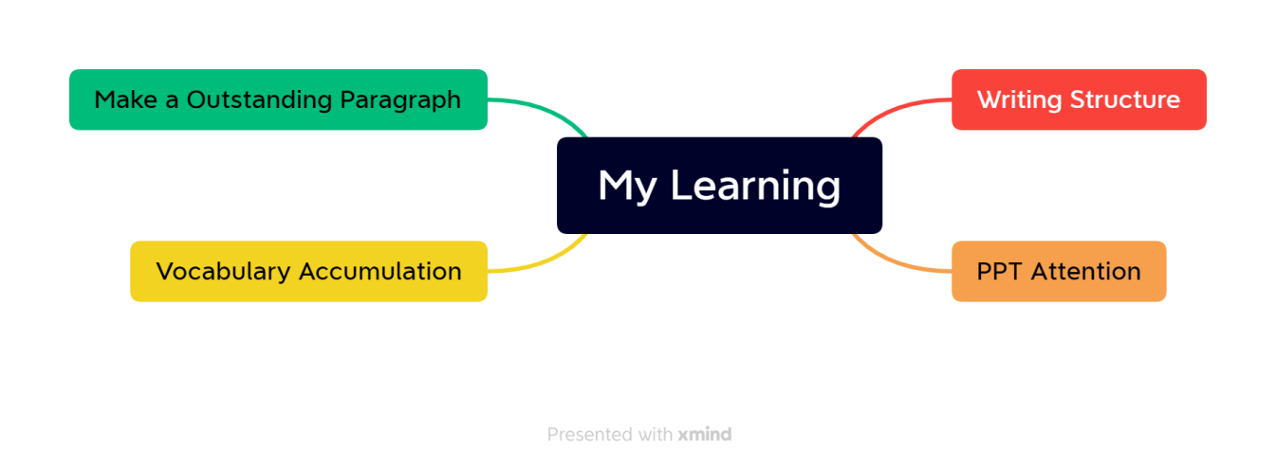

1. **Learning outcomes**

In this week's class, I learned some basic knowledge about writing and making ppt, such as the basic framework of the paper, the main framework of the essay, the focus of writing, and the main color of ppt making should be sunny and cheerful, so as not to leave a negative first impression on people.

Besides, I also learned a lot outside class, such as the specific classification of a sentence and its related functions, the standards that an excellent paragraph should have and how to write an excellent paragraph. In addition, I also completed vocabulary accumulation on time and reviewed the old and learned new things.

In the future when making ppt, I will pay special attention to the overall tone; In the future writing work documents will have a focus to write; When sending invitations or other important letters, pay special attention to unity, coherence and Transition.

1. **My behavior and attitude**

After class, I accumulated vocabulary independently and finished my homework on time on Saturday night. I spent an afternoon feeling good about myself and taking my homework seriously. Above class, poor performance this week, entering college taking few notes, lack of concentration.

1. **Improvement**

Should improve the attention in class, treat the class seriously, actively answer questions, do a good job in class notes to facilitate the review of income.

# Week 2

1. **learning**

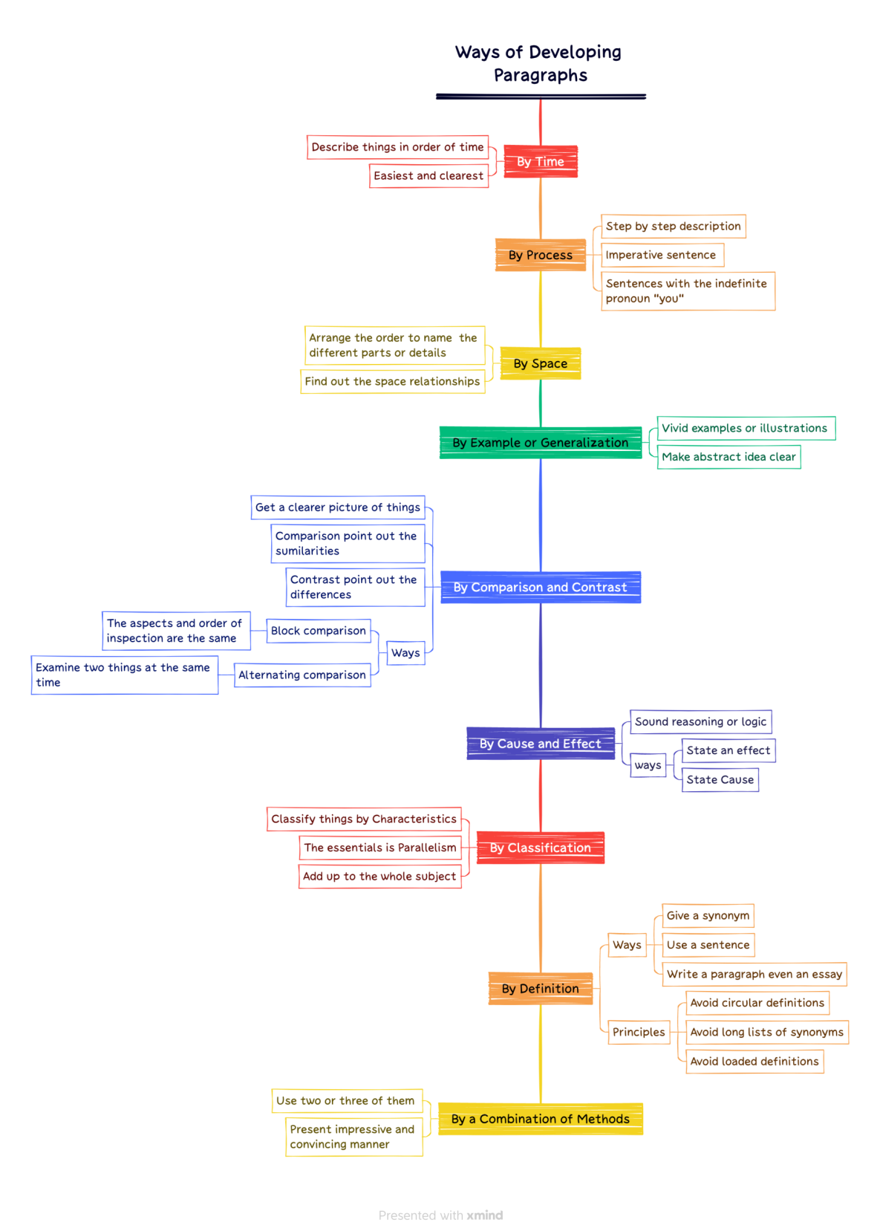

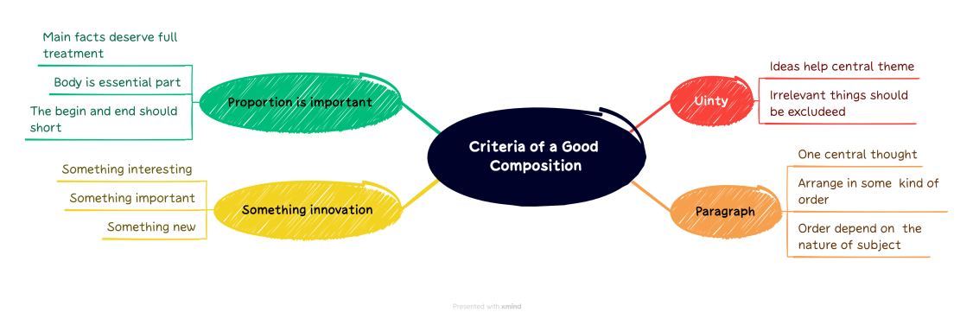

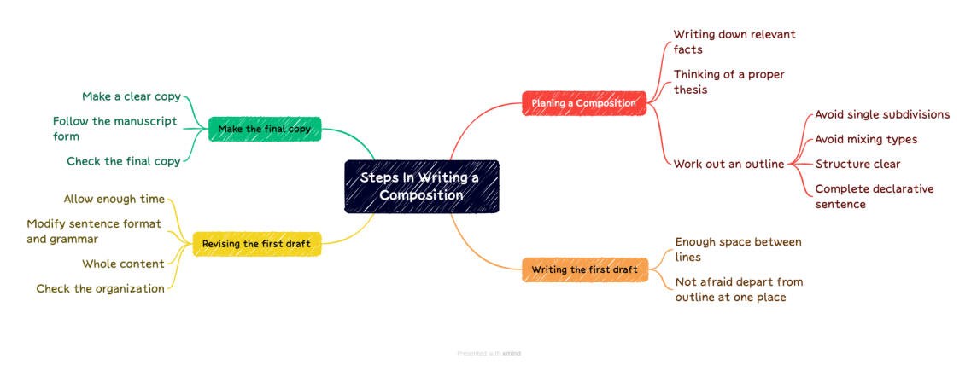

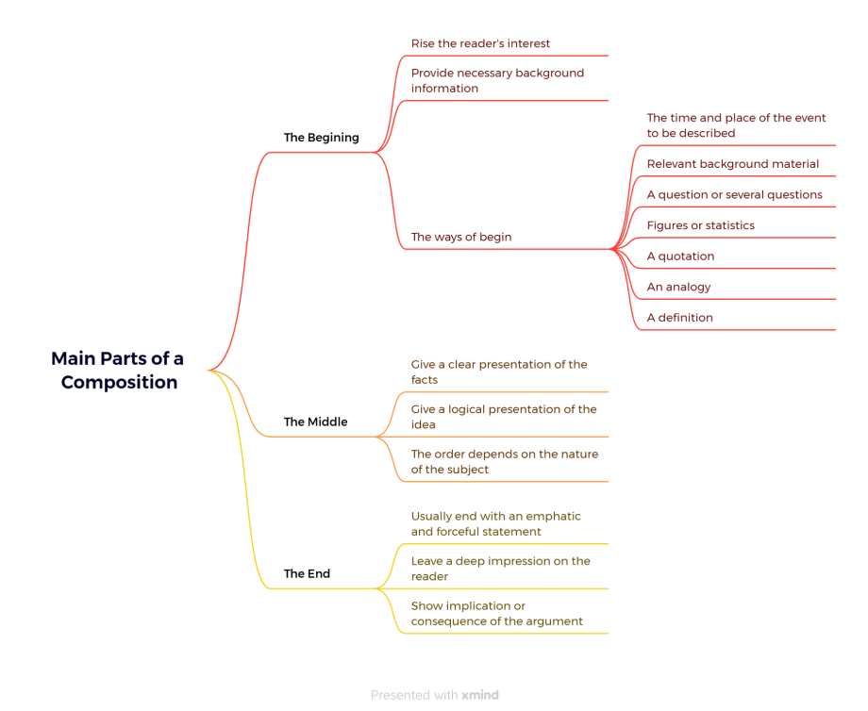

The mind map above is my extracurricular study content.

Here's what we'll learn in class.

First of all, PPT should be visual, clear, concise, but not too simple, need to find a balance.And PPT should choose the appropriate software production, otherwise there may be pre-effect between different equipment errors, leading to unexpected situations.

Secondly, the stage report should be clear, loud, should put an end to hesitancy, small voice. The only way to achieve this effect is with practice.

Finally, learn about writing a paragraph that stands out. A paragraph needs a center, and around the center, to be illustrated by facts and examples, the various forms of sentences should also be flexible use, reasonable expression of their own meaning. The above can be described in an outline and then written.

1. **Learning outcomes**
2. Learned the production method of mind map proficiently, and can skillfully use the way of mind map in the future work report.
3. Learned the nine development ways of paragraphs. Whether it is in my future work or study, such as course papers and graduation papers, I can complete them in an orderly and sequential manner in accordance with certain development ways.
4. Knowing that an article should have a center.Content should be detailed slightly proper. And it needs to be innovative to attract readers. When introducing products or items to others in the future, should also be detailed and interesting.
5. **My behavior and attitude**

I was not very satisfied with my performance this week. Due to my lack of experience in reporting on stage, I hesitated, uttered unclear words and felt at a loss. I practiced hard.

I am not skilled in making PPT, so I need to be more familiar with the operation and continue to learn.

Improve your attitude and enthusiasm to answer questions in class and make persistent efforts.

1. **Improvement**

After class, we also need to practice oral English frequently, improve our oral ability and the ability to report on stage, and correctly do not get stage fright.

Familiar with PPT making and clear presentation of content.

# Week 3

1. **My learning**

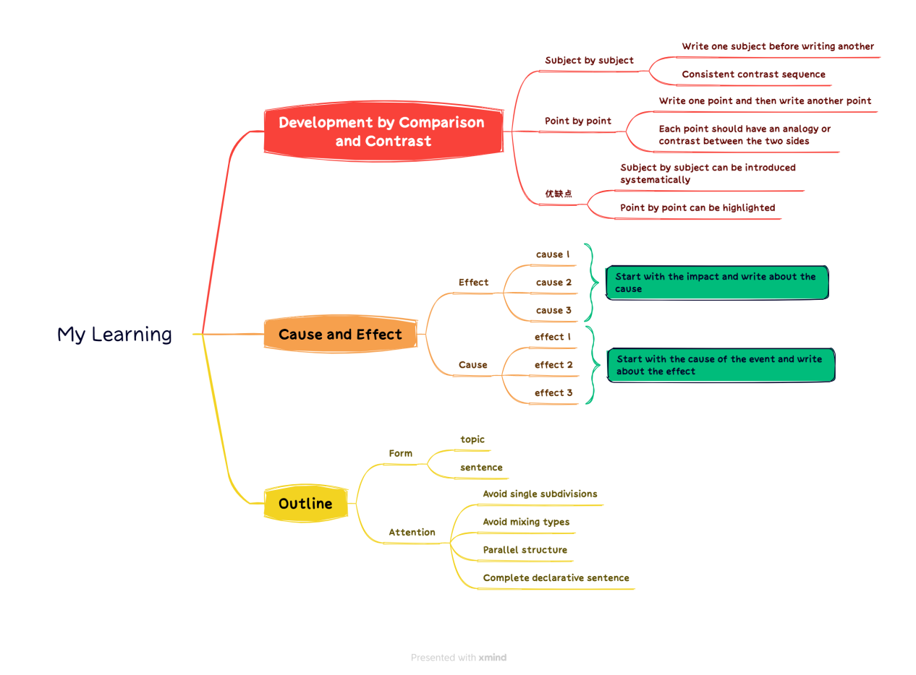

1. **Learning outcomes**

1. Introduce the topic with specific examples during the presentation.

2.when reporting can use the universal three-layer structure for reporting, the structure is clear.

3. Analogies and comparisons can highlight important points.

4. the report can choose photos and other forms to make the content more vivid.

5. the content of the article is relevant, the structure is clear, the proportion is reasonable, the language is beautiful.

6. Analogies require a wide range of objects.

1. **My behavior and attitude**

This week's study has begun to catch up with the pace of the teacher, I can understand the teacher's content well and make relevant notes. I took the CET-6 at the weekend, realized my shortcomings, and made great efforts to meet the next time.

1. **Improvement**

I should make better use of online resources such as MOOC for better learning and help myself in weak subjects.

# Week 4

1. **My learning**

(1)Topic Selection

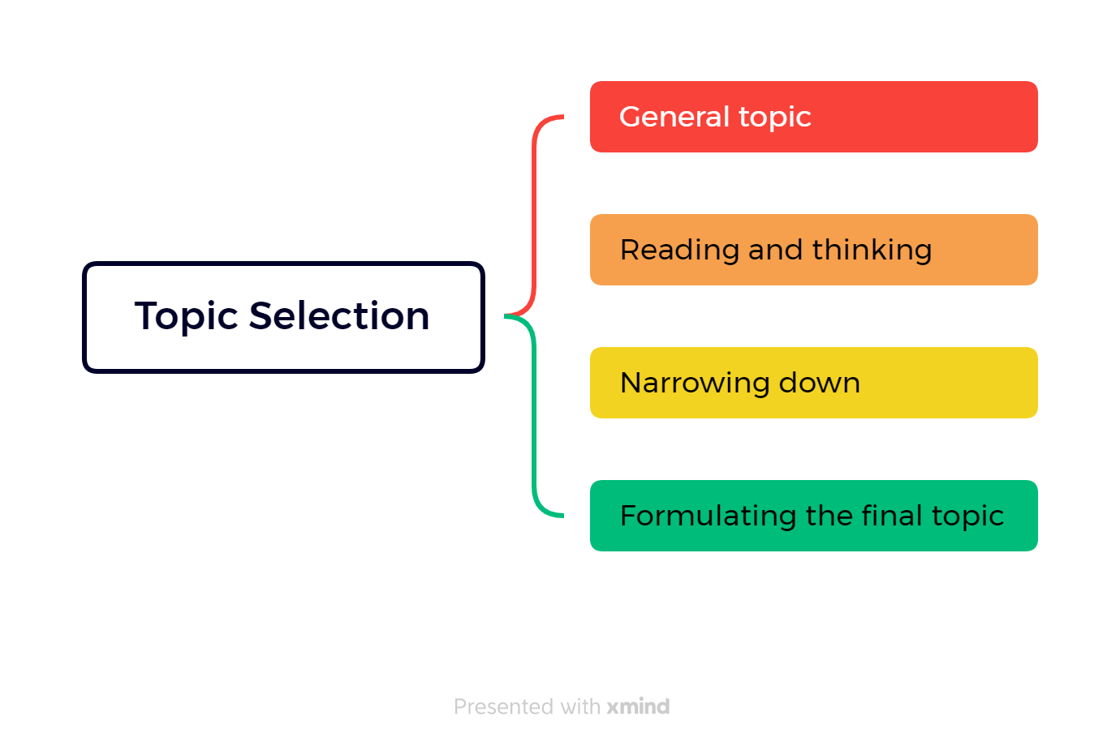

(2)Topic Attention

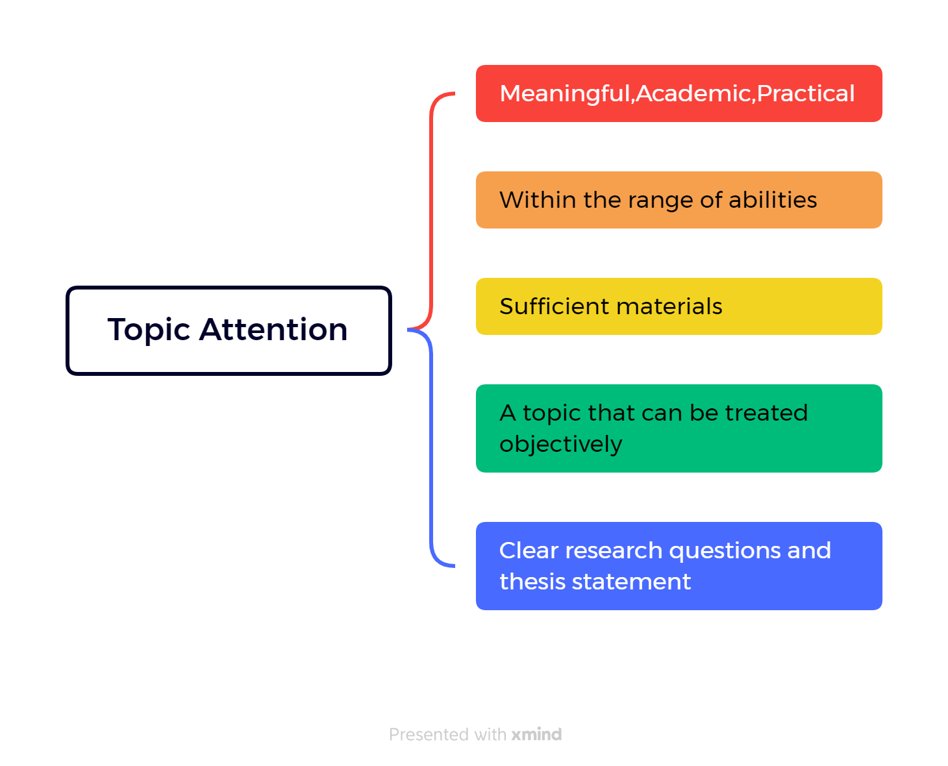

(3)Three keys element of a title

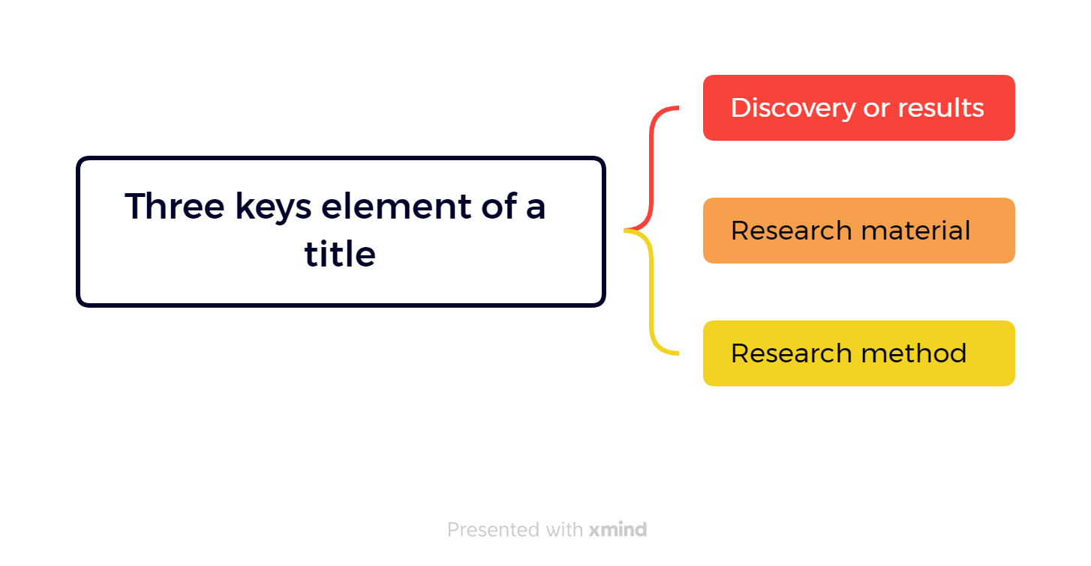

1. **Learning outcomes**

* A good topic should be meaningful, academic, and practical. In the future, I can apply this principle to select research direction and choose topics with research value to better serve the company and society.
* The topic should be researchable and have enough materials available. In the future, I can follow this principle to determine research direction and ensure sufficient data and information support.
* The topic should be treated objectively and have clear research questions and a thesis statement. In the future academic writing, I can follow this principle to ensure that my paper can be understood and accepted by readers.
* Narrowing down the topic is an essential step in the process. In future research, I can use this principle to help me better locate research questions and improve research efficiency.
* Reading and thinking critically about the general topic can help to focus on specific aspects. In future academic research, I can use this principle to help me better understand the research object, and improve research quality.
* A good title should include key elements, such as discovery or results, research material, and research method. In future academic writing, I can use this principle to design more attractive and readable titles to better attract readers to read my papers.
* Selecting a topic for research requires careful consideration and planning. In the future workplace and academic research, I can use this principle to develop better research plans to improve work efficiency and research quality.
* This process helps to develop critical thinking and research skills. In the future, I can use these skills to better evaluate information, solve problems, and improve judgment and decision-making.

1. **My behavior and attitude**

* Questions will be answered, but the quality and depth of the presentation needs to be further improved.
* The cooperation performance is not so good, so we need to participate more actively in class discussions and speeches to enhance our cooperation ability.

1. **Improvement**

* The quality and depth of speech need to be improved: self-access to information, ask more questions.
* Cooperation skills need to be enhanced: active participation in teamwork projects, participation in class discussions and presentations.

# Week 5

1. **My Learning:**
2. Objective and function of the introduction

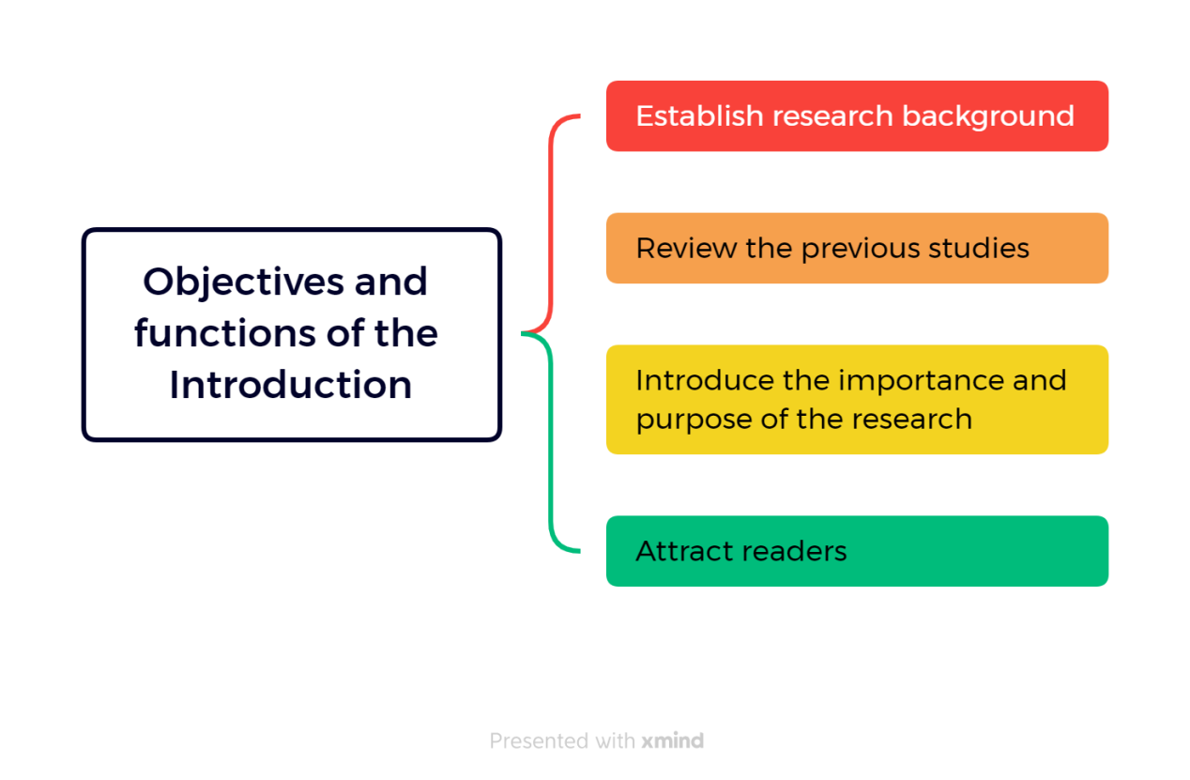

1. How to write a introduction

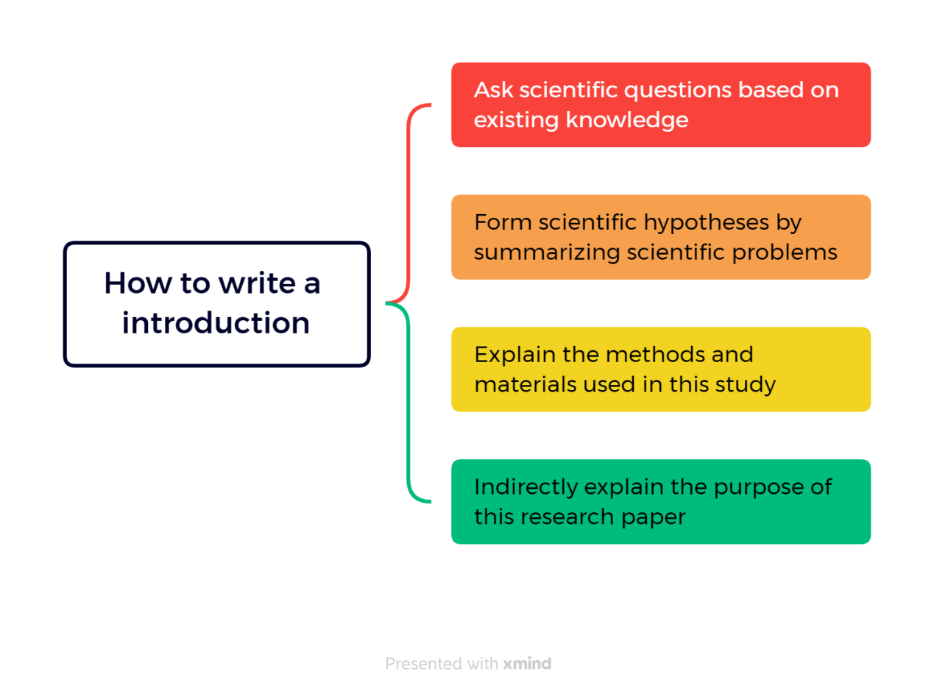

1. Write the introduction in five steps

* General statements about a field of a research to provide the readers with a setting for problems.
* More specific statement about the aspects of the problems already studied by other researchers.
* Statements that indicate the need for more investigation.
* Very specific statement giving the purpose of the writer's study.
* Optional statement that give a value or justification for carrying out the study.

1. Introduction and write a roadmap

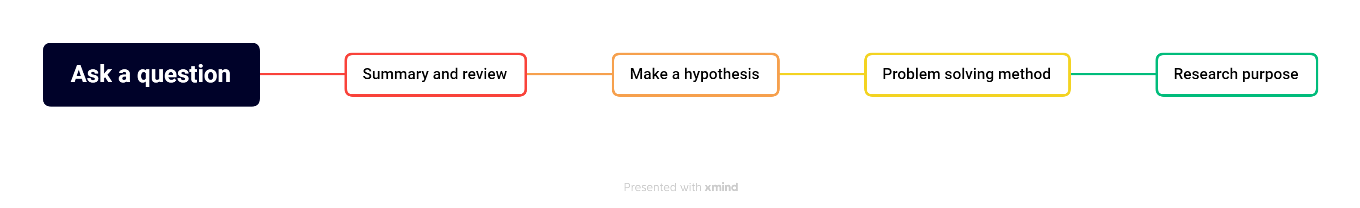

1. English thesis tense

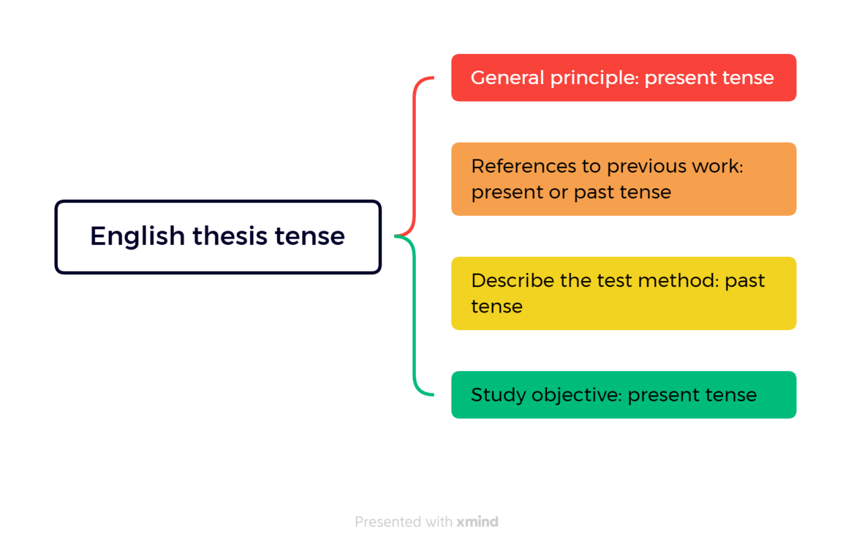

1. Precautions for introduction writing

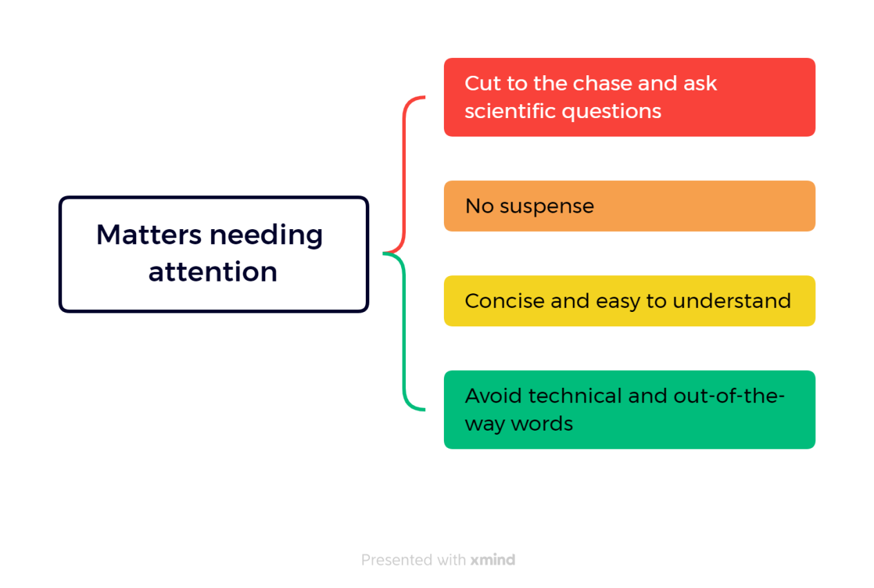

1. **Outcomes:**

* The purpose of the introduction is to provide research background, introduce scientific problems, and enable readers to understand and evaluate the significance of research results.
* Writing the introduction requires moving from general to specific, using the five-step method that includes presenting the problem, reviewing previous research, stating the hypothesis, explaining the methods, and stating the purpose.
* When writing the introduction, it is important to use appropriate tenses, such as the present tense for general principles, the present or past tense for citing previous work, the past tense for describing experimental methods, and the present tense for stating the research purpose.
* The introduction should clearly and concisely present the scientific problem, avoiding leaving readers confused or uncertain.
* Common issues to avoid when writing the introduction include missing important elements, vague descriptions, being overly long and losing focus, having a narrow background, and using overly general statements.
* When writing the introduction, it is important to avoid overly technical or esoteric vocabulary to ensure readers can understand the content.

1. **My behavior and attitude**

* I finish my homework carefully, but sometimes I procrastinate because of improper time management.
* Listen carefully and take notes, but sometimes I miss something important because I lose focus.

1. **Improvement**

* Time mismanagement: Make to-do lists and set time limits.
* Inattention: Reduce distractions and find quiet.