大学生短视频使用现状调查研究



重庆大学课程论文

学生姓名：文红兵

任课教师：张梅教授

课程名称：英语学术论文写作

英语班级：002

**2023年5月**

**A Research on the Use of Short Videos in College Students**



Course Paper Submitted to Chongqing University

**By**

**Wen Hongbing**

**Supervised by Professor Zhang Mei**

**Academic English Writing**

**English Class: 002**

**May, 2021**

# 摘要

大学生对短视频平台的使用已经成为一个备受关注的话题。然而，对于大学生使用短视频平台的多样化需求，平台偏好和分享特征，目前还缺乏全面而系统的研究。为了弥补这一研究空白，本研究对大学生使用短视频的情况进行了深入调查，重点关注他们的平台使用习惯、观看选项和分享偏好。采用问卷调查法和深度访谈法，对不同群体的大学生进行相关数据收集，进行分析。

研究发现，大学生对短视频的需求是多种多样的，包括娱乐、获取知识和技能、分享生活经验和交流思想。抖音是最常用的平台，学习视频是最受欢迎的观看选项。大学生观看短视频的频率和时长相对较高，大多数人每天观看2-4小时。短视频主要在社交媒体上分享，可见短视频在传播上具有明显的优势。此外，内容创意也是短视频平台吸引用户关注的重要因素。基于这些发现，可以对短视频平台进行优化，以满足大学生多样化的需求和偏好，并通过社交媒体等渠道与用户建立更紧密的联系和沟通，提高用户粘性和忠诚度。

**关键词：**短视频；大学生；平台；偏好

# Abstract

College students' use of short video platforms has become a topic of great concern.However, there is a lack of systematic and comprehensive research on the diverse needs and platform preferences, as well as the sharing characteristics, of college students who use short video platforms.To address this research gap, this study conducted an in-depth investigation into the use of short videos by college students, focusing on their platform usage habits, viewing options, and sharing preferences. Questionnaire survey and in-depth interview were used to collect and analyze relevant data of different groups of college students.

The study found that college students' needs for short videos are diverse, including entertainment, knowledge and skill acquisition, sharing life experiences, and exchanging ideas.Douyin is the most commonly used platform, and learning videos are the most popular viewing option.The frequency and duration of watching short videos among college students are relatively high, with most of them watching 2-4 hours daily.Short videos are mainly shared on social media, indicating that short videos have significant advantages in communication.In addition, content originality is an important factor in attracting user attention to short video platforms.Based on these findings, short video platforms can be optimized to meet the diverse needs and preferences of college students, and establish closer connections and communication with users through social media and other channels to improve user stickiness and loyalty.

**Key words:** Short video; College students; Platform; Preference

**Table of Content**

**摘要 I**

**Abstract II**

**Chapter 1 Introduction 3**

**1.1 Background of the Study 3**

1.1.1 Importance of the Research 3

1.1.2 Necessity of the Research 3

**1.2 Research Questions 4**

**1.3 Research Methods 4**

**1.4 Purpose of the Study 5**

**1.5 Significance of the Study 5**

**Chapter 2 Research Methodology 6**

**2.1 Research questions 6**

**2.2 Participants 6**

**2.3 Instruments 6**

2.3.1 Source 6

2.3.2 Content 7

2.3.3 Standards and Principles 7

2.3.4 Reliability and Validity 8

**2.4 Data collection 8**

**Chapter 3 Data Analysis 10**

**3.1 Reliability analysis 10**

**3.2 Preliminary analysis of survey results 11**

3.2.1 Analysis of the usage of short video platform 11

3.2.2 Analysis of college students' cognition of short video 14

3.2.3 Interview analysis 16

**Chapter 4 Results and Discussion 18**

**4.1 Short video usage pattern 18**

**4.2 Preference for short video use 19**

**4.3 Summary 20**

**Chapter 5 Conclusion 22**

**5.1 Major findings 22**

**5.2 Implications 22**

**5.3 Limitations 23**

**5.4 Suggestions for future research 23**

**Acknowledgement 24**

**References 25**

**Appendices 26**

**Appendix 1 Questionnaire items 26**

**Appendix 2 Interview outline 26**

# Introduction

Introduction includes research background, research questions, research methods, research purpose and research significance

## Background of the Study

The research background includes the importance and necessity of research

### Importance of the Research

In recent years, short videos have become a ubiquitous form of entertainment and communication, particularly among young people, including college students. Short videos are defined as videos that are less than 10 minutes in length and are usually created and shared through social media platforms.According to a survey conducted by China Internet Network Information Center (CNNIC), the number of short video users in China has reached 873 million in 2020[1], accounting for 86.5% of the total internet users, and the market size of short videos is expected to reach 157.8 billion yuan by 2022 (Xinhua, 2020).

The popularity of short videos has brought about significant changes in the way people consume and create content.Short videos have become a new form of social media, providing users with a platform to express themselves, share their experiences, and connect with others. As a result, short videos have become an essential part of the daily lives of many people, especially college students.

Understanding the usage patterns and preferences of college students regarding short videos is crucial for social media platforms, content creators, and marketers. This knowledge can help them create more engaging and relevant content, improve user experience, and increase user retention. Therefore, this study aims to investigate the current usage patterns and preferences of college students regarding short videos.

### Necessity of the Research

Despite the popularity of short videos among college students, there is a lack of research on their usage patterns and preferences.Most of the existing studies have focused on the impact of short videos on mental health, addiction, and academic performance.However, few studies have investigated the factors that influence college students' usage patterns and preferences, such as the type of content, platform, and frequency of use.

This study is necessary because short videos have become an integral part of the daily lives of college students, but there is a lack of research on their usage patterns and preferences.Understanding these patterns and preferences can help stakeholders create more effective content and improve user experience, which is important for the success of social media platforms, content creators, and marketers. Additionally, the study can inform educational institutions and policymakers about the potential impact of short videos on college students' academic performance and mental health, which is essential for ensuring the well-being of students. Overall, this study can contribute to a better understanding of the role of short videos in the lives of college students and their impact on society. The existing literature has not fully explored the usage patterns and preferences of college students regarding short videos.Therefore, this study aims to fill this gap by investigating the following research questions.

## Research Questions

1.What are the usage patterns of short videos among college students?

2.What are the preferences of college students regarding short videos, such as the type of content, platform, and frequency of use?

## Research Methods

This study will use a mixed-methods approach, including a survey and in-depth interviews.The survey will be conducted among college students to investigate their usage patterns and preferences regarding short videos.The survey will include questions about the type of content, platform, and frequency of use.

The in-depth interviews will be conducted among a subset of the survey respondents to gain a deeper understanding of their experiences and perceptions of short videos.The interviews will be semi-structured and will focus on the factors that influence their usage patterns and preferences.

## Purpose of the Study

The purpose of this study is to investigate the current usage patterns and preferences of college students regarding short videos.The study aims to fill the gap in the existing literature and provide insights into the factors that influence college students' usage patterns and preferences.

## Significance of the Study

This study has significant implications for various stakeholders, including social media platforms,content creators,marketers,educational institutions, and policymakers. The knowledge gained from this study can help these stakeholders create more engaging and relevant content, improve user experience, and increase user retention.Additionally, the study can inform educational institutions and policymakers about the potential impact of short videos on college students' academic performance and mental health. Overall, the study can contribute to a better understanding of the role of short videos in the lives of college students and their impact on society.

# Research Methodology

Research Methodology covers the question of research, the selection of participants and the collection of data

## Research questions

The research questions for this study are:

1.What are the usage patterns of short videos among college students?

2.What are the preferences of college students regarding short videos, such as the type of content, platform, and frequency of use?

To answer these research questions, the following aspects will be examined: the types of short videos that college students prefer to watch, how often they watch such videos, the platforms they use to access short videos, the impact of short videos on their academic performance, and their perceptions of the originality of short video content.

## Participants

The selection process for participants in this study will involve several steps to ensure a representative sample.First, identify the faculties within Chongqing University that have a high number of undergraduate students.These faculties will include the Computer Science, Art, Foreign Language, Electrical Engineering, and Mathematics departments.

Participants were selected through a simple random sampling method to reduce bias and ensure that all ages and genders were included. Participants' data will be kept confidential.

## Instruments

Instruments includes survey methods, survey content, survey standards and principles, and reliability and validity tests

### Source

A self-developed questionnaire will be used to collect data from the participants. The questionnaire will include both open-ended and closed-end questions covering all aspects related to short video use, including demographic information, frequency of short video viewing, preferred platforms, preferred types of content, and the impact of short video on academic performance. Part of the questions are designed in the form of Likert scale, which takes into account relevant literature and expert opinions on the use of short videos.

### Content

The content of the survey will be divided into two parts, one is a questionnaire and the other is an interview.

The questionnaire consists of 10 questions, including basic information such as age, gender, college, favorite type of short video and platform used, as well as questions related to short video viewing frequency, sharing behavior, influence and value. The questionnaire involves multiple choice questions and scale measurement questions, aiming to understand the respondents' habits and attitudes of short video consumption.

There are five questions in total in the interview, which mainly involve short video in different grades, entertainment and learning help, the choice of different platforms, the originality of short video content, and the development prospect of short video. These questions are aimed at understanding respondents' attitudes and views on the use of short videos, including personal views and predictions of the future development trend of short videos.

### Standards and Principles

This scale has a total of 5 questions and is scored on 5 scales, including “strongly agree”, “somewhat agree”, “neutral”, “somewhat disagree”, and “strongly disagree”. Each question is scored on a scale of 1-5, with 1 being “strongly disagree” and 5 being “strongly agree” . A higher score indicates a higher level of agreement with the issue.

### Reliability and Validity

Reliability, or reliability or consistency, means that a measurement can withstand repeated testing. Reliability reflects the size of random errors in measurement. High reliability means that the results of multiple measurements for the same thing can be consistent, indicating that the measurement tool is reliable and stable. If the reliability is lacking, the results of the measurement before and after will be inconsistent, indicating that there is something wrong with the measurement tool.

Validity, or reality, refers to the fact that the measuring tool can actually measure what it is intended to measure. High validity indicates that the measurement results can well reflect the real characteristics of the measured object, and can ensure that different researchers have a consistent understanding of the meaning and connotation of a certain research variable. The lack of validity indicates that the measurement tool does not correctly obtain the data reflecting the real characteristics.

What reliability tests is the internal consistency of the scale. The higher the consistency is, the more accurate the measured data will be and the stronger the reliability of the evaluation results will be. Cronbach-α is the most commonly used test method for scale reliability. Cronbach-α coefficient ranges from 0 to 1, and the closer it is to 1, the better the reliability is. Its criterion is: coefficient above 0.9, indicating that the reliability of the measuring tool, namely the scale, is good. 0.8-0.9, indicating good reliability; 0.7-0.8 is acceptable, but some contents of the scale need to be modified; Below 0.7, it indicates that some contents of the scale need to be rewritten. Therefore, Cronbach-α test was used in this investigation.

## Data collection

During the collection of questionnaire data, participants' personal information will be kept confidential and all data will be processed anonymously. In designing the questionnaire, a variety of types of questions were used to get as comprehensive a picture as possible of the participants' perspectives and perceptions. Questionnaire data will be collected through an online survey platform. Participants will be given a link to the questionnaire and asked to complete it within a specified period of time. Approximately 50 pieces of data will be collected.

Interview data will be collected by invitation to obtain more detailed and specific information. During the interview, we will respect the wishes and privacy of the interviewees and ensure that all information is kept confidential and protected. About ten pieces of data were collected.

# Data Analysis

Data Analysis includes data validity analysis and survey results analysis

## Reliability analysis

The reliability of the scale was analyzed and the Cronbach 'scoefficient was used to evaluate the scale.The low reliability :< 0.35, medium reliability : 0.35 << 0.70, high reliability : 0.70 <. Generally, thecoefficient of the questionnaire is above 0.8, which is of use value. Cronbach 'svalues were above 0.85, indicating that the reliability of the questionnaire was good.

According to Table 1 and Table 2, the Cronbach 'scoefficient of the questionnaire is 0.902, indicating that the whole questionnaire has high reliability. After deleting a single analysis item, the Cronbach 'scoefficient was above 0.862, indicating that each analysis item had a certain contribution to the overall reliability of the questionnaire, so it was recommended to retain all analysis items. At the same time, the correlation between each analysis item and the overall after deletion is above 0.698, indicating that each analysis item has a certain correlation with the overall, and also supports the retention of all analysis items. In summary, the reliability of the questionnaire is high, and all analysis items can be retained.

|  |  |  |
| --- | --- | --- |
| Cronbach'scoefficient | Items | samples |
| 0.902 | 5 | 29 |

Table 1

|  |  |  |  |  |
| --- | --- | --- | --- | --- |
| index | Item name | Correlation between deleted items and the total after deleting items | Cronbach 's  coefficient after item deletion | conclusion |
| 1 | 一天中观看短视频时间 | 0.805 | 0.869 | good |
| 2 | 经常在社交媒体上分享短视频 | 0.736 | 0.884 | good |
| 3 | 短视频对自己的影响 | 0.834 | 0.862 | good |
| 4 | 短视频可以帮助了解文化 | 0.698 | 0.892 | good |
| 5 | 短视频可以缓解压力和疲劳 | 0.709 | 0.891 | good |

Table 2

## **Preliminary analysis of survey results**

The survey received a total of 29 questionnaires, 29 valid questionnaires, of which girls accounted for 51.72 %, boys accounted for 48.28 %. In terms of age, respondents were mainly 21-23 years old, accounting for 41.38 %, and 18-20 years old, accounting for 37.93 %. From the selected five colleges, each college accounts for an equal proportion.

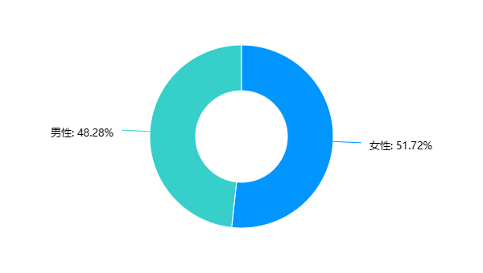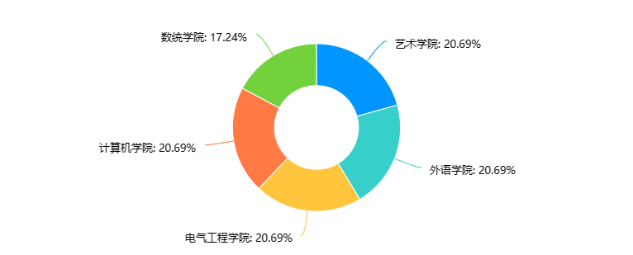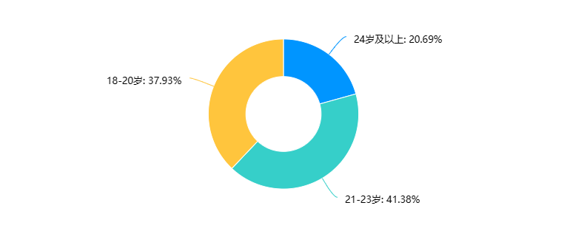

Figure 1

In-depth interviews a total of three college students were interviewed to talk about their views on the short video.

### Analysis of the usage of short video platform

In general, short video platforms are very popular among college students, who often watch and share videos on the platform. The video needs of college students are more diversified, not only limited to entertainment and recreation, but also to acquire knowledge and skills, share life and exchange experience. In the short video platform, Douyin is the most commonly used platform for college students, probably because its content is more diverse and interesting, and the user interface is more friendly and easy to use. On social media, most college students are willing to share short videos, which also reflects the advantages of short videos in communication and communication.

* **College students use short video platform time**

It can be seen from the data in the Figure 2 that college students use the short video platform mainly between 2-4 hours a day, accounting for more than half of the proportion. This shows that short video platforms are very popular among college students and have become an important part of their daily entertainment life. In addition, some people use the short video platform for less than 1 hour a day, which may be because they are busy and do not have much free time. The number of people using short video platforms for more than 4 hours a day is relatively small, probably because long-term use of short video will affect learning and life, and college students are aware of this. It can be seen that the frequency and duration of most college students watching short videos are relatively high.

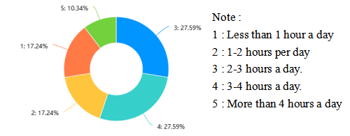

Figure 2

* **College students' favorite type of short video**

It can be seen from the data in the Figure 3 that learning video is the most popular viewing option, accounting for 44.83 %. This shows that college students are more inclined to acquire knowledge and skills when using video platforms, rather than just entertainment. Life records have also received some attention, accounting for 34.48 %, which shows that college students have a strong demand for sharing life and exchanging experience. In addition, the proportion of other videos is 20.69 %, which may include some entertainment, music, film and other content. In general, the demand for video platforms for college students is more diversified, not only limited to entertainment and recreation, but also includes acquiring knowledge and skills, sharing life and exchanging experience.

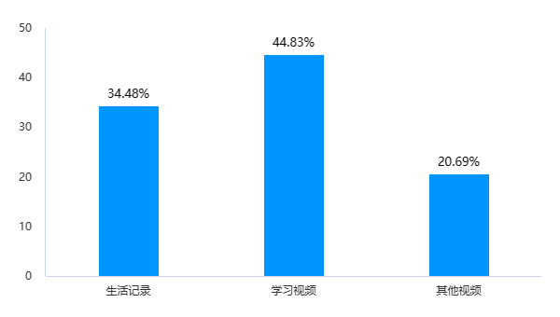

Figure 3

* **The most commonly used short video platform**

According to the data in the Figure 4, TikTok is the most commonly used short video platform for college students, with a proportion of 44.83 %, micro-vision and Kuaishou are 34.48 % and 20.69 % respectively. The popularity of tremolo among college students may be due to its more diverse and interesting content, while the user interface is more friendly and easy to use. As a product of Tencent, micro-vision also has a certain user base among college students, but its content and user interaction may be relatively simple. The Kuaishou pays more attention to localization and regional characteristics, but it may have a relatively small audience among college students.

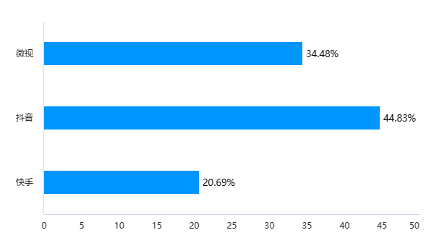

Figure 4

* **Analysis of sharing short video**

According to the data in the Figure 5, most college students share a high proportion of short videos on social media, and the highest proportion is the choice of ' 3 : somewhat agree ', accounting for 31.03 %. This may be because short video is simple, vivid and easy to spread, which can attract the attention of young people and transmit information quickly. In addition, the proportion of choosing ' 2 : disagree ' and ' 1 : completely disagree ' is low, probably because now short video has become a popular form of social media, and most people will watch and share short video on social media.

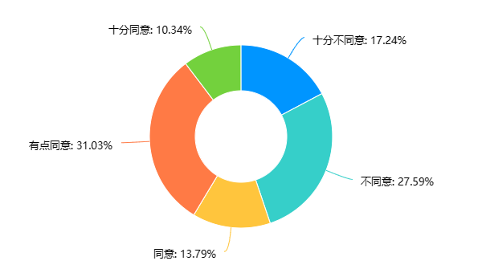

Figure 5**: results of the ‘often share short videos on social media’**

### Analysis of college students' cognition of short video

College students' cognition of short video shows a more diversified distribution, but most people think that short video has a certain impact on themselves, which can help understand culture and trends, and can also relieve stress and fatigue. However, a small number of people think that short video has little or no effect on themselves.

* **The impact of short video on self**

According to the data in the Figure 6, the influence of college students ' short video on themselves shows a relatively average distribution. Among them, 41.38 % of the respondents agree or agree with this statement, which may be because the short video content is vivid, interesting and diverse, which can arouse their interest and resonance, thus affecting their ideas and values. At the same time, 34.48 % of respondents believe that short video has little or no impact on themselves. This may be because they have a more objective attitude towards short video, can better distinguish between facts and false information, and will not be easily affected by short video.

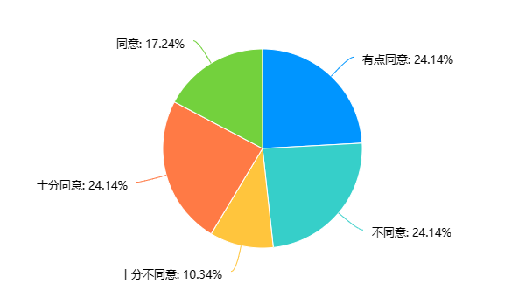

Figure 6**: results of the ‘Short video has a greater impact on yourself’**

* **Short video to understand culture**

According to the data in the Figure 7, 51.73 % of college students believe that short videos can help them understand culture and trends. This may be because short videos cover a variety of topics, including culture, art, fashion, science and technology, etc. By watching short videos, they can access knowledge and trends in different fields. In addition, 24.14 % of college students chose to agree very much, indicating that they believe that short video can indeed provide this help, while only 6.9 % of college students completely disagree. This may be because they believe that the content of short video is not deep enough, only superficial understanding, can not really understand the culture and trends. Overall, it shows that most college students think that short videos can help understand culture and trends.

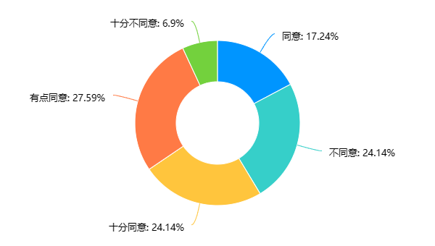

Figure 7**: result of the ‘Short videos can help understand culture and trends’**

* **Relieve stress and fatigue**

According to the data in the Figure 8, it can be seen that most people ( 48.28 % ) think that short videos can relieve stress and fatigue, of which 27.59 % say they agree very much and 20.69 % agree. In addition, 20.69 % of people think a little agree, 13.79 % of people think disagree, 4.17 % of people think completely disagree. This shows that short videos can help people relieve stress and fatigue to some extent, but not everyone thinks so. Maybe some people think that short video is just a way of entertainment, which is not significant for relieving stress and fatigue.

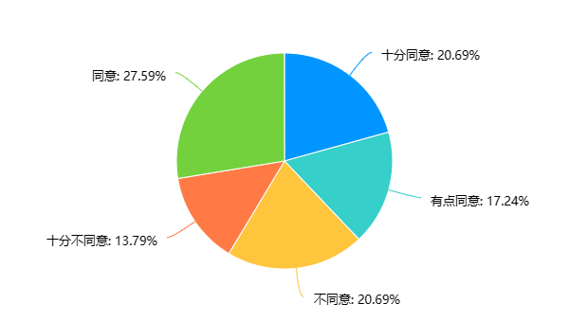

Figure 8**: result of the ‘Short video can relieve stress and fatigue’**

### Interview analysis

It can be seen from the answers of the three interviewers that there are differences in their cognition and use of short videos. Among them, the first interviewer believes that there is a certain relationship between the frequency and performance of short videos, but moderate viewing can relieve learning pressure ; the second interviewer believes that short videos are mainly for entertainment, but they can also be used as learning aids ; the third interviewer believes that short video can be used as a learning aid, but excessive addiction will affect learning efficiency.

In the choice of short video platform, the three interviewers have their own preferences. The first interviewer prefers to watch short videos on Douyin, the second interviewer prefers to watch on the Kuaishou, and the third interviewer has no clear preference.

In terms of the originality of short video content, all three interviewers think it is very important. The original short video content can attract the attention and interest of the audience, and also bring more attention and fans to the video author.

For the future development trend of short video, all three interviewers believe that short video will be more intelligent, personalized and social. For example, artificial intelligence technology can help the video production process more efficient and time-saving ; the intelligent recommendation system can provide users with more accurate short video content recommendations based on their preferences and historical browsing records. At the same time, short videos will also focus more on social interaction, further enhancing the user experience and platform stickiness by strengthening the connection and interaction between users.

On the whole, short video has become one of the main ways for people to entertain, and it can also be used as a learning aid. In the future, with the continuous development of technology, short videos will be more diversified and intelligent, providing users with a better viewing experience.

# 

# Results and Discussion

Results and Discussion include short video usage patterns, short video usage preferences and summary

## Short video usage pattern

Through questionnaire survey and in-depth interview, this study investigated the use pattern of short video among college students. The results show that college students' viewing needs on short video platforms are more diversified, not only limited to entertainment, but also include acquiring knowledge and skills, sharing life and exchanging experiences.  
 Among short video platforms, Douyin is the most commonly used by college students, probably because its content is richer and more diverse and its user interface is more user-friendly.

On social media, most college students are willing to share short videos, which also reflects the advantages of short videos in communication and communication. Among college students, the frequency and duration of watching short videos are relatively high. Most of them watch short videos for 2-4 hours every day, indicating that short videos have become an important part of college students' daily entertainment life.

Among college students, learning videos are the most popular viewing option, accounting for 44.83%. Life records also receive some attention, accounting for 34.48%, indicating that college students have a strong demand for sharing life and exchanging experiences. Among college students, short videos are mainly shared on social media, which indicates that short videos have strong advantages in communication.

The results fit the purpose of the study. Our aim is to understand the current situation and patterns of short video usage by college students, and the results clearly indicate the usage patterns and preferences of college students for short video.

The findings are consistent with those of other experts. Other studies have also shown that short video platforms are very popular among young people, and college students' demands for short videos are more diversified, not just for entertainment and leisure, but also for acquiring knowledge and skills, sharing life and exchanging experiences, etc.

The usage pattern and preference of college students for short video are closely related to the characteristics of short video platform. The content of short video platforms is more diverse and interesting, and the user interface is also more friendly and easy to use, which attracts a large number of young users. College students' demands for short videos are more diversified, not only for entertainment and leisure, but also for acquiring knowledge and skills, sharing life and exchanging experiences. These demands reflect college students' diversified cognition and use of short videos.

The deficiency is that our study only focused on the use pattern and preference of college students for short videos, without in-depth study on the impact and significance of short videos on college students. Future studies can further explore the influence and significance of short videos on college students.

## Preference for short video use

Through questionnaire survey and in-depth interview, this study investigated college students' preference for short videos, including content type, platform and frequency of use.

In terms of preference for short video types, learning video is the most popular viewing option for college students, accounting for 44.83%. This shows that college students are more inclined to acquire knowledge and skills when using video platforms, rather than just entertainment. Life records also received some attention, accounting for 34.48%, indicating that college students have a strong need to share their lives and exchange experiences. In general, college students have more diversified demands for video platforms, which are not limited to entertainment, but also include acquiring knowledge and skills, sharing life and exchanging experiences.

In terms of preference for short video platform, DouYin is the most commonly used short video platform among college students, accounting for 44.83%, while micro-visio and Kuaishou are 34.48% and 20.69%, respectively. Because Douyin's content is richer and more interesting, and the user interface is more user-friendly. As a Tencent product, micro-visio also has a certain user base among college students, but its content and user interaction may be relatively simple. Kuaishou pays attention to localization and regional characteristics, but it may have a relatively small audience among college students.

In terms of the use time of short video, the frequency of short video use of college students is mainly concentrated in the range of 2-4 hours a day, accounting for 55.18%. 17.24% use short video less than one hour a day. 10.34% use short videos for more than four hours a day. This shows that most college students regard short videos as a way of entertainment and relaxation, and they are aware of the negative effects of excessive use of short videos on their life and study.

## Summary

Through questionnaires and in-depth interviews, this study investigated the patterns and preferences of college students in using short videos. The results show that college students' viewing needs on short video platforms are more diversified, not only limited to entertainment, but also include acquiring knowledge and skills, sharing life and exchanging experiences. Among short video platforms, Douyin is the most commonly used platform for college students, and learning videos are the most popular viewing options. Among college students, the frequency and duration of watching short videos are relatively high. Most of them watch short videos for 2-4 hours every day, indicating that short videos have become an important part of college students' daily entertainment life. Among college students, short videos are mainly shared on social media, which indicates that short videos have strong advantages in communication. Among college students, the original content of short videos is very important, which can attract the audience's attention and interest, as well as bring more attention and fans to the video writer. In the future, with the continuous development of technology, short videos will become more intelligent, personalized and social.

The research sample size is small, with only 29 valid questionnaires, which may affect the representativeness of our research results. The survey covers only a few short video platforms, and there may be others that are also popular with college students. Finally, the survey focused only on college students' preferences and usage patterns, and did not explore the impact of short videos on their mental health and academic performance.

Future studies could expand the sample size to include more short video platforms, making the findings more representative. In addition, future research could also explore the impact of short videos on college students' mental health and academic performance, and provide recommendations for healthy use of short videos.

The research results are of great significance for the development and marketing of short video platforms. Short video platforms can offer more diverse and interesting content based on college students' usage patterns and preferences, and optimize user interfaces and interactive experiences to attract more young users. In addition, short video platforms can strengthen the connection and communication with users through social media and other channels to improve user stickiness and loyalty.

# Conclusion

After the above analysis, this chapter mainly summarizes and looks forward to the above, including Major findings, Implications, Limitations and Suggestions for future research

## Major findings

This study investigated the patterns and preferences of college students in using short videos. The results showed that college students' viewing needs on short video platforms are more diversified, not only limited to entertainment, but also include acquiring knowledge and skills, sharing life and exchanging experiences. Among short video platforms, Douyin is the most commonly used platform for college students, and learning videos are the most popular viewing options. Among college students, the frequency and duration of watching short videos are relatively high. Most of them watch short videos for 2-4 hours every day, indicating that short videos have become an important part of college students' daily entertainment life. Among college students, short videos are mainly shared on social media, which indicates that short videos have strong advantages in communication. The original content of short videos is also very important, which can attract the audience's attention and interest, as well as bring more attention and fans to the video writer.

## Implications

The research results have implications for the development and marketing of short video platforms. Short video platforms can optimize user interfaces and interactive experiences to attract more young users and offer more diverse and interesting content based on college students' usage patterns and preferences. In addition, short video platforms can strengthen the connection and communication with users through social media and other channels to improve user stickiness and loyalty.

## Limitations

The research sample size is small, and the survey covers only a few short video platforms, which may affect the representativeness of our research results. In addition, the survey focused only on college students' preferences and usage patterns, and did not explore the impact of short videos on their mental health and academic performance.

## Suggestions for future research

Future studies could expand the sample size to include more short video platforms, making the findings more representative. In addition, future research could also explore the impact of short videos on college students' mental health and academic performance, and provide recommendations for healthy use of short videos.

# Acknowledgement

In the paper, I would like to thank my teacher for his great support and help in my study. The teacher provided me with many valuable opinions and suggestions, and gave me very useful help in research design, data collection, data analysis and other aspects, which benefited me a lot in the process of writing the paper.

In addition, I would like to thank all the college students who participated in the questionnaire and interview. You provided important data and information for this study, which made the results more objective and accurate.

I would like to express my heartfelt thanks.

# References

1. CNNIC. 第47次《中国互联网络发展状况统计报告》[EB/OL]. [2023-3-29].<https://www.gov.cn/xinwen/2021-02/03/content_5584518.htm>

# Appendices

## Appendix 1 Questionnaire items

7. 你经常在社交媒体上分享自己的短视频。

a. 十分同意

b. 同意

c. 有点同意

d. 不同意

e. 十分不同意

8. 短视频对你有很大的影响。

a. 十分同意

b. 同意

c. 有点同意

d. 不同意

e. 十分不同意

9. 我认为短视频可以帮助我更好地了解当下的文化和趋势。

a. 十分同意

b. 同意

c. 有点同意

d. 不同意

e. 十分不同意

10. 我认为短视频可以帮助我缓解压力和疲劳。

a. 十分同意

b. 同意

c. 有点同意

d. 不同意

e. 十分不同意

1. 你的年龄是？

a. 18-20岁

b. 21-23岁

c. 24岁及以上

2. 你的性别是？

a. 男性

b. 女性

3. 你所在的学院是？

a. 计算机学院

b. 艺术学院

c. 外语学院

d. 电气工程学院

e. 数统学院

4. 你最喜欢的短视频类型是？

a. 搞笑视频

b. 生活记录

c. 美食视频

d. 旅游视频

5. 你最常使用的短视频平台是？

a. 抖音

b. 快手

c. 微视

6. 你一天中经常观看短视频。

a. 强烈同意（每天超过4小时）

b. 同意（每天3-4小时）

c. 有点同意（每天2-3小时）

d. 不同意（每天1-2小时）

e. 强烈不同意（每天不到1小时）

## Appendix 2 Interview outline

1. 您觉得短视频的使用频率与年级有关系吗？请谈一下您的观点。
2. 在您看来，短视频的使用主要是休闲娱乐还是学习帮助？
3. 对于同样的内容，您更喜欢在哪个平台观看短视频？为什么？
4. 你对短视频内容的原创性有什么看法？
5. 最后，您认为短视频的发展前景如何？