代码：

clc; clear ;

y1=[22.1,15.4,11.7,10.3,11.4,7.5,13,12.8,14.6,18.9,19.3,30.1,28.2,25.6,37.5,36.1,39.8,44.3]';

y2=[7.2,5.4,7.6,2.5,2.4,1.7,4.3,3.7,3.9,7,6.8,10.1,9.4,7.9,14.1,14.5,14.9,15.6]';

x1=[1.89,1.94,1.95,1.82,1.85,1.78,1.76,1.76,1.75,1.74,1.7,1.7,1.68,1.6,1.61,1.64,1.67,1.68]';

x2=[6.1,6.2,6.3,8.2,9.8,10.3,10.5,8.7,7.4,6.9,5.2,4.9,4.3,3.7,3.6,3.1,1.8,2.3]';

X = [ones(size(x1)) x1 x2] ;

[b,bint,r,rint,stats] = regress(y1,X)

rcoplot(r,rint) ; % 残差图

数据 ：

0.8593 45.7992 0.0000 20.7910

|  |  |
| --- | --- |
|  | 估计值 |
| R2 | 0.8593 |
| F | 45.7992 |
| σ2 | 20.7910 |
| P | 0.0000 |

b =

90.1814

-27.6588

-3.2283

bint =

46.1971 134.1656

-54.5542 -0.7634

-4.2747 -2.1819

r =

3.8867

-1.1075

-4.2081

-3.0699

4.0253

-0.1967

5.3958

-0.6152

-3.2886

-0.8794

-7.0740

2.7575

-1.6326

-8.3824

3.4714

1.2870

1.6199

8.0107

rint =

-4.8772 12.6506

-9.4242 7.2092

-12.0425 3.6263

-12.5304 6.3907

-4.8996 12.9501

-9.0838 8.6904

-2.6778 13.4694

-10.0584 8.8280

-12.8323 6.2550

-10.6419 8.8830

-15.9554 1.8075

-6.8659 12.3810

-11.2470 7.9817

-16.2006 -0.5641

-5.5645 12.5073

-8.0480 10.6220

-7.3639 10.6037

0.0213 16.0000

stats =

0.8593 45.7992 0.0000 20.7910

|  |  |  |
| --- | --- | --- |
|  | 估计值 | 置信区间 |
| β1 | 90.1814 | [46.1971 ,134.1656] |
| β2 | -27.6588 | [-54.5542 ,-0.7634] |
| β3 | -3.2283 | [-4.2747 ,-2.1819] |

残差图1

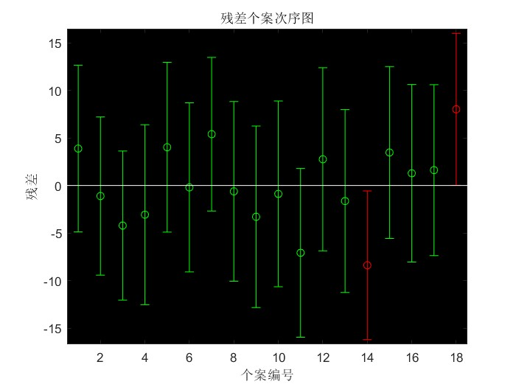

残差图2：

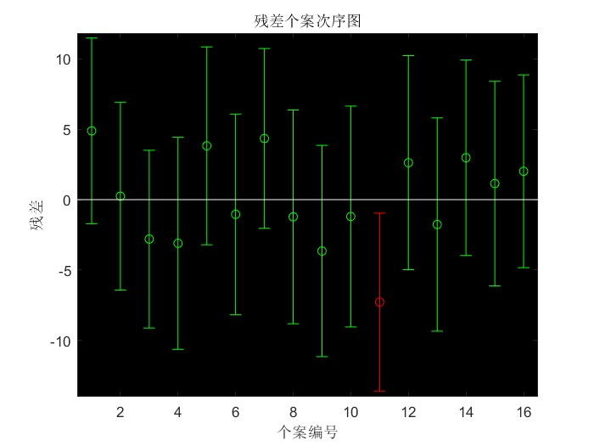

残差图3：

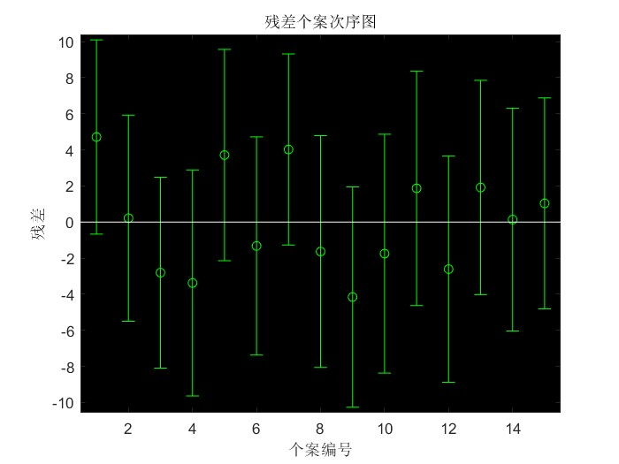

数据已经剔除完毕；

此时代码：

clc; clear ;

y1=[22.1,15.4,11.7,10.3,11.4,7.5,13,12.8,14.6,18.9,30.1,28.2,37.5,36.1,39.8]';

x1=[1.89,1.94,1.95,1.82,1.85,1.78,1.76,1.76,1.75,1.74,1.7,1.68,1.61,1.64,1.67]';

x2=[6.1,6.2,6.3,8.2,9.8,10.3,10.5,8.7,7.4,6.9,4.9,4.3,3.6,3.1,1.8]';

X = [ones(size(x1)) x1 x2] ;

[b,bint,r,rint,stats] = regress(y1,X)

rcoplot(r,rint) ; % 残差图

此时数据：

|  |  |  |
| --- | --- | --- |
|  | 估计值 | 置信区间 |
| β1 | 107.5601 | [75.3160,139.8042] |
| β2 | -37.9283 | [-57.2842,-18.5723] |
| β3 | -3.0314 | [-3.7862,-2.2767] |

b =

107.5601

-37.9283

-3.0314

bint =

75.3160 139.8042

-57.2842 -18.5723

-3.7862 -2.2767

r =

4.7162

0.2157

-2.8018

-3.3728

3.7154

-1.3238

4.0239

-1.6327

-4.1529

-1.7479

1.8721

-2.6054

1.9176

0.1398

1.0367

rint =

-0.6630 10.0953

-5.4946 5.9261

-8.0904 2.4868

-9.6351 2.8895

-2.1389 9.5697

-7.3720 4.7243

-1.2736 9.3213

-8.0565 4.7911

-10.2577 1.9519

-8.3658 4.8700

-4.6277 8.3719

-8.8772 3.6664

-4.0228 7.8581

-6.0348 6.3143

-4.8094 6.8829

stats =

0.9334 84.0758 0.0000 9.2746

|  |  |
| --- | --- |
|  | 估计值 |
| R2 | 0.9334 |
| F | 84.0758 |
| σ2 | 9.2746 |
| P | 0.0000 |