代码：

clc; clear ;

y2=[7.2,5.4,7.6,2.5,2.4,1.7,4.3,3.7,3.9,7,6.8,10.1,9.4,7.9,14.1,14.5,14.9,15.6]';

x1=[1.89,1.94,1.95,1.82,1.85,1.78,1.76,1.76,1.75,1.74,1.7,1.7,1.68,1.6,1.61,1.64,1.67,1.68]';

x2=[6.1,6.2,6.3,8.2,9.8,10.3,10.5,8.7,7.4,6.9,5.2,4.9,4.3,3.7,3.6,3.1,1.8,2.3]';

X = [ones(size(x1)) x1 x2] ;

[b,bint,r,rint,stats] = regress(y2,X)

rcoplot(r,rint) ; % 残差图

数据：

|  |  |  |
| --- | --- | --- |
|  | 估计值 | 置信区间 |
| β1 | 24.5471 | [5.9501,43.1740] |
| β2 | -4.6285 | [-16.0184,6.7615] |
| β3 | -1.4360 | [-1.8792,-0.9929] |

b =

24.5471

-4.6285

-1.4360

bint =

5.9201 43.1740

-16.0184 6.7615

-1.8792 -0.9929

r =

0.1605

-1.2645

1.1254

-1.8478

0.4887

0.1827

2.9773

-0.2075

-1.9206

0.4151

-2.4113

0.4579

-1.1963

-3.9282

2.1745

1.9953

0.6673

2.1316

rint =

-3.6679 3.9889

-4.7216 2.1927

-2.2856 4.5365

-5.7830 2.0873

-3.4051 4.3825

-3.5797 3.9452

-0.2620 6.2167

-4.2077 3.7926

-5.8905 2.0493

-3.7179 4.5481

-6.3081 1.4855

-3.6638 4.5796

-5.2293 2.8366

-7.0957 -0.7608

-1.5403 5.8892

-1.8018 5.7924

-3.1384 4.4730

-1.5746 5.8378

stats =

0.8402 39.4474 0.0000 3.7288

|  |  |
| --- | --- |
|  | 估计值 |
| R2 | 0.8402 |
| F | 39.4474 |
| σ2 | 3.7288 |
| P | 0.0000 |

残差图1 ：

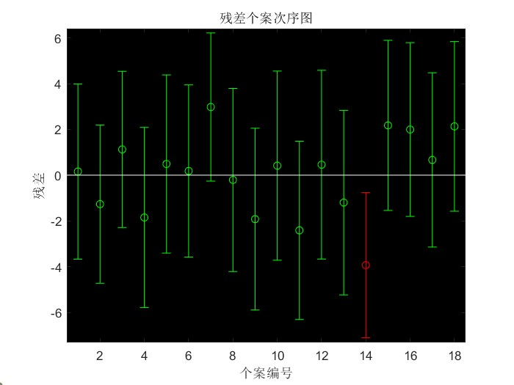

残差图2 ：

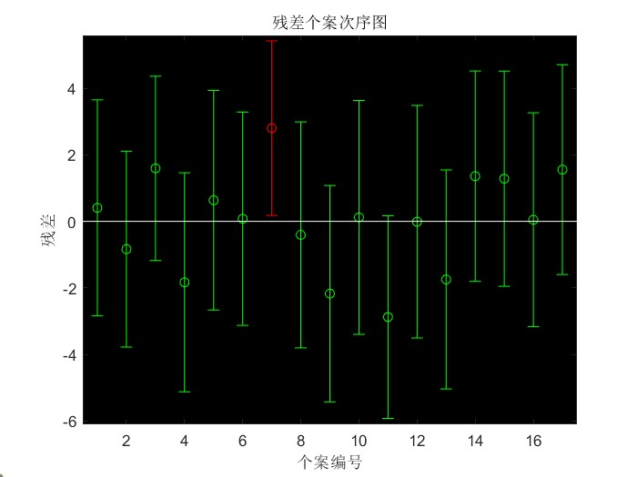

残差图3：

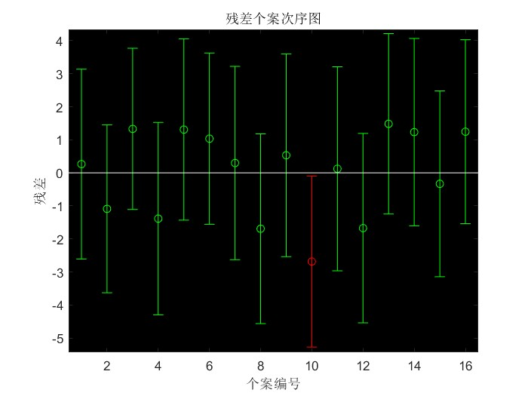

残差图4：

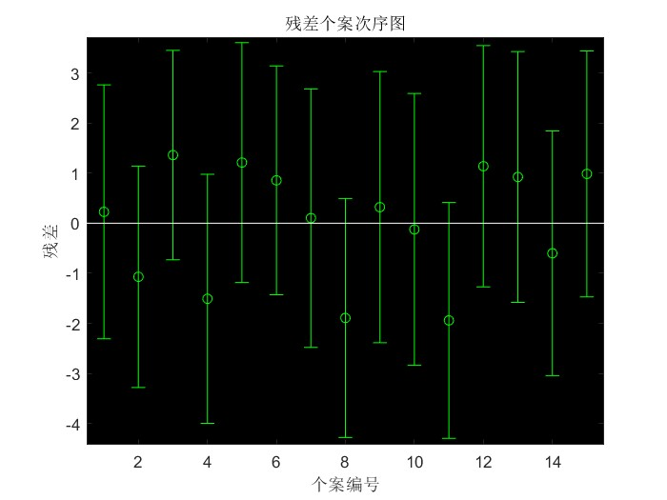

代码：

clc; clear ;

y2=[7.2,5.4,7.6,2.5,2.4,1.7,3.7,3.9,7,10.1,9.4,14.1,14.5,14.9,15.6]';

x1=[1.89,1.94,1.95,1.82,1.85,1.78,1.76,1.75,1.74,1.7,1.68,1.61,1.64,1.67,1.68]';

x2=[6.1,6.2,6.3,8.2,9.8,10.3,8.7,7.4,6.9,4.9,4.3,3.6,3.1,1.8,2.3]';

X = [ones(size(x1)) x1 x2] ;

[b,bint,r,rint,stats] = regress(y2,X)

rcoplot(r,rint) ; % 残差图

数据：

|  |  |  |
| --- | --- | --- |
|  | 估计值 | 置信区间 |
| β1 | 29.7583 | [16.2864,43.2303] |
| β2 | -6.7738 | [-14.9774 ,1.4299] |
| β3 | -1.6367 | [-1.9680 ,-1.3054] |

b =

29.7583

-6.7738

-1.6367

bint =

16.2864 43.2303

-14.9774 1.4299

-1.9680 -1.3054

r =

0.2281

-1.0696

1.3618

-1.5090

1.2130

0.8572

0.1029

-1.8925

0.3214

-0.1230

-1.9405

1.1396

0.9245

-0.6000

0.9861

rint =

-2.3085 2.7647

-3.2824 1.1433

-0.7302 3.4539

-3.9971 0.9791

-1.1838 3.6098

-1.4292 3.1436

-2.4786 2.6845

-4.2803 0.4952

-2.3877 3.0305

-2.8398 2.5938

-4.2963 0.4153

-1.2706 3.5499

-1.5801 3.4291

-3.0445 1.8445

-1.4706 3.4428

stats =

0.9450 103.1152 0.0000 1.5413

|  |  |
| --- | --- |
|  | 估计值 |
| R2 | 0.9450 |
| F | 103.1152 |
| σ2 | 1.5413 |
| P | 0.0000 |