X3 ： 0 普通

1 豪华

代码：

clc; clear ;

n = 18 ;

y=[

22.1,15.4,11.7,10.3,11.4,7.5,13,12.8,14.6,18.9,19.3,30.1,28.2,25.6,37.5,36.1,39.8,44.3,7.2,5.4,7.6,2.5,2.4,1.7,4.3,3.7,3.9,7,6.8,10.1,9.4,7.9,14.1,14.5,14.9,15.6

]';

x1 = [

1.89,1.94,1.95,1.82,1.85,1.78,1.76,1.76,1.75,1.74,1.7,1.7,1.68,1.6,1.61,1.64,1.67,1.68,1.89,1.94,1.95,1.82,1.85,1.78,1.76,1.76,1.75,1.74,1.7,1.7,1.68,1.6,1.61,1.64,1.67,1.68

]';

x2 = [

6.1,6.2,6.3,8.2,9.8,10.3,10.5,8.7,7.4,6.9,5.2,4.9,4.3,3.7,3.6,3.1,1.8,2.3,6.1,6.2,6.3,8.2,9.8,10.3,10.5,8.7,7.4,6.9,5.2,4.9,4.3,3.7,3.6,3.1,1.8,2.3

]';

x3 = [zeros(1,n) ones(1,n)]' ;

X = [ones(size(x1)) x1 x2 x3] ;

[b,bint,r,rint,stats] = regress(y,X)

rcoplot(r,rint) ; % 残差图

|  |  |  |
| --- | --- | --- |
|  | 估计值 | 置信区间 |
| β1 | 64.5753 | [33.5007,95.6499] |
| β2 | -16.1436 | [-35.1193 ,2.8320] |
| β3 | -2.3322 | [-3.0705 ,-1.5939] |
| β4 | -14.4222 | [-17.6546,-11.1898] |

数据：

b =

64.5753

-16.1436

-2.3322

-14.4222

bint =

33.5007 95.6499

-35.1193 2.8320

-3.0705 -1.5939

-17.6546 -11.1898

r =

2.2625

-3.3971

-6.7024

-5.7699

-0.4541

-4.3181

1.3255

-3.0725

-4.4658

-1.4933

-5.7038

4.3966

0.7744

-4.5164

7.3118

5.2300

6.3825

12.2100

1.7847

1.0251

3.6198

0.8523

4.9681

4.3041

7.0477

2.2498

-0.7435

1.0289

-3.7815

-1.1812

-3.6034

-7.7942

-1.6660

-1.9477

-4.0953

-2.0678

rint =

-6.9078 11.4328

-12.1971 5.4030

-15.1779 1.7731

-15.0142 3.4743

-9.7427 8.8344

-13.3160 4.6798

-7.6864 10.3373

-12.4047 6.2598

-13.8580 4.9265

-11.0343 8.0477

-15.0232 3.6157

-5.0120 13.8052

-8.7220 10.2708

-13.6380 4.6053

-1.6005 16.2242

-3.9308 14.3909

-2.5181 15.2831

4.0693 20.3507

-7.3997 10.9692

-7.8545 9.9048

-5.1040 12.3435

-8.6254 10.3300

-4.1419 14.0781

-4.6946 13.3029

-1.6001 15.6955

-7.1139 11.6134

-10.2733 8.7862

-8.5203 10.5782

-13.2313 5.6683

-10.7168 8.3545

-13.0119 5.8051

-16.6140 1.0257

-10.9521 7.6201

-11.2795 7.3840

-13.1748 4.9842

-11.3253 7.1898

stats =

0.8366 54.6111 0.0000 22.6642

|  |  |
| --- | --- |
|  | 估计值 |
| R2 | 0.8366 |
| F | 54.6111 |
| σ2 | 22.6642 |
| P | 0.0000 |

残差图：

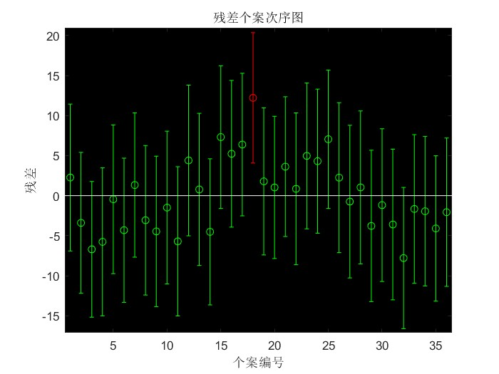

最终模型：

y = 64.5753 - 16.1436x1 - 2.3322x2 - 14.4222x3