代码：

clc; clear ;

n = 18 ;

y=[

22.1,15.4,11.7,10.3,11.4,7.5,13,12.8,14.6,18.9,19.3,30.1,28.2,25.6,37.5,36.1,39.8,44.3,7.2,5.4,7.6,2.5,2.4,1.7,4.3,3.7,3.9,7,6.8,10.1,9.4,7.9,14.1,14.5,14.9,15.6

]';

x1 = [

1.89,1.94,1.95,1.82,1.85,1.78,1.76,1.76,1.75,1.74,1.7,1.7,1.68,1.6,1.61,1.64,1.67,1.68,1.89,1.94,1.95,1.82,1.85,1.78,1.76,1.76,1.75,1.74,1.7,1.7,1.68,1.6,1.61,1.64,1.67,1.68

]';

x2 = [

6.1,6.2,6.3,8.2,9.8,10.3,10.5,8.7,7.4,6.9,5.2,4.9,4.3,3.7,3.6,3.1,1.8,2.3,6.1,6.2,6.3,8.2,9.8,10.3,10.5,8.7,7.4,6.9,5.2,4.9,4.3,3.7,3.6,3.1,1.8,2.3

]';

x3 = [zeros(1,n) ones(1,n)]' ;

X = [ones(size(x1)) x1 x2 x3] ;

[b,bint,r,rint,stats] = regress(y,X) ;

figure(1) ;

title('普通汽车') ;

subplot(1,2,1) ; z = 0 \* x1 ;

plot(x1(1:18), r(1:18),'+',x1,z,'LineWidth',1.5) ;

xlabel('x1') ; ylabel('r') ;

subplot(1,2,2) ;

plot(x2(1:18), r(1:18),'+',x2,z,'LineWidth',1.5) ;

xlabel('x2') ; ylabel('r') ;

figure(2) ;

title('豪华汽车') ;

subplot(1,2,1) ; z = 0 \* x1 ;

plot(x1(19:36), r(19:36),'+',x1,z,'LineWidth',1.5) ;

xlabel('x1') ; ylabel('r') ;

subplot(1,2,2) ;

plot(x2(19:36), r(19:36),'+',x2,z,'LineWidth',1.5) ;

xlabel('x2') ; ylabel('r') ;

普通：

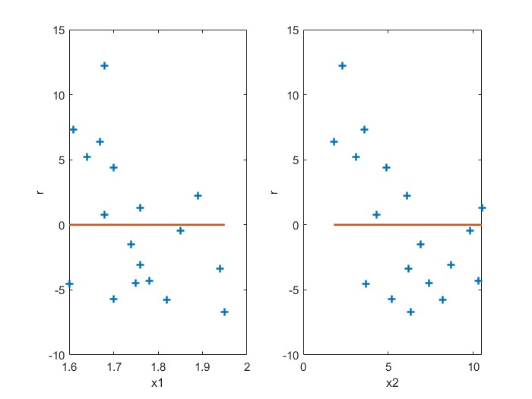

豪华：

