代码：  
clc; clear ;

n = 18 ;

y = [22.1,15.4,11.7,10.3,11.4,7.5,13,12.8,14.6,18.9,19.3,30.1,28.2,25.6,37.5,36.1,39.8,44.3,7.2,5.4,7.6,2.5,2.4,1.7,4.3,3.7,3.9,7,6.8,10.1,9.4,7.9,14.1,14.5,14.9,15.6]';

x1 = [1.89,1.94,1.95,1.82,1.85,1.78,1.76,1.76,1.75,1.74,1.7,1.7,1.68,1.6,1.61,1.64,1.67,1.68,1.89,1.94,1.95,1.82,1.85,1.78,1.76,1.76,1.75,1.74,1.7,1.7,1.68,1.6,1.61,1.64,1.67,1.68]';

x2 = [6.1,6.2,6.3,8.2,9.8,10.3,10.5,8.7,7.4,6.9,5.2,4.9,4.3,3.7,3.6,3.1,1.8,2.3,6.1,6.2,6.3,8.2,9.8,10.3,10.5,8.7,7.4,6.9,5.2,4.9,4.3,3.7,3.6,3.1,1.8,2.3]';

x3 = [zeros(1,n) ones(1,n)]' ;

x4 = x1 .\* x2 ;

x5 = x1 .\* x3 ;

x6 = x2 .\* x3 ;

x7 = x1 .^ 2 ;

x8 = x2 .^ 2 ;

X = [x1 x2 x3 x4 x5 x6 x7 x8] ;

stepwise(X, y, [1,2,3]) % [1,2,3]表示X1、X2、X3均保留在模型中

结果：

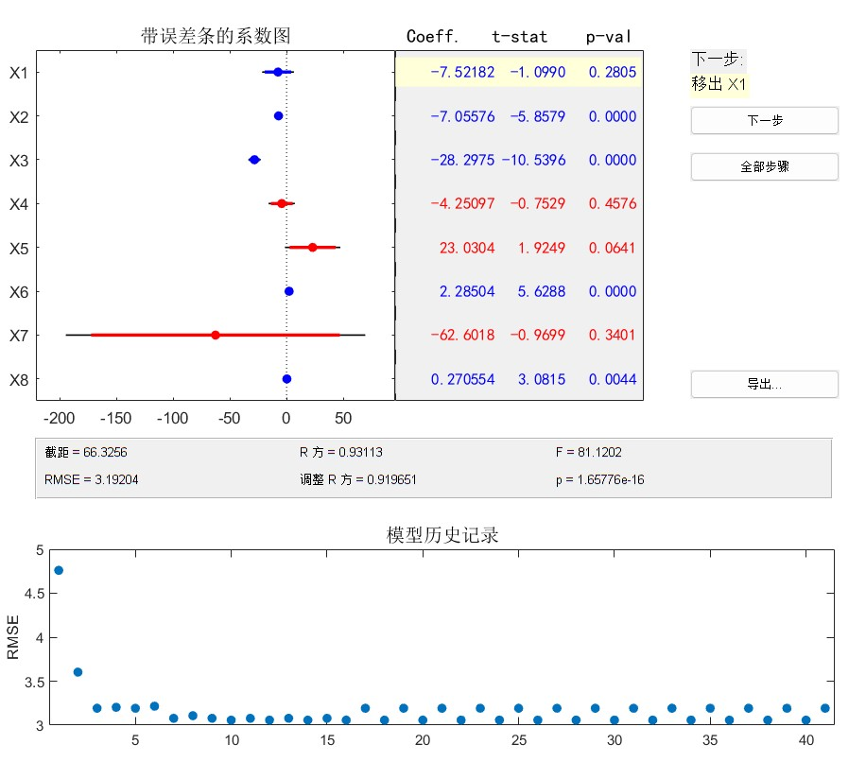

保留x1 x2 x3 的情况下尽量使得 F 大 p 小

得到非劣的情况

此时的回归方程是 ：

y = -1.099x1 - 5.8579x2 - 10.5396x3 + 5.6288x2x3 + 3.0815x22