CHAPTER FIVE
5. PREACHER ON THE PULPIT
አትሮንስ፤ (ጽር ፡ ትሮኖስ) ፡-የንጉሥ ዙፋን፤ የጳጳስ ወንበር፤ ምጡቅ የወንጌል ሰባኪ የመጽሐፍ አንባቢ ስፍራ፤ በቅድስት ቤተክርስቲያን ውስጥ የሚሠራ የመጽሐፍ ወንበር፤ ታጥፎ የሚቀመጥበት ተዘርግቶ የሚነበብበት (፫ነገ፡ ፲፡ ፱፡ ፲፰፡፡ ስንክ፡ ኅዲ፰፡ ፴፡፡ መጋ፲፫፡፡ ፍ፡ ነ፡ ፰፡ ፬)፡፡ (1)

A pulpit is a raised stand for preachers in Holy Orthodox Christian Church. The origin of the word is the Latin pulpitum. In this chapter, we see the protocol connected with all-action around the pulpit that is the protocol before the pulpit, on the pulpit, and after the pulpit. The pulpit manner is one of the preaching methods to describe the ethical consideration of preacher’s action and may be a model for one’s life. Believers give an account not only the Holiness life of the minister or preacher but also the emotional activity of the preacher around the pulpit. Now we see all the activities of the Orthodox preacher around the pulpit.
In Orthodox Church, the pulpit is used to deliver the sermon in the time of preaching and used to read the Gospel in the time of Divine Liturgy. In Ethiopian Orthodox Church, the small pulpit put on the Holy altar to read liturgical books.
The opening part of the Divine Liturgy is the Liturgy of the Catechumens in which all the people. The pulpit used to learn the prayers and also begin with one of St. Paul's letters, the arch deacon says that
“ኵሎ ዘኢያፈቅሮ ለእግዚእነ ወአምላክነ ወመድኃኒነ ኢየሱስ ክርስቶስ ወዘኢየአምን ልደቶ እም ማርያም እም ቅድስት ድንግል በ፪ ታቦተ መንፈስ ቅዱስ እስከ ምጽአቱ ሐዲስ በከመ ይቤ ጳውሎስ ውጉዘ ለይኩን”

Every one that loves not our Lord and our savior Jesus Christ, and not beloved in His birth from Holy Mary, of two-fold virginity, the ark of the Holy Spirit, until His coming again, let him be anathema as St. Paul said. (2) then the Catholic (Universal) Epistle,
መልእክት እምአቡነ ጴጥሮስ፣ ዮሐንስ፣ ያዕቆብ፣ ይሁዳ ረድኡ ወሐዋርያሁ ለእግዚእነ ኢየሱስ ክርስቶስ ጸሎቱ ወበረከቱ የሀሉ ምስለ ኩልነ ሕዝበ ክርስቲያን ለዓለመ ዓለም አሜን፡፡
The word from the Epistle of …. disciple and apostle of our Lord Jesus Christ. His prayer and blessing be with all of us Amen. Followed by a chapter from the Acts of the Apostles,
a pure fountain which is from the pure fountain of the law, to wit the history of the acts of the apostles. The blessing of their prayer be with all of us amen.

ነቅዕ ንጹሕ ዘእም አንቀዕተ ሕግ ንጹሐን ዝ ውእቱ ዜና ግብሮሙ ለሐዋርያት በረከተ ረድኤቶሙ የሀሉ ምስለ ኵልነ ሕዝበ ክርስቲያን ለዓለመ ዓለም አሜን፡፡
in the time of reading the Gospel the deacon raises his hands to serve like a pulpit and he read the Gospel.
After finishing the divine liturgy, the reading also continued with the Synaxarium, The Ethiopian Church created a special rank in its orders to administer the readings which is called Agnostic, meaning reader.

In some occasions like the assumption of Holy Virgin Mary, these deacons read the row word of God and the preacher or the priest will translate and give sermon. The pulpit is the throne of the Holy truth of the Holy Church. The preacher must declare the truth of the Holy Bible in collaboration with the Holy Tradition of the Church.

5.1. THE PREREQUSITIES
5.1.1. Preparation
We borrow one additional remark to broaden our knowledge regarding the sermon preparation of the preaching pyramid of Fr. John A. Peck. (3) Fr. John A. peck is an Orthodox Church servant and a priest in America under the patriarch of Constantinople. He established the first Orthodox seminary website in the world. In addition, a director of the preacher’s institute, an online homiletic resource for Orthodox preachers. He wrote a preaching pyramid, an easy to use guideline for sermon preparation.
- Praying. If you regularly deliver a 30-minute sermon, then your prayer time in preparation for the sermon should be about 300 minutes or 5 hours of prayer. Five hours.
- Preparation, this is the time to sit, to write, to read useful material. Intense study of the Scriptures, the fathers, commentaries, dictionaries; this is all standard fare. You may also select what secular material is useful for you. For a 30-minute sermon, we must sit for preparations at least 3 hours.
- Praxis. One must speak with the three 'Cs' – confidence, clarity, and conviction. It does no good to have a life-changing message that no one can understand because you are mumbling, punctuated with the occasional unmistakable word.
- The last is delivering.

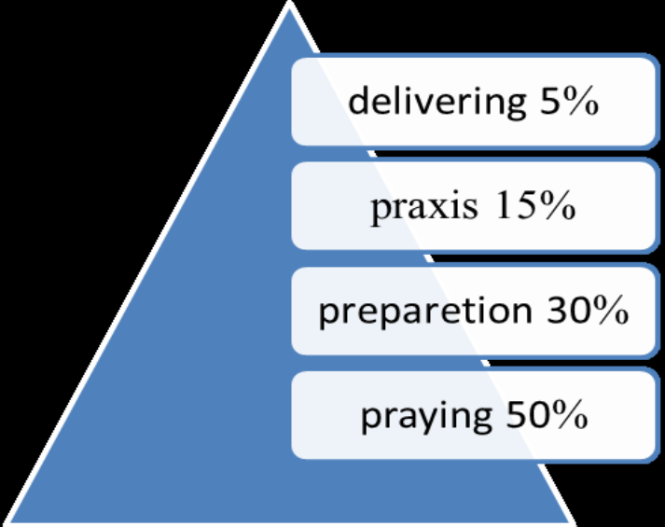

Praxis
5.1.2. Dressing Manner
Simple and well acceptable normal appearance, not something that is excessive in lifestyle. For example, the preacher's private properties (like telephone, hand watch, icon, car, etc.…) must not be more exaggerated. This helps to avoid materialism from the hearer’s mentality.
- Follow and give an account of the country's traditional assets.
- Follow the canonical clothing of the autocephalous church. In Ethiopia Orthodox Tewahedo church at the time of preaching netela, Gabi, Kaba, kemis or cassock, and clerical clothes are not only for a recommendation but they are mandatory.
- Clean and net from hair to leg (hair clean and cut, clean cloths not a fashionable).
- Position up straight.

5.2. ON DELIVERY
- First, give honor to the pulpit.
- Do not lean and sleep on it.
- Use the required materials. Like the Holy Bible, notebook, etc...

- Do not round the pulpit
- Do not use vague words
- Do not express your self
- Do not wander (keep the topic)
- Use an appropriate time

5.2.1. The Intent and Content; message
The message of the pulpit is God and man-centered means the only thing we proclaim the Holy Orthodox Ecclesiastical teaching. The pulpit is not the place for carnal estimation, pagan and heretical philosophy, no spiritual thought, argument, business, or any non-Biblical event.
So, the preacher in his massage must corporate the five stages of human need that can be used in an actual message transmission

5.2.1.1 Satisfy Human Soul Needs with a Gospel
- The uppermost level called “self-actualization.”
People want to help and be involved.
- The next level called “love/acceptance.”
People want to needed.
- The next level called “esteem.”
People want to feel good about them.
- The next level called “job security/safety.”
People want job security, safe marriages, freedom.
- The lowest level called “physiological.”
People want to know they have shelter and food.
After compromising the above attitudes of human beings with the Holy Gospel, you can preach them according to the Biblical understanding.
- Speak the will of God (do not speak your sentiment)
- Speak the message of the church
- Do not forget that you are the human being
- Avoid the use of real names especially if your illustration is a negative illustration and the audience knew that person personally.

5.2.1.2 Adding Influence Power on Sermon
The preacher must know how to tell a story. Poor telling has spoiled many a good illustration. To be able to tell a story well and effectively is quite an art. Special attention must pay to details. Here is some borrowed suggestion on good storytelling.
- Ask the power of the Holy Spirit.
- Impressed on it: if the preacher is not impressed with the idea, he cannot convince and influence the audience.
- Master on it: always practice and repeat it. Repetition is the mother of good storytelling.

- By using emotional actions and by adding true, good, and spiritual stories your emotions must move the listener.
- Read the audience: add your value to change the rhythm
- Link your idea to the story: its energies your audience.
- Use good speaking skills: to develop this, tell your audience ancient traditions, legends, myths, and symbols.
- Motivate your audience for collaboration and connection: through stories, we share passions, sadness, hardship, and joys.

5.2.2 Movement, Action, and Gesture
Movements and gestures help convey the message. Movements mean body motion such as walking forward, backward, side-to-side. Gestures mean what the preacher does with his hands such as: raising and waving them, point and pounding with them.

5.2.2.1 The Sound Usage
The voice helps the preacher convey ideas, feelings, and emphasis on thought. The voice also conveys the preacher’s health, confidence, and emotions.
Three things that must kept in mind about the voice we use.
- The preacher must speak correctly.
He must not strain his voice by speaking too loudly or use too high of a pitch in his voice.
- The preacher must speak fully.

Each preacher has a range of sounds. He can raise his voice to a high pitch or lower his voice to a low pitch.
- The preacher must speak attractively.

The congregation should find the preacher’s voice interesting and pleasant.
The contemporary way that explains your idea and the transmission method is with a microphone. Therefore, do not act like a musician simply talk into it.
- Can you hear your speaking in normal voice levels?
- Be loud as too understood by all. Preach with emotion—do not be a boring preacher!
- Rate or speed: These also can be, and should be, varied to add spice to your speech. Do not talk fast all of the time. Nor should you talk slow all of the time. Vary your speed according to the need and feel of the sentence or phrase you are speaking. Besides, there is the matter of the pause.
- Your voice quality must improve. When your sound is very poor and not strong, you must use technical sound, which means sometimes you may loud, sometimes a little bit down, and sometimes pauses your voice.
- Find the middle tone of your voice and learn to speak there. Then vary your tone from higher pitched to lower-pitched around that pivot point. This will add variety to this element of your speaking ability.

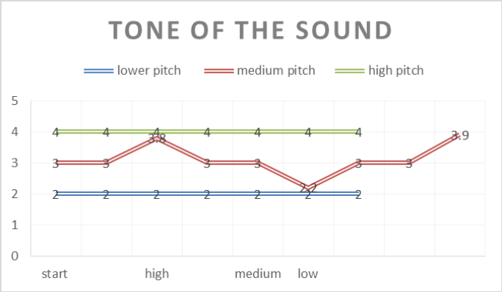

5.2.2.2 Eye contact.
Moreover, the Lord turned and looked upon Peter ጌታም ዘወር ብሎ ጴጥሮስን ተመለከተው፡፡ the way we look at people conveys a message. Christ conveyed an impressionable message to Peter after the rooster crowed in Luke 22:61.

Eye contact helps the preacher understand whether the congregation understands what he saying or not. If they do not understand, they will have a puzzled look on their face. If they do understand, they will show signs on their faces such as smiling.

When the eye of the preacher meets the eye of an enthused listener, it encourages the preacher to keep pressing the point home. Eye contact also conveys the message that the preachers wants to speak to them. The opposite is also true. The preacher that makes no eye contact conveys the message that he does not want to speak to them.
- Eye contact with all the people
- Do not look at the same person. Look around. (Do not look only woman or man only).
- Look away from distractions.

5.2.2.3 Action of the Hands
If the preacher is describing a thought (such as going down to Babylon, Egypt, the river of Eretria) he can show the imaginary picture in the minds of peoples by pointing his hand downward. In addition, if he is describing a thought (such as going up to Church, Jerusalem, and heaven) he can show the image by pointing his hand upward.

Movements and gestures also help with stage fright. When the body moves freely, the speaker will feel more confident and alert. The congregation easily recognizes this confidence and alertness. Movements and gestures also help the congregation experience what the speaker is feeling as they identify with him.

- Playing with the pulpit is boring.
- Adjusting the microphone is adjust before preaching, at the time of preaching it is not recommendable to adjust.
- Doing another work like playing with your eyeglass, and seeing repeatedly your hand watch, preparing your cassock belt is not recommendable.
- Do make proper gestures to help illustrate the message.

5.2.3 Time Usage
To limit a time of sermon the preacher must select his sermon topic. Some topics are not finished in 45 minutes sometimes need three or four days. The problem occurred on the preachers they did not manage their topics beside to this some preachers want to speak all they know in a single sermon.
The preacher must learn about the three kinds of sermon according to their volume, they are focused, broad, and narrow topics. The first choice to limit the time is the preacher must know some techniques for narrowing the broad topic and focusing it to meet time limits.

A broad topic is a topic that covers too much information to discuss within the time limits of the speech. It is also possible to have a topic that is too narrow. A narrow topic is a topic that does not have enough information to discuss within the limits of the speech. A focused topic is a topic that covers the appropriate amount and content of information for the limits of a speech.

Be careful when trying to narrow your topic. You want to have a topic that focused; something that you can go into detail just enough to inform or persuade your audience but still hold their attention. The sermon that you preach on a certain topic can help serve as a guideline on whether or not your topic is too broad or too narrow.

Topics that have many subareas are a good indication that your topic is too broad. A topic that has a small section of another, bigger topic is a good indication that your topic is too narrow. There is not a set standard of measurement on a narrow or broad topic, but if you start getting overwhelmed by too much or too little information, then you will know that you do not have a much-focused topic.

One way you can narrow your topic for time limits is to use limiters on your topic. The following limiters can help you focus your topic so it becomes more manageable:
- Time/ period
- Place/location
- Person/group
- Aspect/event

5.2.4 Additional Points
1. Use your voice and body language to reinforce your message.
2. Focus the attention of your listeners with words that create images in the mind.
3. Pace yourself, move step-by-step in an argument to keep your audience with you.
4. Focus always on concrete points, not on abstractions.
5. Energize your presentation by imagining dialogue and dramatic confrontations.
6. Apply images and vivid language when you are speaking from the heart.
7. Ask yourself in advance, “Who is my audience?” and adapt your speech to address them particularly and directly.
8. Weave familiar quotations and references to well-known texts into your speech.

9. Your tone, your language, and your examples should all choose with a specific audience in mind.
10. Always match your voice and movements to specific words and emotions.
11. When you first start as a speaker, mark the tone, and gestures into your text as reminders, they are as important as the words themselves.
12. Establish and maintain eye contact with your audience.
13. In cases where you are not inciting a revolution, smile.
14. Use stories and narratives to make your speech easy to follow and the details easy to understand and remember.
15. Identify your theme at the beginning of your speech.
16. Include vivid and memorable details that bring your subject to life.
17. Anticipate your audience’s questions, and provide the answers in the body of your speech.
18. Use clear, concise, but neutral reasoning. Avoid personal issues and emotional appeals.

5.3 AFTER FINISHING THE SERMON
After you finished your sermon your spiritual walking also continued and do five basic things.
5.3.1 Private Prayer and Praysing
As we know praying and praising the Lord is our everyday doing but, in this part, you must praise the Lord because of you finished your sermon with Grace and His will and, pray for the fruitful action of your audience as well as yourself also.
Father George Florovsky stated about the personal prayer or the private prayer is possible but it is possible in the context of public prayer. No one is a Christian in isolation, but only as a member of Christian body. Even in the solitude of his room, a Christian prayer as a member of the redeemed community, the Church.(4)
Pray for your self | By saying, your word draws me to the right path.
Pray for the audience | God help your people to repent for their sin.
Praise the Lord | Thanks, my Lord because I finished the sermon with your help

5.3.2 Keep Your Dignity
In Orthodox sence, He who is humble in his opinions and fellings as well as involved in spiritual doing, will apply everything to himself and not to his neighbor, when he reads the Holy Scriptures.
The preacher must look throughout Scripture for his life personal application. The preacher question is not simply “What does the Bible mean?” but the preacher must say “What does the Bible call for me?”
The preacher must assume always in his preparation and deliver in the word of God, Christ Himself is speaking to the preacher. Scripture is a direct, intimate dialogue between the God and the preacher addressing the preacher and his heart responding.

For example, the Bible says for our ancestor Adam “Where are you?” (Gen. 3:9). This question is not oly for Adam but also for us. For us means for the hearers as well as for the preacher. The one that God puts to the Adam in each one of us: “Where are you?”

Therefore, the preacher must keep his dignity to shine the light and the peoples praise the Lord because of the preacher. He must do what he says.
5.3.3 Accept Questions
When you finished the sermon, some peoples ask what is not clear for them or, some peoples ask you to examine your understanding. Anything is happening to you after the pulpit you must accept the question and answer politely.

5.3.4 Accept Criticism
Criticism is two after the pulpit, it can take as upsetting your mind, and discouraging; it can view in a positive way: it is honesty, and it can limb us to do our best. It will be an opportunity to advance our preaching ability. As a preacher when you hear the criticism in positive or in negative action, you must do some which are mentions below

5.3.4.1 Hear With Limited Action
When you hear something good or bad before your first reaction, that is a good felling or a bad, take a minute before responding anything at all. Take a deep breath, and gate some minutes it gives to you a little thought. That cooling off time allows the preacher to give it a little more thought beyond his initial reaction. Do not be happy or do not hang in shame.

5.3.4.2 Change a Bad Opinion to a Optimistic Idea
Do everything for the glory of God. In pessimist or optimist opinion, the preacher will find his keys for success in anything. The preacher must cultivate the custom of changing the sad situations to the positive; it is the ability with the will of Holy Spirit to find positive things in a thing that most people see as a harmful.

With any criticism, discover the positive in it. In the case of real and honest feedback with a good suggestion, you also do your best for your improvement.

5.3.4.3 Do not Leave that Night
After hearing and taking criticism, after changing the negative in to a positive, do not just go to your bed as usual. In point of fact, you must try to analyze and improve your skill.
In our Church, many preachers take criticism as a personal attack or consider it like a hate and their reaction also negative. The preacher must consider himself above every wrongdoing, and will respond in a positive manner and be the better person.

5.3.5 Evaluation
5.3.5.1 Self-evaluation
- After kept your sermon with a video or audio recorder
- See the Stories, languages, references and parables of your sermon
- According to the text, preacher (yourself) and communication.
5.3.5.2 Peer Evaluation

- Discuss about your sermon and analyze the following
- What did the preacher say to you?
- What would you affirm about the presentation?
References
- ኪዳነ ወልድ ክፍሌ ገጽ 249.
- The liturgy of Ethiopian Church translated by Rev. Marcos Daoud p.44.
- www.preachers institute. The world’s premier online orthodox Christian homiletics recourse.
- Living Orthodoxy P. 80

