COMPUTER REPAIR ONLINE RESERVATION SYSTEM
(Tech2U)

A Research Study
Presented to the Faculty of
Polytechnic University of the Philippines
Sto. Tomas, Batangas

In Partial Fulfillment of the Requirements for the Degree
Bachelor of Science in Information Technology

by

Aguilar, Jhon Chamel G.
De Jesus, Julia V.
Pucyutan, Jhim Charles N.
Quiatchon, Edrian M.
Suazo, Wendell C.

March 2021

Chapter 3

METHODOLOGY

RESEARCH DESIGN
The research method used in this study is quantitative. According to Adi Bhat of QuestionPro, quantitative research is defined as a systematic analysis of phenomena through the collection of measurable data and the application of statistical, mathematical, or computational approaches. Quantitative research methods include using sample methods and sending out online surveys, polls, and questionnaires to get information from current and potential clients. The researchers chose this strategy to improve the impartiality and accuracy of results from a broader study with a greater number of subjects, as well as the generalization of the findings. In using quantitative research method, the problem will be analyzed by generating numerical data which can be used or transformed into usable statistics.
The results obtained from all of the data gathered will be used to authenticate and ratify the researchers' premise when they apply a quantitative method of study.
The Software Development Life Cycle (SDLC) is the formal approach that the proponents employed to achieve the objectives. According to Stackify, SDLC is a process that produces software with the highest quality and lowest cost in the shortest time possible. SDLC provides a well-structured flow of phases that help an organization to quickly produce high quality software which is well tested and ready to use.
The stages of SDLC are planning, defining, designing, building, testing and deployment. Software Development Life Cycle is a conceptual model, used in project management, to describe the stages and tasks involved in each step of a project to write and deploy software. The researchers chose to adopt the SDLC since it proposes an analysis and design that holds the system together and serves as a general guide for our research. As a reference to the current facts of Tech2U, SDLC can construct method servers. The group need to research different aspects of the Tech2U business in order to design a solution that will solve the business current dilemma. In addition, they conducted an interview with the owner of the Tech2U to obtain additional information on the business.
The Agile Model is employed by the project team. Agile is a good model for situations that change frequently and a very realistic approach to software development for both fixed and dynamic requirements. The major purpose of Agile is to focus on process adaptation and customer satisfaction by delivering a working software solution quickly. The Agile methodology promotes adaptable planning, evolutionary development, early delivery, and continuous improvement, as well as quick and flexible change reaction.

SOURCES OF DATA
The researchers used random sampling to select the number of respondents. Random sampling is a part of the sampling technique in which each sample has an equal probability of being chosen. A sample chosen randomly is meant to be an unbiased representation of the total population. The entire process of random sampling is done in a single step with each subject selected independently of the other members of the population. The selection of observations must occur in a 'random' way, meaning that they do not differ in any significant way from observations not sampled. In addition to this, the researcher must make sure that the composition of the final sample to be used in the study meets the researcher’s random. One of the goals of research is to be able to make conclusions pertaining to the population from the results obtained from a sample. Due to the representation of a sample obtained by simple random sampling, it is reasonable to make generalizations from the results of the sample back to the population.

RESEARCH INSTRUMENT
The researchers used online type of survey form for the respondents which are the manager and other staff of the Tech2U business establishments. The researchers distributed the survey form to the respondents for a period of time through online platform to determine if the system is usable. They can say if they are agreed on it or not

DATA GENERATION PROCEDURE
The researchers began by delivering or sending online survey forms to the target respondents, who are the users, managers, and customers of Tech2u. If the intended respondents agreed to construct the proposed system, the researchers will send a link for their survey form to them. The responders were given the opportunity to critique and examine every procedure and phase of the online reservation tool and its automation in the system by the researchers. The responses of the respondents are always taken into consideration and kept on file for future website development. The researchers begin data collection after the survey is completed. They collect all of the survey forms and tabulate all of the data to see if the system is fit for its intended purpose.

DATA CASE ANALYSIS

Functional Requirement

Log-in Function – this module allows the administrators and users to gain deeper access to the web application – dashboard for the admin, and the reservation function for the users.
Reservation Function – this module allows users to book a date for device checkup and/or other services.
Administration Panel – this allows the administrators to monitor and track the progress of the business.

I/O Requirement
- Input
- Login (Old user)
- Email
- Password
- Register (New user)
  - First Name
  - Last Name
  - Email
  - Password

- Account Profile
  - Contact number
  - House number
  - Street
  - Barangay
  - City/Town
  - Province
  - Zip code
- Manage Reservations
- Transaction ID
- Case/Service
- Item Name
- Reservation date
- Status
- Manage Products
- Product name
- Price
- Description
- Discount
- Product category
- Manage Product Categories
- Category name
- Services
- Service Name
- Service fee
- Output
- Reservations
- Transaction ID
- Case/Service
- Reservation date
- Status
- Products
- Item name
- Price
- Description
- Product category
- Service
- Service
- Service fee

Input Validation
- Both required and optional fields are filtered before being stored in the database
- Illegal values are filtered through the help of standard validation functions or sometimes regular expressions. If the input did not pass the validation, then it will be rejected.
- Optional fields are nullable values in the database.
Backup and Restore Procedure
- Always back up the entire site before updating or upgrading.
- Date your backups. Save each one into a directory or file with title that includes to be guessing which back up is the most recent one when you are trying to recover your failed side. Panic is not conductive to a good recovery process.
- Save a copy of each backup in a different location than your webserver. Remember, if data doesn’t exist in three places, it doesn’t exist at all. If your web server crashes, then all the backup files might be gone too.
- Document and test your backup and restore procedure before you need it. The forums and IRC chat are full of people who want help recovering from unforeseen fatal error.
- Restore your backups using the same method as you took the backup.
Integrity (log files)
- Progress report can be downloaded from the hosting service
- If you can’t stretch to a dedicated log server, logs should be written to a write once medium, such as a CD-R or DVD-R, or to rewritable media.
- Also check computer clocks and correct any significant time variations on a weekly basis, or more often, depending on the error margin for time accuracy.
Authorization and Access Control
- Users will be required to login to be able to view more resources and access more functions. Guest users will only be able to view limited pages in the website.
- Implement access control through implementation of user roles, which restricts the resources the users have access to and the functions they are allowed to perform.
- Try to quantify relative value of information to be protective in terms of Confidentiality, Sensitivity, Classification, Privacy, and integrity related to the organization as well as the individual users.
- Specify the process for granting and revoking user access control rights on the system, whether it be a manual process, automatic upon registration or account creation, or through an administrative front-end tool.
Design of System Product Processes

System Description
Tech2U Appointment Booking System is a web-based application aimed to help Tech2U Computer Cellphone Gadget Repair Shop to expand their online presence by providing their customers a platform to view and/or avail their offered services. The web app shall allow the patrons to book an appointment for their device checkup and/or reserve a product (such as a storage device or a computer peripheral) they want to purchase. It will also allow the business owners to monitor the clients that access and use their website through a dashboard.
The system shall also serve as another platform of communication with (potential) clients. Aside from showcasing the services and products offered, the website will also provide answers to customers’ frequently asked questions regarding their devices.

System Architecture Diagram
Flowchart of the Proposed System
The flowchart below represents the process of the system. It can also be defined as a diagrammatic representation of an algorithm, a step by step approach to solving a task. It shows the steps as boxes of various kinds, and their order by connecting the boxes with arrows. It helps to clarify complex process and thereby help understand a process and use this knowledge to collect data, identify problems, focus discussions, and identify resources.
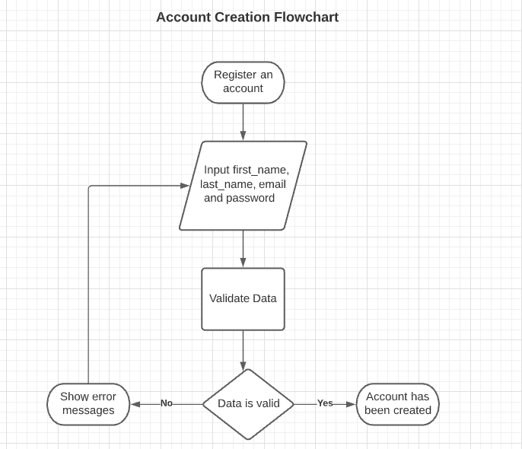

RESERVATION FLOWCHART

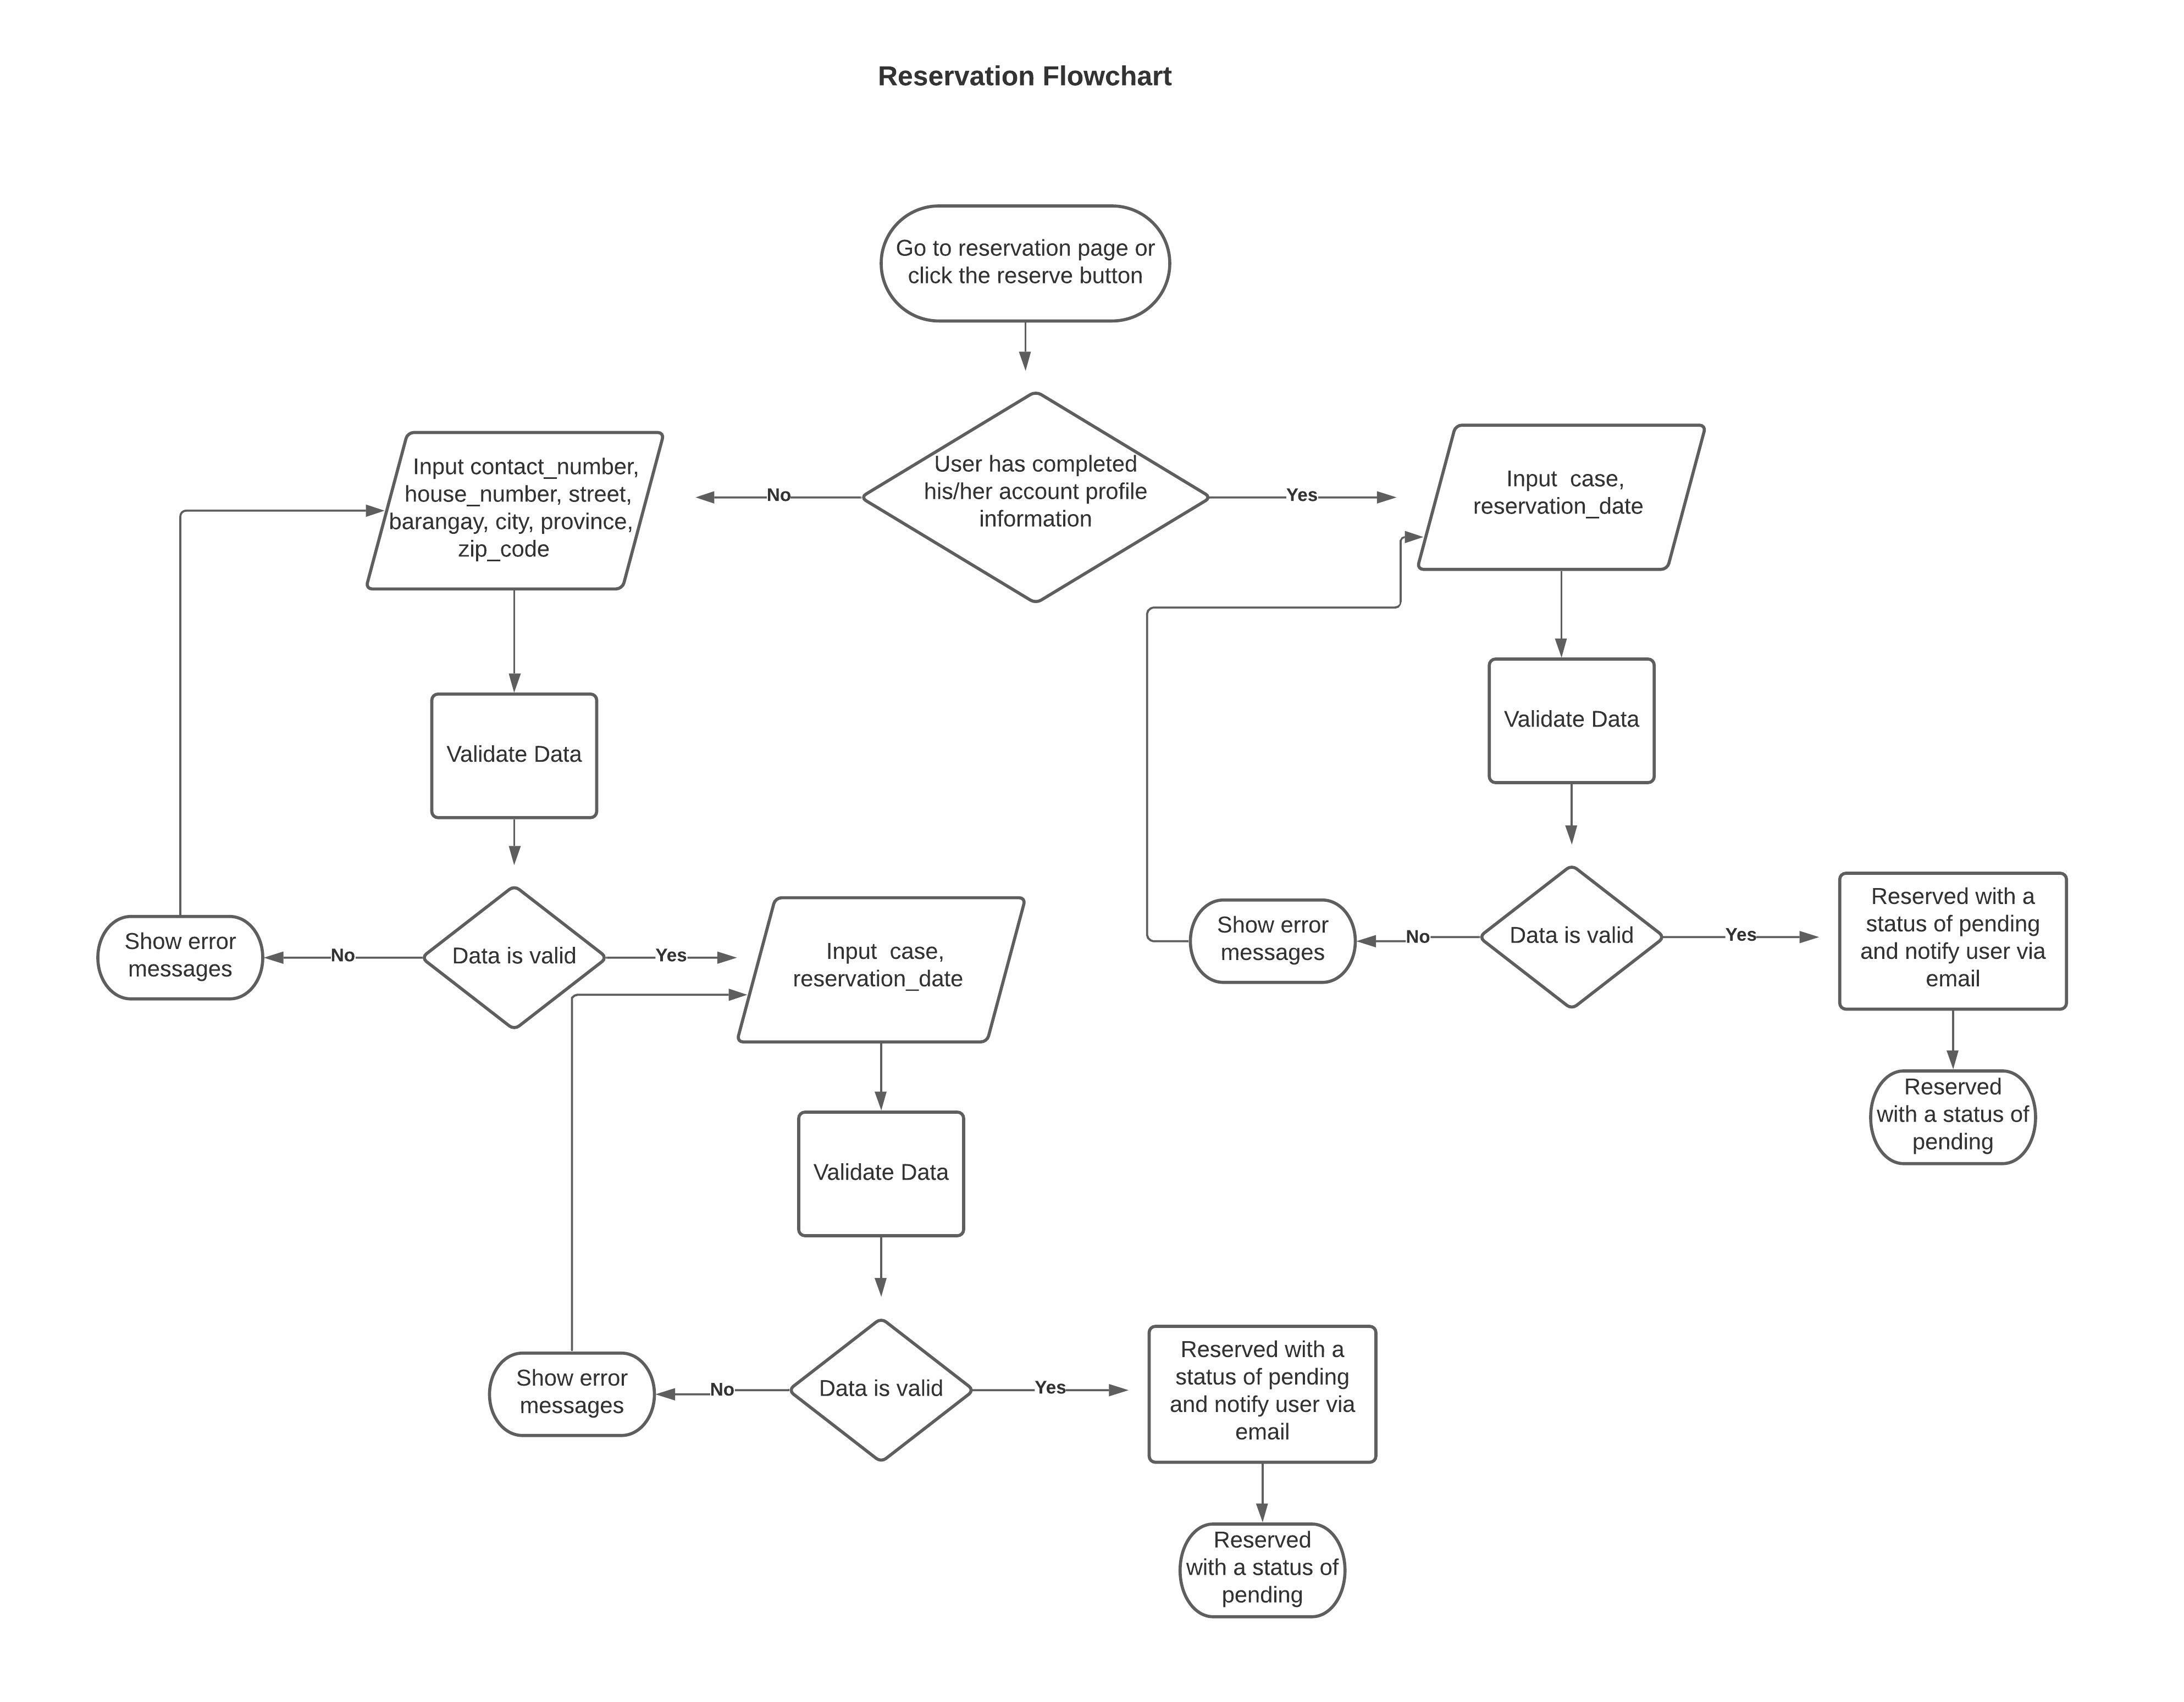

Fig. 1: Flowchart of the System
Theoretical Framework
The researchers based the study in a paper that explains the adoption of e-commerce in Small and Medium Enterprises (SMEs) in developing countries. The paper stated how e-commerce helped SMEs improve their business activities in terms of customer numbers and revenue expansion (Hassen et.al, 2020). However, despite its contribution in the enterprises’ rapid growth, e-commerce is still deemed quite inefficient because of the lack of clear model in adopting it (Hassen et.al, 2020). Some of the models are Theory of Planned Behavior (TPB), Theory of Reasoned Action (TRA), Diffusion of Innovations Theory (DoIT), Technology Acceptance Model (TAM), Unified Theory of Acceptance and Use of Technology (UTAUT), Technology-Organization-Environment Framework (TOE), and Perceived E-Readiness Model (PERM). Among the aforementioned theories, TAM is selected as this study’s basis, as it fits the system’s concept the most.
This model suggests that there are two factors that influence how a user reacts when presented with new technology: Perceived Usefulness (PU) and Perceived Ease-of-Use (PEOU). Someone who perceives the technology as too difficult to use will unlikely want to embrace the technology; but if it is perceived as something that will improve the person’s quality of life, he or she will be more likely to adopt the technology. (Charness & Boot, 2016)

Conceptual/ IPO Diagram
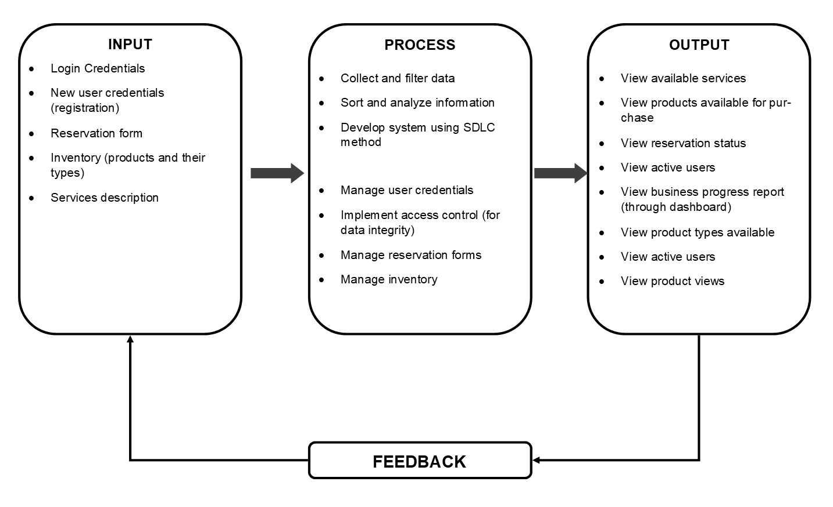
Fig. 2: Conceptual/ IPO Diagram
Figure 2 shows the conceptual paradigm of the project. The first column is allotted for the input, which contains user credentials, reservation forms, and product inventory, which is comprised of the products and their respective types.
The next column contains the general description of the processes needed to produce output. In the first three bullets, the researchers described how to initiate the project development. This involves data gathering and converting them into information that can be manipulated by the target client.
The last column is assigned for description of expected outputs. This includes viewing services, products, reservation status for users and progress report for administrators.

Low-Level DFD
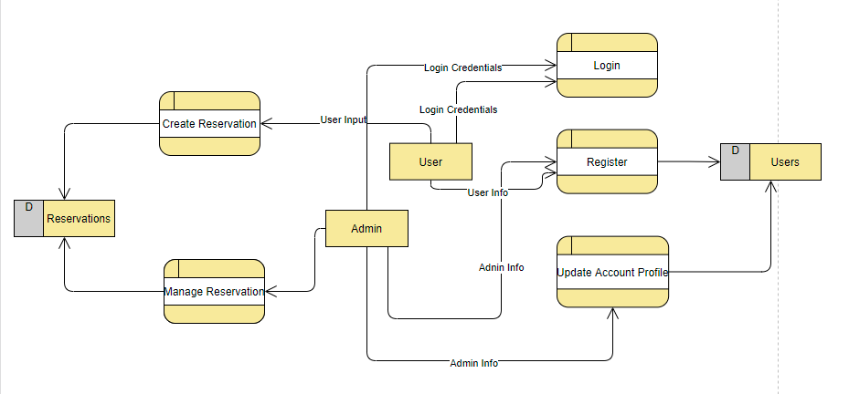
Fig. 3: System DFD
Database Schema
The database schema refers to the organization of data as a blueprint of how the database is constructed (divided into database tables in the case of relational databases).
Fig.4. Database Schema
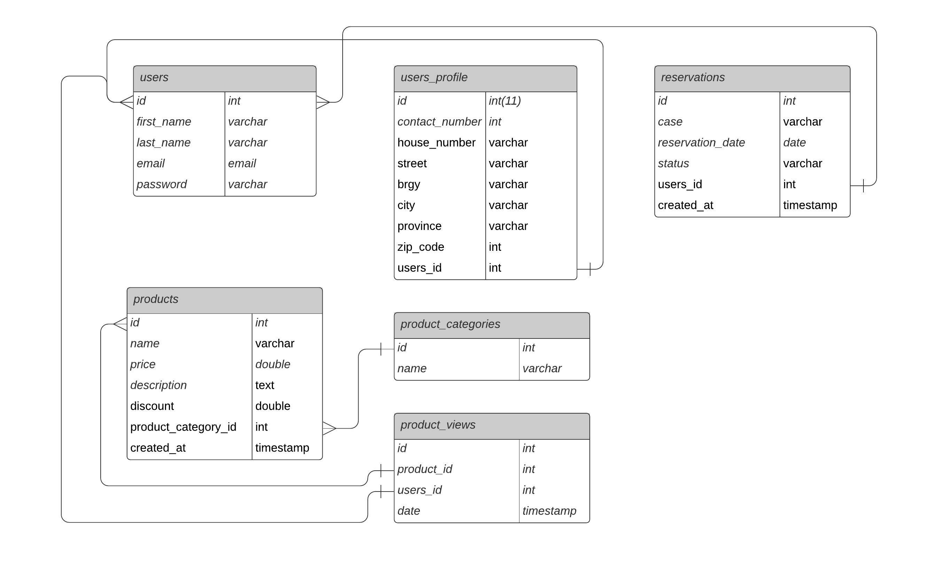
Development and Testing Procedure Plan

The process outlined below is used to create the system. The elicitation of the requirements is completed within the first week. In the second week, the system's objectives are stated. By the third week, a competitive analysis for the system has been completed in order to determine how this system will differ and be distinct from others. Defining the target audience who will use the system in the fourth week. During the same week, the prototype is developed, including the functionality and establishing what the system's structure is based on the target user. The system's back end coding is done on a regular basis. While the paperwork from the first week to the present is being prepared and examined at the same time.
The system's implementation is planned after the development and testing phases are completed.

Table 1. Activity with corresponding weeks
Activity Definition | Week 1 | Week 2 | Week 3 | Week 4 | Week 5 | Week 6
Requirements Elicitation
Specification of System Objectives and Goals
Competitive Analysis Development
User definition
System Structure Development
Coding
System Prototype
Testing
Documentation
Implementation
Implementation Plan

The Computer Repair Online Reservation (Tech2U), a small business in Tiaong, Quezon will create an online reservation system. To keep a track of whatever the vital information has to be preserved, all activities are kept in private. The implementation plan encompasses everything from project planning to how the ideas come together to produce good results, and finally arrived at a conclusion to bring out the best in terms of business matters.
In spite of the pandemic that experiencing, under the General Community Quarantine, the researchers are able to gather ideas and data that are necessary for this matter, communicate with the people involved through social media platforms and finally getting in-between the target goals through collaborative efforts.
Herewith are the strategies, activities, persons involved and the duration of how the project went along.

Table 2. Implementation Plan
Strategy | Activities | Persons Involved | Duration
Brainstorm the desired outcomes | Meeting with the team | Team Leader and members | 2 Days
Approval from the client | Proposal to clients | Team leader  Clients | 2 Days
Gathering of requirements | Call with concerned personnel | Team leader and members | 2 Days
Organizing of ideas | Collaboration of ideas and input from clients | Team leader, members and Client | 3 Days
Initiating of ideas | Designing and  Coding | Team leader and members | 2 Weeks
Alpha and Beta Testing | Test the system procedure | Team Leader, members and client | 1 Week
Developing the implementation plan | Using tools and strategies like WBS and critical path method | Team leader and members | 1 Week
Evaluation | Summing up the assessment | Team leader and member | 2 Days
Releasing of the project to the client | Present the system with the concerned personnel for comments, suggestions and additional inputs | Team leader, members and Client | 1 Day
Analyzation | Clearing the errors of the system | Team leader and member | 2 Days
Implementation | Installing the system at users, workstations and also creating a domain for the system | Team leader and member | 1 Week

