**Republic of the Philippines**

**City of Taguig**

**Taguig City University**

Gen. Santos Avenue, Central Bicutan, Taguig City

**MANAGEMENT INFORMATION SYSTEM**

**ACCOMPLISHMENT REPORT**

**For the Month of June 2019**

|  |  |  |
| --- | --- | --- |
| **Date** | **Actual Accomplishment** | **Result** |
| June 1 – 30 2019 | * Provide technical assistance in Admin Building. * Assist in laboratory to encode the medical of students. * Provide Technical assistance of graduation 2019 in SMX Sm Aura. * Provide Technical Assistance in General Workshop on Ra 10931 in auditorium. | **Successfully completed**  **Successfully completed**  **Successfully completed**  **Successfully completed** |

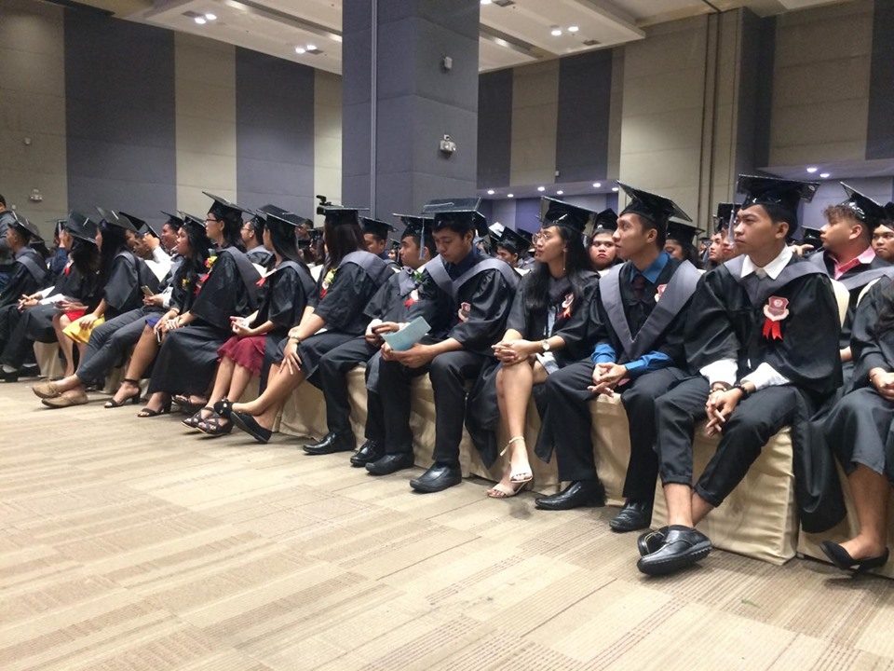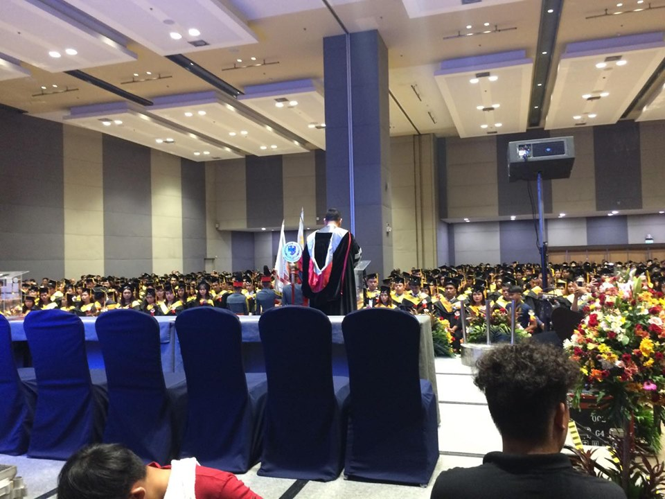

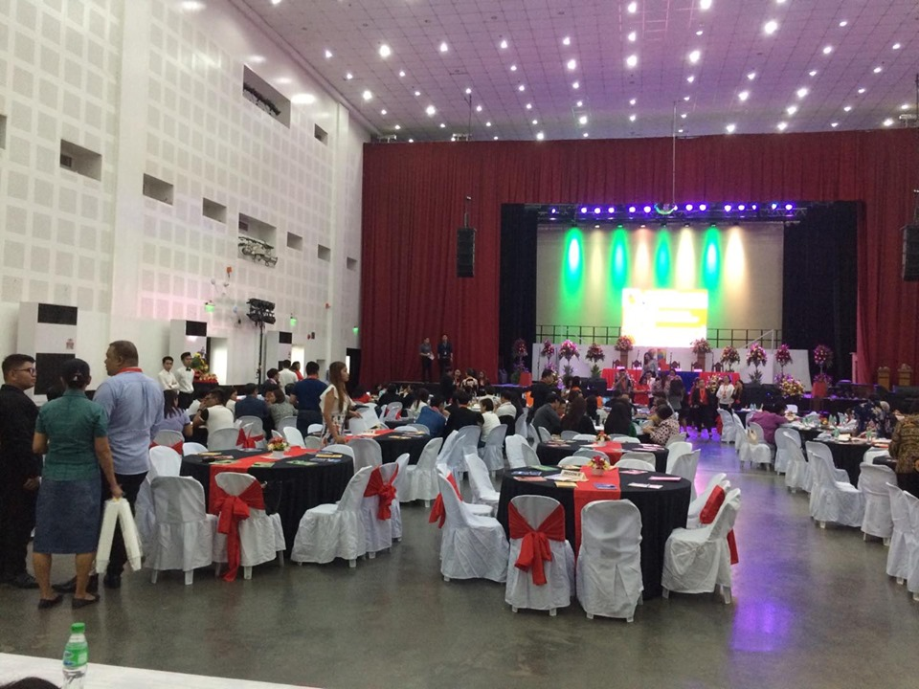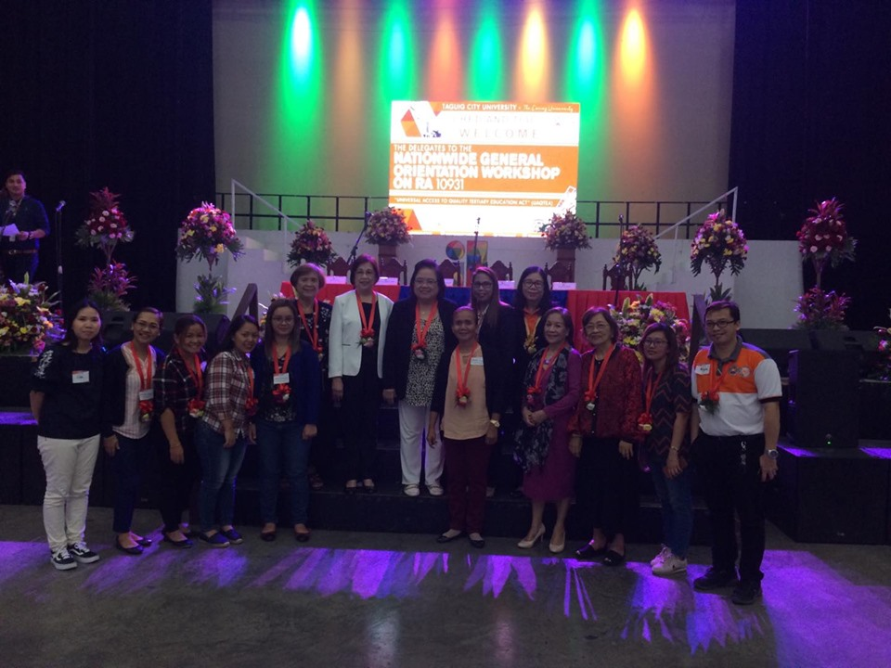

**Prepared By: Approved By:**

**Ivan A. Franco Dr. Reagan Ricafort**

**Technical Support, MIS Director, MIS**