**Problems**

**Problem no. 1**

Create a program that will display your name and course. Use command prompt to compile program.

**Problem no. 2**

Create a program that will concatenate two strings (i.e. your name and course). Use command prompt.

**Problem no. 3**

1. Create a program that will compute the area of a circle wherein you will input the radius. The program will accept input of decimal or fractional numbers.

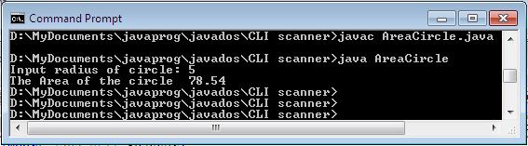

**Problem no. 4.**

Create a program that will test two inputted numbers highest and lowest value of the two.

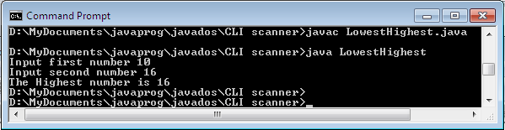

**Problem no. 5**

Create a program wherein you will input two numbers. Test first the two numbers odd or even. If both even perform addition, if both odd perform subtraction, and if odd and even combination perform multiplication.

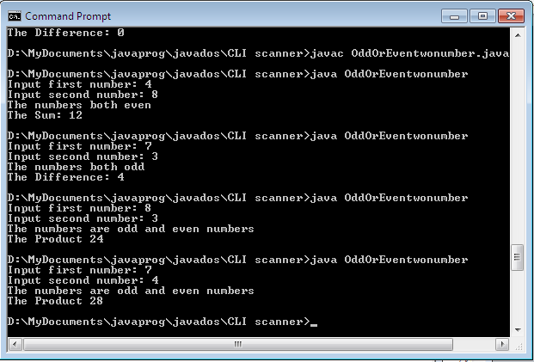

**Problem no. 6**

Create a program that will display your name and course. Show output in GUI using jOptionPane.

**Problem no. 7**

Design a program that will input two numbers. Check the highest number, check if odd or even, show the product and sum of the inputted numbers.

**Problem no. 8**

1. Design a program that will input grade numbers (75 to 100). The program will determine the grade equivalency, that grade of 75 is 3.0, 76-78 is 2.75, 79-81 is, 82-84 is 2.25, 85-87 is 2.0, 88-91 is 1.75, 92-95 is 1.5, 96-98 is 1.25 and 99-100 is 1.0. use switch case.

**Problem no. 9**

1. Design a program that will input grade numbers (75 to 100). The program will determine the grade equivalency, that grade of 75 is 3.0, 76-78 is 2.75, 79-81 is, 82-84 is 2.25, 85-87 is 2.0, 88-91 is 1.75, 92-95 is 1.5, 96-98 is 1.25 and 99-100 is 1.0. use if, else if, else.

**Problem 10.**

Design a program that will display all the even numbers only between 1 to 30. Use any kind of looping.

**Problem 11**

1. Design and develop a Java applet that allows you to both enter text string into a text box and display the text string on the applet. The text string will be displayed only after the Enter key is pressed. Follow the design specification below: use notepad and run it CMD using appletviwer.

