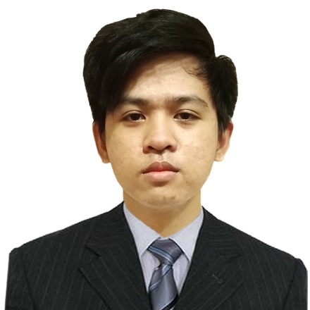Wendell Suazo

Calamba, Calabarzon, Philippines

[wendellchansuazo11@gmail.com](mailto:wendellchansuazo11@gmail.com)

09959768531

[linkedin.com/in/wendell-suazo-8339251aa](https://www.linkedin.com/in/wendell-suazo-8339251aa)

# Experience

## Software Engineer

### FlowerStore Group

Jun 2022 - Present (3 months +)

## Freelance Web Developer

### Freelance

Jan 2021 - Present (1 year 8 months +)

## Full Stack Web Developer Intern

### FlowerStore Group

Mar 2022 - May 2022 (3 months)

## Back End Developer

### IThinkWeb Corporation

Jul 2021 - Jan 2022 (7 months)

# Education

## Polytechnic University of the Philippines

### Bachelor of Science in Information Technology

2018 - 2022

## STI College

### IT and Mobile App Development, Information Technology

2016 - 2018

Graduated senior high school in STI College Calamba with Technical Vocational strand specializing in IT and Mobile App Development

# Licenses & Certifications

 **Introduction to Cybersecurity** - Cisco  **Cybersecurity Essentials** - Cisco **Skills**

Laravel • REST APIs • Vue.js • GraphQL • PHP • JavaScript • Web Development

# Honors & Awards

**President Lister** - Polytechnic University of the Philippines

Oct 2019

Awarded in recognition of my exemplary academic performance in the University during the Second Semester, Academic Year 2019-2020.

**Computer Specialist of the Year** - Majada In Integrated School

Mar 2016

Awarded in recognition of my exemplary performance and achievement during Junior High School, Academic Year 2014-2015

**Class Valedectorian** - Majada In Elementary School

Mar 2010

Awarded in recognition of my academic performance during elementary school, Academic Year 2011-2012

**Tarpaulin Making using Adobe Photoshop (Champion)** - Majada In Integrated School

Aug 2014

Champion in tarpaulin making in two consecutive year in division, composed of different schools in my cluster.

**President Lister** - Polytechnic University of the Philippines

Apr 2021

Awarded in recognition of my exemplary academic performance in the University during the First Semester, Academic Year 2020-2021.