3 – Safe System/Method of Work
Sequence of work:
General

All site personnel are to have received a site induction prior to any works commencing. This will be undertaken by the site agent or his nominated representative. All must attend pre-start meeting and be briefed to this Method Statement.

Notification of relevant bodies prior to commencement of works
- Notify residents/Farm owners of planned site investigation works (By Others)
- Notify KCC operations on planed start date and maintain communication throughout. (By Coffey)
- Letter drop to affected residents (By Others)
- Notify EPA on removal & transport of sludge (By Others)

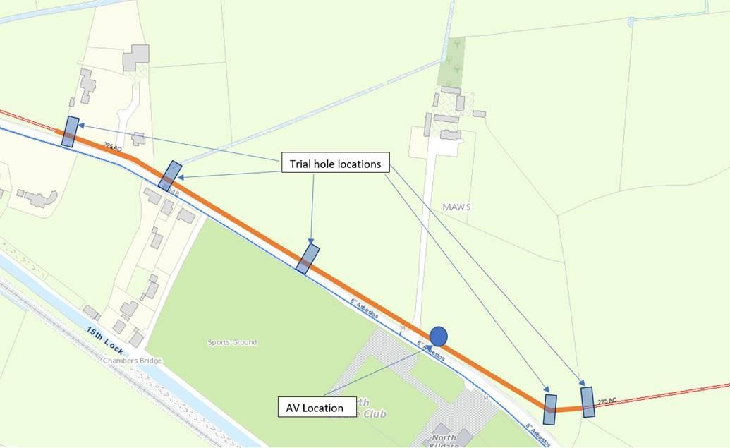
Existing Pipe Route with trail hole excavation locations

Road Works
No works will be required on the public roadway.

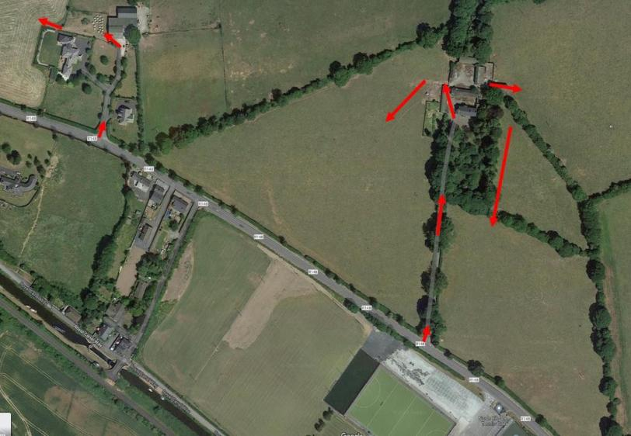
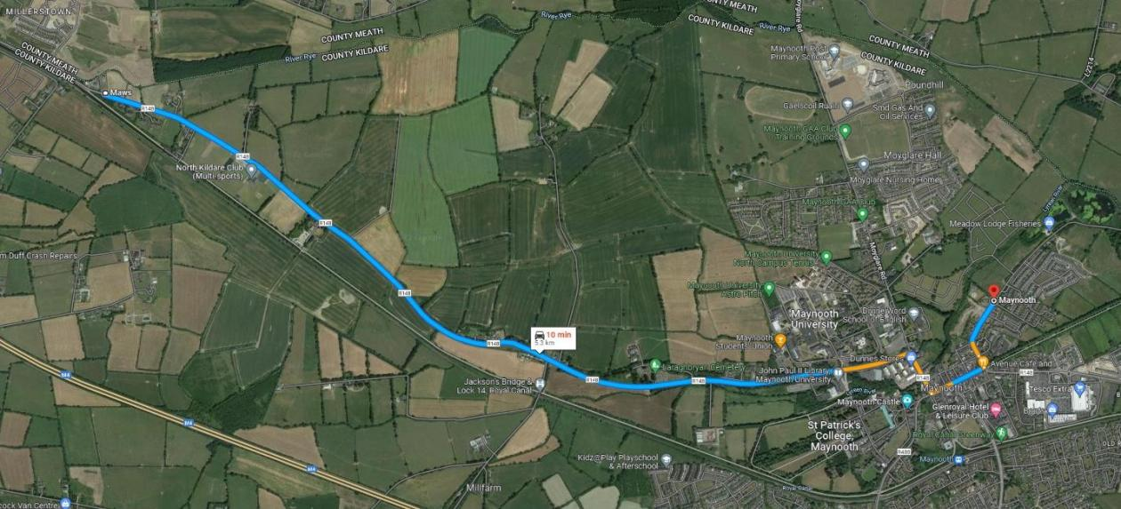

Vehicular Access During Works
All vehicles to access works area through access points agreed with property/Farm owners. Predominately access points will be off the R148.

Site Investigation Works

Prior to excavation Works;

- Coffey Construction to liaise with KCC operations regarding the commencement of planned excavation works.
- EPA to be notified (by others) regarding the proposed scope of works.
- Coffey Construction to contact residents/Farm owners confirming access points and start dates/times.
- KCC operations to pump down the sump in Kilcock Mains WWPS prior to works commencing,
Coffey Construction to provide 2nr sludge removal/transport vehicles to transport sludge from the Kilcock WWPS holding tanks to Maynooth WWPS. This will ensure that the existing 225mm AC rising main has minimal discharge in the line

Route from Kilcock WWPS to Maynooth WWTP

Excavation Works;

- Excavation crew to be briefed on RAMs prior to commencing works.
- All necessary plant sheets to be completed by relevant personnel.
- Permit to Dig CF-HS-049(04) will be issued and signed by all personnel involved and used to notify employees of all known services in the dig area.
- If uncharted service is encountered within vicinity of works, works MUST be stopped and reported to Site Management immediately.
- Site exclusion zone to be setup delineating the works area, a temporary battery powered electric fence must be part of the site exclusion zone to ensure farmyard animals cannot access the works area.
- Existing main to be setout using GPS information provided by KCC.
- Crew to begin excavation works, using vacuum excavator, in designated trail holes locations to determine tie in points, ground conditions, conditions of existing main.
- Crew to document findings to allow for detailed design and assist in confirmation of construction methodology.
- Upon completion of trail hole findings, crew to use 5Ton excavator to place CL 503 backfill around existing pipe to a depth of 150mm, if suitable, previously excavated material to be used to backfill the remainder of the trench, trench to be compacted in layers.
- In the event a trail hole excavation is left un-backfilled, the excavation will be securely fenced off using
1.8m herras fencing, double clipped.
- Coffey Construction will maintain communication with KCC operations regarding the requirement of sludge removal and transport from Kilcock WPS to Maynooth WWPS.
- Once all Trail holes have being completed and backfilled, the crew will removal all fencing, barriers and demob from site leaving the area secure and free from any debris.

In the event of damaged existing 225mm AC Mains;

- If a defect or damage to the existing 225mm AC rising main is noted during the trail excavations, Coffey will notify KCC Operations.
- The crew will assist KCC operatives in exposing the existing mains to allow KCC repair crew sufficient working room.
- Coffey’s will have 250mm ductile iron fittings including pipe available, in the event of a repair being required.
- Any spare fittings/pipework will be issued to KCC operations.

Delivery & Storage of Materials
- Pipe & fittings which may be required for repair works will be unloaded on site in a designated laydown area, this area will be secured with 1.8m Herras fencing panels.
- Other materials such as 503 will also be stored within this designated area.
- If excavated material is unsuitable for backfill spoil will be temporary stored on site and removed prior to demobilisation to a designated waste disposal tip.

Reinstatement
- Works area to be reinstated to its original state, with grass seed sown where required.

Environmental considerations: | Waste transfer – Only accredited waste transfer suppliers will be used to transport sludge from Kilcock WWPS to Maynooth WWPS.
Quality controls: | Following quality controls will be used on this section of the project:  - All materials to be tested and approved for use.  - Slit Trench Record Sheet will be completed.  - Photographs will be taken to record slit trenches.
Access and egress: | Access and egress to site works area will be carried out via public road.  No access permitted to unsupported trench. Barriers and appropriate signage must be erected around working zone and excavation.
Distribution of materials: | Deliveries and storage:  ☑ All deliveries will be to designated storage area on site  ☑ All aggregates will be stock piled on site.
Loading and unloading:
☑ Loading and unloading operations will take place at designated areas.
Lifting operations: | All lifting accessories must be inspected and certified. Please refer to Lift Plans  for further details.
Temporary works: | No Entry into Slit Trench Permitted
Traffic management: | Please see Appendix B for details.
Hazardous substances: | List relevant hazardous substances:  - diesel  - petrol  please refer to COSHH assessments in the HSQE folder.
PPE: |   ☑ ☑ ☑ ☑ ☑ ☐ ☐ ☐ ☑  Other/comments: additional PPE as applicable for particular task i.e.  - cutting pipe - goggles & ear protection
Permits: | Tick below if applicable to the RAMS:
 | - Permit-to-work (client/PC) | ☑ Permit-to-dig
 | - Confined space entry permit | - Hot work permit
 | ☑ Permit to work under overhead lines | - Permit-to-lift/Lift Plan
 | - Other: | - LOTO/Live Energies Permit

Hold points: | The following potential hold points have been identified:  ☑ Encountering uncharted services.  ☑ Significant change in ground conditions.  ☑ Concrete down in the excavation e.g. possibly covering a service.  ☑ Not locating all charted services.  ☑ Significant item/issue not covered by this RAMS.
Change Management: | We all have the authority to stop any work or behaviour that we deem to be unsafe to ourselves or our colleagues.  If something significant changes or a review is needed (i.e. one of the hold points identified above or other unforeseen change): stop and call the person in charge – Richard Alyward/Daire Kiernan  for advice and to review before restarting work.
Record of any on-site changes and additional controls implemented – note here and/or include in the SPA (Safe Plan of Action):
(*Any changes should be copied to the RAMS author for their information/review)

4 – Emergency Arrangements
Task-specific emergency arrangements: | EMERGENCY TELEPHONE NUMBERS  Contact the following in the event of an emergency: -  Emergency Services 999/112  Environmental Emergency  EPA (IRL) 1890 33 55 99.  CG First Aid Responders(s) include:  Richard Alyward 0863885813  Local Hospital(s)  Naas General Hospital (045) 849 500  Local Doctor(s)  Kilcock Medical Centre (062) 87270  Nearest Defibrillator (Eircode/Postcode): North Kildare multi sports club  Garda/Police Station(s)  Kilcock Garda Station (01) 675 7390  Electrical Emergency  ESB (IRL) 1850 372999  Gas Emergency  Gas Networks Ireland (IRL) 1850 205050  Telecom (IRL) Eir 1850 245 424

