Risk Assessment
RISK RATING = LIKELIHOOD* CONSEQUENCES
A likelihood of occurrence |  | B Consequences (Injury severity)
Almost certain | 5 | Extreme | 5
Likely | 4 | Major | 4
Possible | 3 | Moderate | 3
Unlikely | 2 | Minor | 2
Rare/Remote | 1 | Negligible | 1

Risk classification | Risk value
High | 16-25
Medium | 9-15
Low | 1-8

5*5 Risk Matrix
5 | 5 | 10 | 15 | 20 | 25
4 | 4 | 8 | 12 | 16 | 20
3 | 3 | 6 | 9 | 12 | 15
2 | 2 | 4 | 6 | 8 | 10
1 | 1 | 2 | 3 | 4 | 5
 | 1 | 2 | 3 | 4 | 5

HIGH | The risk should ceased immediately until further control measures to mitigate the risk are introduced.
MEDIUM | The risk should only be tolerated for short term and then only whilst further control measures to mitigate the risk are being planned and introduced, within a defined time period.
LOW | Are largely acceptable, subject to reviews periodically, or after significant change etc…

Project Name | Potential Hazard | Possible Result (Injury/ Damage/ Loss) | Risk  Evaluation |  |  | SWP  (Safe work procedure) | Control  (Supervision/ register)
 |  |  | A | B | R
- Working on Unprotected Slab edges  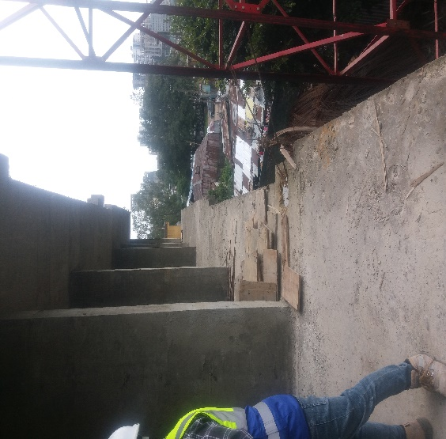  Unprotected slab edge | - Falling from heights  OSHA’s fall protection standard:  Each employee on working surface between 6 and 15 feet from the edge, you will need standard fall protection, including Guardrail and fall arrest. | - Fatal injury  (Including death) | 4  20 = HIGH RISK  == | 5 | 20 | - Maintain Guardrail to protect workers from falling down.  - Provide strong barricades to close slab peripheries.  - Provide Toolbox briefings.  - Post warning signs and use warning tapes. | - Site safety representative  (Site Engineer)  - Forman  - EHS Engineer
- Working on Unprotected Staircases  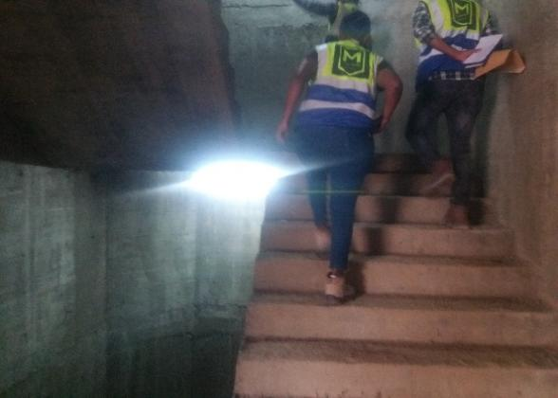  Unprotected stair edge | - Falling from heights  The 6-foot rule:  Workers requires the use of fall protection when construction workers are working at heights of 6 feet or greater above a lower level. | - Fatal injury  (Including death | 3  12 = MID RISK  == | 4 | 12 | - Maintain Guardrail to protect workers from falling down.  - Provide strong barricades to close slab peripheries.  - Provide Toolbox briefings.  - Post warning signs and use warning tapes. | - Site safety representative  (Site Engineer)  - Forman  - EHS Engineer
- General Housekeeping  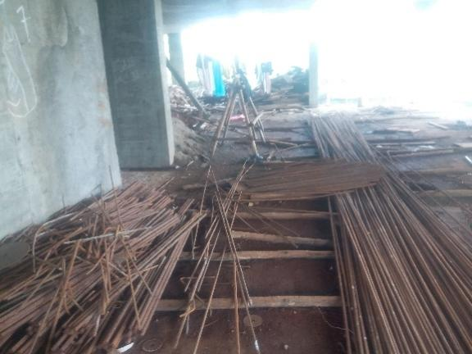  Messy working areas | - Slip  - Trip  - Fall hazards and  - Material damage  OSHA’s crane standard:  All places of employment, passageways, storerooms, service rooms, and walking-working surfaces are kept in a clean, orderly, and sanitary condition. | - Abrasion, and bleeding  - Property damage. | 3  6 = LOW RISK  == | 2 | 6 | - All passageways, gangways and access ways shall be kept free of materials, supplies, and obstructions at all times.  - Tools, materials, extension cords, hoses, or debris shall not cause tripping or other hazards.  - Material shall stack properly.  - Avoid corrections and damage to the property. | - Site safety representative  (Site Engineer)  - Forman  - EHS Engineer

