##### Environment setup

**jdk11**

**apache-tomcat-9.0.53**

**mongodb**

**rabbitmq 3.9**

**ec2 2c4g**

##### framework

├─client

│ │ nmtb.png

│ │ pom.xml

│ │

│ └─src

│ └─main

│ ├─java

│ │ └─client

│ │ │ ImageMetaData.java

│ │ │ PlotUtil.java

│ │ │ ThreadWork.java

│ │ │

│ │ ├─part1

│ │ │ Part1Client.java

│ │ │

│ │ └─part2

│ │ Part2Client.java

│ │

│ └─resources

│ nmtb.png

│

├─javaDbAlbum

│ │ pom.xml

│ │

│ └─src

│ └─main

│ ├─Java

│ │ └─org

│ │ └─example

│ │ AlbumInfo.java

│ │ AlbumServlet.java

│ │ ImageMetaData.java

│ │ MongoTool.java

│ │ MqMessage.java

│ │ ReviewsServlet.java

│ │

│ ├─resources

│ │ nmtb.png

│ │

│ └─webapp

│ │ index.jsp

│ │ nmtb.png

│ │

│ └─WEB-INF

│ web.xml

│

└─rabbitProject

│ pom.xml

│

└─src

└─main

└─java

└─org

└─example

Consumer.java

MongoTool.java

MqMessage.java

client 创建线程池，多线程发起http请求压测客户端，通过CountDownLatch等待线程池执行完，计算服务器接口的响应时间

rabbitProject rabbitmq consumer，消费消息中间件消息，写入mongodb

javaDbAlbum java servlet提供doGet，doPost分别处理客户端发送的post/get请求，读写mongoDb数据库

1. The client creates a thread pool, and the multi-thread initiates HTTP requests to stress test the client, and waits for the thread pool to be executed through CountDownLatch to calculate the response time of the server interface
2. rabbitProject rabbitmq consumer，消费消息中间件消息，写入mongodb
3. javaDbAlbum The java servlet provides doGet, which handles post/get requests sent by clients and reads and writes mongoDb databases

##### Tomcat Server配置

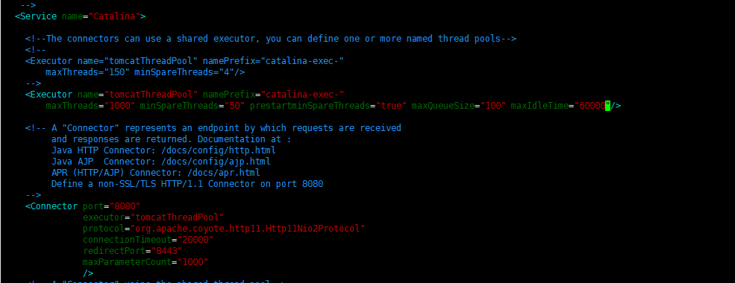

##### 数据库设计

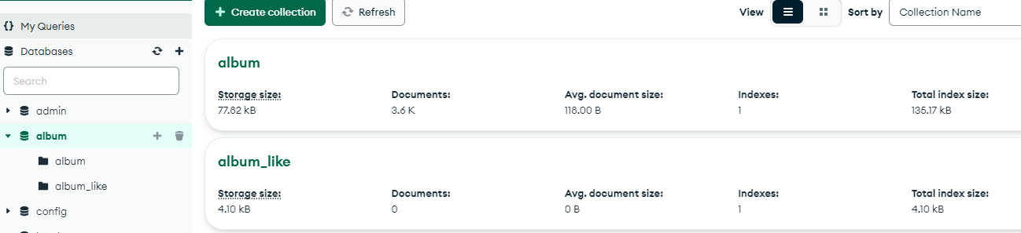

##### 消息列表输出报告

**threadGroupSize = 10, numThreadGroups = 10, delay = 2**

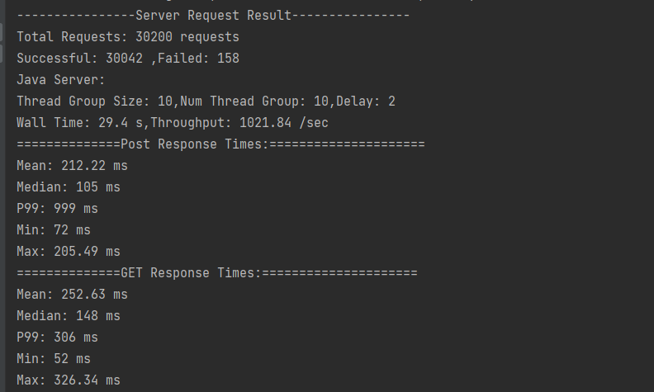

**Timeout: 60.0 seconds ...**

**Listing queues for vhost / ...**

**name messages**

**album 20000**

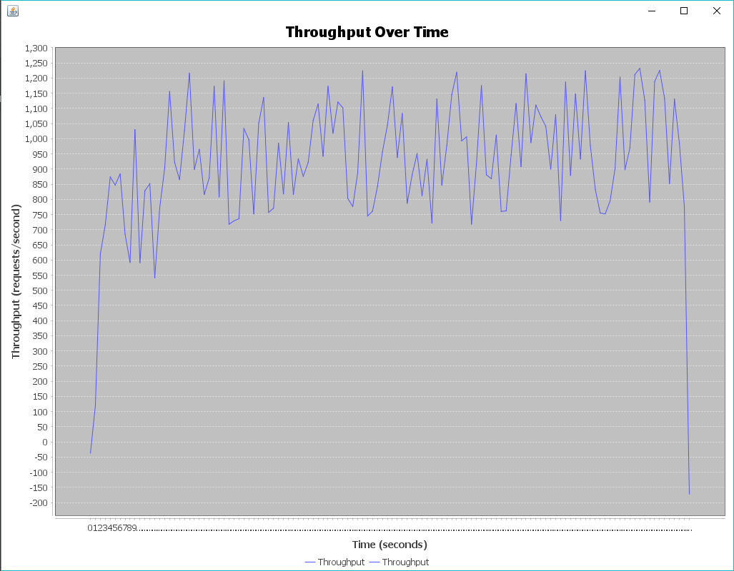

**threadGroupSize = 10, numThreadGroups = 20, delay = 2**

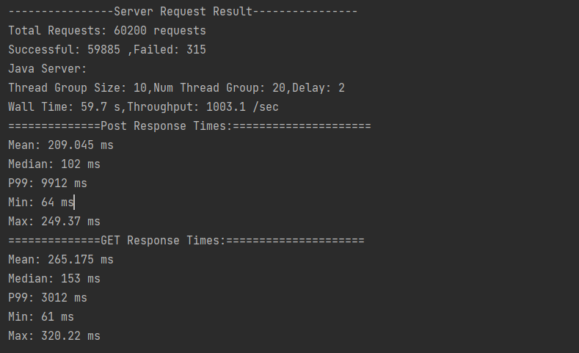

**Timeout: 60.0 seconds ...**

**Listing queues for vhost / ...**

**name messages**

**album 40000**

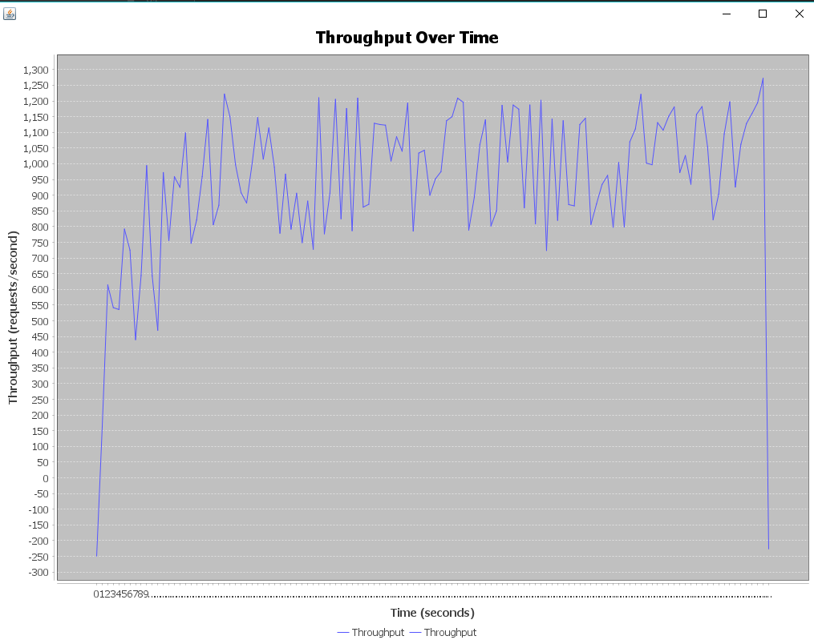

**threadGroupSize = 10, numThreadGroups = 30, delay = 2**

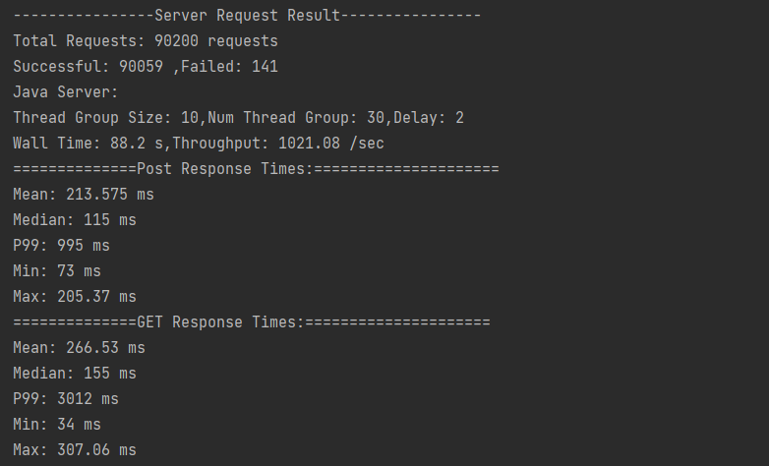

**Timeout: 60.0 seconds ...**

**Listing queues for vhost / ...**

**name messages**

**album 60000**

