A Data-Driven Analysis of Electronics Retail Sales: Exploratory Analysis, Statistical Inference, and Machine Learning
Given Name Surname: Wenke(wendy) Yuan
University / Organization Name: University of Canterbury
City, Country: Christchurch, New Zealand
email@address: wendy .yuan09212gmail.com
Abstract—This paper reports a complete data-science study of one year of transaction records from a United States electronics retailer. The dataset contains 185,950 transaction records corresponding to 178,437 unique orders placed during 2019. The work follows the standard workflow of data verification and cleaning, exploratory analysis, formal statistical testing, market basket analysis, and supervised machine learning. Revenue peaks in October and December, with San Francisco generating the highest sales. Although low-cost accessories account for the largest share of unit sales, total revenue is primarily driven by a small number of high-priced products. Order activity peaks around midday and at approximately 19:00. A strong negative rank correlation (ρ = −0.777, p < 0.001) indicates that higher-priced products tend to sell in lower quantities. Association rules show that phones and their matching charging cables are the only strongly co-purchased pairs. A key finding is that Sales is deterministically calculated as Quantity × Price, meaning that any model including both variables as predictors simply reproduces a predefined mathematical relationship rather than learning from the data. Once this source of data leakage is removed, order-level sales cannot be reliably predicted using contextual features alone. In contrast, aggregating transactions to daily sales transforms the problem into a meaningful forecasting task, yielding a test R² of approximately 0.90.
Keywords—sales analytics; exploratory data analysis; association rules; regression; feature importance; data leakage

Introduction
Electronic retailers collect transaction data from every customer purchase. These records provide useful information about sales trends, customer behaviour, and product performance. Analysing this data helps businesses understand when demand is highest, which products generate the most revenue, and which items are commonly purchased together. This report analyses a retail sales dataset to answer a set of research questions using exploratory data analysis, statistical analysis, and machine learning.
The dataset is a full year of order-line records from a United States electronics retailer. The aim of the study is to apply an end-to-end data science process to it, from cleaning through to modelling, and to report what the data actually supports. The analysis is guided by eight research questions: identifying the highest revenue month, the leading sales city, the best-selling and highest-revenue products, the busiest time of day for orders, the relationship between product price and sales quantity, products that are frequently purchased together, the ability of machine learning models to predict sales revenue, and the features that contribute most to those predictions. The results presented in this report are supported by visualisations, statistical analysis, and model evaluation.

Dataset Description and Preprocessing

The data
The dataset contains 185,950 order-line records from a United States electronics retailer. Each record includes the order ID, product, quantity ordered, unit price, order date and time, and shipping address. Additional variables (Month, Sales, City, and Hour) were created from the original fields for analysis. The dataset includes 19 products across nine cities. As one order can contain multiple products, the dataset represents 178,437 unique orders.

Verifying the derived columns
Each derived variable was verified against its original source, and all were found to be correct. The check also showed that Sales is calculated directly from Quantity Ordered × Price Each. Because of this, using both variables to predict Sales would introduce data leakage, as the model could reproduce the target value without learning any underlying relationships in the data [1].

Cleaning and feature engineering
The dataset contains no missing values, so no imputation was required. Therefore, the preprocessing mainly focused on checking data quality. Most records were collected during 2019, with only 34 transactions recorded in the early hours of 1 January 2020. These transactions were likely completed shortly after midnight on New Year's Eve. They were kept for the product and city analyses because they represent valid sales, but removed from the daily time series to avoid creating an isolated data point in 2020. The dataset also contains 264 duplicate rows and 311 repeated order–product pairs, which were identified during preprocessing. In addition, a new TimeOfDay variable (morning, afternoon, evening, and night) was created to improve the readability of tables and figures, while the original Hour variable was retained for modelling to preserve more detailed time information. All data preparation, visualisation, statistical testing and modelling reported in this study were carried out in Python using pandas [1], scikit-learn [2], Matplotlib [3] and SciPy [4].

Exploratory Data Analysis

Revenue by month
December generated the highest revenue, with $4.61 million, accounting for 13.4% of the annual total of $34.49 million. This was approximately 2.5 times higher than January, which recorded the lowest monthly revenue of $1.82 million. Revenue followed a clear seasonal pattern: it started at a low level in January, increased to an early peak in April, declined slightly during the middle of the year, and then rose steadily from September to reach its highest point in December. October was the second-highest revenue month, generating $3.74 million. Figure 1 also shows that the average order value remained relatively stable throughout the year, at around $190–199. In contrast, both the number of orders and the number of units sold increased noticeably in October and December. This suggests that the higher holiday revenue was mainly driven by more customer purchases, rather than customers spending more per order.
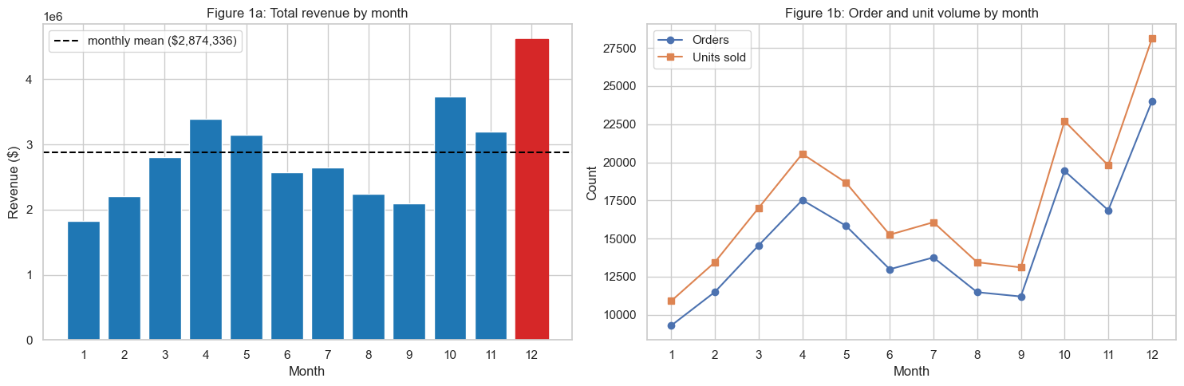
Fig. 1. Monthly revenue (left) with the count of orders and units and the average order value (right). Revenue peaks in December and October.

Revenue by city
San Francisco generated the highest revenue, with $8.26 million, accounting for 24.0% of total sales. This was approximately 1.5 times the revenue of Los Angeles, which ranked second with $5.45 million. Austin recorded the lowest revenue at $1.82 million. Similar to the monthly analysis, the difference in revenue was mainly driven by the number of orders rather than the amount spent per order. The average order value remained fairly consistent across all nine cities, ranging from $191 to $196. Therefore, San Francisco achieved the highest revenue because it had the largest number of orders, not because customers spent more on each purchase.
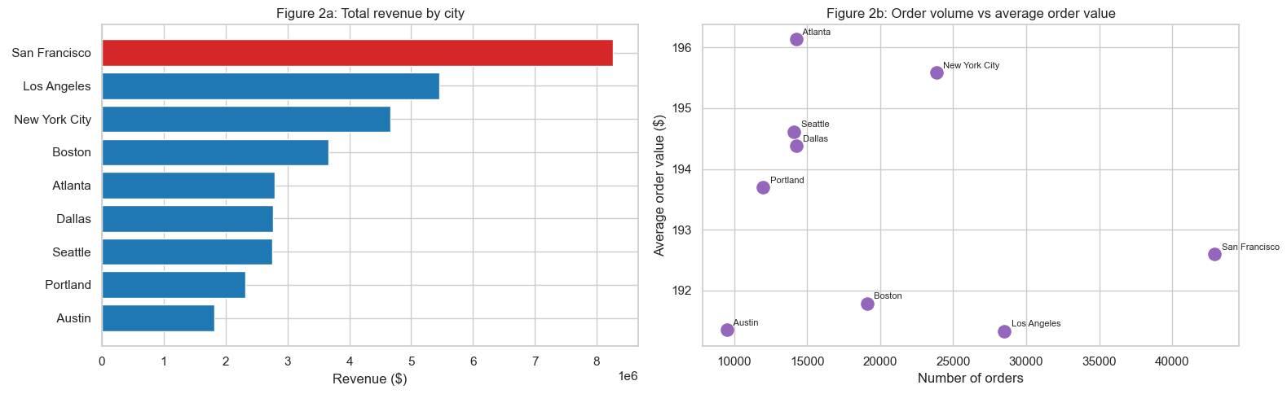
Fig. 2. City revenue (left) and average order value against order count (right). San Francisco leads on volume, not on spend per order.

Products by units and by revenue
The best-selling products and the highest-earning products are almost two different lists. On units, AAA Batteries (4-pack) lead with 31,017 sold, followed by AA Batteries (4-pack) at 27,635 and USB-C Charging Cables at 23,975, which are all cheap, frequently bought accessories. On revenue, the MacBook Pro Laptop is first with $8.04 million, or 23.3% of the total, ahead of the iPhone ($4.79 million) and the ThinkPad Laptop ($4.13 million). These sell in far smaller numbers but their high prices dominate revenue. The Pareto view in Figure 4 makes the concentration explicit: the top 8 of 19 products account for roughly 80% of revenue.
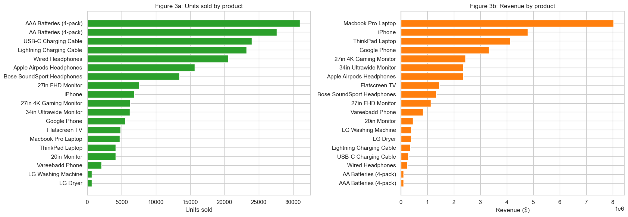
Fig. 3. Units sold and revenue by product. High-volume accessories differ from high-revenue hardware.
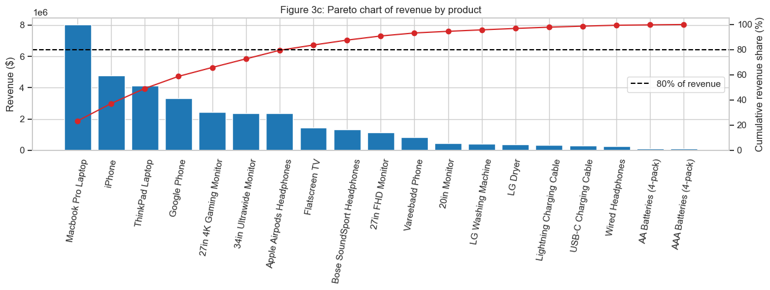
Fig. 4. Pareto chart of product revenue. About eight products supply four fifths of total revenue.

Order activity by time
The busiest single hour is 19:00, with 12,377 orders, closely followed by 12:00 (12,082) and 11:00 (11,882). The daily curve has two peaks: activity builds through the morning to a midday high, dips in the early afternoon, and rises again to the evening peak before falling away at night. Grouped into broad bands, the afternoon holds the most orders simply because it spans more hours. Across the week the picture is flat. Tuesday is highest and Friday lowest, but only by a few percent, so there is no real weekday or weekend effect. A 30-day moving average of daily revenue (Figure 6) reproduces the same seasonal rise and fall seen in the monthly totals.
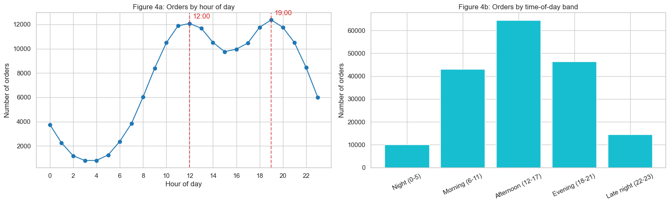
Fig. 5. Orders by hour of day. Peaks occur near midday and at 19:00.
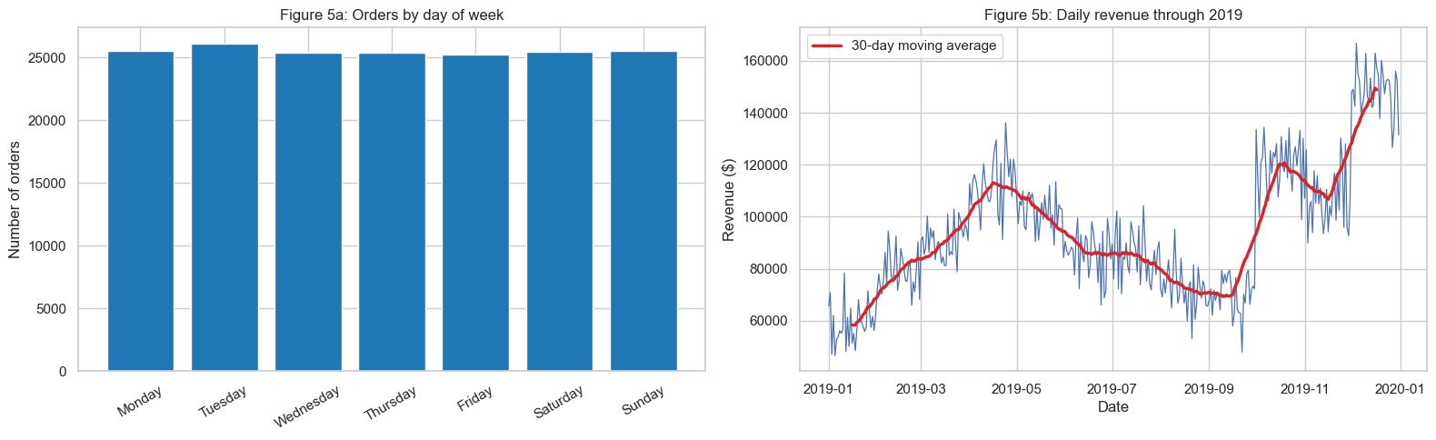
Fig. 6. Daily revenue with a 30-day moving average, showing the seasonal trend against near-flat day-of-week variation.

Statistical Analysis

Price against quantity sold
The fifth question asks whether expensive products sell less often. This was tested at the product level using three complementary methods, each capturing a different aspect of the relationship and implemented using SciPy [4]. Table I summarises the results. The Pearson correlation of −0.601 (p = 0.006) indicates a moderate negative linear relationship, while the Spearman rank correlation of −0.777 (p < 0.001) reveals an even stronger monotonic association. Applying Pearson correlation to log-transformed values produces −0.765 (p < 0.001), suggesting a power-law relationship between price and quantity sold. All three tests are significant at the 1% level, allowing the null hypothesis of no association to be rejected. Cheap products such as batteries and charging cables sell in much larger quantities than high-priced items like laptops, and Figure 7 shows this relationship becoming approximately linear on log–log axes. However, this analysis compares different products at different price points rather than the same product before and after a price change. It therefore demonstrates an association between price and sales volume, rather than providing causal evidence that lowering a product's price would increase its sales.
Test | Statistic | p-value | Interpretation
Pearson (linear) | r = -0.601 | 0.006 | moderate negative
Spearman (rank) | rho = -0.777 | <0.001 | strong monotonic
Pearson (log-log) | r = -0.765 | <0.001 | power-law
TABLE I. Price versus units sold (product level).
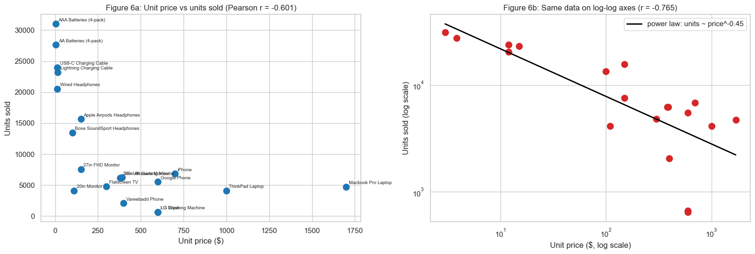
Fig. 7. Units sold against unit price on linear (left) and log-log (right) axes. Sales fall steadily as price rises.

Order value across cities and hours
Two additional analyses examine whether average order value differs by location or time. A one-way ANOVA shows no significant difference across the nine cities (F = 0.529, p = 0.836). The Kruskal–Wallis test reaches the same conclusion (H = 6.150, p = 0.631) [4]. Average order values range only from $191.33 to $196.13, while the median order value is $14.95 in every city. Order value also shows no meaningful relationship with the time of day. The Spearman correlation is −0.0007 (p = 0.776), and Figure 8 shows that average order value remains close to $193.30 throughout the day. These results suggest that differences in sales across cities and times are driven by the number of orders rather than the value of each order.
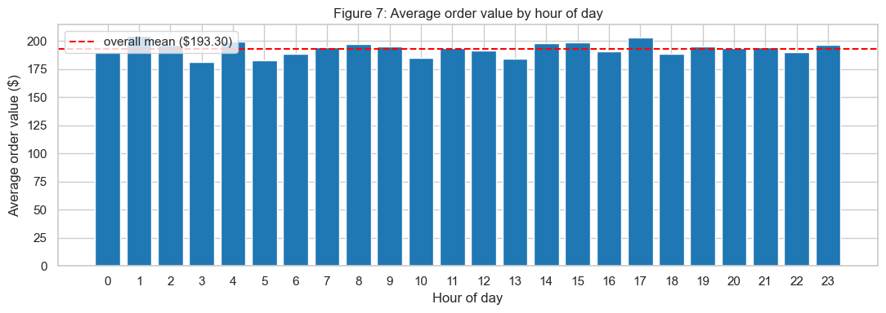
Fig. 8. Average order value by hour, staying close to the overall mean.

Association Rule and Market Basket Analysis
Orders with the same order ID appearing on more than one line represent purchases containing multiple products. These multi-item orders were used for the market basket analysis, with support, confidence and lift calculated for every product pair [5]. Table II shows that the strongest associations are between smartphones and their matching charging cables. Customers purchasing a Google Phone or Vareebadd Phone often also buy a USB-C Charging Cable, while iPhone customers are more likely to purchase a Lightning Charging Cable. Around 15–18% of phone orders include the corresponding cable. Lift helps distinguish genuine associations from products that simply sell frequently [6]. For example, Wired Headphones and the iPhone appear together 462 times, but their lift is only 0.64, indicating that they co-occur less often than expected under independence.
Pair | Count | Confidence | Lift
Google Phone -> USB-C Cable | 997 | 18.1% | 1.47
Vareebadd Phone -> USB-C Cable | 368 | 17.8% | 1.46
iPhone -> Lightning Cable | 1,011 | 14.8% | 1.22
Wired Headphones + iPhone | 462 | — | 0.64
TABLE II. Strongest association rules and a high-count, low-lift counter-example.
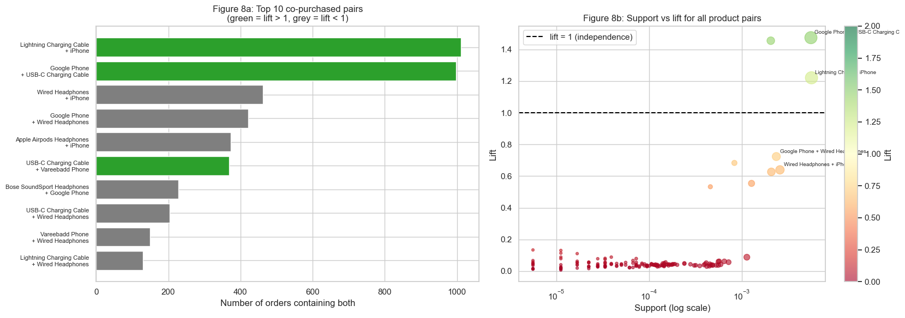
Fig. 9. Association metrics for the leading product pairs. Phone-and-cable combinations carry the highest lift.

Machine Learning Modelling
The seventh question that can machine learning predict sales revenue. It cannot be answered honestly without first dealing with the leakage identified in Section II. Because Sales equals Quantity times Price, any model given both inputs simply rebuilds the target. To illustrate this, three modelling approaches were compared using scikit-learn [2]. Model A includes both Quantity and Price and achieves an R-squared of almost 1.000, with an RMSE of only a few dollars compared with a target standard deviation of about $334. This near-perfect performance results from data leakage rather than predictive ability. Model B uses only contextual variables (city, hour, month and day of week). Its performance falls to an R-squared of 0.000 for linear regression and −0.045 for the random forest model [7], indicating that these variables provide little useful information for predicting order value. This is consistent with the earlier statistical analysis, which found no meaningful relationship between order value and either city or hour. Adding product identity increases the R-squared to 0.999, but this is because each product has a fixed price, making product identity an indirect representation of price. These results show that, at the order-line level, contextual variables have almost no predictive value, while product choice explains nearly all of the variation in sales revenue.
A more practical prediction task is to estimate daily revenue. The 2019 order records were aggregated to daily totals, and calendar variables were used as predictors. Unlike the order-line models, daily revenue is not a fixed function of the input variables, making this a valid forecasting problem. Linear regression achieved a test R-squared of approximately 0.90, with an RMSE of around $8,900 compared with an average daily revenue of $94,475, corresponding to an error of less than 10% of the daily average. Cross-validation produced similar results, indicating that the model generalises well and that the performance is not dependent on a particular train–test split. Linear regression also performed as well as, or slightly better than, the random forest and gradient boosting models. With only 365 daily observations, the seasonal pattern is relatively smooth, leaving little advantage for the more flexible tree-based models. Figure 10 shows that the fitted values follow the overall seasonal pattern, although larger errors occur on days with unusually high or low revenue.
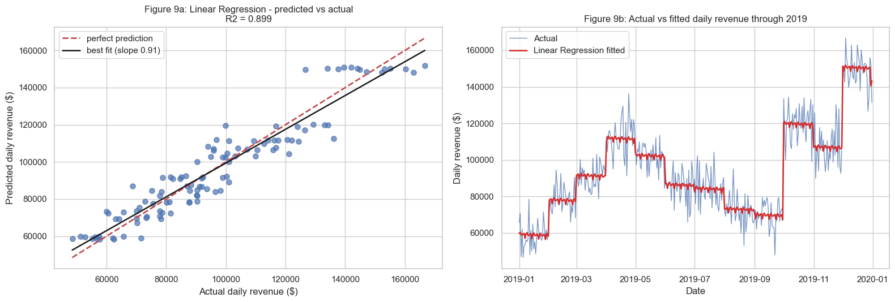
Fig. 10. Actual and predicted daily revenue for the daily linear model (test R-squared about 0.90).

Feature Importance
Feature importance was examined for both the order-line and daily prediction models. In the order-line model, product identity accounts for most of the predictive power. The most important features are the high-priced products, including the MacBook Pro, ThinkPad, iPhone and Google Phone, because product identity is closely related to price (Figure 11). City and calendar variables make only a small contribution. In the daily model, seasonal variables become the most important predictors. Random forest impurity importance identifies week of year as the most influential feature, while permutation importance gives greater importance to the month indicators [2]. Both methods indicate that day of week contributes little to prediction (Figure 12). Although the two importance measures rank individual features slightly differently, both identify seasonality as the dominant factor influencing daily revenue.
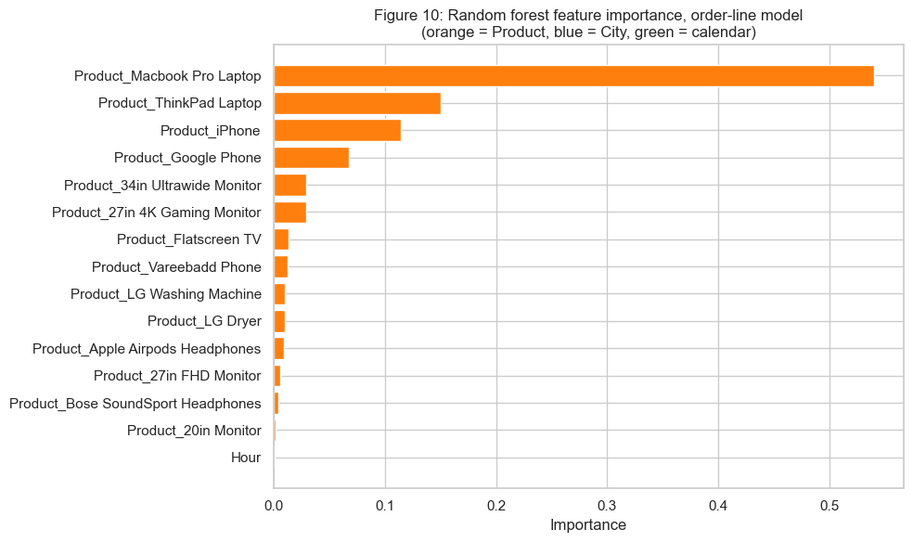
Fig. 11. Order-line feature importance. High-priced products dominate.
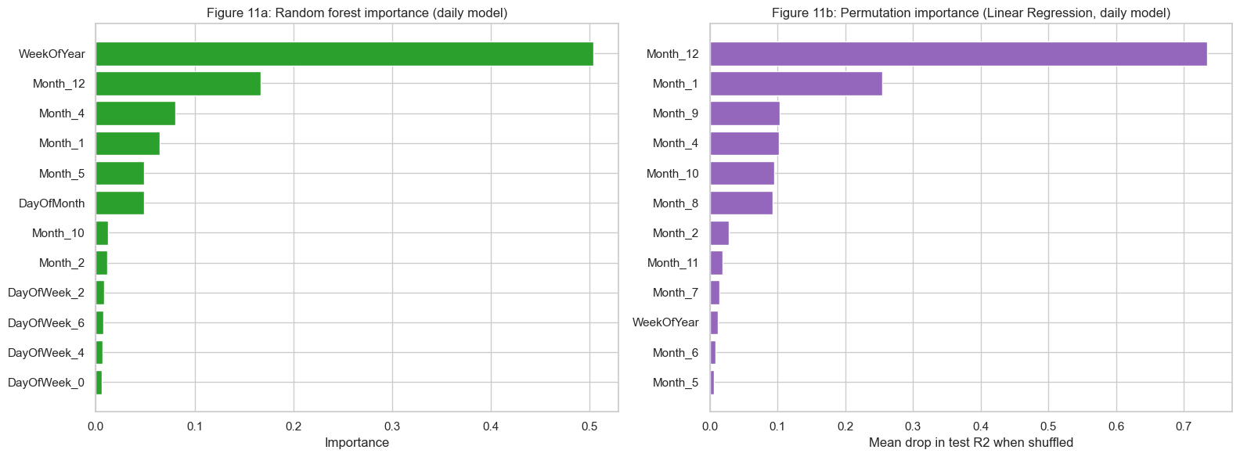
Fig. 12. Daily-model importance from impurity and permutation. Seasonal features lead; day-of-week is negligible.

Discussion
The results show a consistent pattern across the analyses. Differences in revenue between months, cities and hours are mainly explained by changes in the number of orders rather than the value of each order. December, San Francisco and 19:00 generate the highest revenue because they have more transactions, while average order value changes very little. The ANOVA results and the near-zero correlation between hour and order value support this finding. For the business, this suggests focusing staffing, inventory and marketing resources on the fourth quarter and the midday and early-evening peaks, when demand is highest.
The modelling results also highlight the importance of selecting an appropriate prediction task. At the order-line level, including both Quantity and Price produces an R-squared close to 1.000, but this reflects data leakage because Sales is calculated directly from these variables. Aggregating the data to daily revenue removes this issue and produces a meaningful forecasting problem, with linear regression achieving a test R-squared of about 0.90. The market basket analysis identifies a small number of useful cross-selling opportunities, mainly between smartphones and their matching charging cables, while also showing that frequently co-occurring products do not necessarily have strong associations. Finally, the contrast between high-volume accessories and high-revenue products suggests different inventory priorities. Batteries and charging cables contribute consistent sales through high demand, whereas laptops and smartphones account for a large proportion of total revenue despite lower sales volumes.

Conclusion
This study analysed one year of electronics sales data using a complete data science workflow and addressed the eight research questions. Revenue was highest in October and December, with San Francisco generating the largest share of sales. A small number of high-priced products accounted for most revenue, while low-cost accessories sold the greatest number of units. Order activity peaked around 19:00, and product price showed a strong and significant negative relationship with sales quantity. Market basket analysis identified the strongest associations between smartphones and their matching charging cables. Machine learning models achieved high predictive performance only after the data were aggregated to daily revenue, avoiding the data leakage present in the order-line models. At the order-line level, product identity explained most of the variation in sales revenue, whereas seasonal variables were the most important predictors in the daily forecasting model.
This study has several limitations. First, the dataset covers only 2019, so the observed seasonal patterns are based on a single year and cannot capture longer-term trends. Second, approximately 96% of orders contain only one item, resulting in low support values for all association rules. Although some product pairs show meaningful associations, the results should be interpreted cautiously. In addition, the dataset does not include customer identifiers, making it impossible to examine repeat purchasing behaviour, customer lifetime value or cohort retention. The relationship between price and quantity sold is also based on observational data and should not be interpreted as evidence of price elasticity. Finally, the dataset contains sales revenue but not product costs, so the analysis focuses on revenue rather than profitability. Future research could extend the analysis by including multiple years of data, customer-level information, promotional variables and product cost data to provide a more complete understanding of sales performance and profitability.

References
[1] W. McKinney, "Data structures for statistical computing in Python," in Proc. 9th Python in Science Conf. (SciPy), 2010, pp. 56-61.
[2] F. Pedregosa et al., "Scikit-learn: Machine learning in Python," J. Mach. Learn. Res., vol. 12, pp. 2825-2830, 2011.
[3] J. D. Hunter, "Matplotlib: A 2D graphics environment," Comput. Sci. Eng., vol. 9, no. 3, pp. 90-95, 2007.
[4] P. Virtanen et al., "SciPy 1.0: Fundamental algorithms for scientific computing in Python," Nature Methods, vol. 17, pp. 261-272, 2020.
[5] R. Agrawal, T. Imielinski, and A. Swami, "Mining association rules between sets of items in large databases," in Proc. ACM SIGMOD Int. Conf. Management of Data, 1993, pp. 207-216.
[6] J. Han, M. Kamber, and J. Pei, Data Mining: Concepts and Techniques, 3rd ed. Waltham, MA, USA: Morgan Kaufmann, 2011.
[7] L. Breiman, "Random forests," Mach. Learn., vol. 45, no. 1, pp. 5-32, 2001.

