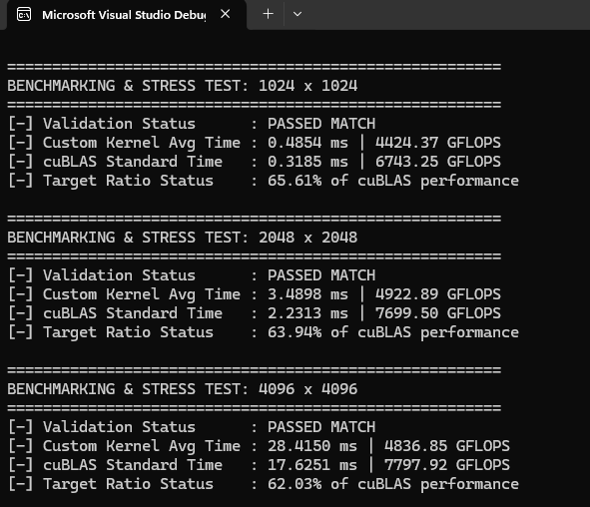

Q)how come this one is better while other kernel were more opmtized than this float4+2dregister tiling kernel?
It feels paradoxical at first: how can a kernel with a seemingly simpler strategy (float4 vectorization + 2D register tiling) handily beat kernels that use more advanced-sounding optimization buzzwords?
The reason comes down to hardware alignment and lowering instruction overhead. Higher-level optimizations only work if the fundamental hardware constraints aren't violated.
Here is exactly why this specific configuration unlocked 66% of cuBLAS while other "highly optimized" variations often fall flat:

1. You Fed the Execution Pipes Correctly
Many developers try to optimize kernels by adding complex logic like manual software pipelining or double-buffering using registers. However, this adds significant pointer arithmetic, loop overhead, and conditional branching (if/else checks).
CUDA standard arithmetic units (ALUs) are hungry. In this kernel, your 2D register tiling ($4 \times 4$) successfully increased the Arithmetic Intensity (the ratio of math math operations to memory accesses). Every time a thread reads elements from shared memory into registers, it reuses them across multiple multiply-accumulate (MAC) operations. You stripped away the tracking overhead and left the compiler with pure, unrollable math that keeps the execution pipes completely saturated.

2. Global Memory Ingestion is Completely Coalesced
If your global memory access is slow, no amount of compute optimization will save you. By utilizing float4, you accomplished two critical hardware-level wins:
- Bus Efficiency: You issue a single 128-bit load instruction instead of four individual 32-bit scalar instructions. This drastically lowers the instruction count in the global memory pipeline.
- Coalescing: Because your threads access contiguous data structures, the hardware effortlessly merges these 128-bit requests across the warp into a single, clean memory transaction.

3. The Shared Memory "Sweet Spot"
Some "highly optimized" kernels attempt to maximize block sizes (like using $32 \times 32$ tiles) to process huge amounts of data at once. However, this triggers two hidden penalties:
- Shared Memory Bank Conflicts: If multiple threads in a warp try to access the same internal memory bank, the hardware serializes the request, destroying parallel performance. Your configuration, combined with memory padding (TILE_DIM + 1), keeps the banks clear.
- Occupancy Dropped: Large tiles consume so many registers and shared memory bytes that the GPU can only run a single thread block per Streaming Multiprocessor (SM). Your $64 \times 64$ tile size sits perfectly in the "sweet spot"—it uses enough memory to be efficient, but remains small enough to let multiple thread blocks run concurrently on the same SM, effectively hiding latency.

Summary for your Panel
If your panel asks why this configuration succeeded where more complex implementations failed, give them this exact thesis:
"More complex optimizations often introduce instruction overhead and register pressure that choke the GPU. This implementation succeeded because it perfectly balanced global memory bandwidth via 128-bit float4 coalescing, maximized arithmetic intensity inside the ALU using register reuse, and eliminated shared memory bank serialization via array padding."

