**Hw1**

CNN1

|  |  |  |  |  |
| --- | --- | --- | --- | --- |
|  | Mini-batch size | Learning rates | loss | Loss on validation |
| CNN1 | 32 | 0.01 | 0.27167237 | 0.26664451 |
| CNN1 | 32 | 0.0001 | 0.406794809 | 0.34358755 |
| CNN1 | 64 | 0.01 | 0.282041679 | 0.2736536 |
| CNN1 | 64 | 0.0001 | 0.444547867 | 0.36521428 |

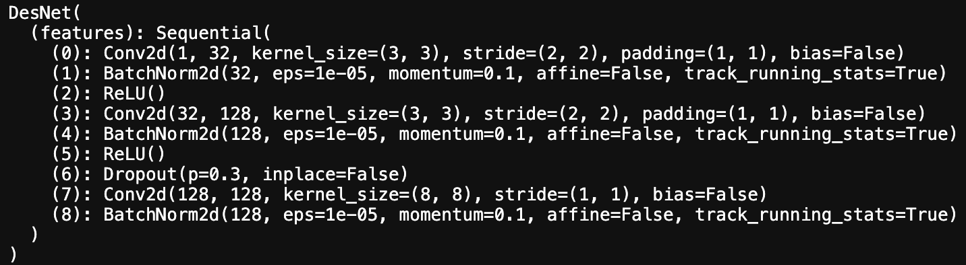

Mini-batch size:**32** Mini-batch size:**64**

Learning rates:**0.01** Learning rates:**0.01**

Epoch: **60** Epoch: **60**

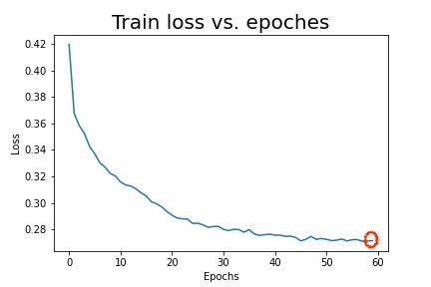 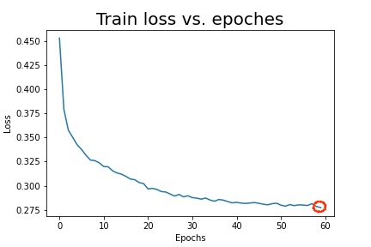

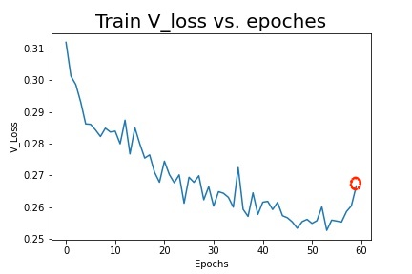 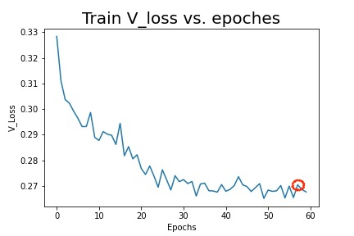

Mini-batch size:**32** Mini-batch size:**64**

Learning rates:**0.0001** Learning rates:**0.0001**

Epoch: **60** Epoch: **59**

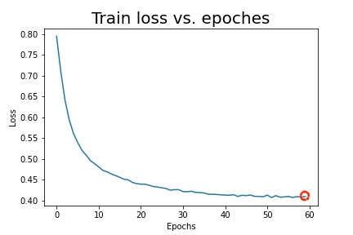 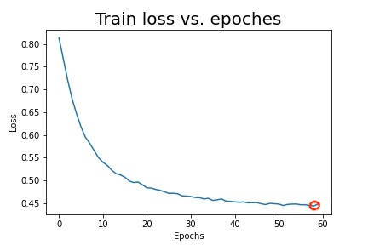

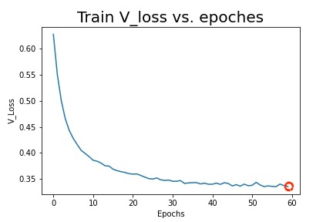 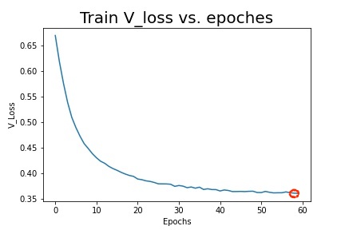

CNN2

|  |  |  |  |  |
| --- | --- | --- | --- | --- |
|  | Mini-batch size | Learning rates | loss | Loss on validation |
| CNN2 | 32 | 0.01 | 0.276053868 | 0.27632351 |
| CNN2 | 32 | 0.0001 | 0.499659879 | 0.42807123 |
| CNN2 | 64 | 0.01 | 0.289850905 | 0.28061572 |
| CNN2 | 64 | 0.0001 | 0.536881234 | 0.46434413 |

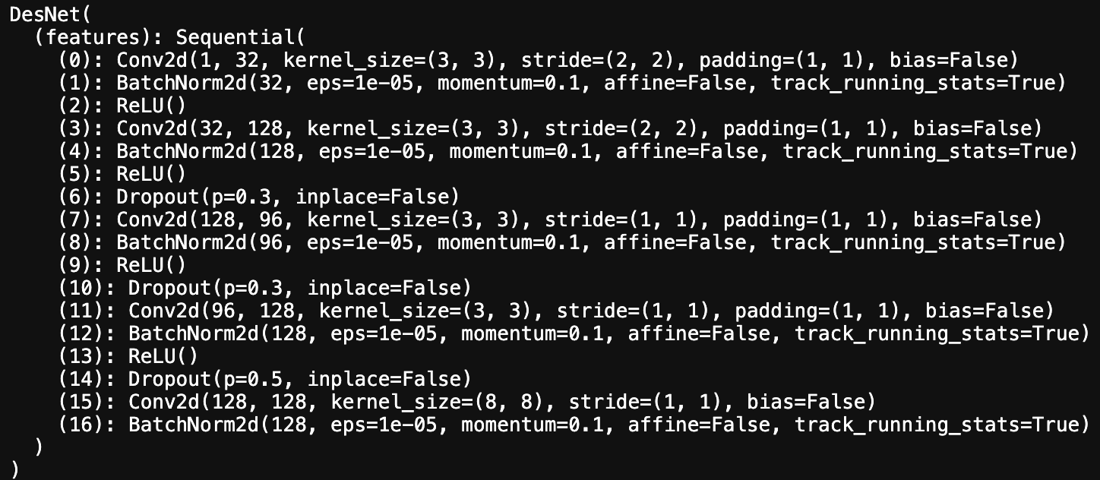

Mini-batch size:**32** Mini-batch size:**64**

Learning rates:**0.01** Learning rates:**0.01**

Epoch: **60** Epoch: **58**

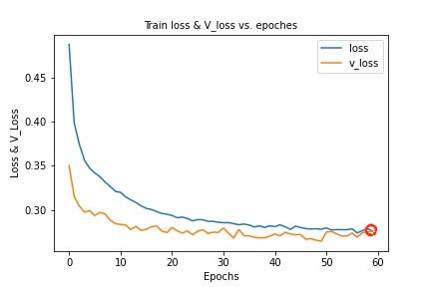 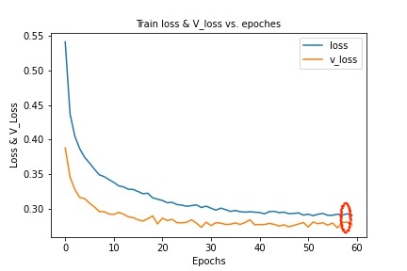

Mini-batch size:**32** Mini-batch size:**64**

Learning rates:**0.0001** Learning rates:**0.0001**

Epoch: **60** Epoch: **57**

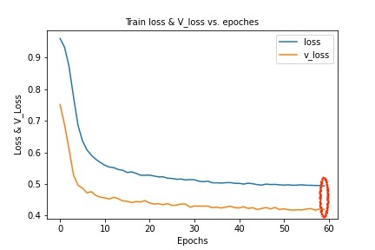 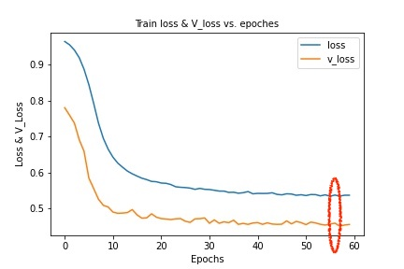

CNN3

|  |  |  |  |  |
| --- | --- | --- | --- | --- |
|  | Mini-batch size | Learning rates | loss | Loss on validation |
| CNN3 | 32 | 0.1 | 0.280579409 | 0.27892809 |
| CNN3 | 32 | 0.008 | 0.315234764 | 0.31644679 |
| CNN3 | 64 | 0.1 | 0.271975602 | 0.27199495 |
| CNN3 | 64 | 0.008 | 0.266286147 | 0.27062264 |

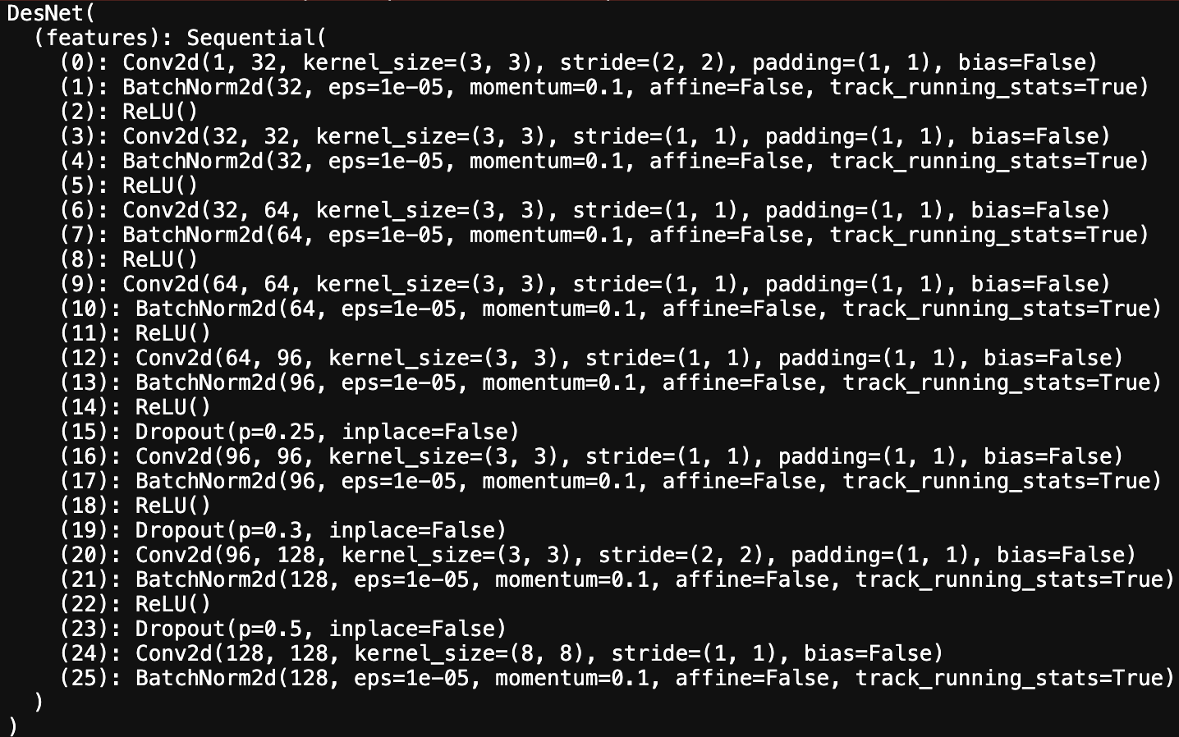

Mini-batch size:**32** Mini-batch size:**64**

Learning rates:**0.1** Learning rates:**0.1**

Epoch: **5** Epoch: **6**

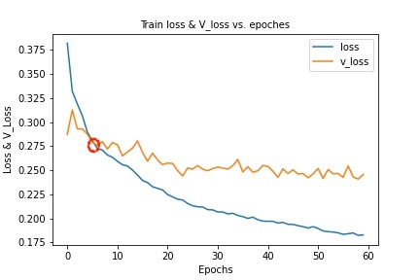 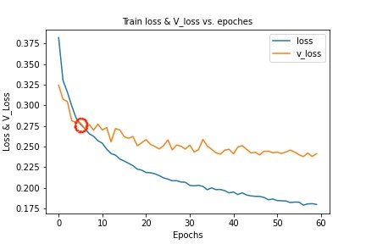

Mini-batch size:**32** Mini-batch size:**64**

Learning rates:**0.08** Learning rates:**0.08**

Epoch: **13** Epoch: **53**

