**CS 550 PROJECT 2**

Name: CHI CHIEH WENG

Email: wengchic@oregonstate.edu

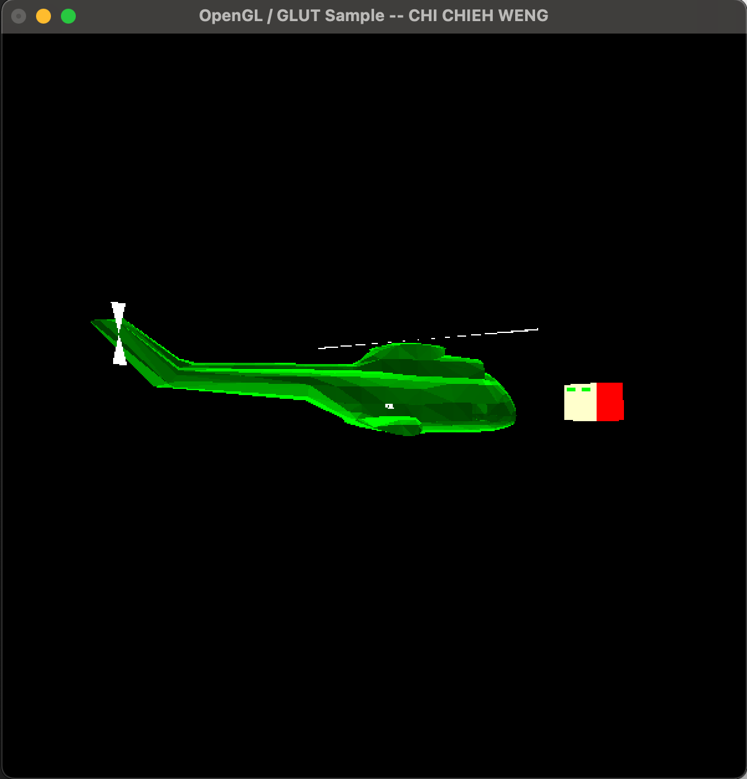

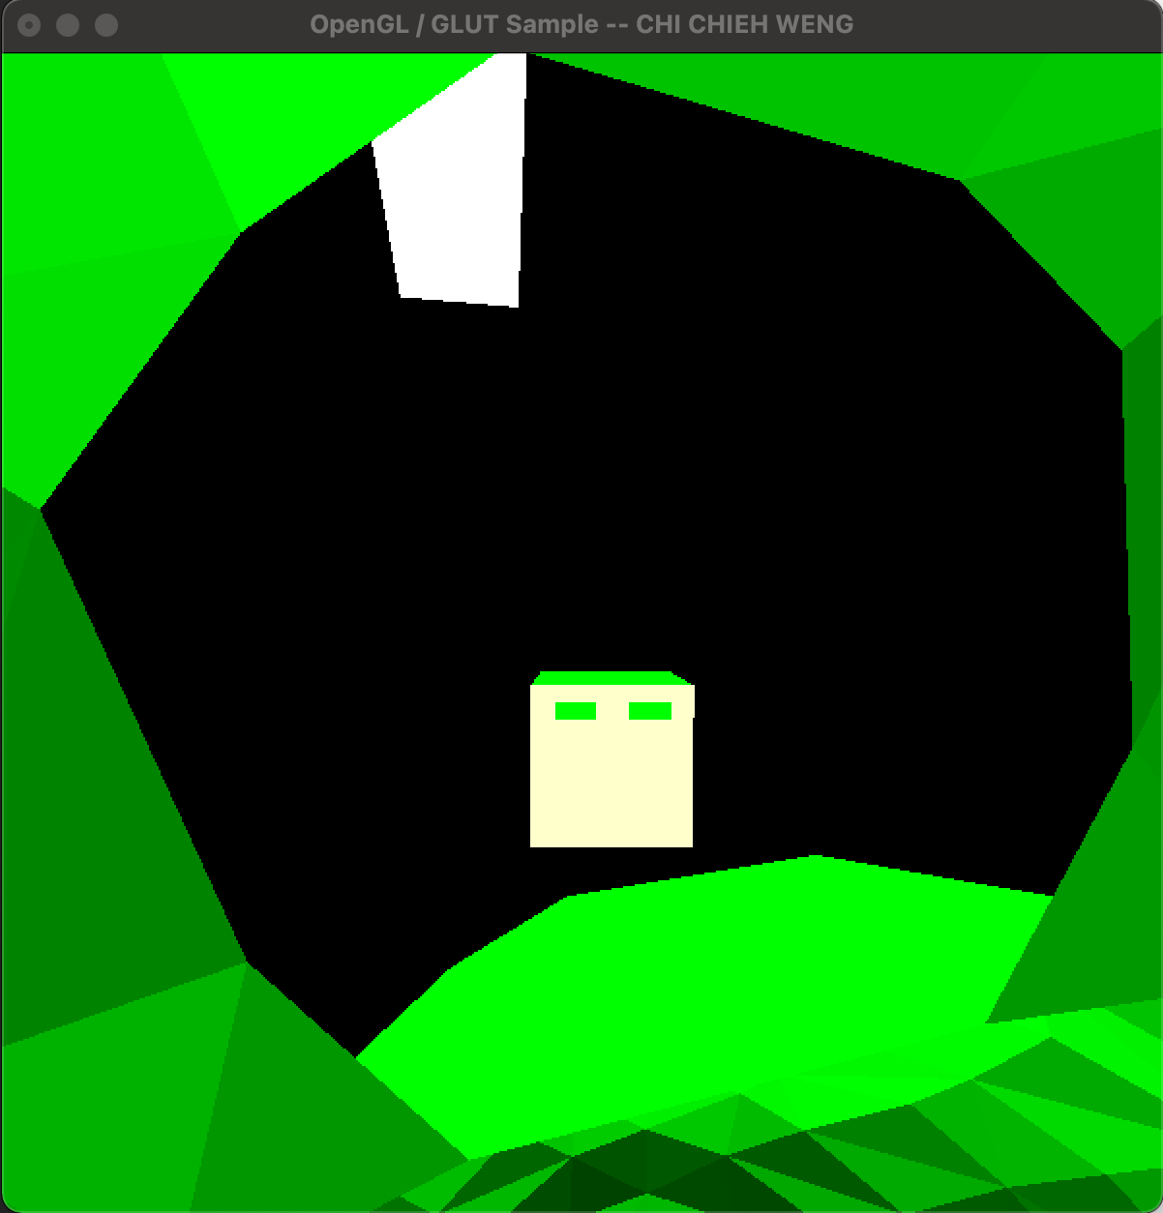

Video lnik:

https://media.oregonstate.edu/media/t/1_u3lf2d4k